Thread /  Transition | 0  Server main | 1  Downloader | Worker
0 | Read configuration  call accept
1 |  | Create output file  connect
2 | Accept  read request
3 |  | Create socket  initialize streams
4 | Send header  and file content  call accept
5 |  | Read socket output  start new Downloader(?)
6 - 10 |  | Read to buffer from inputstream  Write from buffer to outputstream
11-13 |  |  | Print info
13-16 |  |  | initiate new sockets
17 |  |  | Exit worker?
18 | Call accept  new worker  initiate streams and buffer  read line from buffer
19-21 |  |  | Create new sockets
21-22 |  |  | Init printwriter
23-30 |  |  | Library code
31-33 |  |  | Init printwriter
34-36 |  |  | Get input stream
37-39 |  |  | Print range
40-45 |  |  | Lib code
46 | Check range line  send file with range
47-51 |  |  | Reset line  read line from inputstream  Build line from input stream  validate line
52-55 |  |  | Reading stops  connect  getData
56-60 |  |  | Write to buffer  seek
61-62 | Check if main finished
63-69 |  |  | Close writer  close inputstream  close socket  decrement downloaders
70 | Check main finished

------------------------------------------------------ transition #67 thread: 3
nas.java.net.choice.NasThreadChoice {id:"SOCKET_CLOSE" ,2/2,isCascaded:false,attrs:[gov.nasa.jpf.vm.GlobalSchedulingPoint@52525845]}
[24 insn w/o sources]
Downloader.java:216 : is.close();
[12 insn w/o sources]
Downloader.java:217 : s.close();
------------------------------------------------------ transition #68 thread: 3
gov.nasa.jpf.vm.choice.ThreadChoiceFromSet {id:"SHARED_OBJECT" ,2/2,isCascaded:false}
Downloader.java:217 : s.close();
[2 insn w/o sources]
Downloader.java:221 : }
Downloader.java:222 : }
Downloader.java:142 : downloaders--;
------------------------------------------------------ transition #69 thread: 3
gov.nasa.jpf.vm.choice.ThreadChoiceFromSet {id:"SHARED_CLASS" ,2/2,isCascaded:false}
Downloader.java:142 : downloaders--;
------------------------------------------------------ transition #70 thread: 1
gov.nasa.jpf.vm.choice.ThreadChoiceFromSet {id:"SHARED_CLASS" ,1/2,isCascaded:false}
Downloader.java:201 : if (main_finished ||

What happens:
1. Downloaders closes sockets and streams
2. Downloaders decrements the shared object downloaders
3. A thread switch occurs (before the if statement that is dependent on downloaders is evaluated)
4. Main thread evaluates if statement dependent on downloaders
5. Data race occurs and the behavior of the main thread is unpredictable.

- see next page -
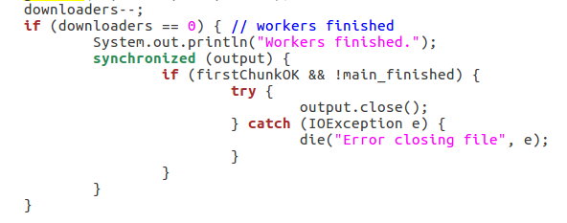
The intention is for one of the workers to close the output stream, but if a race condition occurs then both will enter the if statement and one of the workers will throw the error trying to close the file.

Another example is that the if statement may evaluate the variable fore the WRITE occurs.

