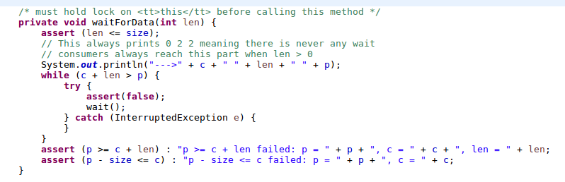
In this method we have modified waitForData to assert(false) (aka fail with a trace) whenever we are supposed to wait for data, yet it succeeds. This must mean that there are no waiting consumers. This is because when we only run two threads the notify will always call the other thread, ensuring that theres never a reason to wait to consume because the producers and consumers operations run in tandem on two threads. Increasing the number of works to >2 will reveal the problem.

