Gustav Jones
IT Graad 10 PAT – Fase 1
Freelance Development Application
You may add an image / your own logo (not required)
Table of Contents
Define the task 2
Topic: 2
Purpose of program: 2
Possible solution: 2
Scope: 2
User Stories 2
Acceptance Test – List FOUR Functions 2
Data Dictionary 2
User defined function 2
Navigation 3
GUI Design 3
Tab Sheet 1 (User 1): 3
INPUT: 3
OUTPUT: 3
Tab Sheet 2 (User 2): 3
INPUT: 3
OUTPUT: 3
IPO – Software Design Tool 4
INPUT VALIDATION: 4
PROCESSING: 4

Define the task

Topic:

Purpose of program:

Possible solution:

Scope:

User Stories
User 1:
WHO | WHAT | WHY

User 2:
WHO | WHAT | WHY

Acceptance Test – List FOUR Functions
- The system
- The system
- The system
- The system

Data Dictionary

User defined function
Signature | Explanation

Navigation

GUI Design

Tab Sheet 1 (User 1):
Screenshot
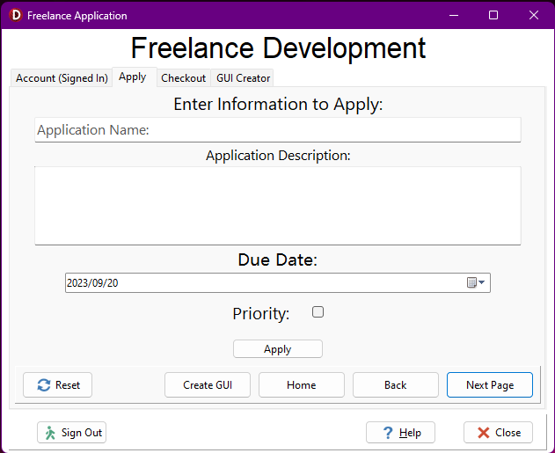

INPUT:
tsApply (Apply)
Source | Variable name & data type | Format (size, M/F for gender, yyyy/mm/dd) | Object Name | Local/Global variable
edtApplyTaskName | sTaskName : String | String with no more than 50 characters | Edit | Local
redApplyDescription | sDescription :  String | String that consists of at least one line | Richedit | Local
dtpApplyDueDate | dDueDate : Date | Date object to store the due date from picker | DateTimePicker | Local
chkApplyPriority | bPriority : Boolean | Boolean from checkbox indication priority true/false | Checkbox | Global
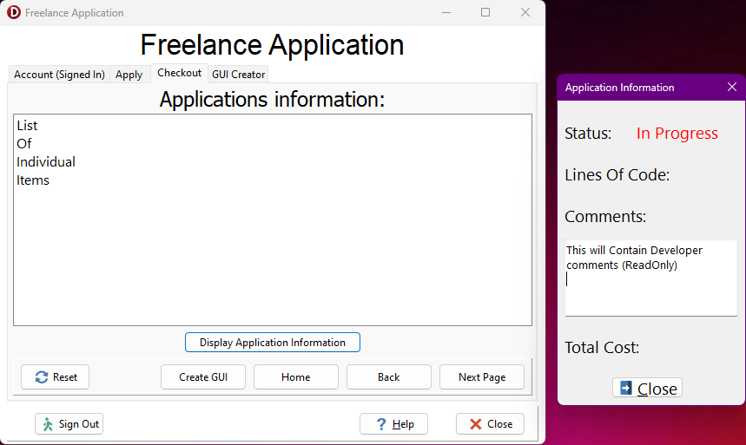

OUTPUT:
tsCheckout (Checkout)
Output | Format (Type, size) | Component
Task Information | Caption: <Task Name without Description as a String> | Listbox
Total Cost | Total Cost: <Cost of Task with Consult Fee as a Real formatted as a currency> | Label
Status | Status: <Status 'In Progress'/'Completed' as a String | Label
Lines Of Code | Lines Of Code: <Amount of lines as an Integer> | Label
Developer Comments | <Comments from the developer in lines of Strings> | Richedit

Tab Sheet 2 (User 2):
Screenshot
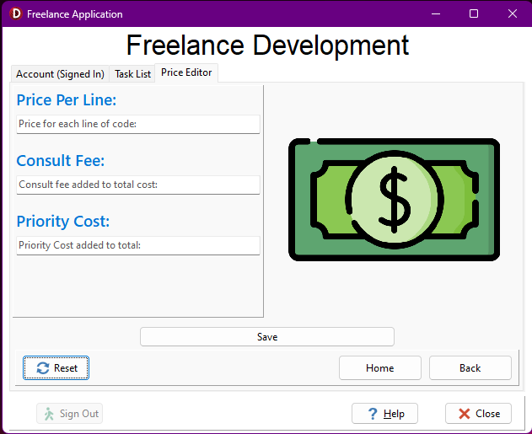
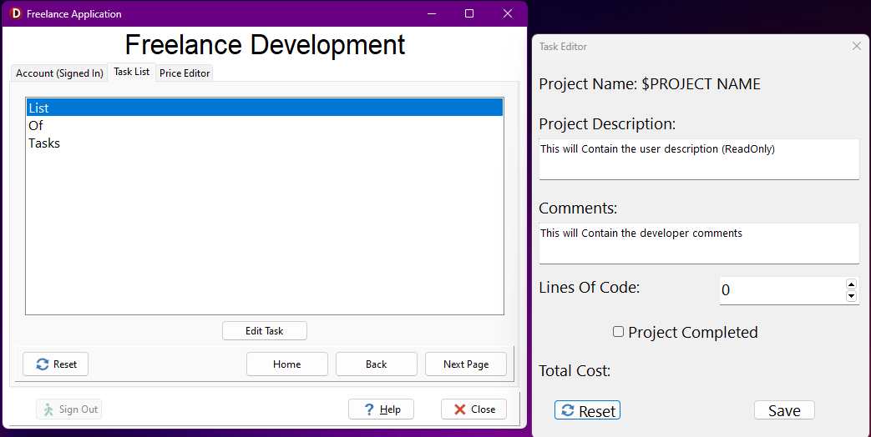

INPUT:
tsPriceEditor (Price Editor)
Source | Variable name & data type | Format (size, M/F for gender, yyyy/mm/dd) | Object Name | Local/Global variable
edtPriceEditor | rPricePerLine : Real | Real with only a max of 2 desimal points formatted as a currency | Edit | Global
edtPriceEditorConsultFee | rConsultFee : Real | Real with only a max of 2 desimal points formatted as a currency | Edit | Global
edtPriceEditorPriorityCost | rPriorityCost : Real | Real with only a max of 2 desimal points formatted as a currency | Edit | Global

tsTaskList (Task List)
Source | Variable name & data type | Format (size, M/F for gender, yyyy/mm/dd) | Object Name | Local/Global variable
redComments | sComments :  String | Lines of Strings that contain the developer comments from the Richedit | Richedit | Local
sedLinesOfCode | iLinesOfCode : Integer | Integer of the total amount of code lines | Spinedit | Local
chkCompleted | bCompleted : Boolean | True/False value for if the project is completed | Checkbox | Local

OUTPUT:

tsTaskList (Task List)
Output | Format (Type, size) | Component
Total Cost | Total Cost: <Cost of Task with Consult Fee formatted as a currency> | Label
Project Description | <Paragraph formatted in lines from the stored values in the text file> | Richedit
Project Name | Project Name: <String from stored value in text file> | Label

IPO – Software Design Tool

INPUT VALIDATION:
Input | Validation technique and description | Associated error message
iLinesOfCode | Range Check: Check if the value is in a certain range (iLinesOfCode > 100) | 'Minimum lines of code not reached! Cannot charge consult fee for less than 100 lines of code'
lstTaskListItems.ItemIndex | Presence Check: Check if an Item was selected from the lstTaskListItem | 'Please Select an item!'
sTaskName | Allowed Character Check: Check if special characters were used in the Task Name | 'Please remove special characters from Application Name'
sTaskName | Range Check: Check if the Task Name has at least 1 Character and at most 50 | 'Application Name must be between 1 and 50 characters'

PROCESSING:
What processing will be done | Algorithms, formulas, etc.
List: | Algorithms:
1 Total Cost | iLinesOfCode <- input from text file  rCost <- iLinesOfCode * rPricePerLine  rTotalCost <- rCost + rConsultFee  if bPriority  rTotalCost <- rTotalCost + rPriorityFee  Display rTotalCost formatted as a currency
2 File IO | Algorithm 2

