BugTanks
Design Document

Authors:
 | Martin Wexö Olsson  871220  mawm06@student.bth.se | Dennis Jönsson  850417  zelebsel@hotmail.com | Viktor Svensson  880127  wiktor_sv@hotmail.com

Over View
This is the design document for BugTanks. The goal with this document is to identify and explain all the game mechanics in detail. This document will serve two purposes, It will be a fully fledged game manual of how to play the game and also a more detailed reference that the game developers need to specify all the necessary modules and mechanics on a lower level.
Contents
Over View 1
Game Play 3
Overview 3
Levels 3
Objectives 3
Pedestrians 3
Weapons 3
CloseCombat Tank Weapons 3
Minigun 3
Flamethrower 4
Pulse Cannon 4
LongRange Tank Weapons 4
Cannon 4
Gauss Cannon 4
Beam Cannon 4
Enemies 4
Ants 4
Kamikaze Ant 4
Normal Ant 5
Fire Ant 5
Spiders 5
Tarantula 5
Jumper 5
Black Widow 5
Beetles 5
Scarab 5
Plasma Beetle 5
AI (Behavior) 6
Sound and Music 6
Sounds that are needed: 6
Enemies 6
Civilians 6
Tanks 6
Voice Overs 6
GUI/HUD 7
Network 7
Concept Art 7
References 7

Game Play

Overview
Your main objective in this game is to kill all the bugs and save humanity. You have a team of 2 to 4 members each driving a tank, there are two types of tanks that each have their own specialty.
The city is your playfield where you will be beamed down and given certain tasks or missions you need to accomplish in order to beat the bugs. The different missions will be briefed to you throughout the game.
At times you will be swarmed by enemies in groups of 20, these are the smaller insects. For each bug you kill you will gain points that can be used for upgrading old weapons, buying new weapons and also buying a new tank if necessary.
These purchases are made trough a popup menu and when you have bought something it will be beamed down to you from the HQ from space, It might take some time to before the item can be beamed down depending on the size of the item, A new tank for example could take up to 10 sec to mount and beam down.

Camera
The camera view is almost top down, 3/4 . The camera follows the your tank but does not rotate. If you crash into something the camera will shake a little. The camera will fall back to a greater distant when driving in high speeds allowing you to see further ahead.

Controls
There will be two sets of controls for you. One when you are in control of the tank and one when you are outside the tank as a human. The tank will have to kinds of steering wheels so to speak, one for the actual turning of the tank and one for turning the gun barrel. When you are in "person mode" you will steer your character just like in GTA, Left and Right turns the character and back and forward is for walking. The "fire button" will be the same for both modes.
There are menu buttons as well, one for Main menu and one for HQ menu.

Levels
Each level is a city or a part of a city. You can move freely over the whole level where there will be some triggered scenarios scattered all over the place so that whenever you enter such a scenario there will be a lot of humans and spawning holes will appear in the ground spawning enemies, you will have to kill the bugs before they get to the humans.
The skirmish game will only be one level

Objectives
For each level you will be given a main objective, but when you are progressing trough the level you will stumble upon some scenarios where a lot of people are in danger and you need to save them or your game ratings will suffer for it. You will also be briefed with several sub missions on the way that you need to deal with. Some missions will be just to make it from point A to point B and(or) blow something up. Other missions will be emergency missions where a timer will start counting down then you will have a certain amount of time to complete the task, if you fail to complete such a task your game rating will also suffer from that.
Type of objectives:
- Main Objective(s)
ex. Kill A Certain type of super bug in that area (The Boss) or Blow up the bugs lair.
- Sub Objectives
ex. Get to a certain area for examining a distress call.
- Time Critical Emergencies Missions
ex. A close by emergency has emerged and you have a time limit to solve the problem.

Tank
There are two types of tanks in the game, one long ranged tank and one short range. The long ranged tank is a bit slow and not so resistant to enemy attack but deal heavy damage with it's weapons. The short range is well armored and very agile but the fire power is weak and mostly just good for smaller bugs.
Each type of tank has three kinds of weapons that works differently well on different types of bugs. All the weapons are upgradable, what kind of upgrade it is depends on the type of weapon. Some might get more fire power and others might get higher fire rate.
If your tank gets destroyed you will be ejected and enter person mode. You will have a handheld weapon for self defense until you can beam down another tank.

Pedestrians
You are supposed to protect the people of the city from the bugs. The bugs eat humans so sometimes you might have to chase after the bugs that are chasing the humans. There are a lot of pedestrians walking the streets in the city. But in times like this when chaos roams the streets the humans are fleeing for their lives and are willing to do anything to stay alive. When a bug is within a certain range of a human, that human will start to run in the opposite direction. If a human is within a certain range from your tank and it's standing still or just driving very slowly there is a 30% chance that he might try to steal it from you, by sneaking up behind you and toss you out of the tank GTA style and drive away with it. The humans spawn nearby outside the camera view. You get minus points for killing humans and it also affects you rating after completing a level.

Enemies
Enemies spawn from so called worm holes in the ground that can appear anywhere even right in front of you. Each wormhole has a fixed number of how many enemies will emerge from it. When they have spawned the first thing they will do is to attack the nearest oponent which is either you or the humans. If you shoot on a bug chasing a human it will start chasing you instead. You get plus points for every bug you kill, how much depends on the size of the bug.

Weapons

CloseCombat Tank Weapons

Minigun
- Base Damage 10
- Damage Effectiveness Light/Small, can be upgraded with armor piercing rounds for slightly higher effectiveness against Medium and Heavy armored foes) . Fires massive amounts of bullets in short succession, effective at slaughtering large amounts of smaller enemies, less effective against bigger enemies

Flamethrower
- Base Damage 10/sec in a conal AoE
- Damage Effectiveness Light/Small
Sustained damage in a small cone in front of the player, able to deal damage against many enemies at once, effective against many smaller enemies

Pulse Cannon
- Base Damage 50 in a large cylindrical AoE
- Damage Effectiveness Light/Small
Shoots a large pulse of energy in a cylinder in front of the tank, deals massive damage to all enemies in its path, but alot less effective to large targets. Has a small cooldown

LongRange Tank Weapons

Cannon
- Base Damage 50
- Damage Effectiveness Heavy/Large
Shoots a projectile into a single target, effective against heavily armored foes, because of slower rate of fire its less effective against many smaller foes, can be upgraded with explosive shots, this will make it more effective against swarms and less effective against single large targets

Gauss Cannon
- Base Damage 75
- Damage Effectiveness Heavy/Large
Shoots projectiles at very high speeds, very effective against larger/more heavily armored foes

Beam Cannon
- Base Damage 40
- Damage Effectiveness Heavy/Large
Fires a beam of heated energy, it will hit everything in a straight line from the tank to the target, deals double damage versus large enemies and needs to recharge between shots

Enemies

Ants
Ants are the more numerous and less dangerous of the insectoid invaders, they come in 3 variations all of them small in size

Kamikaze Ant
- Health points 20
- Armor Type/Size Light/Small
They will try to get up close to the tanks and explode on them, if you can kill then while they are close to other enemies, they will explode and hurt or kill them instead though

Normal Ant
- Health points 30
- Armor Type/Size Light/Small
The most standard type of enemy you will encounter, they will just try to swarm over you with sheer numbers

Fire Ant
- Health points 35
- Armor Type/Size Light/Small
Will circle your tank and fire goblets of fire

Spiders
Generally fewer in number and more dangerous than ants, they are also larger, all of them considered medium in size

Tarantula
- Health points 50
- Armor Type/Size Medium/Medium
Brutish spider that will typically just charge head on and try to rip open your tank

Jumper
- Health points 40
- Armor Type/Size Medium/Medium
An annoying spider that likes to jump around alot and attack you with a leaping attack

Black Widow
- Health points 60
- Armor Type/Size Medium/Medium
Will stay back and assault you with corrosive venom

Beetles
Huge insects with heavy armor and a slow brain :D

Scarab
- Health points 200
- Armor Type/Size Heavy/Large
Big and slow and a heavy hitter, try to stay out of its way

Plasma Beetle
- Health points 150
- Armor Type/Size Heavy/Large
Will spit acidic sludge towards you, but he is slow so stay out of the line of fire

Sound and Music

The game will be using FMOD EX as its sound-engine. FMOD can handle both sounds and music, that we will create ourselves. Some placeholder-sounds may be used to save time.
FMOD EX will be used over FMOD3 because we would like to try out sound-occlusion and also because of its reputation to be easier to use.

Sounds that are needed:

Enemies
-Spawn
-Attack melee
-Attack ranged
-Death
-Movement

Civilians
-Fleeing
-Cheering
-Screams/panic
-Angry

Tanks
-Weapon sounds (for every weapon)
-Movement
-Engine
-Beaming sounds (beaming down equipment from space)
-Destruction (when the player dies/tank is destroyed)

Voice Overs
-PC (Player Character)
-Civilians
-Enemies/Boss Monster
-"The General" (your boss)*
-"The Equipment Handler" (the one that beams down your equipment)*

(*No names yet)

The music in the game will be fast and give a sense of action. It will kick in frm the stat and loop around until the level is finished.
There are third-party programs that could be used to do the music (FruityLoops?).

GUI/HUD
GUI objects
We will use the existing GUI API in DirectX for making menus.
The Heads Up Display(HUD) will show your health, points(money), current weapon and a small radar that shows where your team mates are.

Menus in the game:

1. Create/Join menu
2. Game type selection menu ( Skirmish, Survival, ...more?)
3. Host Screen menu
3. Join Screen menu
4. HQ menu (Buy stuff from Head Quarters)
5. Option menu (Configure menu, Sound, Graphics, controls)

Network
The players will communicate via a P2P network setup. All the game events and position updates will be communed this way. All events and player messages will be sent via TCP protocol.
The host will be listening for join requests on one port/socket and then each player will be given their own socket for communication. The players socket will then be added to a dispatcher wich is responsible all future communication witch the clients.
Dispatcher
The dispatcher unit has a list of all clients/players. It will be possible to broadcast messages to everyone but also to send to specific client.

Graphic
Shadows
- Cascaded/Split shadow mapping

Particles
1. Explosions( small, medium, large)
2. Blood splatter ( insects and human )
3. blood trail from the tank
4. sparks when colliding with solid objects
5. flamethrower.
6. minigun ( spray effect )
7. grenade splitter
8. RayGun
9. Smoke
10. fire

Concept Art
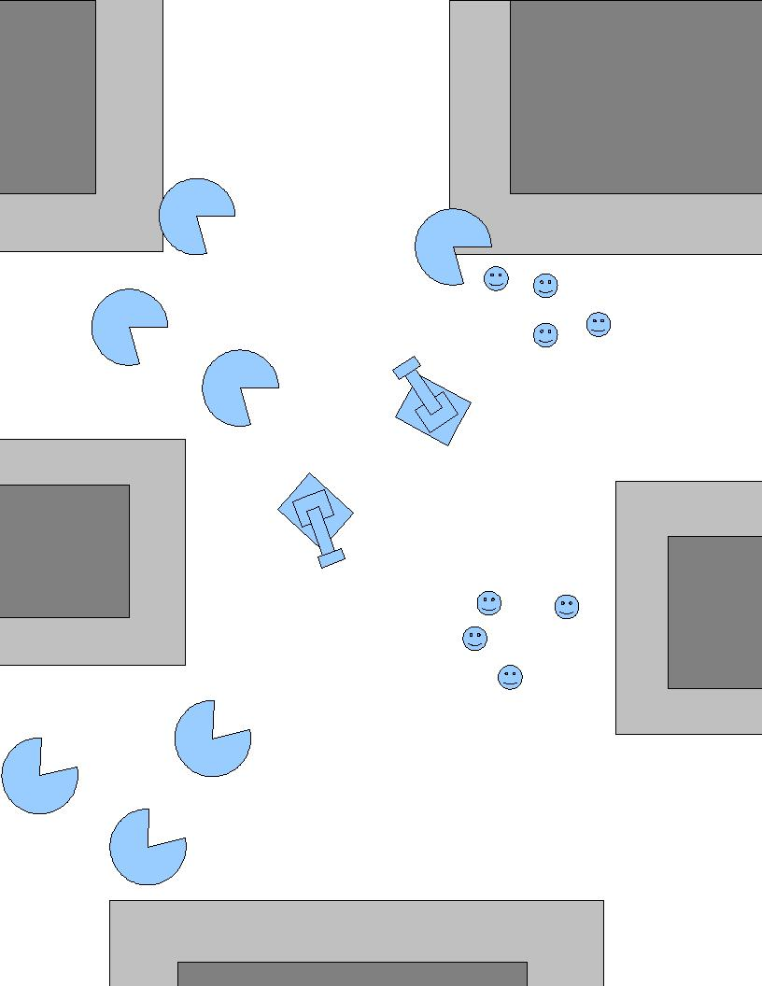

Tanks
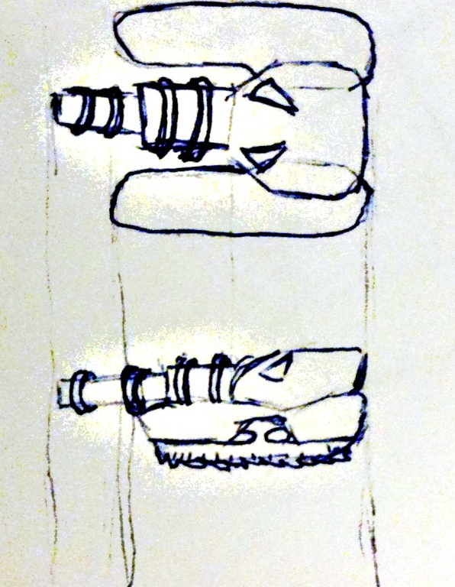 | 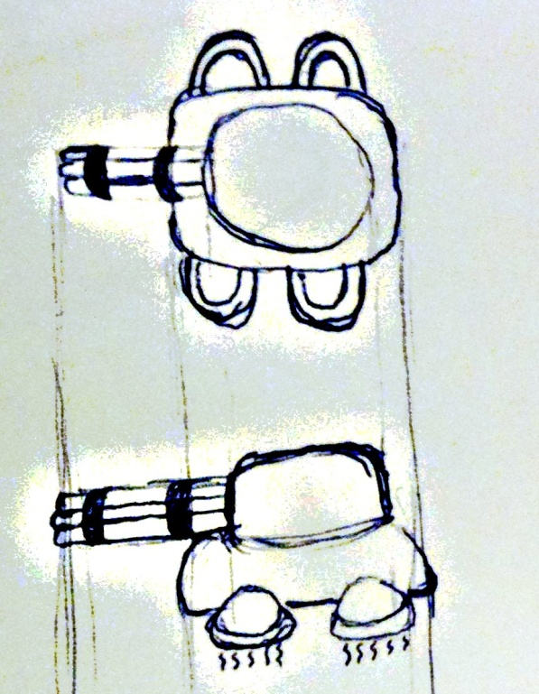
Long Ranged Tank | Short Ranged Tank

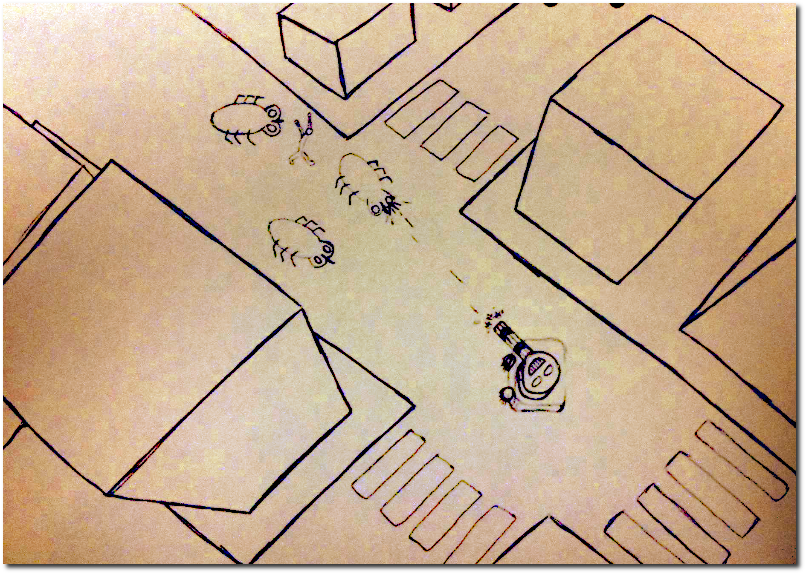
The City

