**UA Support Ticket**

*Made by:*

*Gustav Walter & Emil Hadås*

To start things off, I would like to briefly describe what this project is about and what it can be used for. The plugin that we have built is a support ticket component that organization owners easily can include in their web application using node package manager. But now you may ask, why? What is it used for? Let me explain.

The solution that this component brings are great. It solves the problem that developers face every day. The issue in making a website perfectly accessible. When creating an accessible web application, the issue that we face is ‘*how do we test this site?*’ It is impossible to put yourself in the view of a person that use screen readers on the web. So what is our solution? Support tickets!

When building an application, doing it yourself can be rough, including the testing. This way, we can launch an application with our own experience in accessibility. During the time that the website is up, more and more people will join the site and find bugs, issues and wrong-coded components. Our solution includes a small accessibility support ticket where users can send information about their issue and we can solve it. You may think this is a normal contact form, but no, the backend is where things start to get interesting!

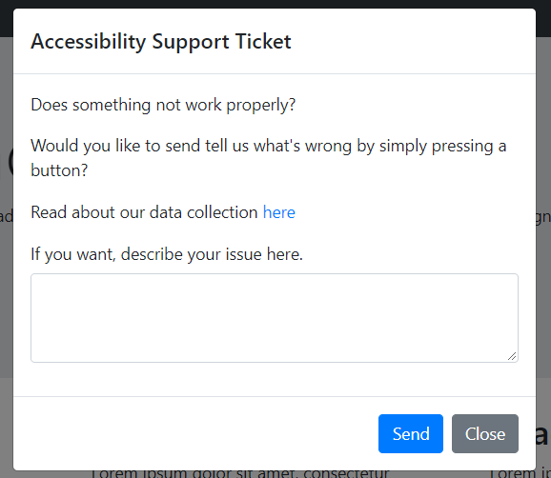

So what exactly does this support ticket do? Let me describe step by step what is actually happening.

1. We create an object that includes all the information that is accessible to us through the user agent. If you’re not familiar with the user agents, it is a request header. This way, we gather the data from the user’s web browser, this includes:

* Browser name
* Browser version
* OS name
* OS version
* Platform (desktop/laptop)

1. The next step is to calculate the user’s font-size. What is interesting about this part is that it’s not as simple as getting the font-size of the websites paragraphs, but you actually have to calculate the accorded zoom-level together with the font-size. This was quite some work to detect the zoom-levels on every browser, including mobile devices. The reason why we would like to have the user’s font-size on the paragraphs is so that the organization owner can replicate the issue that the user is experiencing. A lot of people, including me, have a poor eyesight which means that we see the text at 150% of the regular size. This means that an issue might appear on that zoom level that you can’t see on 100%.
2. Third step is to take a screenshot so we can see what the issue is. For this we used a library called html2canvas, since this was way too much work to write ourselves. So what exactly is happening here? We take a screenshot of the whole body section and convert it into a canvas element. After that we convert the canvas to base64 encoding so we can store it in the object. After that we convert the base64 back to an image and store it in the user-feedback folder.
3. The fourth step is to get the corresponding URL that the user is having trouble with. This makes it extremely clear for the owner to see which site is having issues.
4. The fifth step is to get the custom message that the user provided. If there is no message included, the object will not include empty text but instead simply say “No message included.”
5. The final step is to fetch a POST request to the backend that includes the object. After that we collect the data from the request and convert it into JSON to save it in our folder called user-feedback. This is what we have done in the example, although remaking it into a library will lead to it only returning an object where the organization owner can chose what to do with the data.

This was a brief summary of what the support form does.

Our audience is mainly users with disabilities. This can include users that enable tools for navigating through the site or people who zoom to a high value. Our main focus is to provide a simple way for users to give great feedback without any complicated work.

What issues will this component solve? First of all, it will solve the issue that people with impaired vision will be able to give great feedback without any knowledge in technology. This creates a way for everyone to give feedback.

But why would *you* want to have this support ticket component? The most common reasons that we heard from users that we have asked is that it solves the issue about accessibility feedback. Everyone can’t be an expert in accessibility, it would be great but it’s not possible. That is why I think a way for users to give support would solve a small part of this.

There are several parameters of the solution. The first one is the user, for this to work we obviously have to get people to be on the site so they can find issues. Their main goal on the site might not be to find bugs, but if they find any I think it is important for the user to be able to give feedback.

The second one is the organization owner, it has to be someone that is interested to making the web accessible. If we get a request about an issue, it has to be someone willing to solve it. This is why it’s important to spread the message about accessibility on the web.

The third one is the developer. If the developer is comfortable in working with Node.JS and have a basic understanding on how components work, everyone can implement it in their site. After that they need to decide what to do with the data that the users provide.

This might of course be able to rewrite to other languages such as Python but that would take quite a while.

So to make a quick summary, this is a solution for organization owners that don’t have a lot of experience in accessibility. It would provide a solution for users to easily give feedback and a way for developers to replicate an issue that the user is experiencing. This way we can create a more accessible web for everyone.

**Gustav Walter & Emil Hadås**