Course Project 1

Gustavo Sánchez

3/6/2020

## R Markdown

* This is the Homework (Course Project 1) by Data_analisys course.
* The PNG files was create by separate R code file (plot1.R, plot2.R, etc.)

The four plots constructed are shown below.

## Plot 1

## R code

Data <- read.csv('C:/Users/GUSTAVO/Desktop/Data analisys/Taller 1/data1.csv', header=TRUE , se= ";", colClasses = c("character" ,"character" ,"numeric","numeric","numeric","numeric","numeric","numeric","numeric"))  
  
  
head(Data)

## Date Time Global_active_power Global_reactive_power Voltage  
## 1 1/02/2007 0:00:00 0.326 0.128 243.15  
## 2 1/02/2007 0:01:00 0.326 0.130 243.32  
## 3 1/02/2007 0:02:00 0.324 0.132 243.51  
## 4 1/02/2007 0:03:00 0.324 0.134 243.90  
## 5 1/02/2007 0:04:00 0.322 0.130 243.16  
## 6 1/02/2007 0:05:00 0.320 0.126 242.29  
## Global_intensity Sub_metering_1 Sub_metering_2 Sub_metering_3  
## 1 1.4 0 0 0  
## 2 1.4 0 0 0  
## 3 1.4 0 0 0  
## 4 1.4 0 0 0  
## 5 1.4 0 0 0  
## 6 1.4 0 0 0

str(Data)

## 'data.frame': 2880 obs. of 9 variables:  
## $ Date : chr "1/02/2007" "1/02/2007" "1/02/2007" "1/02/2007" ...  
## $ Time : chr "0:00:00" "0:01:00" "0:02:00" "0:03:00" ...  
## $ Global_active_power : num 0.326 0.326 0.324 0.324 0.322 0.32 0.32 0.32 0.32 0.236 ...  
## $ Global_reactive_power: num 0.128 0.13 0.132 0.134 0.13 0.126 0.126 0.126 0.128 0 ...  
## $ Voltage : num 243 243 244 244 243 ...  
## $ Global_intensity : num 1.4 1.4 1.4 1.4 1.4 1.4 1.4 1.4 1.4 1 ...  
## $ Sub_metering_1 : num 0 0 0 0 0 0 0 0 0 0 ...  
## $ Sub_metering_2 : num 0 0 0 0 0 0 0 0 0 0 ...  
## $ Sub_metering_3 : num 0 0 0 0 0 0 0 0 0 0 ...

date <- paste(Data[,1],Data[,2],sep=" "); head(date)

## [1] "1/02/2007 0:00:00" "1/02/2007 0:01:00" "1/02/2007 0:02:00"  
## [4] "1/02/2007 0:03:00" "1/02/2007 0:04:00" "1/02/2007 0:05:00"

d<- cbind(date,Data[,-c(1,2)]); head(d)

## date Global_active_power Global_reactive_power Voltage  
## 1 1/02/2007 0:00:00 0.326 0.128 243.15  
## 2 1/02/2007 0:01:00 0.326 0.130 243.32  
## 3 1/02/2007 0:02:00 0.324 0.132 243.51  
## 4 1/02/2007 0:03:00 0.324 0.134 243.90  
## 5 1/02/2007 0:04:00 0.322 0.130 243.16  
## 6 1/02/2007 0:05:00 0.320 0.126 242.29  
## Global_intensity Sub_metering_1 Sub_metering_2 Sub_metering_3  
## 1 1.4 0 0 0  
## 2 1.4 0 0 0  
## 3 1.4 0 0 0  
## 4 1.4 0 0 0  
## 5 1.4 0 0 0  
## 6 1.4 0 0 0

d$date <- as.POSIXct(strptime(d$date,   
 format="%d/%m/%Y %H:%M:%S"))  
library(datasets)  
  
p<- hist(d$Global_active_power, col="green", xlab=expression("Global_active_power"))

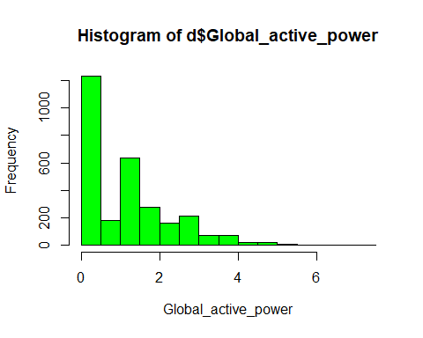

png(file = "Plot1", height = 480, width = 480, ) # Una figura de 5x10 cm  
  
p

## $breaks  
## [1] 0.0 0.5 1.0 1.5 2.0 2.5 3.0 3.5 4.0 4.5 5.0 5.5 6.0 6.5 7.0 7.5  
##   
## $counts  
## [1] 1234 181 633 276 160 212 69 69 20 16 6 2 0 1 1  
##   
## $density  
## [1] 0.8569444444 0.1256944444 0.4395833333 0.1916666667 0.1111111111  
## [6] 0.1472222222 0.0479166667 0.0479166667 0.0138888889 0.0111111111  
## [11] 0.0041666667 0.0013888889 0.0000000000 0.0006944444 0.0006944444  
##   
## $mids  
## [1] 0.25 0.75 1.25 1.75 2.25 2.75 3.25 3.75 4.25 4.75 5.25 5.75 6.25 6.75 7.25  
##   
## $xname  
## [1] "d$Global_active_power"  
##   
## $equidist  
## [1] TRUE  
##   
## attr(,"class")  
## [1] "histogram"

dev.off()

## png   
## 2

` ## Plot2

Data <- read.csv('C:/Users/GUSTAVO/Desktop/Data analisys/Taller 1/data1.csv', header=TRUE , se= ";", colClasses = c("character" ,"character" ,"numeric","numeric","numeric","numeric","numeric","numeric","numeric"))  
date <- paste(Data[,1],Data[,2],sep=" "); head(date)

## [1] "1/02/2007 0:00:00" "1/02/2007 0:01:00" "1/02/2007 0:02:00"  
## [4] "1/02/2007 0:03:00" "1/02/2007 0:04:00" "1/02/2007 0:05:00"

d<- cbind(date,Data[,-c(1,2)]); head(d)

## date Global_active_power Global_reactive_power Voltage  
## 1 1/02/2007 0:00:00 0.326 0.128 243.15  
## 2 1/02/2007 0:01:00 0.326 0.130 243.32  
## 3 1/02/2007 0:02:00 0.324 0.132 243.51  
## 4 1/02/2007 0:03:00 0.324 0.134 243.90  
## 5 1/02/2007 0:04:00 0.322 0.130 243.16  
## 6 1/02/2007 0:05:00 0.320 0.126 242.29  
## Global_intensity Sub_metering_1 Sub_metering_2 Sub_metering_3  
## 1 1.4 0 0 0  
## 2 1.4 0 0 0  
## 3 1.4 0 0 0  
## 4 1.4 0 0 0  
## 5 1.4 0 0 0  
## 6 1.4 0 0 0

d$date <- as.POSIXct(strptime(d$date,   
 format="%d/%m/%Y %H:%M:%S"))  
  
  
library(datasets)  
  
p<-plot(d[,1],d[,2],type="l",ylab=expression("Global active power (Kilowatts)"),xlab=" ", main="Global active power")

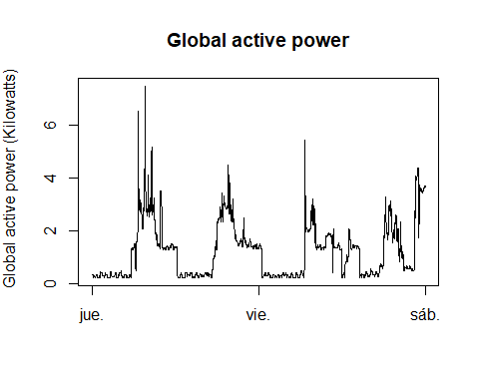

png(file = "Plot2", height = 480, width = 480, ) # Una figura   
  
p

## NULL

dev.off()

## png   
## 2

## Plot3

Data <- read.csv('C:/Users/GUSTAVO/Desktop/Data analisys/Taller 1/data1.csv', header=TRUE , se= ";", colClasses = c("character" ,"character" ,"numeric","numeric","numeric","numeric","numeric","numeric","numeric"))  
date <- paste(Data[,1],Data[,2],sep=" "); head(date)

## [1] "1/02/2007 0:00:00" "1/02/2007 0:01:00" "1/02/2007 0:02:00"  
## [4] "1/02/2007 0:03:00" "1/02/2007 0:04:00" "1/02/2007 0:05:00"

d<- cbind(date,Data[,-c(1,2)]); head(d)

## date Global_active_power Global_reactive_power Voltage  
## 1 1/02/2007 0:00:00 0.326 0.128 243.15  
## 2 1/02/2007 0:01:00 0.326 0.130 243.32  
## 3 1/02/2007 0:02:00 0.324 0.132 243.51  
## 4 1/02/2007 0:03:00 0.324 0.134 243.90  
## 5 1/02/2007 0:04:00 0.322 0.130 243.16  
## 6 1/02/2007 0:05:00 0.320 0.126 242.29  
## Global_intensity Sub_metering_1 Sub_metering_2 Sub_metering_3  
## 1 1.4 0 0 0  
## 2 1.4 0 0 0  
## 3 1.4 0 0 0  
## 4 1.4 0 0 0  
## 5 1.4 0 0 0  
## 6 1.4 0 0 0

d$date <- as.POSIXct(strptime(d$date,   
 format="%d/%m/%Y %H:%M:%S"))  
  
  
library(datasets)  
y1<- d[,6]  
y2<- d[,7]  
y3<- d[,8]  
  
  
plot(d[,1],y1, type = "l" ,ylab="Energy Sub metering",xlab=" ", main="")  
lines(d[,1],y2,type="l",col="red")  
lines(d[,1],y3,type="l",col="blue", ylab="Energy Sub metering", xlab=" ", main="")  
legend("topright", c("Sub_metering_1","Sub metering_2","Sub metering_3"), col= c("black","red","blue") , lty=1, cex=0.8)

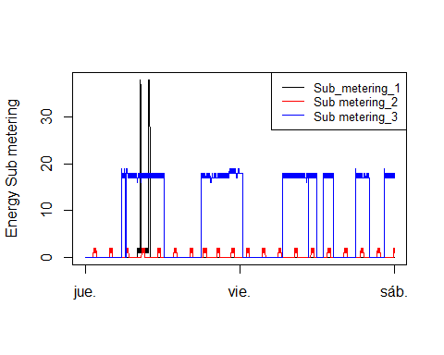

## Plot4

Data <- read.csv('C:/Users/GUSTAVO/Desktop/Data analisys/Taller 1/data1.csv', header=TRUE , se= ";", colClasses = c("character" ,"character" ,"numeric","numeric","numeric","numeric","numeric","numeric","numeric"))  
date <- paste(Data[,1],Data[,2],sep=" "); head(date)

## [1] "1/02/2007 0:00:00" "1/02/2007 0:01:00" "1/02/2007 0:02:00"  
## [4] "1/02/2007 0:03:00" "1/02/2007 0:04:00" "1/02/2007 0:05:00"

d<- cbind(date,Data[,-c(1,2)]); head(d)

## date Global_active_power Global_reactive_power Voltage  
## 1 1/02/2007 0:00:00 0.326 0.128 243.15  
## 2 1/02/2007 0:01:00 0.326 0.130 243.32  
## 3 1/02/2007 0:02:00 0.324 0.132 243.51  
## 4 1/02/2007 0:03:00 0.324 0.134 243.90  
## 5 1/02/2007 0:04:00 0.322 0.130 243.16  
## 6 1/02/2007 0:05:00 0.320 0.126 242.29  
## Global_intensity Sub_metering_1 Sub_metering_2 Sub_metering_3  
## 1 1.4 0 0 0  
## 2 1.4 0 0 0  
## 3 1.4 0 0 0  
## 4 1.4 0 0 0  
## 5 1.4 0 0 0  
## 6 1.4 0 0 0

d$date <- as.POSIXct(strptime(d$date,   
 format="%d/%m/%Y %H:%M:%S"))  
  
  
library(datasets)  
y1<- d[,6]  
y2<- d[,7]  
y3<- d[,8]  
y4<- d[,4]  
y5<- d[,3]  
par(mfrow=c(2,2), mar=c(5,4,2,1))  
  
#Plot1  
plot(d[,1],d[,2],type="l",ylab=expression("Global active power (Kilowatts)"),xlab=" ", main="Global active power")  
#plot2  
plot(d[,1],y4, type = "l" ,ylab="Voltage",xlab="date/time ", main="")  
#Plot3  
  
plot(d[,1],y1, type = "l" ,ylab="Energy Sub metering",xlab=" ", main="")  
lines(d[,1],y2,type="l",col="red")  
lines(d[,1],y3,type="l",col="blue", ylab="Energy Sub metering", xlab=" ", main="")  
legend("topright", c("Sub_metering_1","Sub metering_2","Sub metering_3"), col= c("black","red","blue") , lty=1, cex=0.1)  
  
  
  
#plot#4  
plot(d[,1],y5, type = "l" ,ylab="Global_reactive_power",xlab="date/time ", main="")

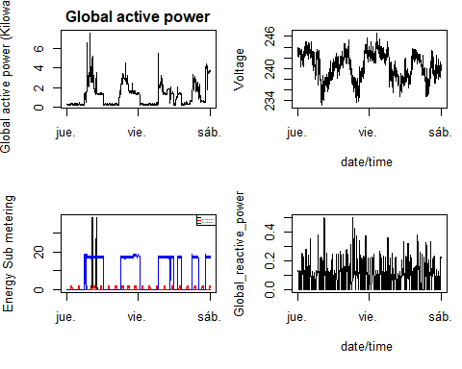

use_github()