# Regional Game Mobiele Stad plugin – User Guide

## Introduction

The QGIS plugin Regional Game Mobiele Stad allows players to negotiate and make decisions on spatial plan projects for: 1) housing plans, and 2) infrastructure projects. Players can select or zoom in on a desired location, select one polygon representing either a plan or an project, and view attributes interactively. The plugin features a form docked on the right hand side of the screen, which allows display and modification of attribute values for either a housing plan or an infrastructure project. With this form, players interactively change a selection of attributes for a selected polygon. Once the changes are saved, the plugin will recalculate indicators based on the new values of the attribute table involved. Upon closing, the plugin will bring QGIS to its default configuration.

## Installation

The QGIS plugin Regional Game Mobiele Stad is an extension for QGIS, an open source GIS package available from: <http://qgis.org/en/site/>. The recommended version of QGIS for installation is 2.18 LTR (Long Term Release). The plugin is not available from the official QGIS plugins repository and must be downloaded from this site: <https://github.com/raphaelsulzer/PlanningTool/releases>

After downloading it, you must install the plugin in the QGIS plugins folder, located under your user profile in: *.qgis2/python/plugins*. Simply unzip the PlanningTool.zip file and move the folder into this folder. Then start QGIS and load the plugin ‘Regional Game Mobiele Stad’ from the ‘Plugins Manager’ window.

The plugin does not require any additional configuration. An activated Microsoft Excel installation on the computer is necessary for the plugin to work. Formulas for calculating indicators are in spreadsheet ***‘20180904 Regional game IMS 2.8.xlsx’***, located inside the *PlanningTool/data/excel* folder. For an optimal user experience set your screen to a resolution 1920x1080.

## User interaction

|  |  |
| --- | --- |
| icons/rgms.png | To start the plugin simply click the toolbar button or ‘Regional Game Mobiele Stad’ entry in the ‘Plugins’ menu. When the plugin starts, it automatically loads the data system and the user interface provided to interact and explore the data. You should now see the screen below. |

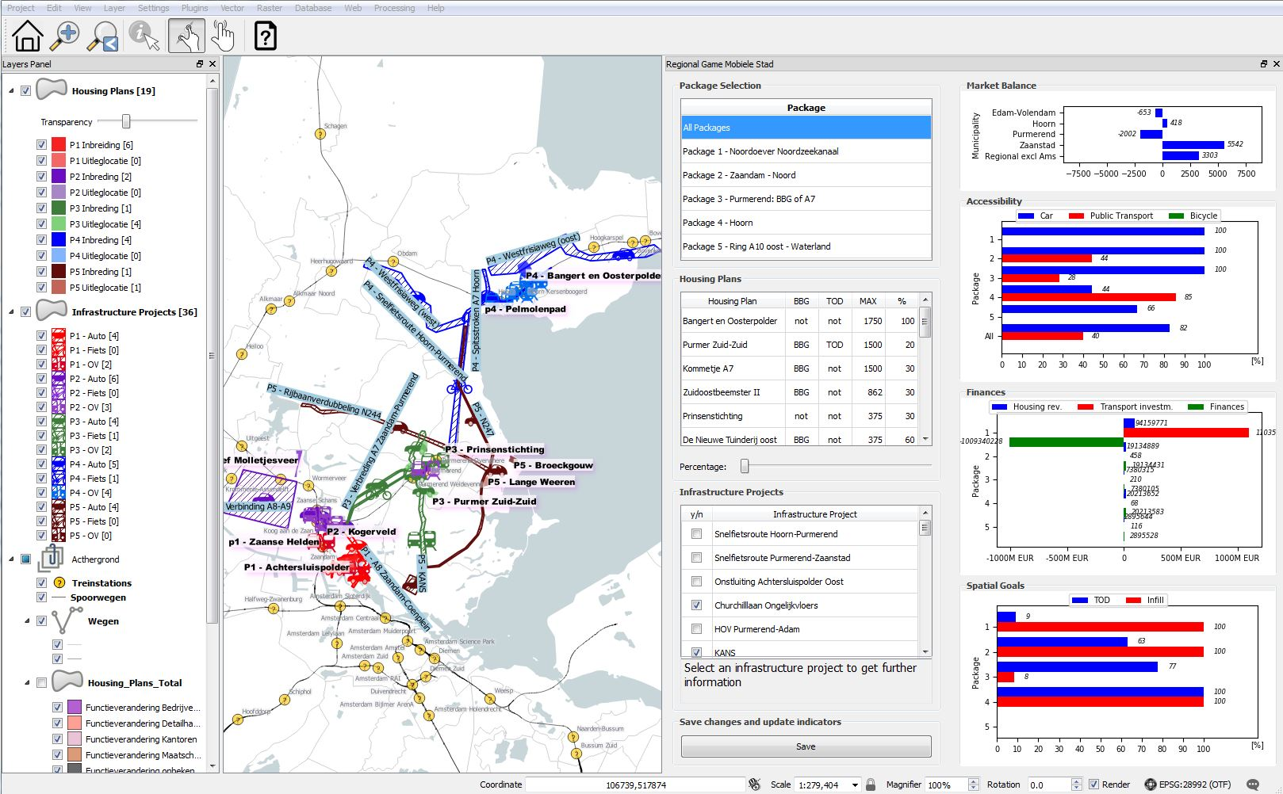

Figure 1: QGIS user interface with Regional Game Mobiele Stad

The plugin shows four main components: toolbar (top left), layers panel (left), map interface (center), input and output window (right).

### Toolbar

|  |  |
| --- | --- |
| ../QGIS_icons/home.png | Zoom to “All Packages” extent. |
| ../QGIS_icons/zoom.svg.png | Draw a rectangle and zoom to its extent. |
| ../QGIS_icons/zoom_last.svg.png | Zoom to previous extent. |
| ../QGIS_icons/identify.svg.png | Activate ‘Identify Features’ map tool to get further information about a plan or project. This tool can only be activated if a layer is selected on the layers panel. |
| ../QGIS_icons/touch.svg.png | Activate map tool for panning (one finger) and zooming (two fingers). |
| icons/select.png | Activate ‘Selection’ map tool. Once this map tool is activated a single-click on a polygon will select the corresponding plan or project and highlight the corresponding row in the housing plans or infrastructure projects table. A double-click on the map interface unselects all plans and projects. |
| ../QGIS_icons/deselectAll.png | Unselect all plans and projects. |
| ../QGIS_icons/help.png | Open this documentation. |

### Map interface and layers panel

Interaction with the map interface is only possible if one of the mapping tools is activated. Interaction with the layers panel is only necessary for the use of the ‘Identify Features’ map tool.

### Input and output window

|  |  |  |
| --- | --- | --- |
|  | X | To close the plugin and go back to the QGIS default configuration click on the X on the top right corner. |
| Input | Package Selection | Select a package. The map interface automatically zooms on the package extent and the plan and project tables show only entries from the selected package. |
| Housing  Plans | The housing plans table shows housing plans (per package). A housing plan can be selected by clicking on the corresponding row. The map interface automatically zooms to the corresponding polygon and the housing percentage of this plan can be changed with the housing percentage slider. |
| Percentage Slider | Change the percentage of housing. The percentage is shown in the housing plans table. |
| Infrastructure Projects | The infrastructure projects table shows infrastructure projects (per package). An infrastructure project can be selected by clicking on the corresponding row. The map interface automatically zooms to the corresponding polygon. Infrastructure projects can be (de-)activated by clicking on the check box of a package. |
| Description | Description of the selected infrastructure project. |
| Save | Save housing plans and infrastructure projects data to the spreadsheet ***‘20180904 Regional game IMS 2.8.xlsx’*** and update the four indicators (market balance, accessibility, finances and spatial goals). |
| Output | Market Balance | Shows the market balance per municipality in housing units (HU). |
| Accessibility | Shows the accessibility per package in percent (%). |
| Finances | Shows the finances per package in euros (EUR). |
| Spatial Goals | Shows the spatial goals per package in percent (%). |