# Neural Networks Practice 4-Adaline

## Elizarraras Llanos Angel Gustavo

## Practice 1

50 EPOCHS  
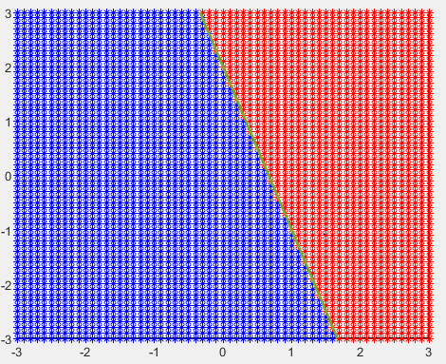

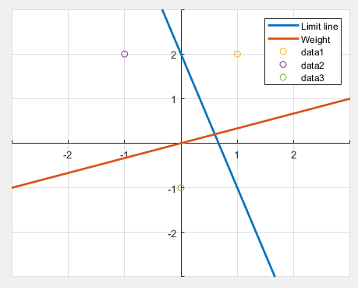

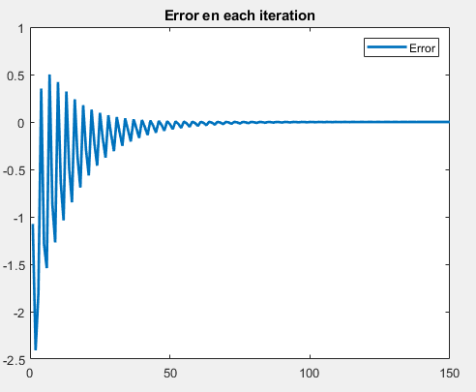

10 EPOCHS

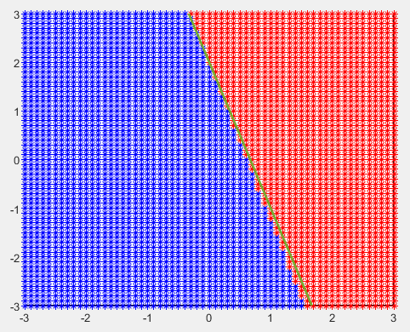

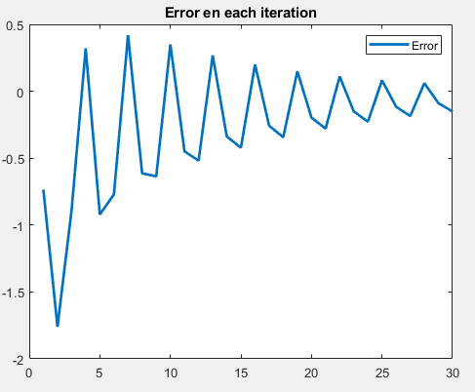

|  |
| --- |
| %% Training  for i = 1:Epochs  for j = 1:3    a = W*P(:,j) + b;  e = Target(j) - a;  x = alpha*e*P(:,j)  W = W + x';  b = b + alpha*e;  g(j) = e; % saves the value of error in a 1x3 vector  end  error = [error,g]; % concatenate g for the total error vector  end |

# Practice 2

Designs and implement an artificial neural network able to separate four different classes.

Proposed classes:

$$\left\{\begin{aligned}P_{11}=\left[\begin{aligned}&-3 \\ & 1\end{aligned}\right] \\ P_{12}=\left[\begin{aligned}&-1 \\ &2\end{aligned}\right] \\ t=[\begin{matrix}1 \\ 1\end{matrix}]\end{aligned}\right\}\left\{\begin{aligned}P_{21}=\left[\begin{aligned}&-2 \\ &2\end{aligned}\right] \\ P_{22}=\left[\begin{aligned}&4 \\ &3\end{aligned}\right] \\ t=[\begin{matrix}0 \\ 0\end{matrix}]\end{aligned}\right\}\left\{\begin{aligned}P_{31}=\left[\begin{aligned}&-2 \\ &-4\end{aligned}\right] \\ P_{32}=\left[\begin{aligned}&-1 \\ &-3\end{aligned}\right] \\ t=[\begin{matrix}1 \\ 0\end{matrix}]\end{aligned}\right\}\left\{\begin{aligned}\begin{aligned}P_{41}=\left[\begin{aligned}&3 \\ &0\end{aligned}\right] \\ P_{42}=\left[\begin{aligned}&4 \\ &2\end{aligned}\right]\end{aligned} \\ t=[\begin{matrix}0 \\ 1\end{matrix}]\end{aligned}\right\}$$

50 Epochs

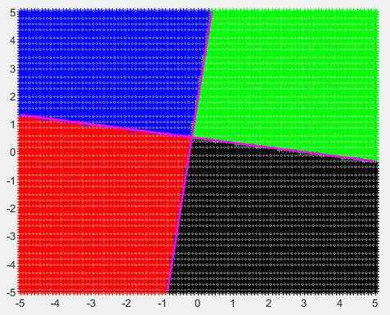

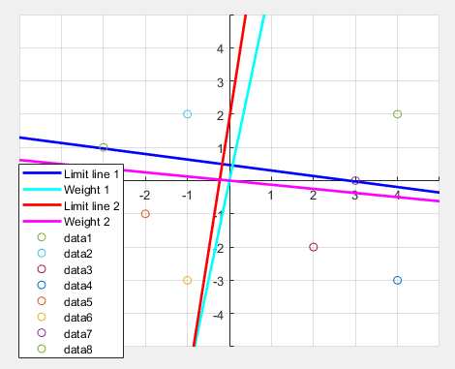

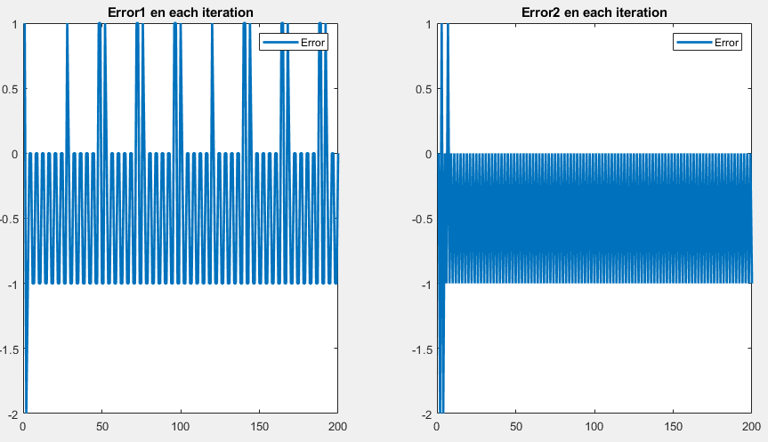

10 Epochs

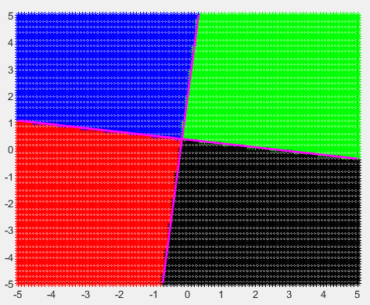

I will add the other graph, because the lines are slightly moved.

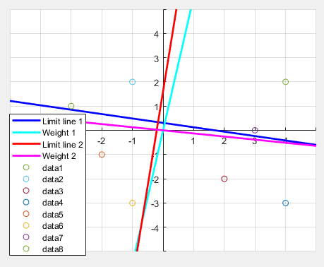

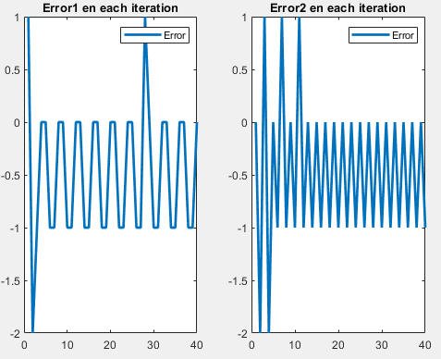

Error is a 2x1 matrix, so I plot both errors.

|  |
| --- |
| %% Training  for i = 1:Epochs  for j = 1:4    a(1) = dot(W(1,:),P(:,j)) + b(1);  a(2) = dot(W(2,:),P(:,j+4)) + b(2);  e = Targets(j,:) - hardlim(a);  x1 = alpha*e(1)*P(:,j);  x2 = alpha*e(2)*P(:,j+4);  W(1,:) = W(1,:) + x1';  W(2,:) = W(2,:) + x2';  b(1) = b(1) + alpha*e(1);  b(2) = b(2) + alpha*e(2);  g1(j) = e(1); %first 4 error 1 values  g2(j) = e(2); %first 4 error 2 values  end  error1 = [error1,g1];%fillling vector to plot  error2 = [error2,g2];%fillling vector to plot  end |

# Practice 3

50 epochs

User input = [ -2 2 1 ], we notice is in the side of apple. The weight plane is the transparent one

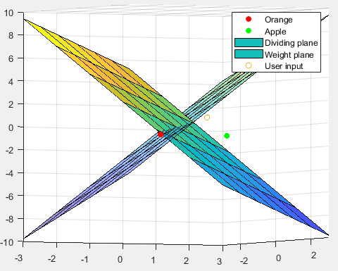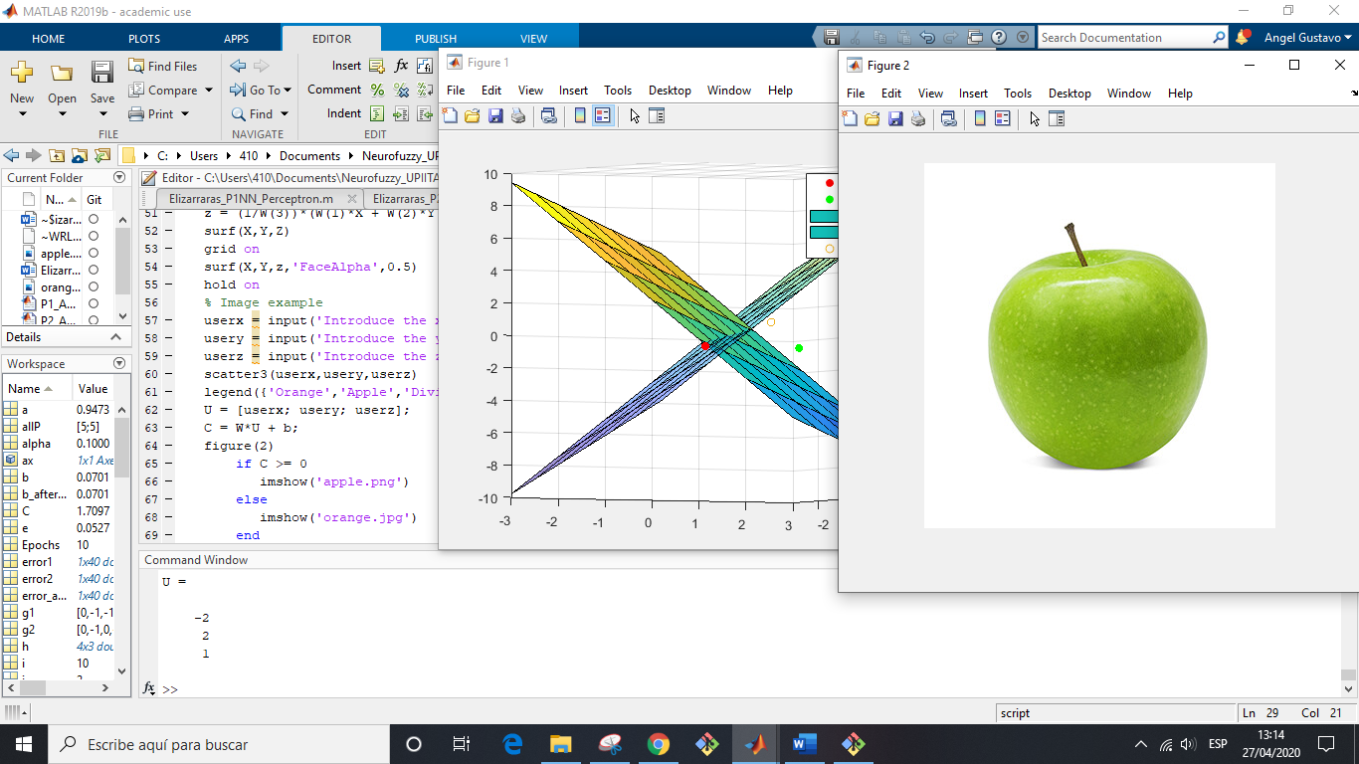

User input = [-3 -3 -3]. We notice that the input user is in the orange side.

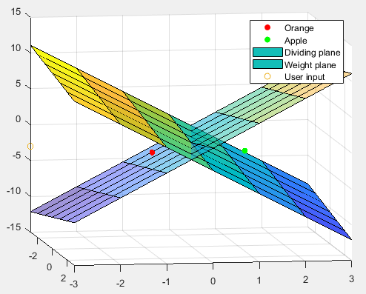

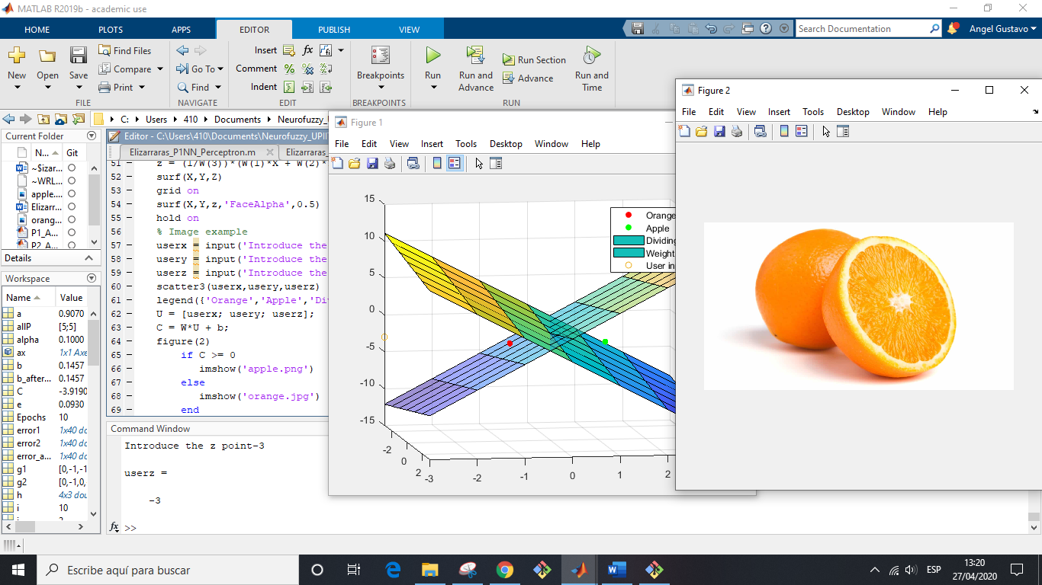

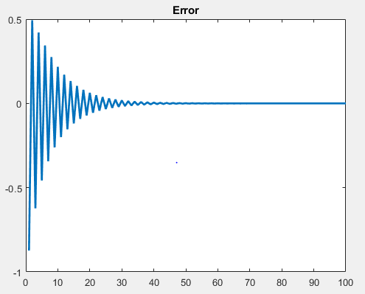

The error is not cero

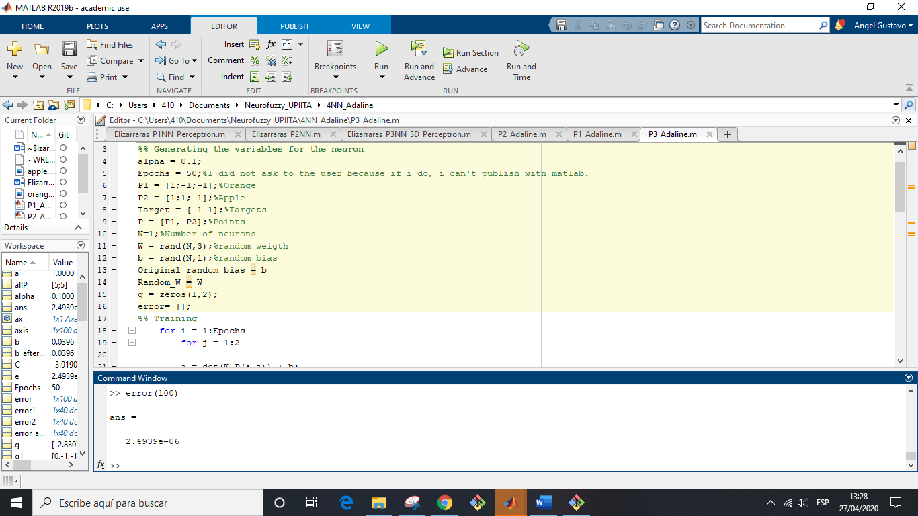

10 Epochs

