# Elizarraras Llanos Angel Gustavo_______30/03/20 Class

Figure 1 1

## Figure 1

newcolors = [0.40 0.30 0.90; 1 0.65 0.15];  
colororder(newcolors)  
%Generating limit lines  
X = -5:0.2:5;  
Y1 = 0.25*X+1;  
Y2 = -X+2;  
%Generating weight  
Xw1=0:-0.01:-0.24;  
Xw2=0:0.1:1;  
W1 = -4*Xw1;  
W2 = Xw2;  
figure(1)  
plot(X,Y1,X,Y2,Xw1,W1,Xw2,W2, 'Linewidth',2)  
legend({'Limit Line 1','Limit Line 2','Weight 1','Weight 2'},'Location','northeast')  
grid on  
%Axis  
ax = gca;  
ax.XAxisLocation = 'origin';  
ax.YAxisLocation = 'origin';  
box off  
hold on  
%Given data points  
scatter(3,4,'k')  
hold on  
scatter(4,3,'k')  
hold on  
scatter(-4,3,'r')  
hold on  
scatter(-3,1,'r')  
hold on  
scatter(-3,-3,'b')  
hold on  
scatter(-4,-4,'b')  
hold on  
scatter(5,-1,'g')  
hold on  
scatter(4,-1,'g')  
  
  
% Figure 2  
  
figure(2)  
plot(X,Y1,X,Y2,'Linewidth',2)  
grid on  
hold on  
%Axis  
ax = gca;  
ax.XAxisLocation = 'origin';  
ax.YAxisLocation = 'origin';  
  
 for i = 1:length(X)  
 for j = 1:length(X)  
 W = [-0.5 2;0.5 0.5];  
 P = [X(i);X(j)];  
 b = [-2;-1];  
 C = hardlim(W*P + b);  
  
 if( C(1) == 0 && C(2) == 0 )  
 scatter(X(i) , X(j), 'b')  
  
 elseif ( C(1) == 0 && C(2) == 1 )  
 scatter(X(i) , X(j), 'g')  
  
 elseif ( C(1) == 1 && C(2) == 1 )  
 scatter(X(i) , X(j), 'k')  
  
 elseif ( C(1) == 1 && C(2) == 0 )  
 scatter(X(i) , X(j), 'r')  
 end  
 hold on  
 end  
 end

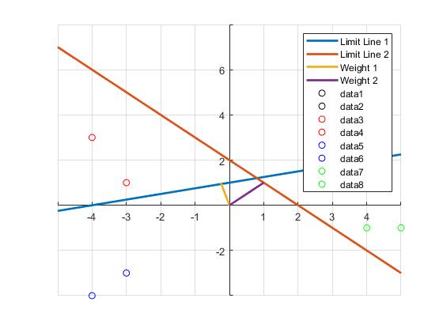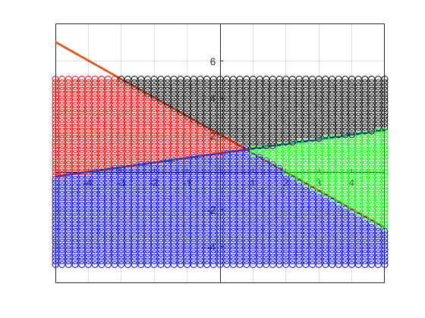

[*Published with MATLAB® R2019b*](https://www.mathworks.com/products/matlab)

