Neural Networks Practice 10 - Heart Shape

Elizarraras Llanos Angel Gustavo

I did two functions, one for the training and the other for testing. This way was much faster to test multiple alphas and epochs in order too see the behavior of the network, and I can confirm that smaller the alpha, the more epochs you need. The network has two layers, the first one is composed by 12 neurons and the last one is the decision boundary, with only one neuron.
I will highlight the code with cyan with more accuracy (the best heart shapes are the last four images), and they are similar, have the same alpha and “a close number” of epochs.
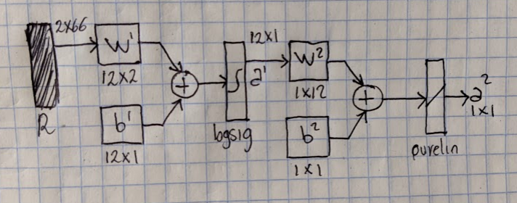

Generating the variables for the neuron
% Proposed points
P1 = [2; 3];
P2 = [5; 2];
P3 = [6; 0];
P4 = [5; -2];
P5 = [4; -4];
P6 = [2; -6];
P7 = [0; -7];
P8 = [-2; -6];
P9 = [-4; -4];
P10 = [-5; -2];
P11 = [-6; 0];
P12 = [-5; 2];
P13 = [-2; 3];
P14 = [0; 1];
P15 = [-4; 1];
P16 = [-2; 1];
P17 = [-3; 0];
P18 = [-2; -1];
P19 = [0; 1];
P20 = [4; -1];
P21 = [4; 1];
P22 = [2; 1];
P23 = [3; 0];
P24 = [2; -1];
P25 = [0; -2];
P26 = [-3; -2];
P27 = [3; -2];
P28 = [-3; -3];
P29 = [0; 1];
P30 = [3; -3];
P31 = [-1; -4];
P32 = [1; -4];
P33 = [0; -5];
P34= [0; -6];
P35 = [0; 3];
P36 = [-2; 6];
P37 = [2; 6];
P38 = [-4; 5];
P39 = [4; 5];
P40 = [-6; 6];
P41 = [6; 6];
P42 = [-8; 0];
P43 = [8; 0];
P44 = [-8; -3];
P45 = [8; -3];
P46 = [-7; -6];
P47 = [7; -6];
P48 = [-6; -8];
P49 = [-3; -8];
P50 = [3; -8];
P51 = [0; -9];
P52 = [0; 6];
P53 = [10; 0];
P54 = [-9; -4];
P55 = [-10; 0];
P56 = [9; 4];
P57 = [3; 7];
P58 = [-3; 7];
P59 = [-4; -8];
P60 = [4; -8];
P61 = [0; 6];
P62 = [0; -11];
P63 = [-1; 5];
P64 = [1; 5];
P65 = [-2; -9];
P66 = [2; -9];
t = [1 1 1 1 1 1 1 1 1 1 1 1 1 1 1 1 ...
1 1 1 1 1 1 1 1 1 1 1 1 1 1 1 1 1 1 ...
-1 -1 -1 -1 -1 -1 -1 -1 -1 -1 -1 -1 -1 -1 -1 -1 -1 -1 ...
-1 -1 -1 -1 -1 -1 -1 -1 -1 -1 -1 -1 -1 -1];%targets
P = [P1 P2 P3 P4 P5 P6 P7 P8 P9 P10 P11 P12 P13 P14 P15 P16 P17 ...
P18 P19 P20 P21 P22 P23 P24 P25 P26 P27 P28 P29 P30 P31 P32 P33 P34 ...
P35 P36 P37 P38 P39 P40 P41 P42 P43 P44 P45 P46 P47 P48 P49 P50 P51 P52 ...
P53 P54 P55 P56 P57 P58 P59 P60 P61 P62 P63 P64 P65 P66];%Points
num_patterns = 66;
N=12;%Number of neurons
W1 = rand(N,2);%random weigth layer 1
b1 = rand(N,1);%random bias layer 1
W2 = rand(1,N);%random weigth layer 2
b2 = rand(1,1);%random bias layer 2
F = zeros(1,N);

Training function
function [W1,W2,b1,b2] = training_lines(alpha, epochs, num_patterns, P, W1,W2, b1,b2, target,F)
% Training with backpropagation
for i = 1:epochs
for j = 1:num_patterns

% a1 and a2
a1 = logsig(W1*P(:,j) + b1);
a2 = W2*a1 + b2;
e = target(j) - a2;
% df1 = (1 - a1).*a1;
df2 = 1;
s2 = -2*df2*e;
%Values for the diagonal of the matrix
F(1) = (1 - a1(1))*a1(1);
F(2) = (1 - a1(2))*a1(2);
F(3) = (1 - a1(3))*a1(3);
F(4) = (1 - a1(4))*a1(4);
F(5) = (1 - a1(5))*a1(5);
F(6) = (1 - a1(6))*a1(6);
F(7) = (1 - a1(7))*a1(7);
F(8) = (1 - a1(8))*a1(8);
F(9) = (1 - a1(9))*a1(9);
F(10) = (1 - a1(10))*a1(10);
F(11) = (1 - a1(11))*a1(11);
F(12) = (1 - a1(12))*a1(12);
D = diag(F); %Diag matrix
s1 = D*W2'*s2;
%New weights and bias
W2 = W2 - alpha*s2*a1';
b2 = b2 - alpha*s2;
W1 = W1 - alpha*s1*P(:,j)';
b1 = b1 - alpha*s1;

end
end
end

Plotting function
function plotting(W1,W2,b1,b2)
X = -8:0.2:8;

for i = 1:length(X)
for j = 1:length(X)

P = [X(i);X(j)];

a1 = logsig(W1*P + b1);
a2 = W2*a1 + b2;

if( a2 >= 0 )
plot(X(i) , X(j), '*b')
else
plot(X(i) , X(j), '*g')

end
hold on
end
end

Calling the Training Function
[W11, W12, b11, b12] = training_lines(0.002, 4800, num_patterns, P, W1, W2, b1, b2, t, F);
[W21, W22, b21, b22] = training_lines(0.003, 4900, num_patterns, P, W1, W2, b1, b2, t, F);
[W31, W32, b31, b32] = training_lines(0.004, 5400, num_patterns, P, W1, W2, b1, b2, t, F);
[W41, W42, b41, b42] = training_lines(0.005, 5000, num_patterns, P, W1, W2, b1, b2, t, F);
[W51, W52, b51, b52] = training_lines(0.001, 5200, num_patterns, P, W1, W2, b1, b2, t, F);
[W61, W62, b61, b62] = training_lines(0.001, 5550, num_patterns, P, W1, W2, b1, b2, t, F);
[W71, W72, b71, b72] = training_lines(0.001, 5300, num_patterns, P, W1, W2, b1, b2, t, F);
[W81, W82, b81, b82] = training_lines(0.001, 5050, num_patterns, P, W1, W2, b1, b2, t, F);

Plotting
figure(1)
plotting(W11, W12, b11, b12)
figure(2)
plotting(W21, W22, b21, b22)
figure(3)
plotting(W31, W32, b31, b32)
figure(4)
plotting(W41, W42, b41, b42)
figure(5)
plotting(W51, W52, b51, b52)
figure(6)
plotting(W61, W62, b61, b62)
figure(7)
plotting(W71, W72, b71, b72)
figure(8)
plotting(W81, W82, b81, b82)
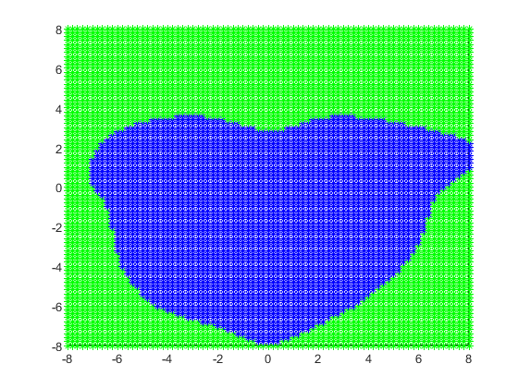
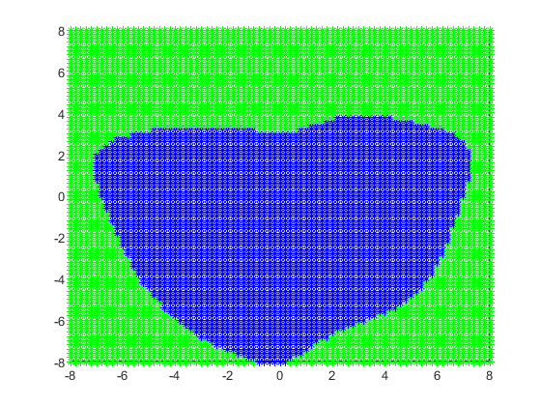
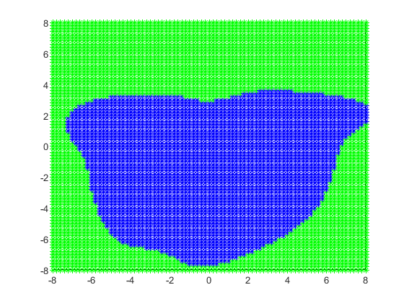
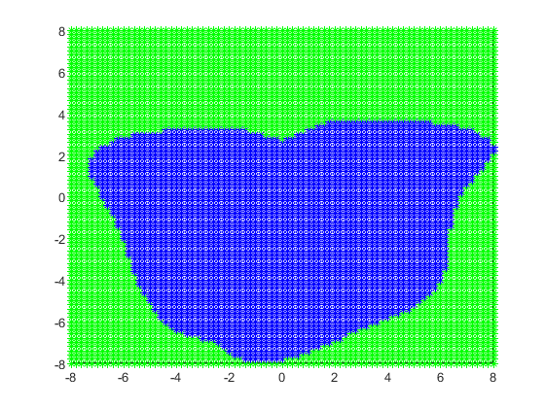
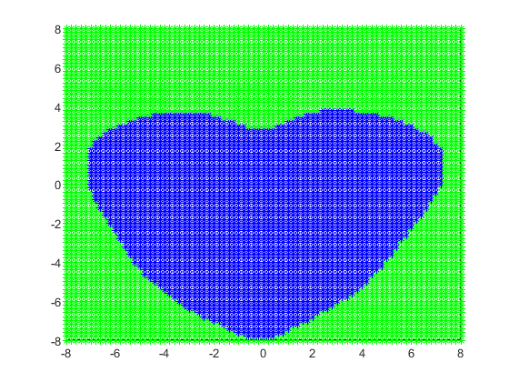
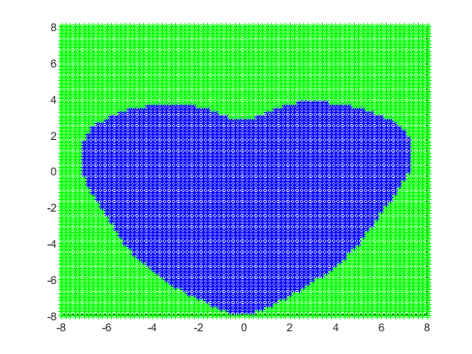
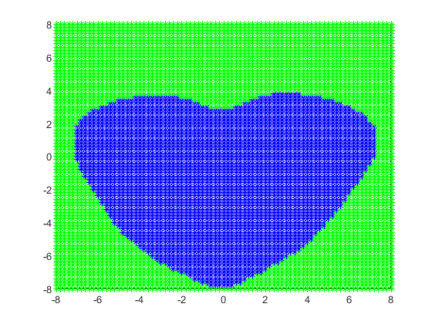
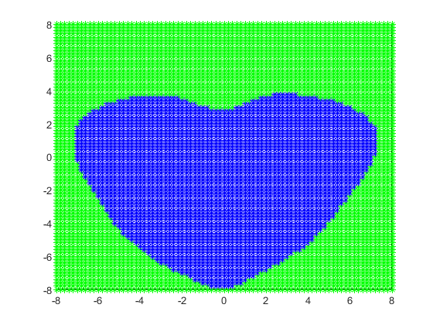
Published with MATLAB® R2019b

