Exercise Kohonen

Elizarraras Llanos Angel Gustavo
Patterns
p1 = [-0.1961;0.9806];
p2 = [0.1961;0.9806];
p3 = [0.9806;0.1961];
p4 = [0.9806;-0.1961];
p5 = [-0.5812;-0.8137];
p6 = [-0.8137;-0.5812];
P = [p1 p2 p3 p4 p5 p6];
% Weights
w1 = [0.7071;-0.7071];
w2 = [0.7071;0.7071];
w3 = [-1;0];
W =[w1';w2';w3'];
c = [0 0 0];
scatter(w1(1),w1(2), 100, 'filled', 'd');
hold on
scatter(w2(1),w2(2), 100, 'filled', 's')
hold on
scatter(w3(1),w3(2), 100, 'filled', 'h')
hold on
%alpha
alpha = 0.2;
%epochs
epochs = 20;
%number of patterns
num_p = 6;
%Training
for i = 1:epochs
for j = 1:num_p
a = compet(W * P(:,j));
%The if determines what Weight is going to be updated depending of
%the compet activation function
if a(1) == 1
W(1,:) = W(1,:) + alpha * (P(:,j)' - W(1,:));
b = W(1,:);
plot(b(1),b(2), '*r')
elseif a(2) == 1
W(2,:) = W(2,:) + alpha * (P(:,j)' - W(2,:));
b = W(2,:);
plot(b(1),b(2), '*g')
else
W(3,:) = W(3,:) + alpha * (P(:,j)' - W(3,:));
b = W(3,:);
plot(b(1),b(2), '*b')
end
end
hold on
end
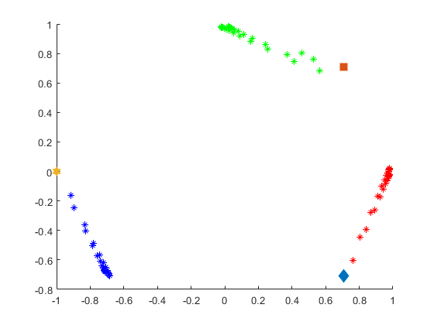
Published with MATLAB® R2019b

