Practice 7 Neural Networks - Multilayer Perceptron. Happy face

Elizarraras Llanos Angel Gustavo

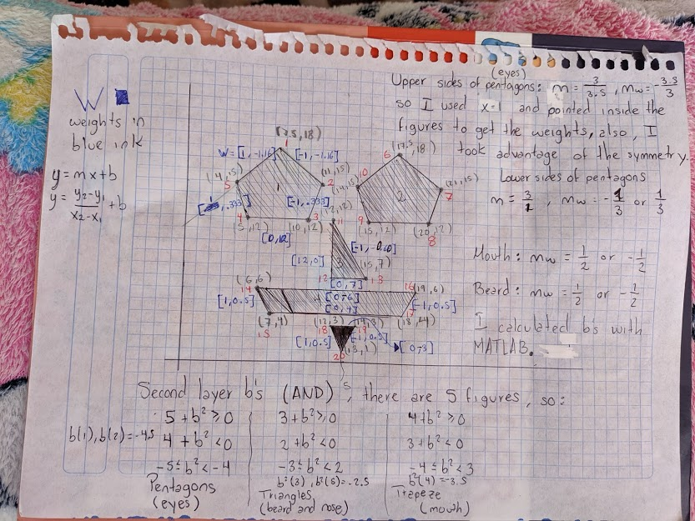
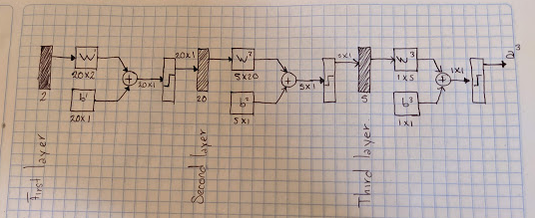

% Calculating first layer b’s
W1 = [1 -1.16];
p1 = [7.5; 18];
b1 = -dot(W1,p1);
W2 = [-1 -1.16];
p2 = [11; 15];
b2 = -dot(W2,p2);
W3 = [-1 .333];
p3 = [10; 12];
b3 = -dot(W3,p3);
W5 = [1 .333];
p5 = [4; 15];
b5 = -dot(W5,p5);
W4 = [0 12];
p4 = [5; 12];
b4 = -dot(W4,p4);
W6 = [1 -1.16];
p6 = [17.5; 18];
b6 = -dot(W6,p6);
W7 = [-1 -1.16];
p7 = [21; 15];
b7 = -dot(W7,p7);
W8 = [-1 .333];
p8 = [20; 12];
b8 = -dot(W8,p8);
W10 = [1 .333];
p10 = [14; 15];
b10 = -dot(W10,p10);
W9 = [0 12];
p9 = [14; 12];
b9 = -dot(W9,p9);
W11 = [-1 -0.60];
p11 = [12; 12];
b11 = -dot(W11,p11);
W12 = [12 0];
p12 = [12; 7];
b12 = -dot(W12,p12);
W13 = [0 7];
p13 = [15; 7];
b13 = -dot(W13,p13);
W14 = [1 0.5];
p14 = [6; 6];
b14 = -dot(W14,p14);
W15 = [0 4];
p15 = [7; 4];
b15 = -dot(W15,p15);
W16 = [0 -6];
p16 = [19; 6];
b16 = -dot(W16,p16);
W17 = [-1 0.5];
p17 = [18; 4];
b17 = -dot(W17,p17);
W18 = [1 0.5];
p18 = [12; 3];
b18 = -dot(W18,p18);
W19 = [0 -3];
p19 = [14; 3];
b19 = -dot(W19,p19);
W20 = [-1 0.5];
p20 = [13; 1];
b20 = -dot(W20,p20);
x = 0:0.2:25;
y = 0:0.2:25;
for i = 1:length(x)
for j = 1:length(y)
P = [x(i);y(j)];
a1 = hardlim(W1*P + b1);
a2 = hardlim(W2*P + b2);
a3 = hardlim(W3*P + b3);
a4 = hardlim(W4*P + b4);
a5 = hardlim(W5*P + b5);
a6 = hardlim(W6*P + b6);
a7 = hardlim(W7*P + b7);
a8 = hardlim(W8*P + b8);
a9 = hardlim(W9*P + b9);
a10 = hardlim(W10*P + b10);
a11 = hardlim(W11*P + b11);
a12 = hardlim(W12*P + b12);
a13 = hardlim(W13*P + b13);
a14 = hardlim(W14*P + b14);
a15 = hardlim(W15*P + b15);
a16 = hardlim(W16*P + b16);
a17 = hardlim(W17*P + b17);
a18 = hardlim(W18*P + b18);
a19 = hardlim(W19*P + b19);
a20 = hardlim(W20*P + b20);
%Second layer
psecondlayer = [a1; a2; a3; a4; a5; a6; a7; a8; a9; a10; a11; a12; a13; a14; a15; a16; a17; a18; a19; a20];
W21 = [1 1 1 1 1 0 0 0 0 0 0 0 0 0 0 0 0 0 0 0];
W22 = [0 0 0 0 0 1 1 1 1 1 0 0 0 0 0 0 0 0 0 0];
W23 = [0 0 0 0 0 0 0 0 0 0 1 1 1 0 0 0 0 0 0 0];
W24 = [0 0 0 0 0 0 0 0 0 0 0 0 0 1 1 1 1 0 0 0];
W25 = [0 0 0 0 0 0 0 0 0 0 0 0 0 0 0 0 0 1 1 1];
Wsecondlayer = [W21; W22; W23; W24; W25];
bsecondlayer = [-4.5; -4.5; -2.5; -3.5; -2.5];
a21 = hardlim(Wsecondlayer(1,:)*psecondlayer + bsecondlayer(1));
a22 = hardlim(Wsecondlayer(2,:)*psecondlayer + bsecondlayer(2));
a23 = hardlim(Wsecondlayer(3,:)*psecondlayer + bsecondlayer(3));
a24 = hardlim(Wsecondlayer(4,:)*psecondlayer + bsecondlayer(4));
a25 = hardlim(Wsecondlayer(5,:)*psecondlayer + bsecondlayer(5));
%Third Layer
pthirdlayer = [a21; a22; a23; a24; a25];
Wthirdlayer = [1 1 1 1 1];
bthirdlayer = -0.5;
athirdlayer = hardlim(Wthirdlayer*pthirdlayer + bthirdlayer);
if athirdlayer == 1
plot(x(i) , y(j), '*b')
else
plot(x(i) , y(j), '*k')
end
end
hold on
end
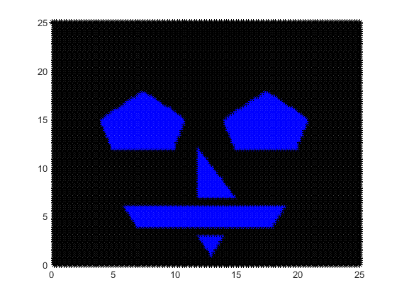
Published with MATLAB® R2019b

