Neural Networks Practice 9 – Multilayer classification

Elizarraras Llanos Angel Gustavo

There were sometimes when I checked the training for the same values, the separation between the classes was in a different shape, I guess it is because the initial random values. Also, in order to try many possibilities at once, I did the algorithm with functions.
epochs12500 = 12500;
epochs3000 = 3000;
%Rabbits
P1 = [2.5 1.5];
P2 = [3.5 3];
P3 = [2 2];
P4 = [2.5 0];
%Bears
P5 = [3 1];
P6 = [3 2];
P7 = [4 1];
P8 = [4 2];
t = [-1 -1 -1 -1 1 1 1 1];%Adaline targets
P = [P1; P2; P3; P4; P5; P6; P7; P8];%Points
num_patterns = 8;
N=2;%Number of neurons
W1 = rand(N,2);%random weigth layer 1
b1 = rand(N,1);%random bias layer 1
W2 = rand(1,2);%random weigth layer 2
b2 = rand(1,1);%random bias layer 2
R = zeros(2,2);
F = zeros(2,2);
alpha1 = 0.05;
alpha2 = 0.2;

Training function
function [W1,W2,b1,b2] = training_lines(alpha, epochs, num_patterns, P, W1,W2, b1,b2, target,F)
% Training with backpropagation
for i = 1:epochs
for j = 1:num_patterns

a1 = logsig(W1*P(j,:)' + b1);
a2 = W2*a1 + b2;
e = target(j) - a2;
% df1 = (1 - a1).*a1;
df2 = 1;
s2 = -2*df2*e;
F(1) = (1 - a1(1))*a1(1);
F(4) = (1 - a1(2))*a1(2);
s1 = F*W2'*s2;
W2 = W2 - alpha*s2*a1';
b2 = b2 - alpha*s2;
W1 = W1 - alpha*s1*P(j,:);
b1 = b1 - alpha*s1;
end
end
end

Plotting function
function plotting(W1,W2,b1,b2)
X = 0:0.1:5;

for i = 1:length(X)
for j = 1:length(X)

P = [X(i);X(j)];

a1 = logsig(W1*P + b1);
a2 = W2*a1 + b2;

if( a2 >= 0 )
plot(X(i) , X(j), '*b')
else
plot(X(i) , X(j), '*g')

end
hold on
end
end
scatter(2.5,1.5,'m','filled')
hold on
scatter(3.5,3,'m','filled')
hold on
scatter(2,2,'m','filled')
hold on
scatter(2.5,0,'m','filled')
hold on
scatter(3,1,'k','filled')
hold on
scatter(3,2,'k','filled')
hold on
scatter(4,1,'k','filled')
hold on
scatter(4,2,'k','filled')
hold on

Training
[W11, W12, b11, b12] = training_lines(alpha1, epochs12500, num_patterns, P, W1, W2, b1, b2, t, F);
[W21, W22, b21, b22] = training_lines(alpha2, epochs3000, num_patterns, P, W1, W2, b1, b2, t, F);

Checking multiple trainings
figure(1)
plotting(W11, W12, b11, b12)
figure(2)
plotting(W21, W22, b21, b22)

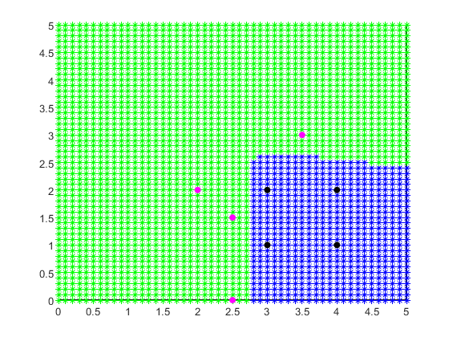
3000 epochs, alpha = 0.2

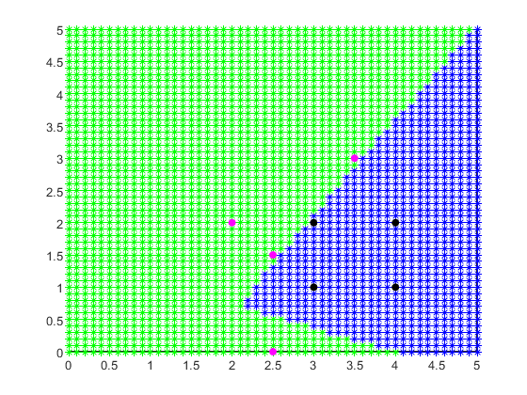
12500 epochs, alpha = 0.05
Published with MATLAB® R2019b

