Neural Networks Practice 1-One layer Perceptron

Elizarraras Llanos Angel Gustavo

Designs and implement an artificial neural network able to separate the following classes:
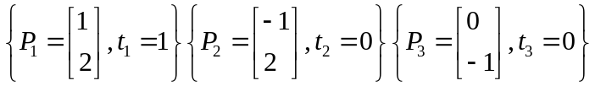

Generating the variables for the neuron

P1 = [1;2];
P2 = [-1;2];
P3 = [0;-1];
Target = [1 0 0];%Targets
P = [P1, P2, P3];%Points
N=1;%Number of neurons
w = rand(2,N);%random weigth
W = w';
b = rand(N,1);%random bias
Original_random_bias = b
W_Random = W
Epochs = 10;%I did not ask to the user because if i do, i can't publish with matlab.

Original_random_bias =
0.9575
W_Random =
0.2785 0.5469

Training

for i = 1:Epochs
for j = 1:3
a = hardlim(dot(W,P(:,j)) + b);
e = Target(j) - a;
x = e*P(:,j);
W = W + x';
b = b + e;
end
end

Checking training

b_after_training = b
W_after_training = W
X = -3:0.1:3;
figure(1)
for i = 1:length(X)
for j = 1:length(X)
allP = [X(i);X(j)];
C = hardlim(W*allP + b);
if C==1
plot(X(i),X(j),'*r')
hold on
else
plot(X(i),X(j),'*b')
hold on
end
end
end

b_after_training =
-1.0425
W_after_training =
3.2785 -0.4531

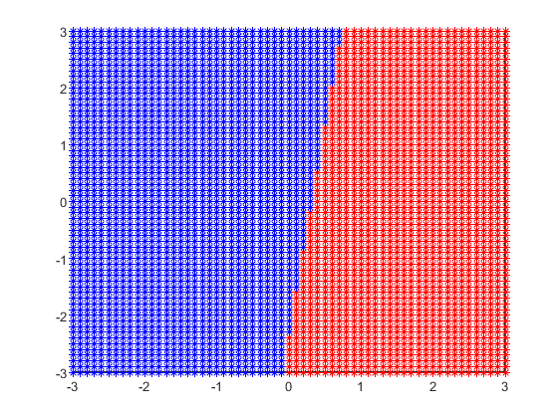

Getting the limit line

xpoint = -b / W(1);
ypoint = -b / W(2);
slope = -ypoint/xpoint;
Y = slope*X + ypoint;
mw = -1 / slope;
Yw = mw*X;
%Plotting the limit line and the weight
figure(2)
%Axis
ax = gca;
ax.XAxisLocation = 'origin';
ax.YAxisLocation = 'origin';
hold on
grid on
axis([-3 3 -3 3]);
plot(X,Y,X,Yw, 'Linewidth',2)
legend({'Limit line','Weight'},'Location','northeast')
hold on
scatter(1,2)
hold on
scatter(-1,2)
hold on
scatter(0,-1)
hold on
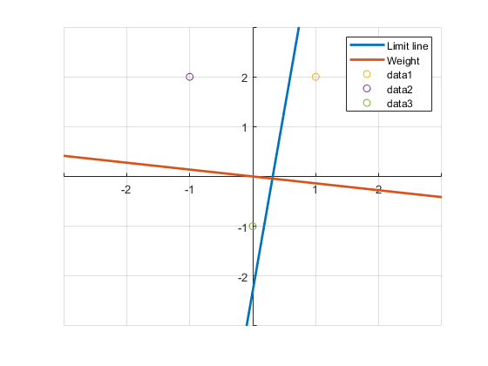
Published with MATLAB® R2019b

