Neural Networks Practice 2- Two Neurons Perceptron
Elizarraras Llanos Angel Gustavo 1
Generating the variables for the neuron 1
Training 1
Checking training 2
Getting the limit line 3

Elizarraras Llanos Angel Gustavo

Generating the variables for the neuron
P11 = [-3,1];
P12 = [-1 2];
P21 = [-2 2];
P22 = [4 -3];
P31 = [-2 -4];
P32 = [-1 -3];
P41 = [3 0];
P42 = [4 2];
Targets = [1; 1; 0; 0; 1; 0;0; 1];%Targets
p = [P11; P12; P21; P22; P31; P32; P41; P42];%Points
P = p';
Number_classes = 4;
N=2;%Number of neurons
W = rand(2,N);%random weigth
b = rand(N,1);%random bias
Original_random_bias = b
W_Random = W
Epochs = 10;%I did not ask to the user because if i do, i can't publish with matlab.
e=zeros(2,1);
x=zeros(2,1);
Original_random_bias =
0.9595
0.6557
W_Random =
0.1419 0.9157
0.4218 0.7922

Training
for i = 1:Epochs
for j = 1:Number_classes
a(1) = dot(W(1,:),P(:,(j+4))) + b(1);
a(2) = dot(W(2,:),P(:,j)) + b(2);
A = hardlim(a(1) + a(2));%Getting only one A
e(1) = Targets(j) - A;
e(2) = Targets(j+4) - A;
x1 = e(1)*P(:,j);
x2 = e(2)*P(:,j+4);
W(1,:) = W(1,:) + x1';
W(2,:) = W(2,:) + x2';
b(1) = b(1) + e(1);
b(2) = b(2) + e(2);
end
end

Checking training
b_after_training = b
W_after_training = W
X = -5:0.1:5;
figure(1)
for i = 1:length(X)
for j = 1:length(X)
allP = [X(i);X(j)];
C = hardlim(W*allP + b);
if( C(1) == 0 && C(2) == 0 )
plot(X(i) , X(j), '*b')
elseif ( C(1) == 0 && C(2) == 1 )
plot(X(i) , X(j), '*g')
elseif ( C(1) == 1 && C(2) == 1 )
plot(X(i) , X(j), '*k')
elseif ( C(1) == 1 && C(2) == 0 )
plot(X(i) , X(j), '*r')
end
hold on
end
end
%
b_after_training =
16.9595
16.6557
W_after_training =
-55.8581 42.9157
4.4218 -27.2078
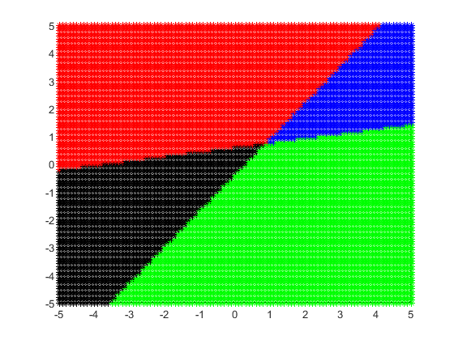

Getting the limit line
xpoint1 = -b(1) / W(1);
ypoint1 = -b(1) / W(3);
slope1 = -ypoint1/xpoint1;
Y1 = slope1*X + ypoint1;
mw1 = -1 / slope1;
Yw1 = mw1*X;
xpoint2 = -b(2) / W(2);
ypoint2 = -b(2) / W(4);
slope2 = -ypoint2/xpoint2;
Y2 = slope2*X + ypoint2;
mw2 = -1 / slope2;
Yw2 = mw2*X;
%Plotting the limit line and the weight
figure(2)
%Axis
ax = gca;
ax.XAxisLocation = 'origin';
ax.YAxisLocation = 'origin';
hold on
grid on
axis([-5 5 -5 5]);
plot(X,Y1,'b',X,Yw1, 'c','Linewidth',2)
hold on
plot(X,Y2,'r',X,Yw2,'m', 'Linewidth',2)
legend({'Limit line 1','Weight 1','Limit line 2','Weight 2'},'Location','northwest')
hold on
scatter(-3,1)
hold on
scatter(-1,2)
hold on
scatter(2, -2)
hold on
scatter(4,-3)
hold on
scatter(-2,-1)
hold on
scatter(-1, -3)
hold on
scatter(3,0)
hold on
scatter(4,2)
hold on
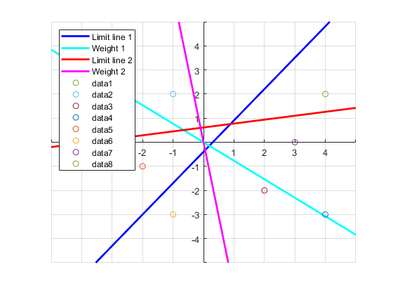
Published with MATLAB® R2019b

