Neural Networks Practice 3-3D Perceptron

Elizarraras Llanos Angel Gustavo

Generating the variables for the neuron
P1 = [1;-1;-1];%Orange
P2 = [1;1;-1];%Apple
Target = [-1 1];%Targets
P = [P1, P2];%Points
N=1;%Number of neurons
W = rand(N,3);%random weigth
b = rand(N,1);%random bias
Original_random_bias = b
Random_W = W
Epochs = 10;%I did not ask to the user because if i do, i can't publish with matlab.
Original_random_bias =
0.3371
Random_W =
0.5688 0.4694 0.0119

Training
for i = 1:Epochs
for j = 1:2
a = hardlims(dot(W,P(:,j)) + b);
e = Target(j) - a;
x = e*P(:,j);
W = W + x';
b = b + e;
end
end

Checking training
b_after_training = b
W_after_training = W
b_after_training =
0.3371
W_after_training =
0.5688 2.4694 0.0119

Getting the plane
To get a plane, you must have a normal vector to the plane and a point in the plane, and we know the weight is perpendicular and to the point we have any intersection with an axis. I will use de y intersection.
figure(1)
scatter3(1,-1,-1,'filled','r')
hold on
scatter3(1,1,-1,'filled','g')
hold on % x = -b / W(1);
y = -b / W(2);
% z = -b / W(3);
% The equation for a this plane is: Ax+B(y-y0)+Cz=
[X, Y] = meshgrid(-3:1:3);
% Isolating z
Z = (1/W(3))*(-W(1)*X - W(2)*Y + W(2)*y);
surf(X,Y,Z)
legend({'Orange','Apple','Dividing plane'},'Location','northeast')
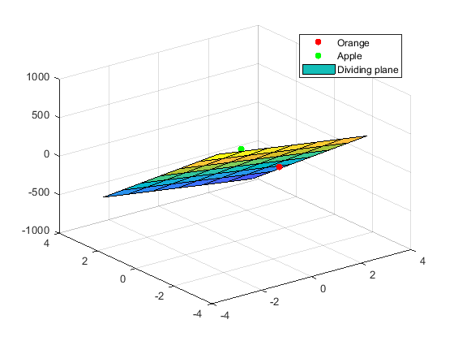
Published with MATLAB® R2019b

% Image example
userx = input('Introduce the x point')
usery = input('Introduce the y point')
userz = input('Introduce the z point')
scatter3(userx,usery,userz)
legend({'Orange','Apple','Dividing plane','User input'},'Location','northeast')
U = [userx; usery; userz];
C = hardlims(W*U + b);
figure(2)
if C==1
imshow('apple.png')
else
imshow('orange.jpg')
end

We notice that user input is in the orange side.
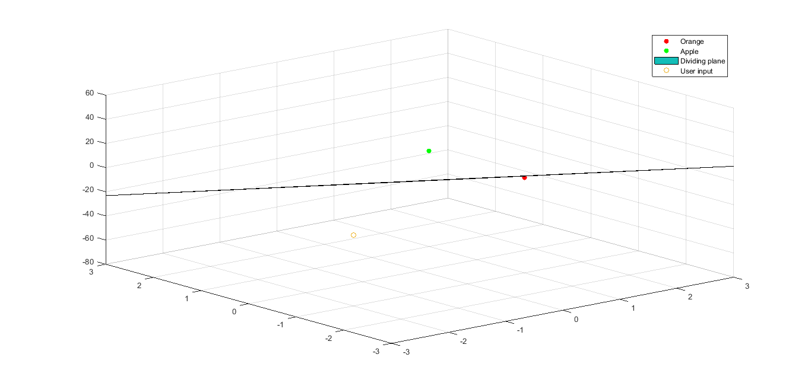
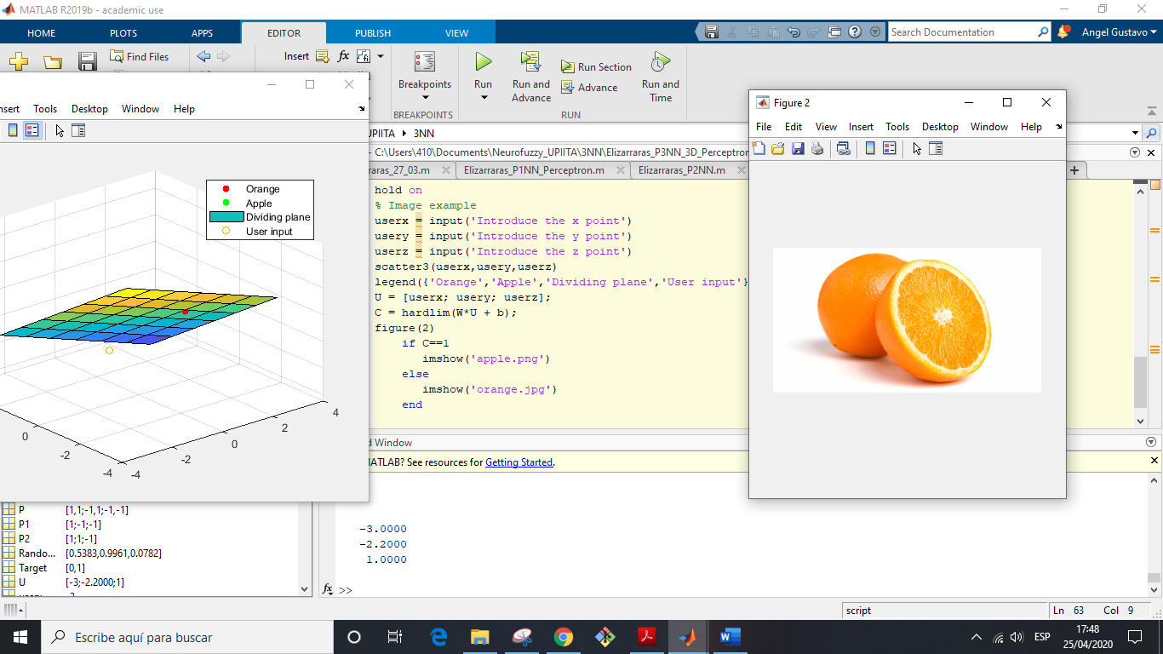

For this example, the user points are [ 5 5 5 ] and we notice it is on the apple side
