EXCELLENCE IN COMMUNITY ASSISTANCE

This award recognizes an individual or group for outstanding community wildland fire mitigation work. The recipient of this award will have excelled in wildland fire prevention, education and mitigation work, collaboration with local agencies, organizations or groups, or grant work, thus enhancing the protection capabilities of rural fire departments, helping the public understand wildland fire and the management challenges it presents, and reducing the risk and impacts of wildfire to communities.
Eligible Nominees
Nominations will be accepted for individuals or groups that have excelled in the area of wildland fire community assistance at the local, state, regional or national level. Nominated projects/activities/actions must have been largely completed during calendar year 2004.
Nominations will be accepted from any individual or group, on behalf of any individual or group, involved in implementing the National Fire Plan, whether federal, state, tribal or local government, partners such as associations or established organizations or contractors.
Nomination Process:
Due to delays in mail delivery procedures in Washington, D.C., we request nominations be sent by Federal Express (or some other express mail delivery system) to:
Simone Dupree, USDA Forest Service
National Fire Plan, Yates Building 1 NW
201 14th St. SW
Washington, D.C. 20250-0001
Emailed or faxed nominations will not be accepted. Nominations must be received by COB November 19, 2004. No late nominations will be accepted.
Nomination Package:
All nominations must include the following:
- A completed Nomination Cover Sheet (a blank cover sheet is attached to this packet),
- A CD that includes a one-page "Success Story" describing this project. The Success Story should be a brief narrative (no more than one page) describing the project, work or accomplishment and its significance to the National Fire Plan at the national, regional, state or local level (refer to the NFP 10 year Comprehensive Strategy). Include where and when the work occurred, who was involved, how it was planned and implemented, and why the work was important. If possible, please also include supporting images (as jpg files) (the Success Stories and supporting images will be posted on the National Fire Plan website),
- One hard copy of the Success Story, and
- Two pages or less in which each of the nomination criteria are addressed separately.
Criteria
Each nomination should address the following criteria:
- Describe how an individual’s or group’s work has accomplished the National Fire Plan’s community assistance goal by developing and implementing an exceptional prevention/education or mitigation program, working with local fire departments to increase their capability or implement an unusual project, or using the grant program to access funding to accomplish projects that benefit communities at risk from wildland fire.
- Discuss how the nominee used collaboration, coordination, partnerships, and/or communities to accomplish the National Fire Plan goals. Describe who was involved, their role, and how this collaboration enhanced the work or project.
- Describe in detail how the nominee demonstrated a commitment to the National Fire Plan under the direction of the 10-Year Strategy and how this commitment exceeded expectations.

2004 National Fire Plan
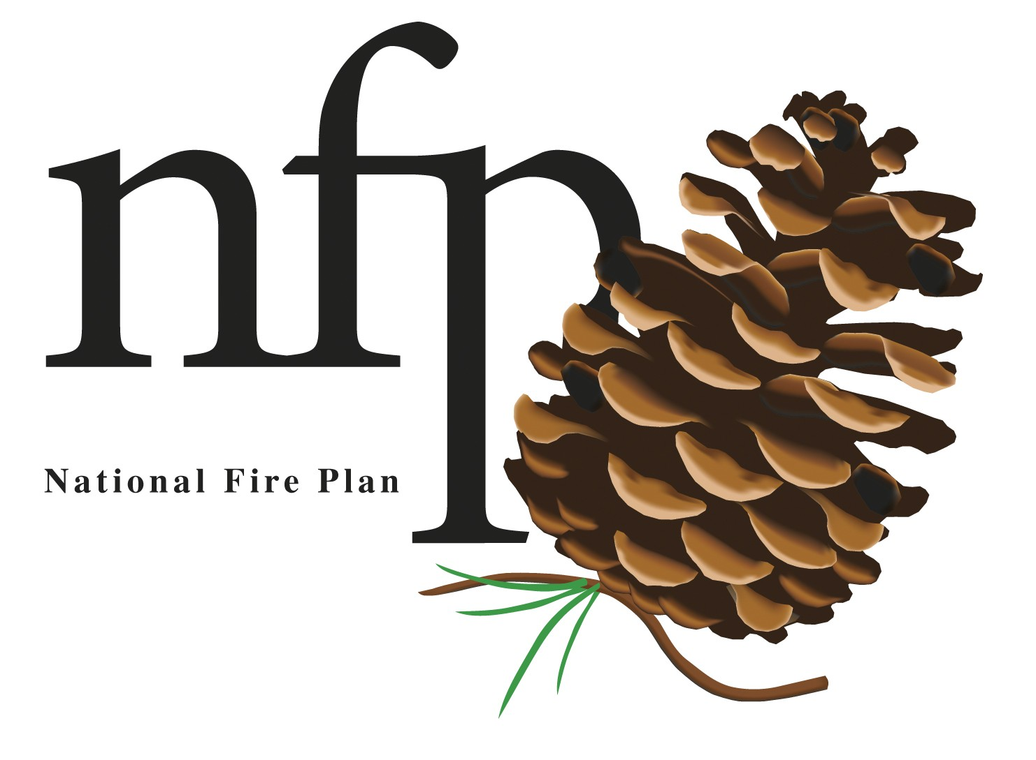
Award Nomination

This nomination cover form is required for all 2004 NFP Award Nominations.
All fields on the form must be completed for the nomination application to be considered.

Award Category: Please check the box that corresponds to the award category for which this nomination is being submitted. Please check ONE box only; if you wish to nominate the individual/group for more than one category, a separate nomination packet must be submitted for each category.
Excellence in Community Assistance
Excellence in Collaboration
Excellence in Hazardous Fuels Reduction
Excellence in Firefighter Preparedness, Training and Safety
Excellence in Rehabilitation and Restoration
Innovation in Biomass Utilization
Excellence in Research

Nominee Information: Please fill out the information below for the individual/group being nominated.
Point of Contact (for group nominations only): Please list one group member as the point of contact for the entire group.
Nominee Name / Group Name:
Title & Organization:
Address:
City: State: Zip:
Phone: Email address:
Nominee's Supervisor: Supervisor Phone:
Supervisor's Signature: Date:

Nominator Information: Please fill out the information below for the person submitting the nomination.
Nominator Name:
Title/Organization:
Address:
City: State: Zip:
Phone: Email address:
Nominator's Signature: Date:

