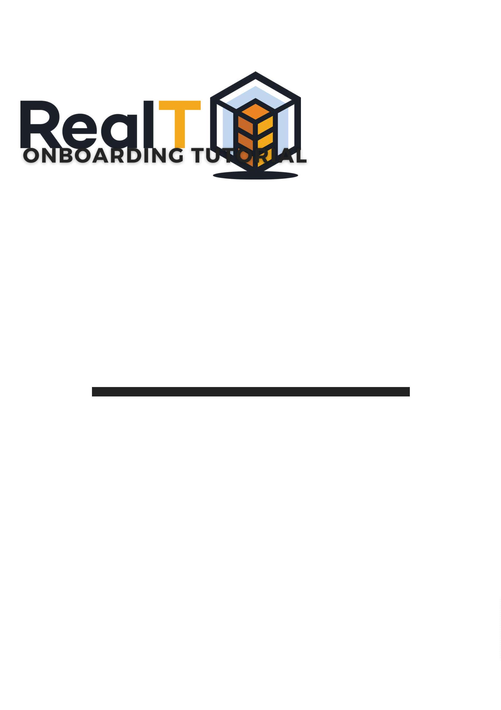

Disclosure
DISCLOSURE
This information is not an offer to invest in any token or other opportunity and is
provided for information only. Any offer to sell or solicitation to buy interests in the
Issuance will be made only by means of an offering memorandum delivered by an
employee or agent of the Issuer.
Any references to past performances are informational and cannot be considered
to indicate or guarantee any future results. Investing in crypto currencies involves a
substantial degree of risk. There can be no assurance that the investment
objectives described herein will be achieved. Investment losses may occur, and
investors could lose some or all of their investment.
Performance results are shown net of all fees, costs, and expenses associated with
the token. Should an investor choose to redeem a token through RealT or on a
secondary market, other processing fees may be assessed that are not factored into
the returns presented.

Onboarding Tutorial
TABLE OF CONTENTS
A - CREATE YOUR ACCOUNT 1
B - PASS YOUR KYC 4
C - SET UP YOUR PORTFOLIO 6
D - BUY YOUR FIRST REALTOKEN 16
E - MORE TUTORIALS 19

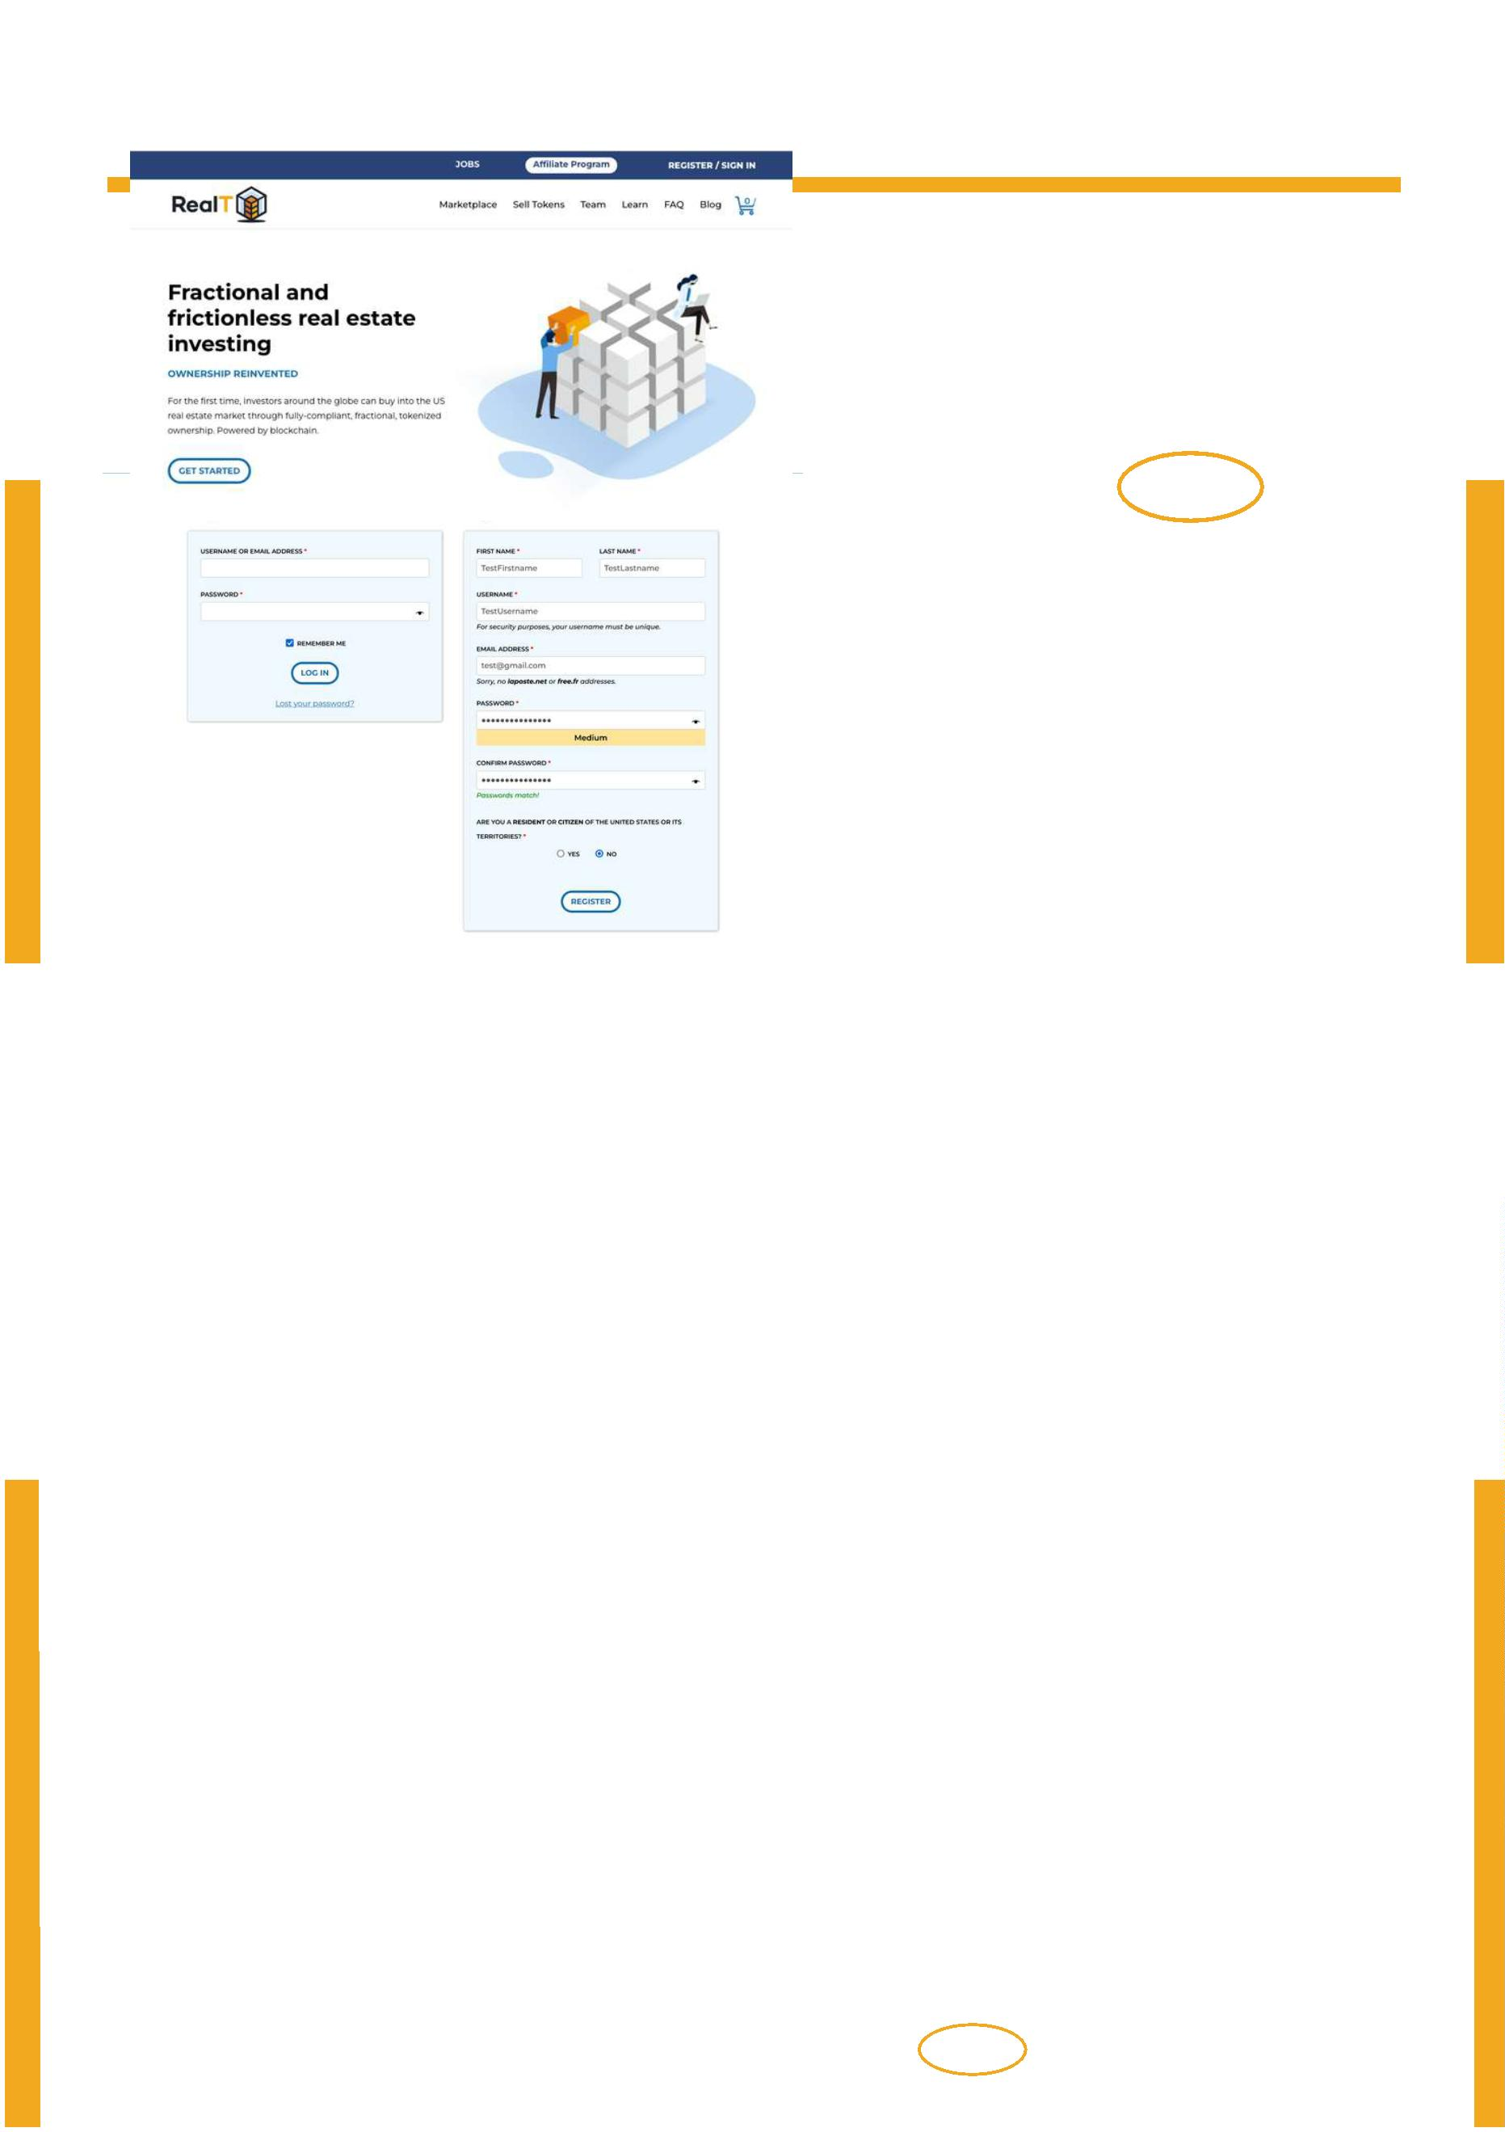A - Create Your Account Page 1
Step 1 : Go to the realt.co website.
Go to the "REGISTER / SIGN IN" tab to create an account.
Step 2 : To register, you will have to fill in some fields, including :
- First and last name
- Your username
- Your email address and a new password
- If you are a US citizen or resident.
Click on the "REGISTER" button and then "I UNDERSTAND".

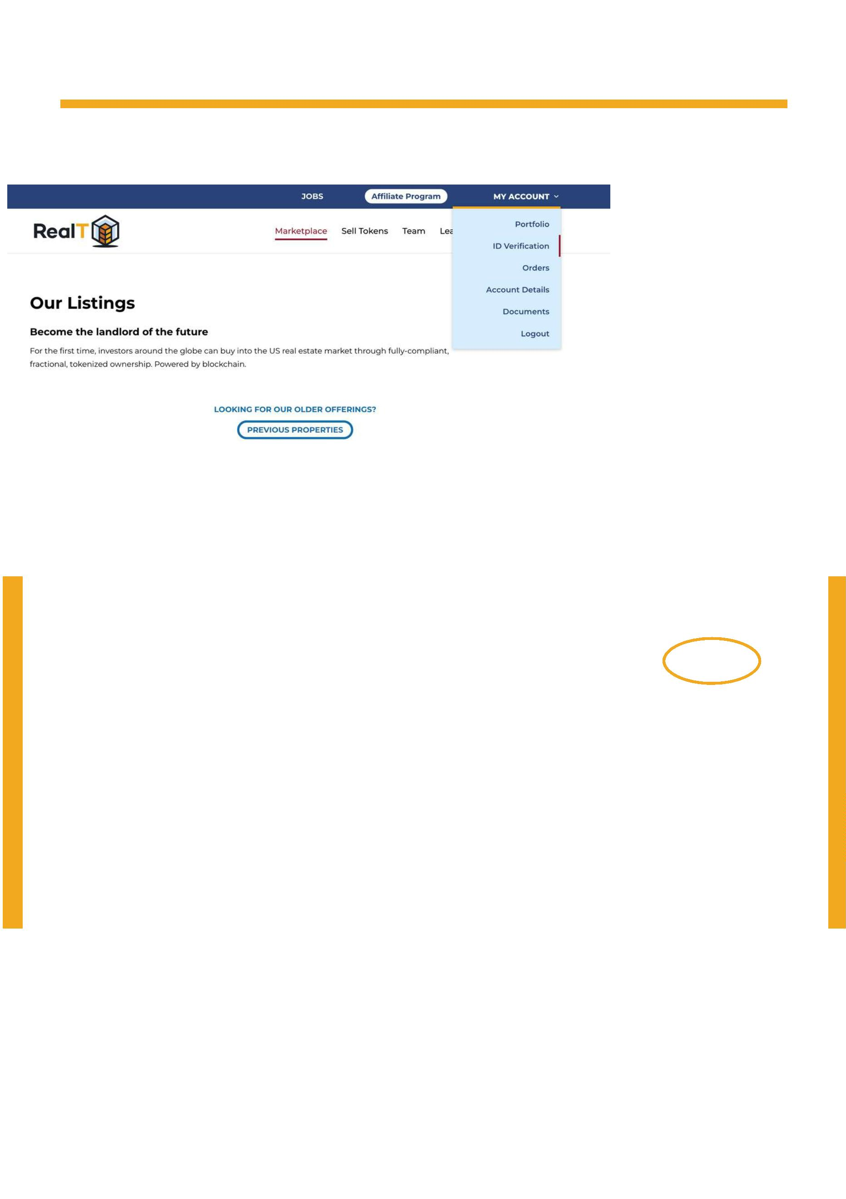 | A - Create Your Account Page 2
This should log you into your account. If one day the government needs to
Next, you will need to validate your know the information of a token
identity and add a wallet where you holder, it can request that information
wish to receive your tokens. As a from RealT. RealT requires this
reminder, you need to validate your information to comply with the
identity so RealT knows who the regulations.
tokens belong to at all times. Only the
company will know your identity.
Step 3 : To validate your identity, go to the "ID verification" tab.

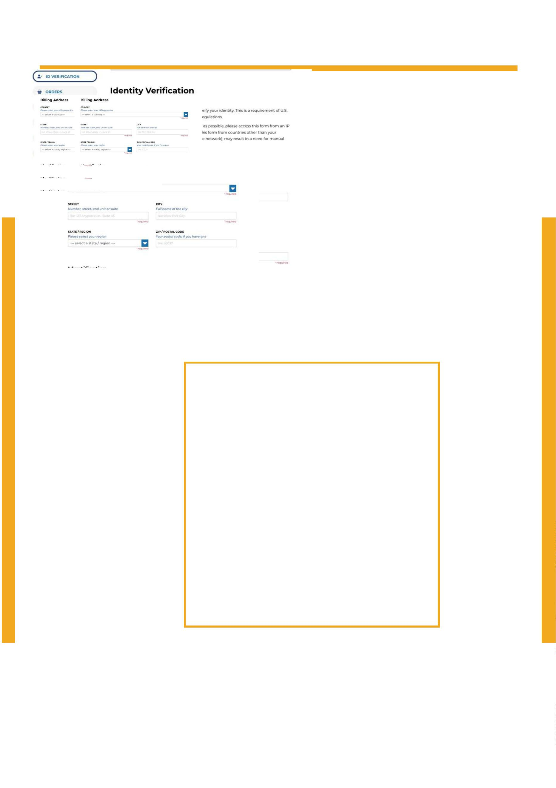A - Create Your Account Page 3
Step 4 : Fill in the fields below:
- Birth Date (Year - Month - Day)
- Phone
- Country
- Street / City / State / Postal Code

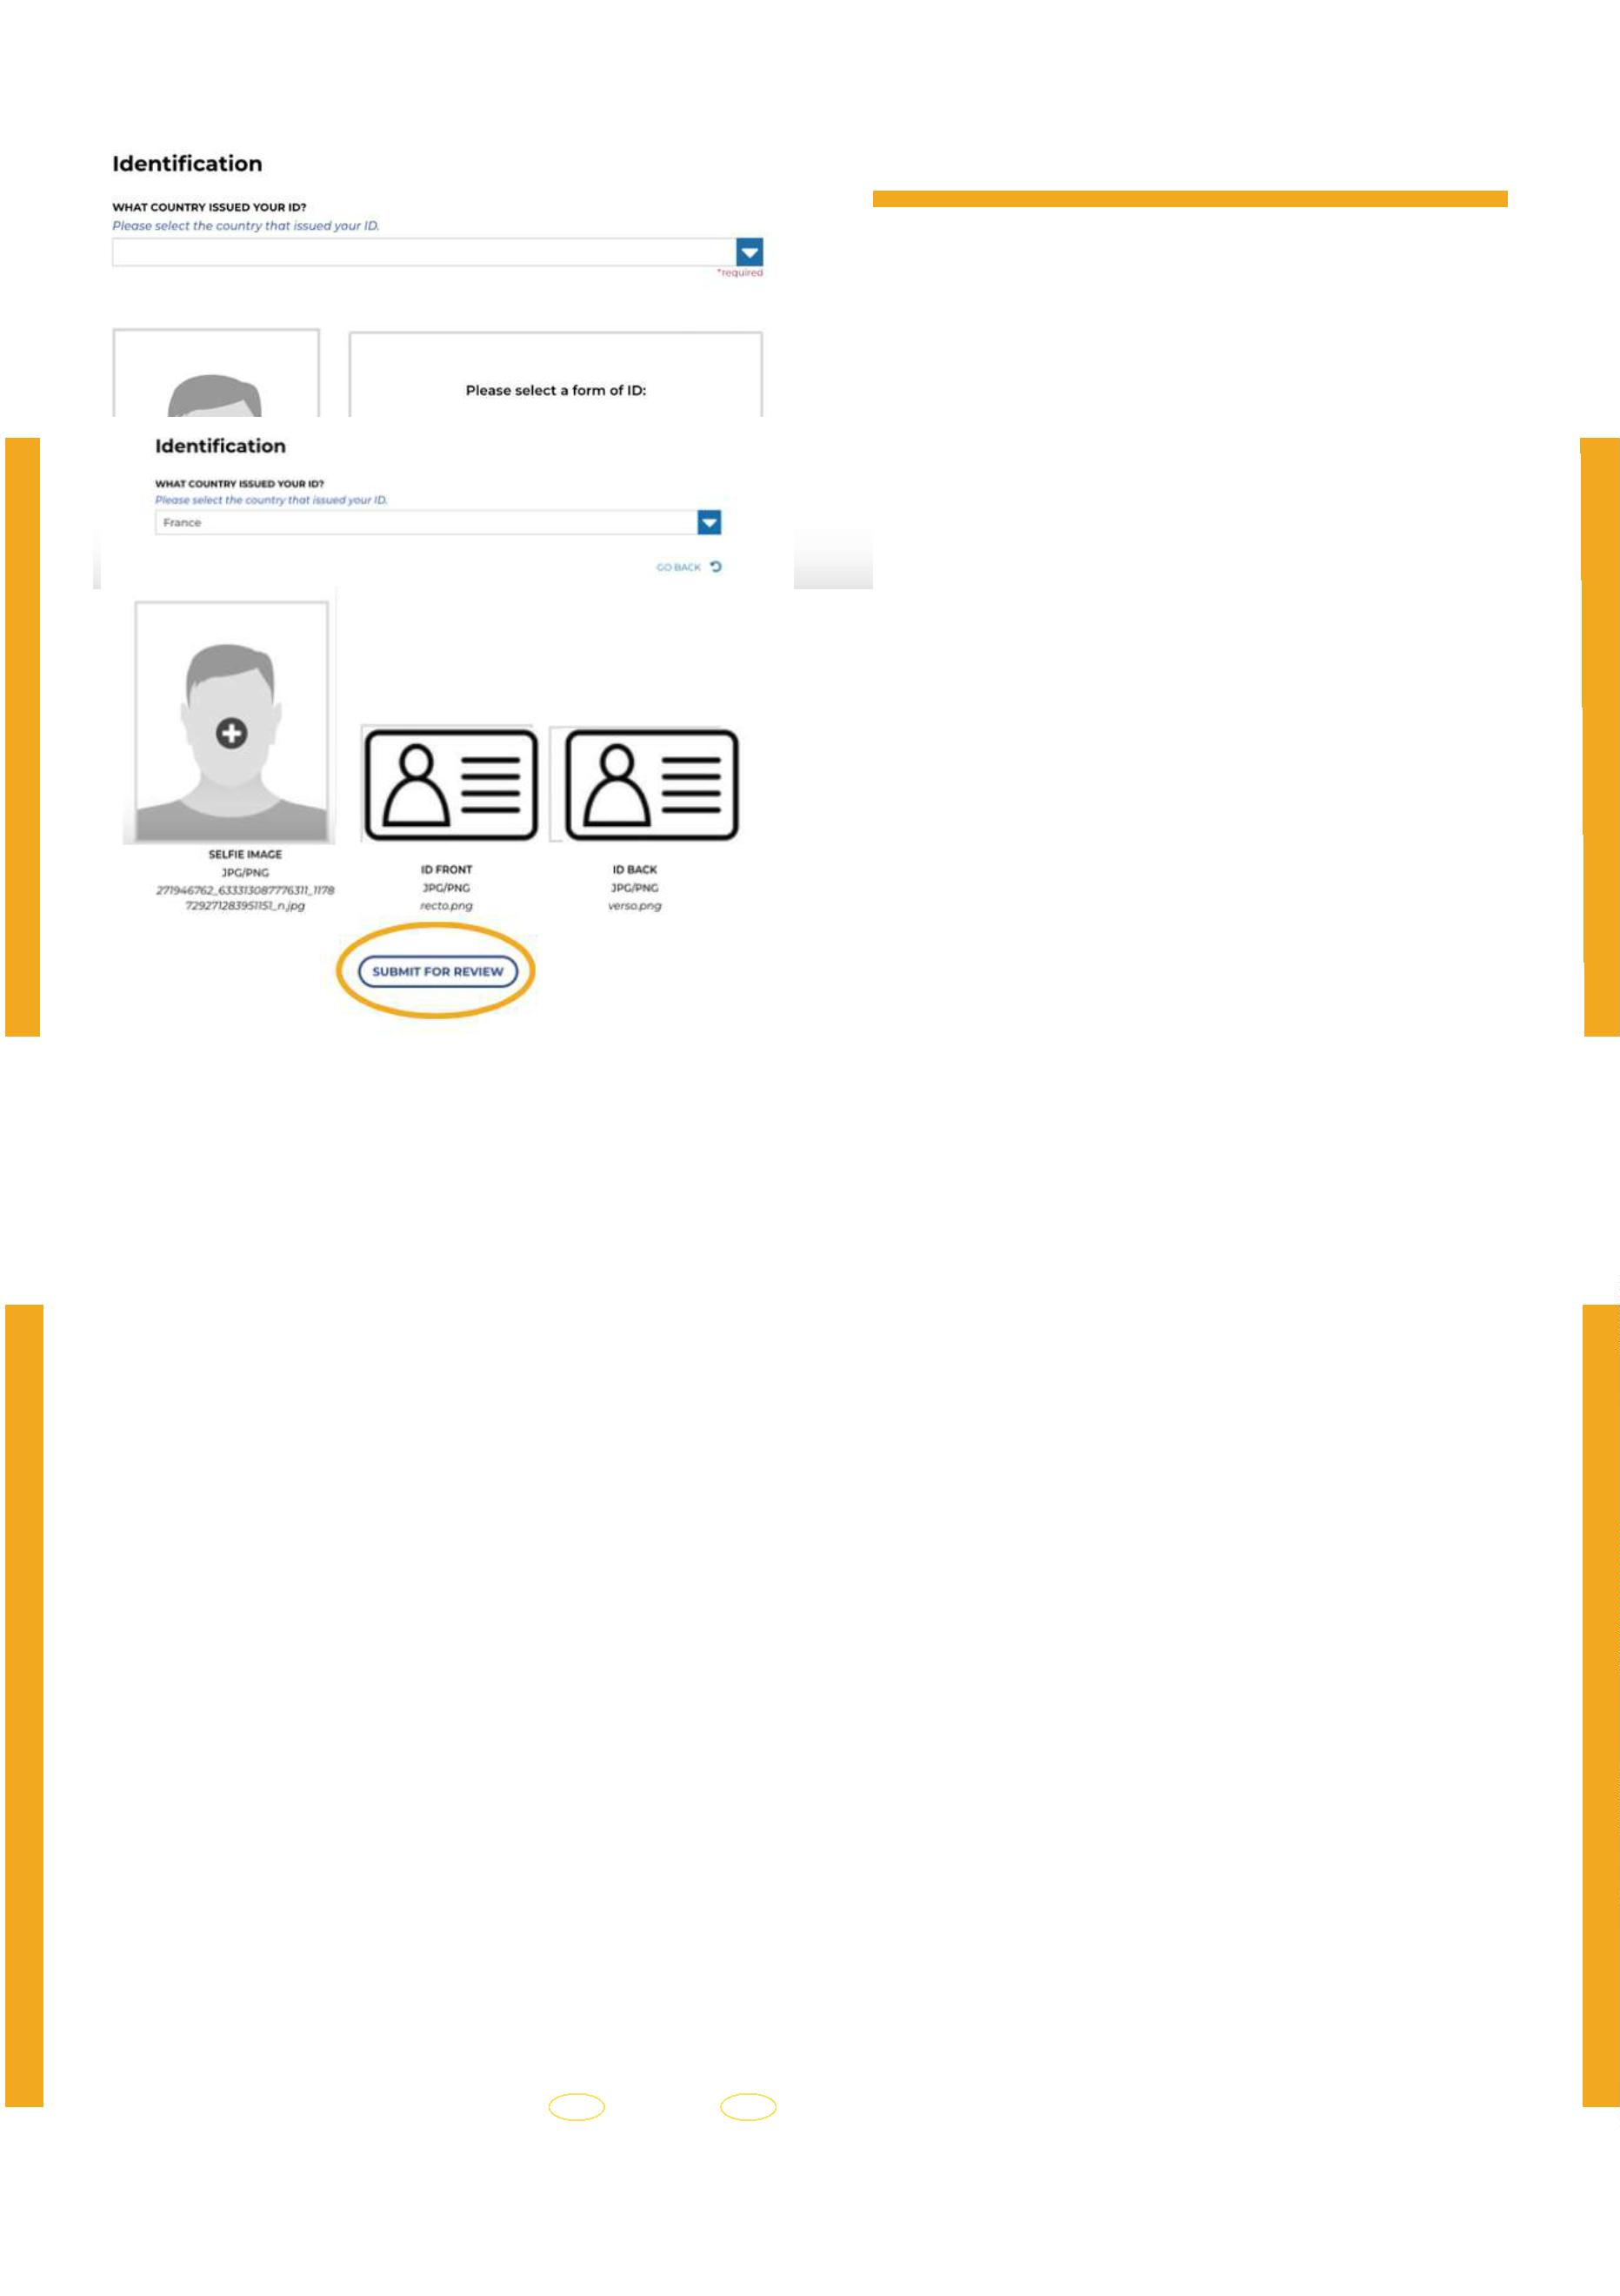B - Pass Your KYC Page 4
Step 1 : Submit a selfie and an official document (passport, driver's licence, id card).
Step 2 : Once the documents have been downloaded, click on "SUBMIT FOR REVIEW".

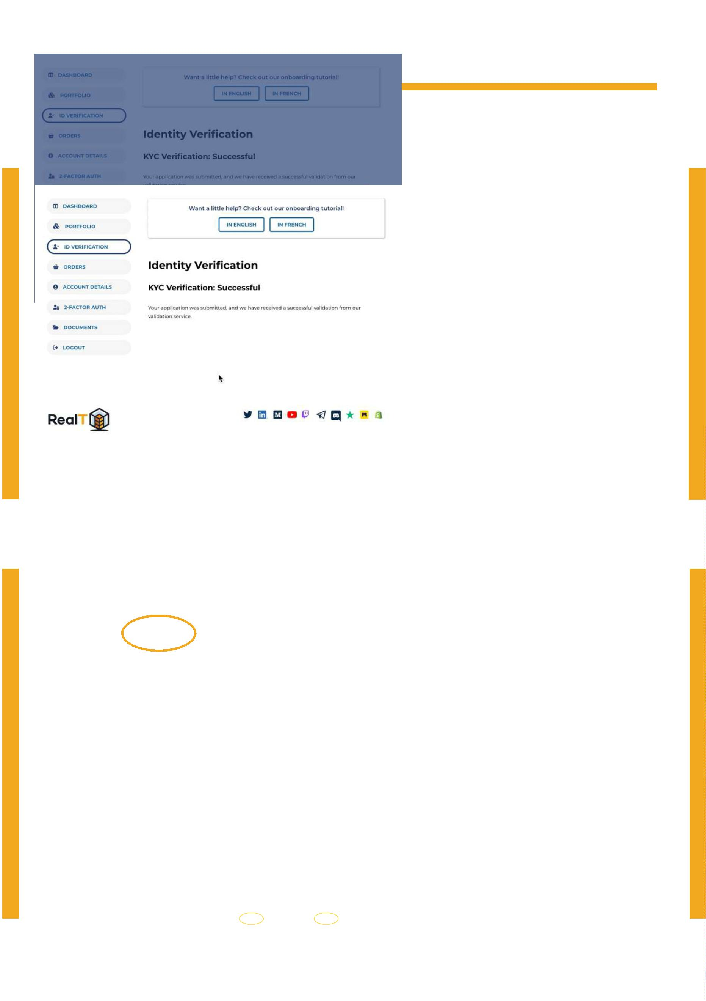B - Pass Your KYC Page 5
Step 3 : Once confirmed, click on the "CLOSE" button.
Step 4 : Go to the "PORTFOLIO" tab.

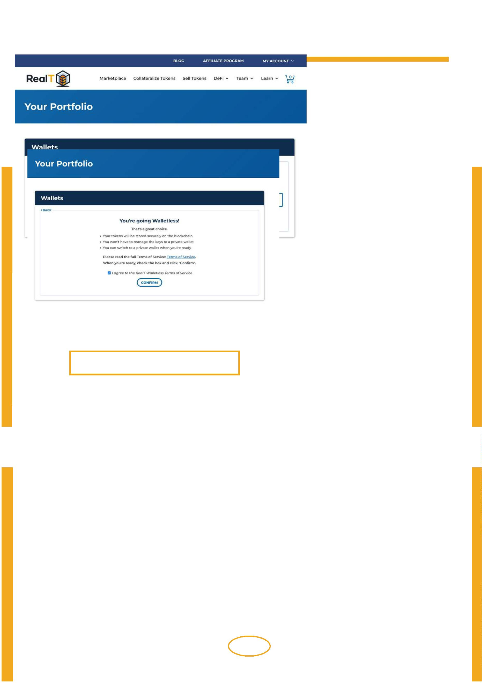C - Set up your portfolio Page 6
Step 1 : Choose between "walletless" or your own crypto-currency wallet.
If you are a beginner in the blockchain and crypto-currency ecosystem and you are not
familiar with some terms like "Metamask", "seed phrase" or "DEFI" then we recommend
"walletless".
To learn more you can read our article on this topic by clicking here.
Step 2 : Mark the box "I agree to the RealT wallettless Terms of Service" and click on
"CONFIRM".

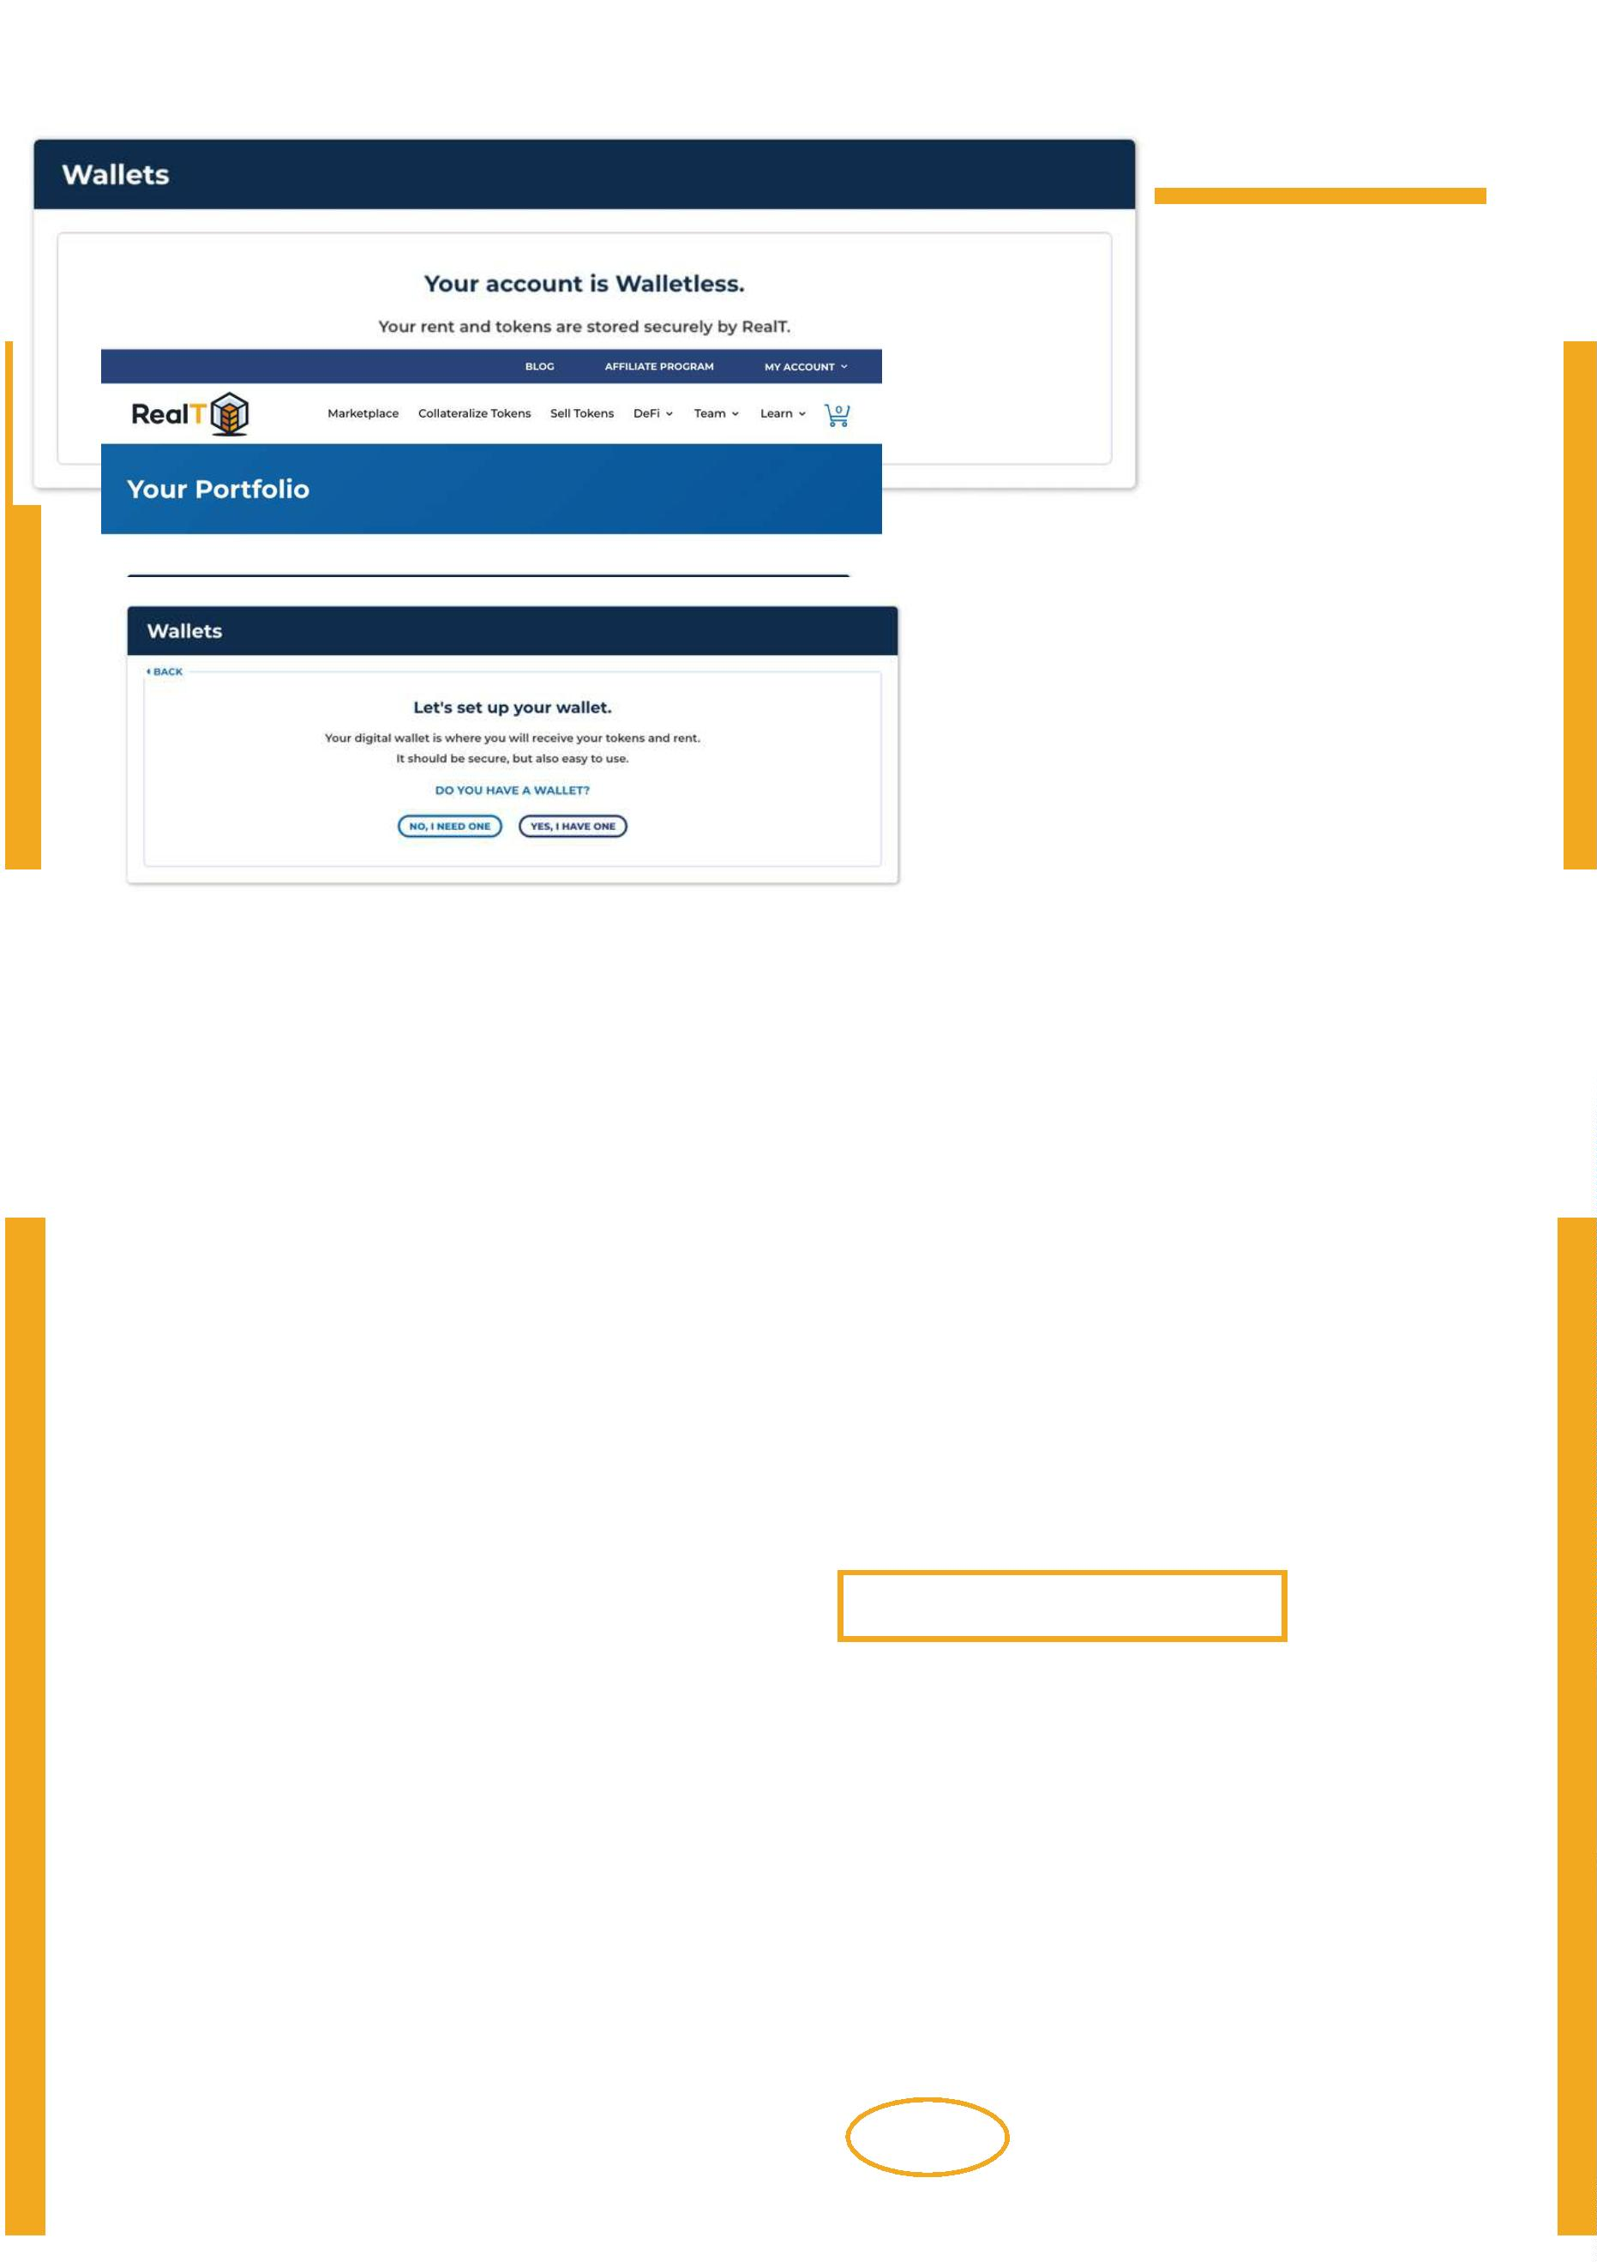 | C - Set up your portfolio Page 7
Step 3 : Congratulations, your wallet is set up and you can go directly to page 12 to
purchase your first RealToken.
Step 4 : You can set up your own crypto wallet.
If you don't know what an Ethereum wallet is, please read our article in clicking here.
Click on "SET UP A PRIVATE WALLET" then "YES, I HAVE ONE"" and go page 9.
Otherwise, continue this tutorial.

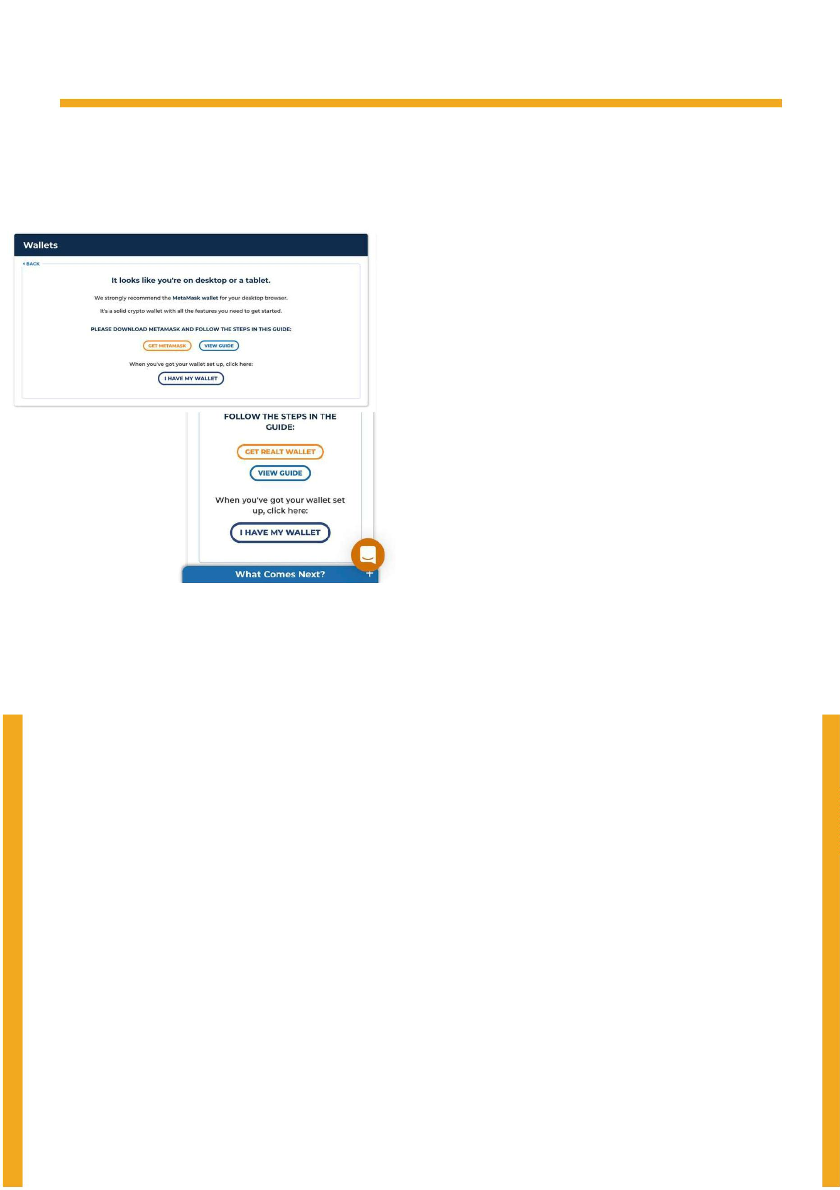C - Set up your portfolio Page 8
If you do not have a wallet, click on "NO, I NEED ONE" and you have 2 options:
1- Create a wallet with MetaMask, recommended if you are on a computer.
2- Create a wallet with the mobile RealT Wallet
Apart from the "walletless", the RealT mobile wallet is easier to manage your investments.
RealT has partnered with Mt Pelerin to develop this wallet. If you choose certain features,
the application may ask you to pass another KYC check. However, this KYC is not
required in order to buy RealTokens. It is only required to enable certain features,
such as withdrawing your rent to your bank account.
If you are on a computer, RealT suggests Metamask.
If you are on a smartphone, RealT suggests the RealT wallet.
By clicking on "View Guide", you will have access to a new tutorial.
Once you have your wallet, click on "I HAVE MY WALLET".
1- View on a computer 2- View on a smartphone

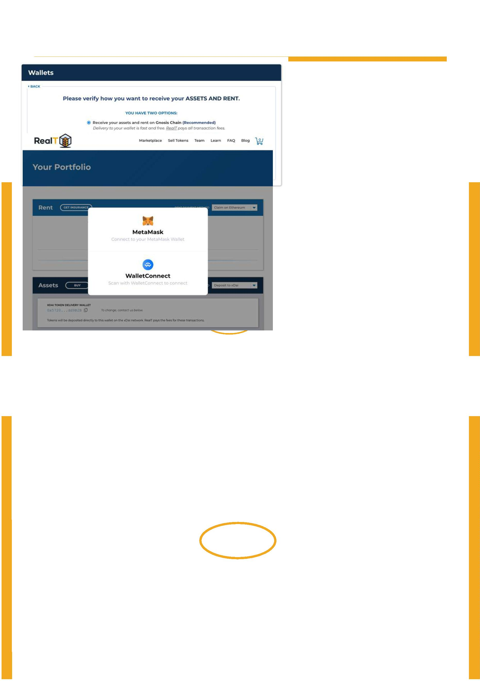C - Set up your portfolio Page 9
Step 5 : Select on which network you want to receive your RealTokens and
distributions:
1- Claim on Ethereum (We don't recommend this choice because the gas fees are high).
2- Receive on Gnosis Chain (The gas fees are low).
Click on "I'M Ready".
Step 6 : if you created your account with the RealT Wallet, click on "WalletConnect".
If you created your account with Metamask, click "Metamask".

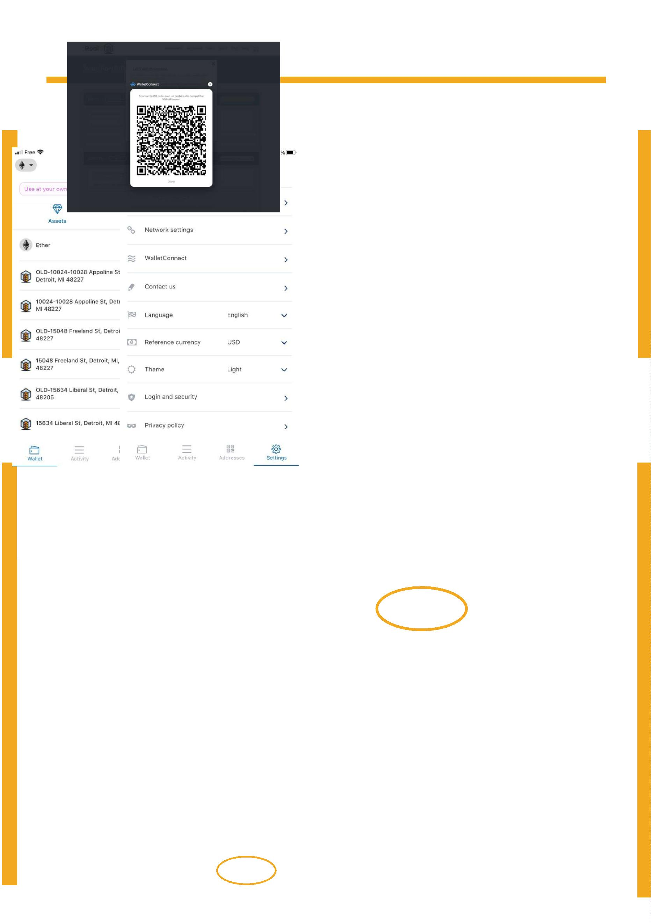 | C - Set up your portfolio Page 10
Step 7 : WalletConnect only: A QR code will appear.
Step 8 : Go to your RealT Wallet app. Step 9 : Click on "WalletConnect".
Click on "Settings"

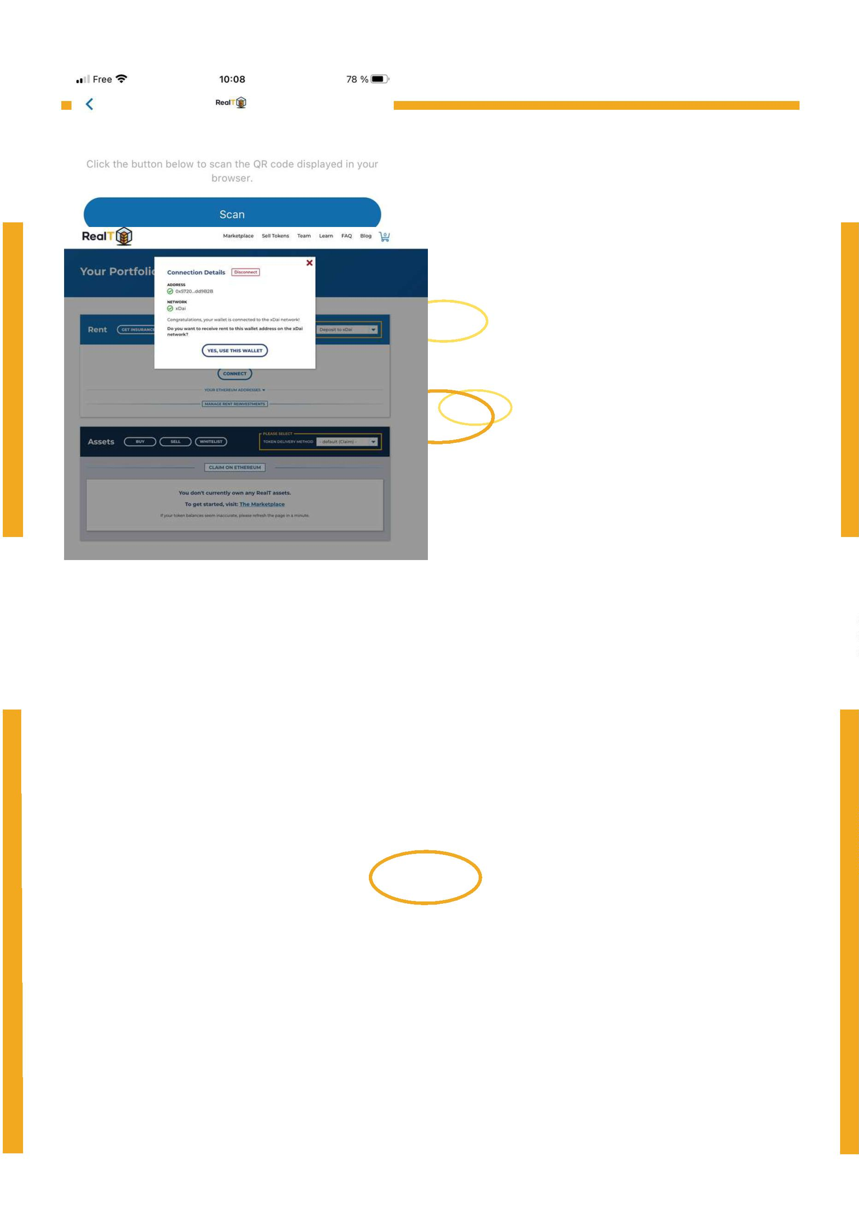 | C - Set up your portfolio Page 11
Step 10 : Click on "Scan" and scan the QR code.
Congratulations! Your portfolio is almost set up.
Click on "YES, USE THIS WALLET".

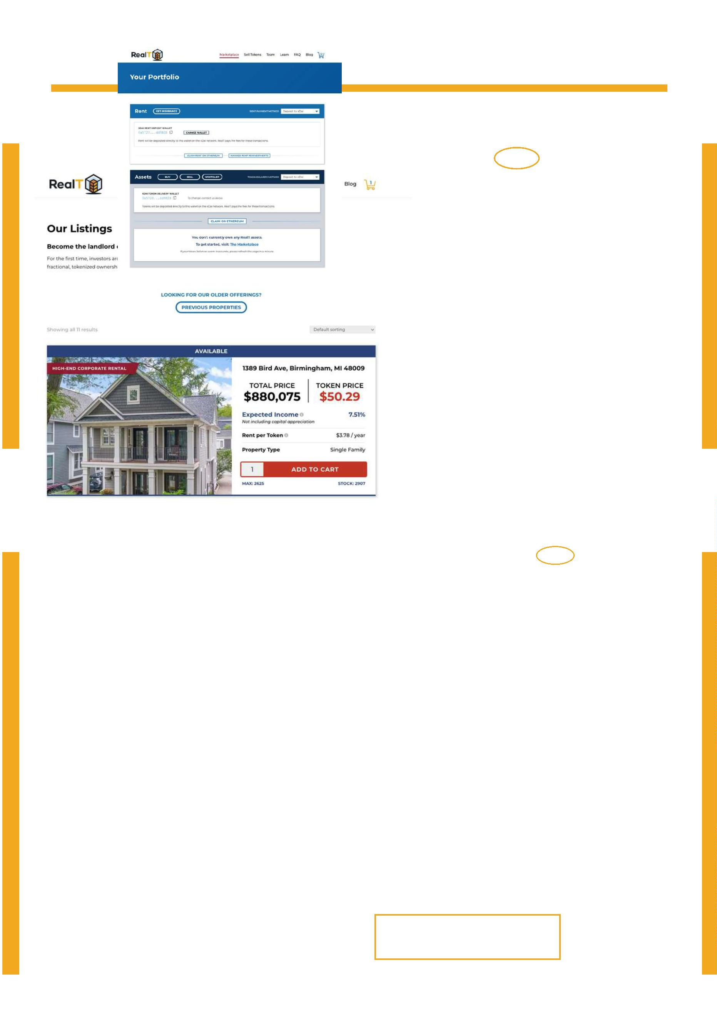D - Buy your first RealToken Page 12
Step 1 : Go to the Marketplace.
Step 2 : Enter the quantity you would like to purchase, then click "ADD TO CART".
When the button says "DONE!", click on the cart icon at the top right.

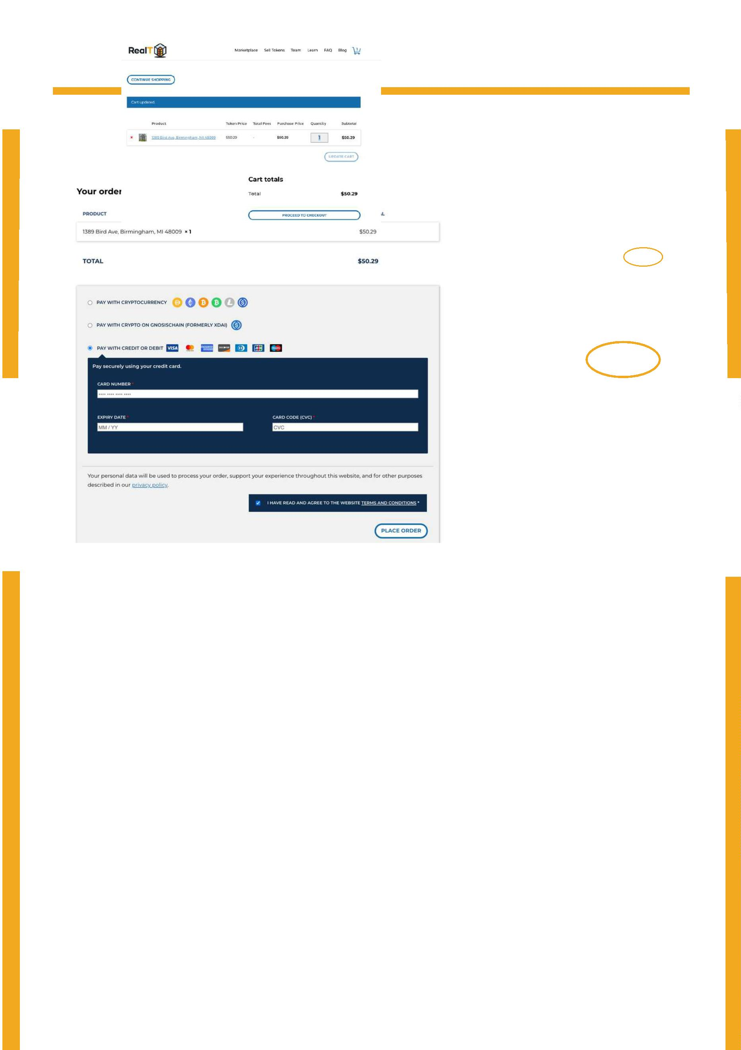D - Buy your first RealToken Page 13
Step 3 :
You can change the quantity here, too.
Then click on "Proceed to Checkout".
Step 4 :
You have 3 ways to pay :
1- Pay with cryptocurrency with your custodial or non-custodial wallet.
2- Pay with cryptocurrency USDC or xDai directly with your wallet on Gnosis Chain.
See the tutorial here.
3- Pay with your credit card.

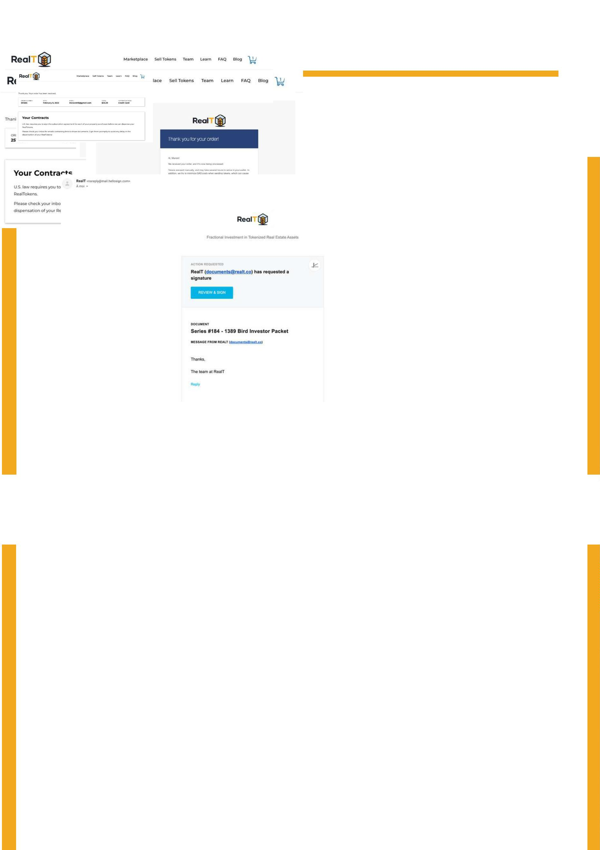D - Buy your first RealToken Page 14
Step 5 :
You will see a summary of your order, and also receive an email.
Step 6 :
A few minutes after your investment, you will receive a second email allowing you to sign
the contract between you and the LLC or the Inc. that "wraps" the property.

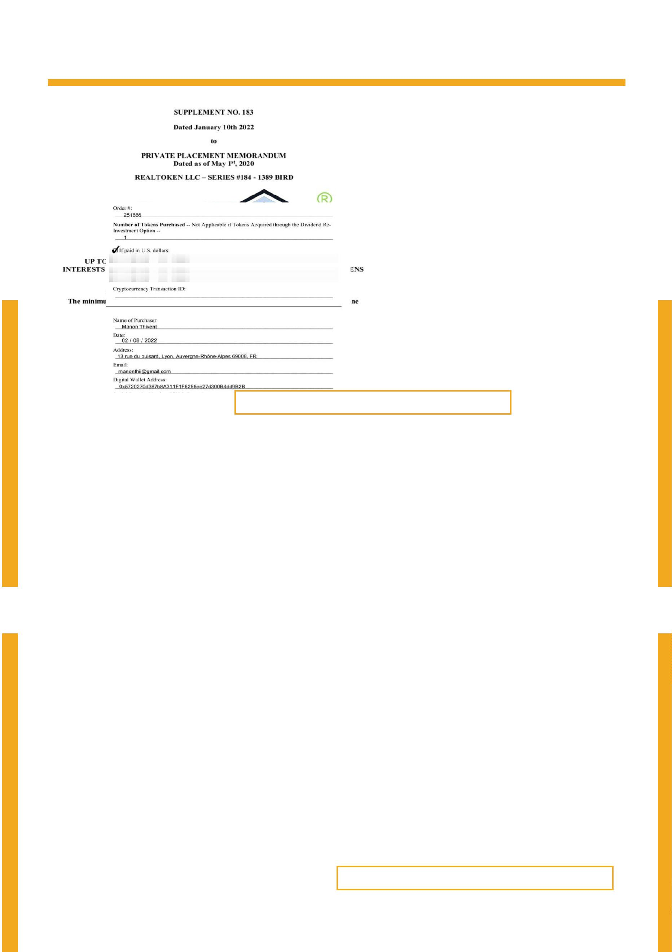 | D - Buy your first RealToken Page 15
Step 6 : Read the contract.
The contract is more than 50 pages long, but I will describe the important information.
In the first picture below, we can see that we are signing a contract with an LLC distinct
from RealT itself. You can see that the LLC "RealToken LLC - Series #184 -1389 BIRD"
owns the property. You own a percentage based on the number of tokens purchased.
RealT the company is an independent structure that allows the management of this LLC.
RealT does not own the LLC, the investors own the LLC!
In the second picture, we have a
summary of our order, including our
Ethereum wallet address. Our tokens
will be sent to this address on the
blockchain we selected in the Portfolio.

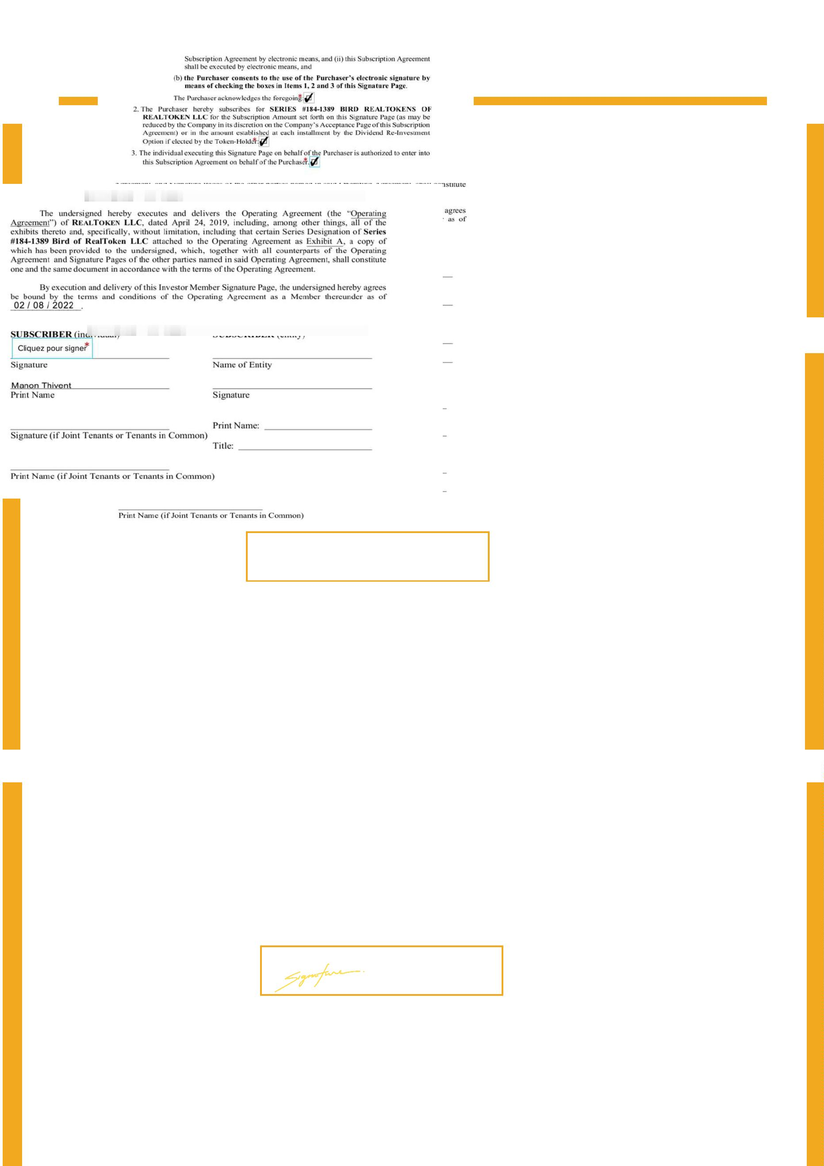D - Buy your first RealToken Page 16
Step 6 : Sign the contract.
Check the 3 boxes.
Sign it.

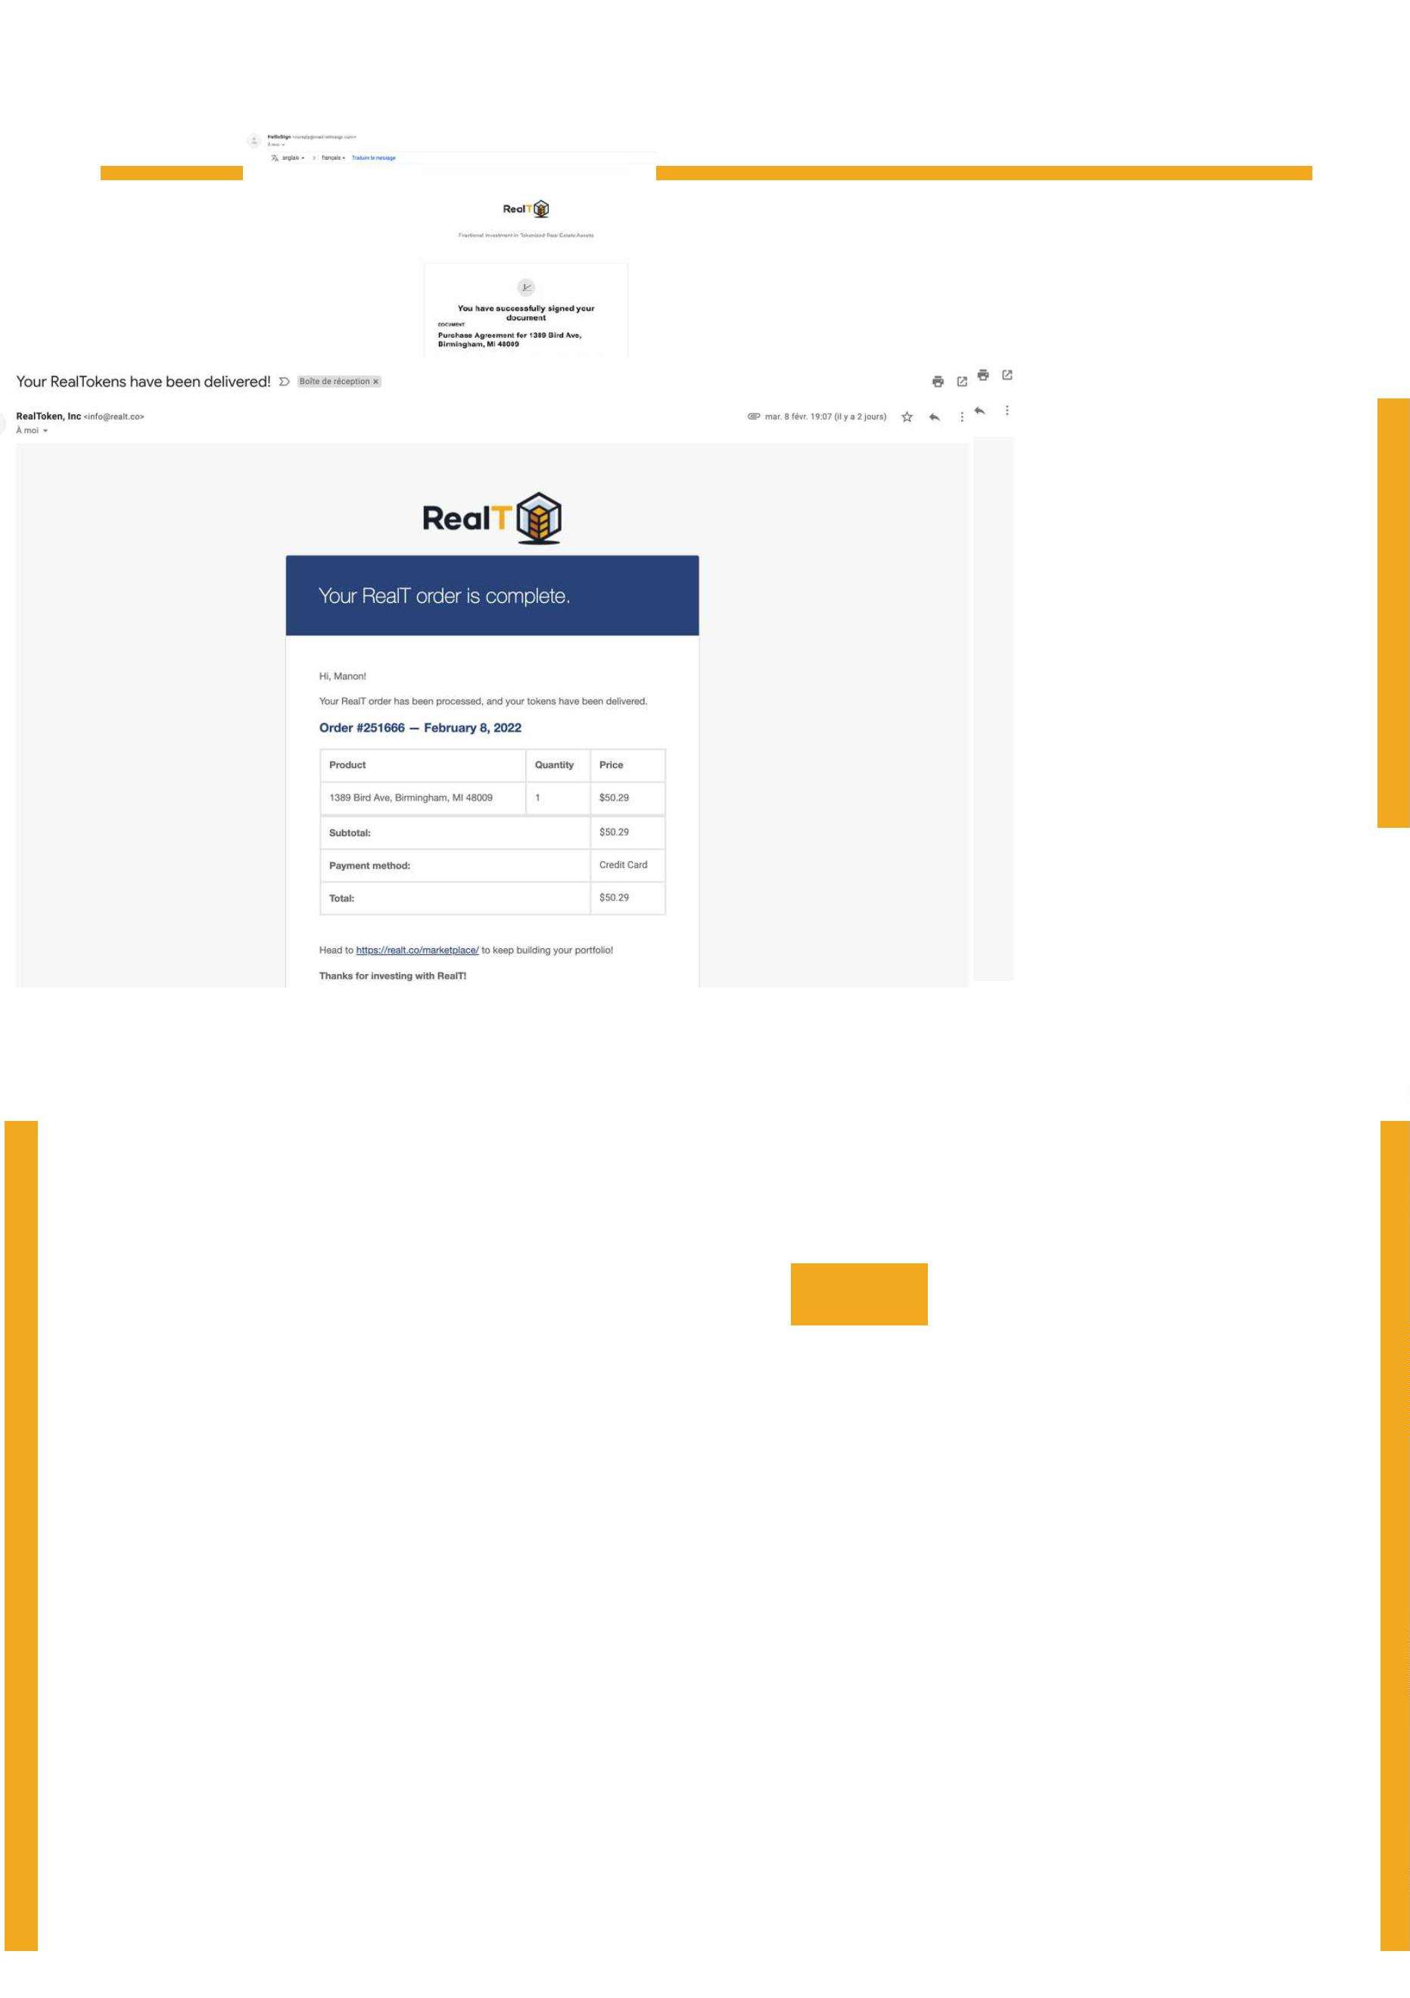D - Buy your first RealToken Page 17
Step 7 : Confirmation of the signature of the contract.
You will receive an email to confirm the signature of the contract.
You can access this contract at any time.
Step 8 : You will receive an email when your RealTokens are delivered.

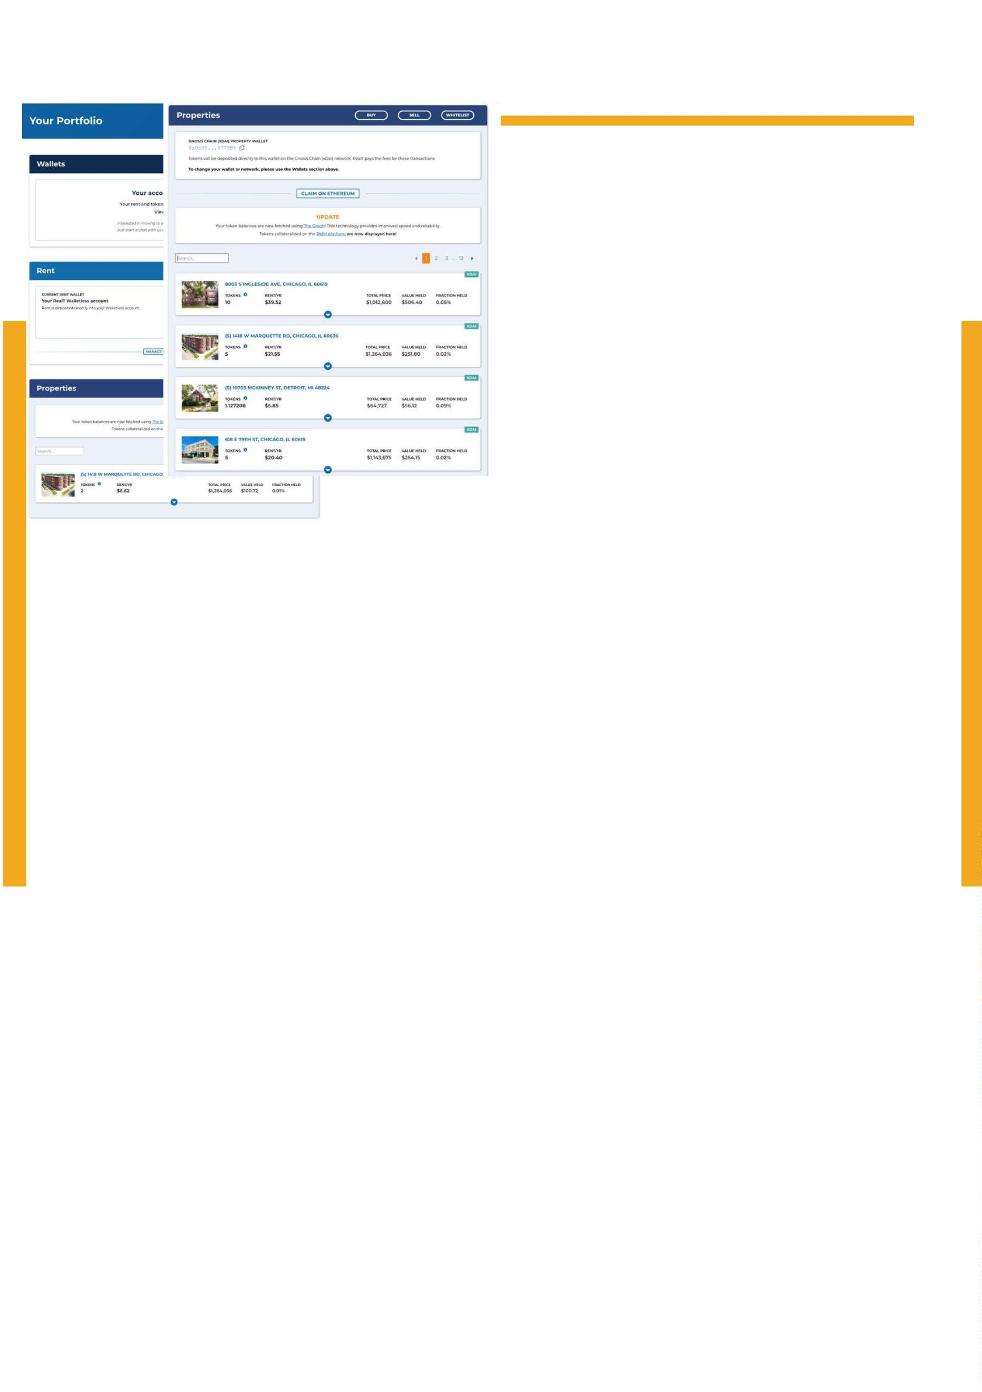D - Buy your first RealToken Page 18
Step 9 : You will be able to see your RealTokens directly in the Portfolio tab and the
Properties section.
View "walletless" View wallet crypto

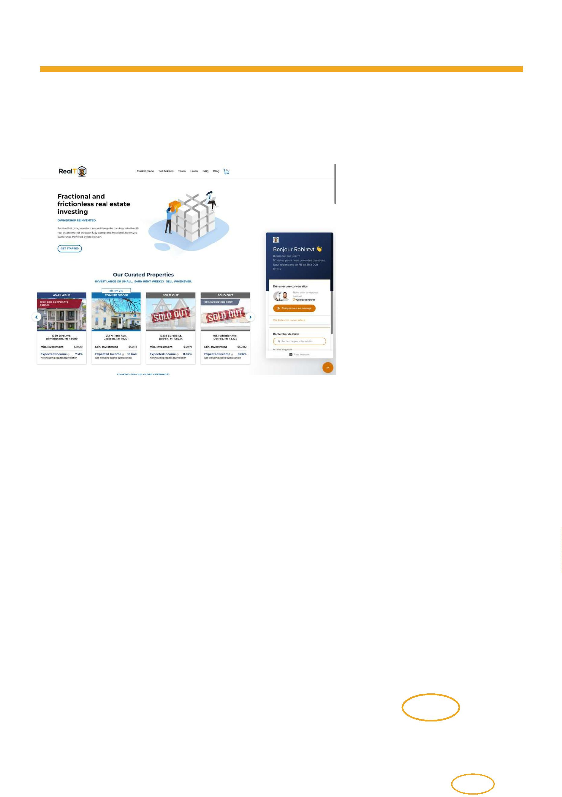E - More tutorials Page 19
Below you can find additional tutorials :
Blockchain :
What is a Blockchain ?
What is a transaction hash ?
How do I transfer my USDC to another sidechain or fiat currencies?
Wallets and Asset Storage :
What is a wallet ?
How to send your tokens back to RealT using the RealT Wallet ?
How to buy RealTokens using Request Network?
How do I receive my rental incomes?
Tutorial about metamask
Other tutorials :
About RealT
About properties
FAQ
Got another question ?
Start a request using the orange button in the bottom right corner of the site

