2027 First Nations Launch
First Nations Launch Competition Proposal
For Wisconsin Space Grant Consortium
Northern Arizona University
10/19/2026

Please use this template as a guide to writing your team design reports. The headers (and bullets) outline the minimum information required. For continuity across teams, do not re-order the sections. You can however, add more information or sections when deemed necessary, or further detail is required.
There are some unique formatting features to this template. Please learn and utilize them. You may add to the formatting, but do not delete any existing formats.
Any [square] bracketed text is expected to be filled by your team. Bulleted text is expected to be deleted/replaced with your content.
Delete this text box prior to submission.
Table of Contents
1 General Information 2
1.1 Team Structure 3
2 Facilities and Equipment 5
2.1 Overview 5
2.2 Facilities Descriptions 5
3 Safety 11
4 Technical Design 13
4.1 General Vehicle Dimensions 13
5 Project Plan 15
5.1 Test Plan 15
5.2 Requirements Verification 19
5.3 Schedule & Budget 19
5 Appendices 22
6.1 Appendix A1 – Machine Shop Training 22
5.2 Appendix A1 – IDEA Lab Equipment and Tools 23
6.2 Appendix A2 – Machine Shop Tools & Equipment Descriptions 24
6 References 25

General Information

Team Name: NAU SpaceJacks
University Name: Northern Arizona University

Faculty Advisor: Carson Pete
Advisor Title: Associate Teaching Professor

Student Team Lead: Haiden Jorgenson
Student Lead Info: Mechanical Engineering, Junior

Student Safety Lead: Marina McGarry
Safety Lead Info: Sociology, Graduate Student

NAR/TRA Mentor: Stonn Billy
NAR/TRA Membership: #26002, Level 1 (Currently getting Level 2)
NAR/TRA Section: In progress

Four students are committed to the vehicle. The table lists each person with the major and the role already assigned. On a team this size, everyone will also support testing outside that role.
Team Member | Major/Project Role
Gustavo Baquero | Mechanical Engineering/Airframe fabrication
Kordell McReeves | Mechanical Engineering / Shared build and test
Haiden Jorgenson | Mechanical Engineering, Junior / Team Lead
Marina McGarry | Sociology, Graduate Student / Safety Officer

Team Structure
The Northern Arizona University SpaceJacks competing in the 2026/2027 FNL Mars Challenge consists of four students, three of which are mechanical engineering majors and one safety lead. The students are split among the following sub-teams, although with such a small team everyone will likely be involved in testing and development of each system.
- Airframe Team – The airframe team is responsible for test execution and fabrication of all structural airframe components such as body tubes, couplers, bulkheads, fins, and the nosecone. The airframe team will utilize RockSim to analyze acceleration forces that the rocket will endure, then use hand-calculations and ANSYS simulations to determine testing parameters and create realistic loading expected during flight. Testing will be conducted for each structural component to establish the best composite layup combination, materials, and orientation to ensure materials will not fail during flight. The simulation team will be incorporated into the airframe team and is expected to run all necessary simulations to ensure that our rocket meets apogee, exit rail velocity, center of pressure/gravity, and mass requirements.

- Avionics Team – The avionics team will design and fabricate our avionics bay, test its structural integrity, decide on altimeters, choose batteries, design circuits/mechanical switches, and test all electronics for reliability during flight. They will ensure that we will be able to collect the required data during flight by launching the avionics on a separate rocket or drone at expected altitudes and accelerations. Additionally, all electrical safety requirements will be monitored by the team safety lead and followed extensively by the sub-team.

- Recovery Team – The recovery team will design our dual deployment recovery system and ensure that the drogue and main parachute eject at the correct altitudes for safe landing. They will utilize RockSim to determine the appropriate parachute size to meet the descent velocity requirements outlined in the handbook (45 – 65 feet per second for drogue and 15 – 20 feet per second for main). Additional components that the recovery team are responsible for are ejection charges, Kevlar shock cords, and parachute heat protectors. This team is crucial in ensuring that our rocket is recovered in excellent condition and able to launch again with no major repairs needed.

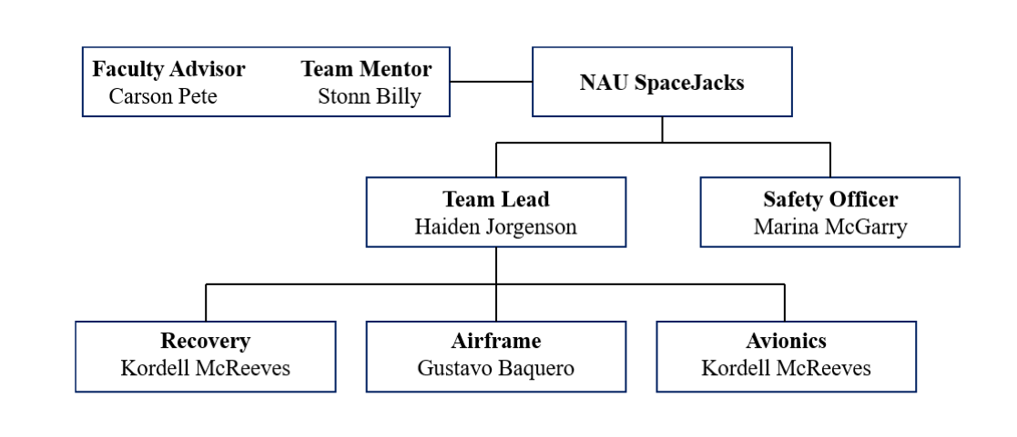Figure 1.1.1 NAU SpaceJacks team structure

Facilities and Equipment

Overview
As an R1 Institution ($50+ million in research funding) [1], Northern Arizona University conducts a plethora of research within the Sanghi College of Engineering (SCE) which caters to a diverse range of disciplines, industries, and student interests. This provides student researchers, on-campus clubs, and competition teams with the facilities and resources needed to succeed. There are dedicated lab spaces for students to fabricate components, access computer software, and utilize top-tier testing equipment that is accessible to students throughout the college.
In the engineering building, there are labs specifically intended for material testing within both the Mechanical Engineering Department and Civil/Environmental Engineering Department. Additionally, there are labs catered towards thermal fluid flow, a wind tunnel, structural testing, and engineering design/prototyping.

Facilities Descriptions
Innovation Design and Engineering Area (IDEA) Lab
The IDEA Lab provides advanced 3D printing services for students and clubs across campus. Bambu Lab A1 printers are available for free for students to check out, as well as rentable equipment made at fee/print cost, including machines like: H2D Bambu Lab, H2S Bambu Lab, Fortus 450mc, Stratasys J35, Formlabs 3 resin printer, and a Xtool P3 laser cutter, as well as hand tools [2].

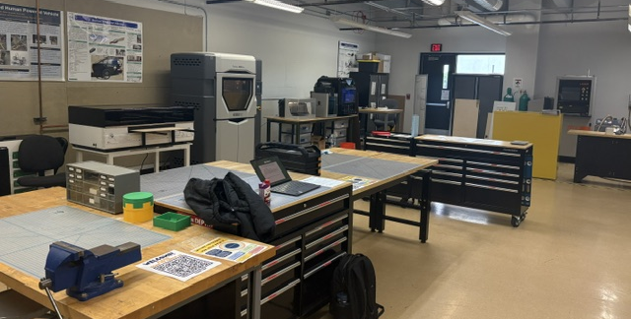
Figure 2.2.1 NAU Innovation Design and Engineering Area (IDEA) Lab

Team member Gustavo Baquero works in this lab, has full access to all printers, and is trained to use each one. This will allow us to access this space whenever needed and print in the highest quality for each machine.

NovaKinetics Aerosystems and Kinetic Defense
NovaKinetics specializes in high-strength composite materials that meet any standard for use in commercial aerospace or defense systems [3]. Their facilities can conduct almost any fabrication process for composites, and they are willing to extend these facilities for use by the SpaceJacks for the FNL Mars Challenge. Additionally, they will provide us with materials for our rocket, such as carbon fiber, fiberglass, and epoxy as well as any manufacturing needs like vacuum bags, vacuum pumps, ports, tubing, seals, etc. Their facility, local to Flagstaff, will provide us with all the materials and equipment needed for us to fabricate the rocket ourselves, while ensuring we meet all strength and quality standards set by our requirements.
For testing our composites, NovaKinetics owns a Tinius Olsen 10000 machine capable of conducting tensile tests on coupons. This will enable us to test our composite layups as we fabricate them, iterate on our techniques, and determine the best layup process and material orientations. NovaKinetics employees will be present to guide us through the processes and offer advice, but all hands-on manufacturing and testing will be done by students on the team.
Overall, this is the most optimal facility and resource for us to manufacture all composite components for our rocket. The materials, equipment, and knowledge offered by NovaKinetics will be a leading factor of success in this project, and exponentially help us meet all structural requirements outlined in the FNL handbook.

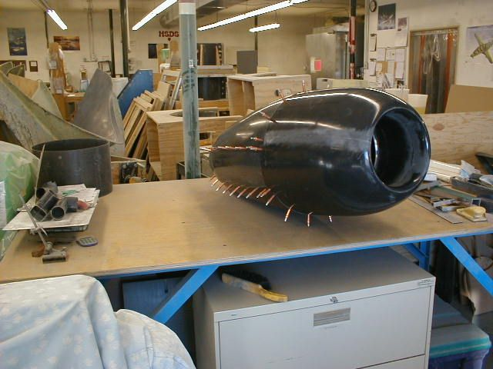
Figure 2.2.2 Composite part manufactured by NovaKinetics [3]

Multifunctional Materials and Adaptive Systems Laboratory
This lab will be our main resource for conducting material tests, as it provides the functionality to run tensile, compressive, shearing, and possibly hoop stress testing. The lab focuses on material characterization and understanding material properties, which aligns closely with our requirements for the FNL Mars Challenge. The professor who runs this space has offered his assistance during testing and a vacuum pump that we can use to manufacture our composite components.
Lab Capabilities:
- Uniaxial and bi-axial (simultaneous axial and torsional) testing at axial loads between 0 and 100,000 N and torsional loads between 0 and 750 N∙m [4]
- Uniaxial and bi-axial (simultaneous axial and torsional) testing at frequencies of up to 100 Hz, depending on the required displacement amplitudes [4]

Snapmaker Artisan 3-in-1 3D Printer
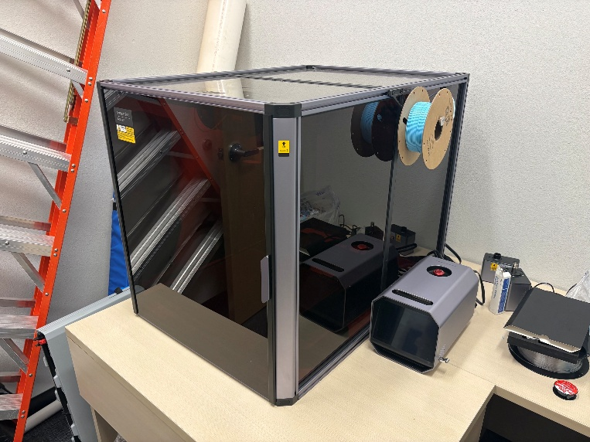
Figure 2.2.3 NAU’s Snapmaker Artisan 3-in-1 3D Printer
For the FNL Mars Challenge, we were given access from our faculty advisor (Carson Pete) to use a Snapmaker Artisan 3-in-1 3D Printer, as shown in Figure 2.2.3. This machine comes with attachments for three different processes, including multi-material 3D printing, CNC operations, and laser cutting. This allows us to create high-quality 3D prints for small components within our rocket and provides the capabilities to cut shapes out of flat composite sheets using the CNC or laser cutting operations. The 3D printing feature allows printing materials such as PLA, PETG, TPU, carbon-infused filaments, nylon, weak support material, etc.

Specifications:
- 400mm x 400mm x 400 mm work area.
- Dual Extrusion 3D Printing, 40W/10W Laser, 200W CNC.
- Dust and laser proof enclosure.
- Free software for all three operations.

Northern Arizona University Machine Shop
The NAU Shop provides access to metalworking machinery such as manual lathes, manual mills, CNC lathes, CNC mills, bandsaws, drill presses, welding equipment, etc [5]. Additionally, basic hand tools and measuring equipment are available for use. This will be useful for small aluminum or plastic parts needed in the avionics bay and any additional machining methods that the team decides to perform. The machine shop will not allow any machining on composite materials due to the shards that are created in the process, but any light metals, plastics, or other polymers that we decide to use in the rocket can be manufactured in this space. The shop is available weekdays from 8:00 AM to 5:00 PM for students with school sponsored projects to use. A table of the available machines is shown in Table 6.2.1 in Appendix 6.2.
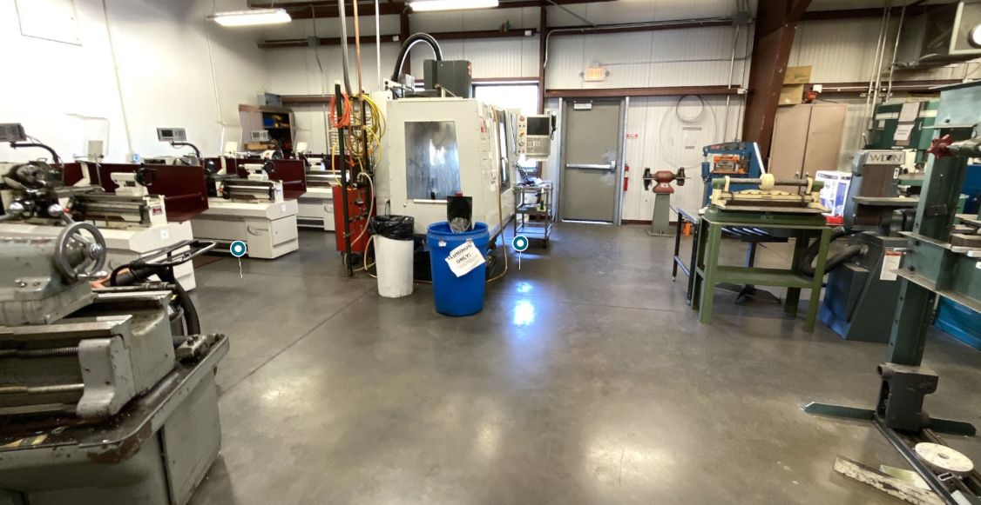
Figure 2.2.4 NAU Machine Shop
To use heavy machinery (lathes and mills) in the machine shop, basic machine shop safety training and advanced machine-specific training is required. Project team lead, Haiden Jorgenson, already has this training completed and can use these machines freely for school-sponsored projects, such as this rocket. Pictures of these training certifications are shown in Appendix 6.1.
Each team member will get their basic machine shop training to be able to use all hand tools, drill press, and bandsaws. Any team member that wishes to gain access to use the mill or lathe can complete a 6-hour training session on either the mill or lathe with a machine shop employee/student worker on a specified weekend. This training is provided through clubs and university class requirements, giving plenty of opportunities to complete the training.
Capstone Project “Solar Shack”
This building houses several other rocketry capstone projects and provides space for us to complete construction of the rocket and composite structures. The space has general hand tools for use (screwdrivers, wrenches files, sandpaper, drills, drill bits, etc.) and rocketry-specific components such as avionics and GPS modules. This building has been used during past projects for fiberglass structure construction, full rocket builds, and is a proven space to accommodate our construction needs for this project. We will have keys to this building as a team, and therefore have 24/7 access to the room, overseen by our faculty mentor Carson Pete.
Additionally, all of our rocketry materials and components that we procure over the course of our project can be stored in this area.

NAU Engineering Building Internet Café & Classrooms
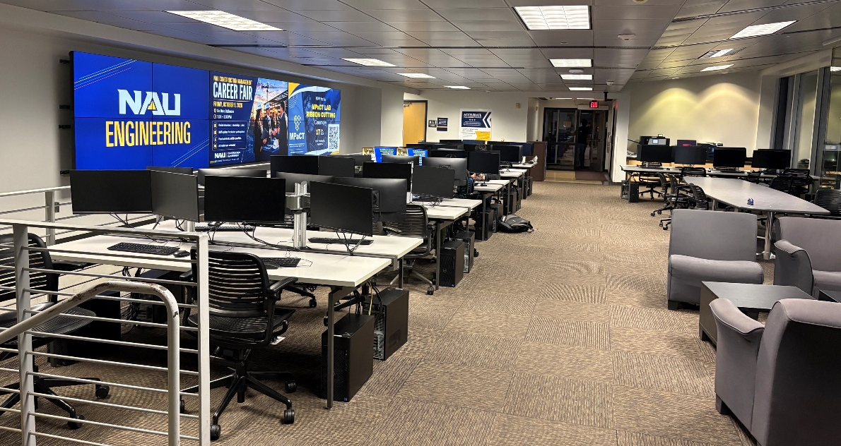
Figure 2.2.5 NAU Engineering Internet Cafe
The “Internet Café” in the Engineering Building at NAU provides students with computers that have modeling tools, simulation software, and other technical/documentation tools needed for this project. This space is open to students from 7:00 AM to 11:00 PM, giving us almost unlimited access to these crucial modeling and simulation tools that we will be utilizing throughout this project. Additionally, this provides every team member with access to email, Microsoft Teams, and other communication software that our team will utilize to stay on task and on schedule throughout this project.
All of our team communications, document sharing, and updates will be directed through Microsoft Teams, which is already set up and accessible by all team members.
Available software through Internet Café computers:
- SolidWorks
- ANSYS FEA
- ANSYS Fluent
- Microsoft Word, PowerPoint, Excel, and Teams

Personal Space for Presentations and Team Meetings
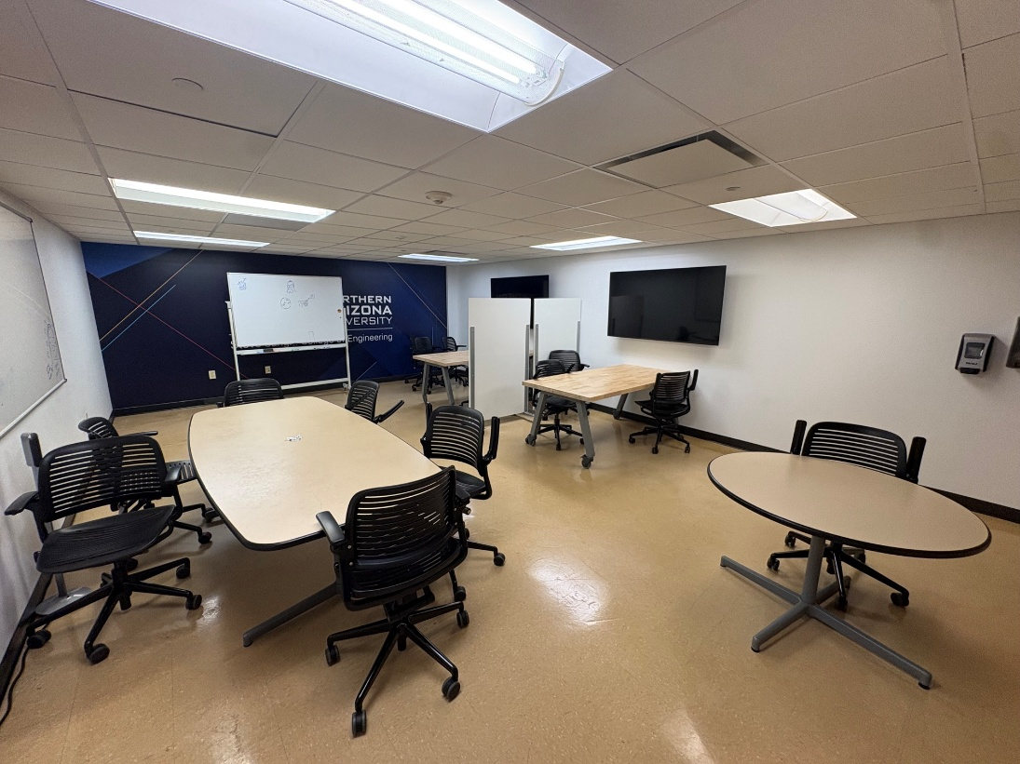
Figure 2.2.6 Reservable space in the NAU Engineering Building
This space is available for students to reserve ahead of time and gives us an area to join meetings, present on our deliverables, and work on our rocket. We will be able to access a webcam and audio from a personal computer in this space and display it on one of the TV’s. This will be more than adequate and meet our needs for this project. This space is open 24/7 for students to reserve and use.

RockSim Licenses
Faculty advisor Carson Pete provided our team with four RockSim licenses, one for each team member. We will be able to use RockSim’s full capabilities throughout the entire extent of our project

Safety
Safety is part of the design of this rocket. Marina McGarry is the student Safety Officer and has the authority to stop work when this plan is not being followed. Stonn Billy, the NAR/TRA mentor, is the only person who handles motors, black powder, and electric matches. Carson Pete, the faculty advisor, controls access to the campus shops. This section covers the materials, the facilities, the mentor's duties, student briefings, personal protective equipment, the federal and local rules, and the statement the team is flying under. A risk assessment is included. The handbook recommends one and does not require it [9].

Safety Officer
Marina McGarry watches the work at each stage the handbook names: design, construction, assembly, ground test, launch day, and recovery. She keeps the current revision of every procedure and the chemical inventory, including the safety data sheets, on the team Microsoft Teams site and as a printed copy in the Solar Shack. A procedure that she has not reviewed is not used for the first time. She takes photographs of sealed or hidden structure while it is still open, because the Flight Readiness Report has to show that work and the parts will be closed by then [9].
The checklists she owns are a layup checklist, a shop-closeout checklist, an avionics checklist that stops before any energetic step, an ejection-test checklist for the mentor, and a launch-day checklist. Launch day uses the host range's own checklist as well. The finished set goes in the Flight Readiness Report and is the set the team will actually use on the field, which is what Safety Requirement 2 asks for [9].

Materials, Facilities, and Chemical Inventory
Inert airframe parts, parachutes, and avionics may be stored and dry-fit in the Solar Shack, which the team can enter at any hour under Carson Pete's oversight. Resin, hardener, and solvent are used only where there is ventilation and an eyewash: NovaKinetics, or the Multifunctional Materials and Adaptive Systems Laboratory when a test fixture is set up there. The Solar Shack is not the infusion shop. If a small bonding operation has to happen there, Marina confirms ventilation with the advisor before the resin is opened.
The machine shop is open on weekdays from 8:00 a.m. to 5:00 p.m. for trained students. Haiden Jorgenson already holds basic shop certification and lathe certification. Every other member completes basic shop training before using hand tools, the drill press, or a bandsaw, and completes the six-hour mill or lathe course before using those machines. The shop does not allow composite machining. Carbon and fiberglass are cut and sanded at NovaKinetics or in a controlled space with a respirator and a vacuum, not on a campus mill. The IDEA Lab and the Snapmaker stay inside their enclosures for laser work, and polyvinyl chloride is not cut on the laser.
Table 3.1 is the inventory Marina will keep current. A bottle or a cloth roll does not come into the shop until its safety data sheet is in the binder. The epoxy products below are the ones the layup plan is written around. Black powder and motors are listed so the control is visible; they are not campus chemicals.
Table 3.1. Materials and process chemicals.
Material | Where it is used | Principal hazard | Control
West System 105 resin | Resin infusion of airframe parts | Skin sensitizer; eye irritant | Nitrile gloves, glasses, sleeves, ventilation; SDS [20]
West System 205 hardener | Room-temperature cure with 105 | Corrosive sensitizer | Same controls as the resin; SDS [21]
Carbon-fiber cloth | Primary structure | Fiber dust; electrically conductive | Respirator when cutting; vacuum cleanup; no campus mill
Fiberglass cloth | Avionics bay, inner plies, fins | Itching; fiber dust | Sleeves, gloves, respirator when sanding
Acetone | Tool cleanup, small quantities | Flammable vapor | Capped, away from ignition; NIOSH pocket guide [22]
Black powder | Mentor-only ground ejection tests | Fire and explosion | Not on campus; mentor purchase, storage, and loading [14]
Electric matches | Mentor-only ignition of test charges | Accidental ignition | Shunted and stored apart from powder; mentor only [9]
APCP reload motors | Competition flight only | Fire; regulated explosive | WSGC issues them at launch weekend; mentor builds them [9], [13]
Alkaline 9 V batteries | Altimeters | Short circuit and leakage | Holders, tape, installed only for test or flight

Mentor Procedures
Stonn Billy is Level 1 and is completing Level 2. A K motor is a Level 2 flight. Before the Preliminary Design Review he has to hold a current certification for the impulse the team will fly, and he has to have flown and recovered at least two electronic dual-deploy flights in that class or higher. Until that is done, the motor selection in this proposal stays provisional and the team does not fly a K motor at a local launch [9].
His procedures follow the Tripoli High Power Safety Code, which is the code NFPA 1127 is written into for Tripoli launches. A NAR host launch uses the NAR High Power Rocket Safety Code for the same limits [10], [11], [15]. He uses only certified commercial motors and does not modify the propellant grain. No one smokes or introduces a flame within 25 feet of a motor. The igniter goes into the motor only at the pad or in the designated prep area. The launch system has a safety interlock in series with a switch that returns to off when it is released. Onboard firing circuits stay inhibited until the rocket is vertical on the rail, and they are inhibited again before the rocket comes off the rail. A misfire means the interlock comes out or the battery is disconnected, and nobody approaches for 60 seconds after the last attempt. The countdown is five seconds and can be heard. He will not fly in surface winds above 20 mph, at an angle more than 20 degrees from vertical, into cloud, at a target, or on a path that crosses spectators or leaves the field. Liftoff weight has to stay at or below one-third of the motor's certified average thrust. The First Nations Launch thrust-to-weight rule is stricter than that, and the motor section shows the check. Recovery uses a parachute and flame-resistant protection, and nobody tries to catch the rocket or pull it out of a power line or a tree that is unsafe to climb.
Students do the design, the reports, the fabrication, and the inert assembly. They do not assemble motors, measure or load black powder, or install electric matches. Those three jobs stay with the mentor for the whole year, including ground tests. NovaKinetics staff may coach a layup. They do not build the competition parts. That split is the project note in the handbook and it is also how the hazardous operations are kept with the certified person [9].

Briefings
Before the first layup, Marina briefs the whole team on the chemicals in Table 3.1, the shop each process is allowed to use, and how to stop a job. Each build day starts with a short briefing: what is being made, which chemicals are open, which protective equipment is required, where the eyewash and the exit are, and who is allowed to do the step. A student who missed the briefing does not join that operation.
The pre-launch briefing happens before any test flight and again on the morning of April 24, 2027, at Richard Bong Recreational Park. It covers the vehicle configuration, the predicted altitude, the weather limits in 14 CFR 101.25 and the Tripoli code, who arms the altimeters, the point at which the mentor takes over for the charges and the igniter, the misfire wait, the recovery plan, and the fact that the Range Safety Officer can scrub the flight. The same briefing is repeated if the launch moves to the April 25 rain date. For a local test flight, the mentor calls the host club's president or prefect and the Range Safety Officer before the team travels, because a configuration that First Nations Launch allows is not automatically allowed at another club [9].

Caution Statements and Protective Equipment
Every written procedure opens with a caution block. The block names the hazard, the protective equipment, and whether the step is mentor-only. Energetic steps are labeled MENTOR ONLY in the heading of the step, not in a footnote. Marina reviews the caution block before the procedure is used, and the old revision is archived rather than left in the working folder. The same block is printed and kept with the job while the job is underway, including layup, machining, ejection tests, and launch prep.
The minimum protective equipment is safety glasses and closed-toe shoes in every shop; nitrile gloves, long sleeves, and glasses for resin; a P100 or N95 respirator plus local extraction when carbon or fiberglass is cut or sanded; hearing protection at the mill, lathe, and bandsaw; and a face shield for anyone near an ejection test, with the team behind the mentor's designated line. Jewelry comes off at rotating tools. Batteries are not installed on a carpet or in a car, because a brownout can corrupt an altimeter; electronics stay in their antistatic bags until they are mounted [9].

Federal, State, and Local Compliance
The competition flight is a Class 2 high-power rocket under 14 CFR 101.22. A Class 1 model rocket is limited to 125 grams of propellant, paper, wood, or breakable plastic, and 1,500 grams liftoff mass. This vehicle is composite, and every motor on the Mars list is far above 125 grams of propellant and far below the 40,960 N·s ceiling that separates Class 2 from Class 3. The largest motor on the list, the K550W, is certified at 1,539.1 N·s [12], [17].
Class 2 flights also follow 14 CFR 101.23 and 101.25. The rocket is unmanned and suborbital, and it is not flown in a way that hazards people, property, or aircraft. It is not flown into cloud, it is not flown where cloud cover at the operating altitude is more than five-tenths, and horizontal visibility has to be at least five miles. There is no night flight. The flight is not within 5 nautical miles of an airport boundary, and not in controlled airspace, unless the FAA has authorized it. Uninvolved people and property stay at least one-quarter of the expected altitude away, or 1,500 feet, whichever is greater. An adult is present who is responsible for the operation and has final authority to start the flight. That person is the mentor at a test launch and the Range Safety Officer at the competition. A means of reporting and controlling a fire is part of the launch setup [12].
14 CFR 101.27 requires notice to the nearest FAA air traffic facility no less than 24 hours and no more than three days before a Class 2 operation. The notice identifies the operator or the event launch coordinator, the start time, the radius and center of the affected area, the highest altitude, and the duration. Tripoli Wisconsin's launch coordinator files that notice for the April 24 event at Richard Bong Recreational Park in Kansasville, Wisconsin. The team does not file a second notice for the competition flight, and the team does not launch if the club states that the authorization does not cover the rocket. Any Arizona test flight is flown only at a scheduled NAR or TRA launch whose existing authorization covers the altitude RockSim predicts. The team will not launch from campus, from a public field without that authorization, or under a waiver the mentor has not read [12].
The handbook cites 27 CFR Part 55 for commerce in explosives. Those rules are now codified at 27 CFR Part 555. Section 555.141(a)(10) exempts model rocket motors of ammonium perchlorate composite propellant, black powder, or a similar low explosive only when the motor contains no more than 62.5 grams of propellant and is a single-use motor or a reload of no more than 62.5 grams. The K550W contains 889 grams of propellant. The other K motors on the approved list are in the same class. They are not exempt, and the team will not purchase, ship, or store them [13], [17].
Black powder used for an ejection charge is also outside the sporting exemption in 27 CFR 555.141(b). That exemption is limited to commercially manufactured black powder, in quantities of 50 pounds or less, used in antique firearms or antique devices. It does not cover pyrotechnic ejection charges [14]. Before any black powder or electric match is bought for a ground test, the mentor will confirm in writing whether a federal explosives user permit is required and will not buy or hold the material until that answer is on file with Marina. Competition charges are not part of this problem: Tripoli Wisconsin provides them at the event [9].
NFPA 1127 is the fire code for high-power rocket motors. The team meets it by flying the Tripoli safety code, using the minimum-distance table the Range Safety Officer posts for the installed impulse, and keeping motors and test charges away from campus buildings [10], [15]. Campus chemical use follows NAU Environmental Health and Safety [23]. The machine-shop and laboratory rules already described are the local controls for tools and resin. Energetics are not brought to the engineering building, the IDEA Lab, the machine shop, or the Solar Shack. If the mentor stores black powder in or near Flagstaff, he confirms the quantity and the storage arrangement with the Flagstaff Fire Department before the first purchase. The competition launch itself is under Wisconsin law and Tripoli Wisconsin's range rules.

Motors and Energetic Devices
WSGC buys the competition motor and the reload hardware and issues them at the motor workshop during launch weekend. Final motor choice is due at the Preliminary Design presentations on December 7–11, 2026. A change after that date is allowed only to increase the safety margin, and it costs points [9]. The mentor attends the workshop, builds the reload, transports the prepared rocket only as the range directs, and installs the igniter at the pad. Students can watch the workshop. They do not build the motor and they do not carry the motor case in personal luggage.
Ground ejection tests, if the team runs them before Wisconsin, use the same canister style Tripoli Wisconsin will supply, as Appendix D-4 of the handbook describes. The mentor buys the powder and the matches through a reputable source, stores them off campus in a locked, dry container, keeps the matches electrically shunted and physically separate from the powder, and transports them himself. Student vehicles are not used. The test starts with a small charge and increases only after the mentor has seen the result, which is already the test plan, and it is done outdoors at a site the mentor and the advisor have both accepted. The team stands behind the line the mentor sets, with face shields, and the body tube under test is not the only copy of a flight part the first time the charge is fired. Unused powder goes back to the mentor's storage the same day. Nothing stays overnight in a dorm, a lab, or a car [9], [14].

Team Commitment
Haiden Jorgenson, Gustavo Baquero, Kordell McReeves, and Marina McGarry understand the following and will abide by them. Carson Pete and Stonn Billy are holding the team to the same words. They will be read again at the pre-launch briefing.
Range safety inspections will be conducted on each rocket before it is flown. Each team shall comply with the determination of the safety inspection or may be removed from the program. A rocket that fails inspection does not fly.
The Range Safety Officer has the final say on all rocket safety issues. Therefore, the Range Safety Officer has the right to deny the launch of any rocket for safety reasons.
The team mentor is ultimately responsible for the safe flight and recovery of the team's rocket. Therefore, the team will not fly a rocket until the mentor has reviewed the design, examined the build, and is satisfied the rocket meets established amateur rocketry design and safety guidelines.
Any team that does not comply with the safety requirements will not be allowed to launch their rocket.

Risk Assessment
Table 3.2 is the initial risk assessment. Likelihood and severity are Low, Medium, or High for the way the team will actually work, after the control in the last column is in place. Marina updates the table when a new process starts, and the updated table goes in the later reports.
Table 3.2. Initial risk assessment.
Hazard | Outcome | L | S | Control | Owner
Epoxy skin contact | Sensitization, eye injury | M | M | Gloves, glasses, eyewash, SDS briefing | Marina McGarry
Composite dust | Airway and skin irritation | M | M | Respirator, vacuum, no campus mill | Gustavo Baquero
Acetone vapor | Fire | L | H | Small bottles, no ignition sources | Marina McGarry
Laser or CNC | Burn, eye injury | L | H | Enclosure, training, no PVC | Gustavo Baquero
Mill or lathe | Cut, entanglement | L | H | Shop certification before use | Haiden Jorgenson
Infusion leak | Resin spill, poor laminate | M | M | Catch pan, mentor or staff present | Gustavo Baquero
Black powder or e-match | Burn, unintended ignition | L | H | Mentor only, off campus, permit check | Stonn Billy
Motor handling | Ignition, regulatory violation | L | H | WSGC issue; mentor builds at the event | Stonn Billy
Thin tube, ejection pressure | Split airframe, late deployment | M | H | Hoop test before a flight charge | Airframe team
Altimeter brownout | No ejection | M | H | Independent batteries and switches; two altimeters | Avionics team
Unstable or overweight flight | Unsafe trajectory | L | H | RockSim gates; RSO and mentor can scrub | Haiden Jorgenson
Recovery in a tree or on a line | Fall or electrocution | M | H | Do not climb or pull; leave it for help | Marina McGarry
Test flight outside an authorization | Airspace violation | L | H | Club waiver only, mentor confirms first | Stonn Billy
Schedule slip on layups | Flying an untested part | M | H | Critical path in Figure 5.3.1; COTS fallback only with the point penalty | Haiden Jorgenson

Technical Design

General Vehicle Dimensions
The Mars rocket will use the outside dimensions of one kit from Appendix A-5, and the fabricated airframe has to come in lighter than that kit while taking the same flight loads. Equation 1 and Equation 2 are the two relations that decide the layup before cloth is cut. Equation 1 defines the fiber volume fraction v_f as fibre volume divided by total volume. Equation 2 estimates the longitudinal modulus as E_composite = E_f v_f + E_m v_m. In a void-free laminate, v_f and v_m add to one. Voids make Equation 2 optimistic, so coupons will measure both the fiber fraction and the modulus and will be compared with the G10 parts from the reference kit [7], [8]. Resin infusion is the process that will hold v_f in a repeatable band.
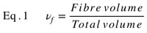
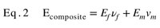

Four RockSim licenses are already on the team, one for each student. Figure 4.1.1 and Table 4.1.1 are the RockSim record for the Tomach on the four 54 mm motors, flown from a 10 ft rail with the flight conditions set to Kenosha, Wisconsin, in late April. The simulated mass includes avionics, parachutes, and hardware such as shear pins and eye bolts. Published motor data and the parachute hand calculation later in this section cover the values RockSim did not report. The RockSim file uploaded with this proposal is this model [9].
Launch Vehicle Selection
Three 4 inch fiberglass kits are allowed: the Tomach, the Pike XL, and the Broken Arrow XL. A RockSim simulation was run across those kits and the 54 mm motors to see which combinations meet the handbook. The checks are an apogee between 3,500 and 4,000 ft, a rail-exit velocity of at least 52 ft/s, and a thrust-to-weight ratio above 5. Every run used a 10 ft launch rail.
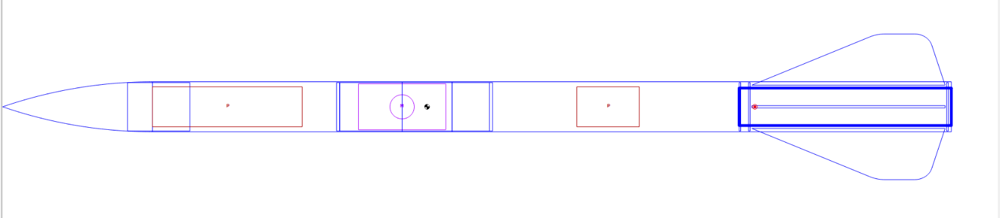Figure 1.1.1 NAU SpaceJacks team structure
Figure 4.1.1. Madcow 4 inch fiberglass Tomach modeled in RockSim.
Figure 4.1.1 is the Tomach model used for the runs. The center of gravity and the center of pressure are marked on that view. Table 4.1.1 records the Tomach result for each 54 mm motor. The K400C is the only motor inside the altitude window. The other three K motors clear the rail-exit and thrust-to-weight checks, then fly past 4,000 ft. The Pike XL and the Broken Arrow XL stay in the trade as the alternates described below. Their runs are not the numbers in the table.
Table 4.1.1. RockSim results for the Tomach on a 10 ft rail.
Rocket kit | Motor | Mass (lb) | Altitude (ft) | Rail exit (ft/s) | Thrust-to-weight
Tomach | K550W | 16.29 | 4,871.9 | 76.8 | 9.2
Tomach | K695R | 16.27 | 4,610.8 | 78.2 | 11.2
Tomach | K535W | 15.74 | 4,311.9 | 71.5 | 9.0
Tomach | K400C | 15.58 | 3,815.6 | 65.0 | 7.6

Table 4.1.2. Appendix A-5 kits considered for the dimensional baseline.
Kit | Length | Fins | Handbook airframe mass | Vendor listing | Decision
Tomach, 4 in | 76 in | 3 | 8 lb 10 oz | 14 lb, $494 | Ordered. Leading baseline.
Pike XL, 4 in | 76 in | 6 | 7 lb 13 oz | 14 lb catalog | Alternate. Twice the fin bonds.
Broken Arrow XL, 4 in | 81 in | 3 | 7 lb 12 oz | Just over 11 lb catalog | Alternate if the Tomach fin planform is too small.

All three are 4.0 inch Madcow fiberglass kits with a 75 mm motor mount. The handbook masses are the dry airframes Frank Nobile weighed for scoring. They do not include recovery hardware, the motor, or the altimeter bay electronics. The vendor masses are the catalog kit weights and are not the number the team will be scored against. A 54 mm competition motor needs a 75 mm to 54 mm adapter in every one of these kits [9], [16].
The Tomach is the leading choice. It is already ordered, so the team can weigh and break the actual G10 parts instead of guessing at the reference strength. It has three fins, which is half the bond lines of the Pike XL and matches the Broken Arrow. The handbook airframe, 8 lb 10 oz, is the heaviest of the three, so the mass reduction is measured against the hardest baseline. The current vendor geometry is a 76 inch rocket with a 40 inch tube, a 20 inch tube, a 4 inch switch band, a fiberglass nose cone, and a 12 inch avionics bay [16]. Fabricated tubes, couplers, the nose cone and shoulder, bulkheads, centering rings, fins, and the avionics sled will follow those dimensions. The Pike stays the alternate if six smaller fins prove easier to keep stiff. The Broken Arrow stays the alternate if the Tomach fin is too small once the stability margin is run, because it is also a three-fin rocket and its handbook mass is 7 lb 12 oz.
The design drivers in the handbook all point the same way. The altitude window is 3,500 to 4,000 ft above ground level, with at least 52 ft/s at the end of the rail, at least 1.0 caliber of stability at rail exit, and thrust-to-weight above 5:1. Diameter is fixed at 4.0 inches by the kit list, and length will stay at the Tomach's 76 inches unless RockSim shows the stability or the mass cannot be met there. A lighter airframe is the challenge score, but the laminate still has to meet or beat the G10 kit in the load each part actually sees. The team can infuse and test that laminate at NovaKinetics, and Haiden can machine the metal secondary parts. The Tomach reference kit is $494. A second airframe will be laid up from the same cloth for ejection and structural tests so the flight article is not the first tube to see a charge. Primary cloth and epoxy are available in kind from NovaKinetics; the budget still carries a cash allowance so the plan does not depend on an unlimited gift [9], [16].
Airframe cloth is limited to carbon fiber and fiberglass. Polymers, light metal, and honeycomb are allowed only as secondary structure. The first coupons, already listed in the test plan, are 3K/6K carbon at 0 degrees, at 45 degrees, and in a 0/45/90 stack; G12 fiberglass; and carbon skins on Nomex, ASA, PETG or PLA, and XPS foam. The leading structural scheme is a carbon skin with a thin fiberglass inner ply. Carbon carries the load at a lower mass than the G10 kit. The fiberglass inner ply gives a sandable, non-conductive surface and is the entire wall of the avionics bay and switch band, because a closed carbon tube would shield the tracker and can short a switch. Sandwich is reserved for the fins if the flat carbon coupons buckle before the kit fins do. Metal is limited to forged eyebolts, a motor retainer, and rail buttons. There is no Blue Tube, no sonotube, and no acrylic fin [9].
Large parts are resin infused and cured at room temperature, which the handbook allows as a cure variation. Students do the infusion. NovaKinetics provides the pump, the bagging film, and coaching. Flat plates are the Preliminary Design demonstration, tubes are the Critical Design demonstration, and the nose cone is the complex shape for the Flight Readiness Review. The nose cone is infused over a mold printed on the Snapmaker or in the IDEA Lab. The shoulder is at least one body diameter, 4 inches, and every coupler shoulder meets that same minimum. The motor-mount tube is a purchased 75 mm G12 tube. The handbook does not allow that tube to be fabricated. Small parts, including the avionics sled and switch brackets, are 3D printed. If the sled fails the drop test, it is replaced with a fiberglass plate rather than a dense metal one. Fins are infused flat, cut to the Tomach planform, and bonded with fillets. A tip-to-tip layup is the alternative if the root bond is the weak point in the fin test. No part is sent out to be made by a shop [9].
Table 4.2. Parts the team will fabricate, and the two parts that stay commercial.
Part | Process | Material direction | Baseline dimension
Nose cone and shoulder | Infusion over a printed mold | Carbon outer, fiberglass inner | Tomach nose; shoulder ≥ 4 in
Forward airframe | Infusion on a mandrel | Carbon with a fiberglass inner ply | Tomach forward tube
Couplers | Infusion on a mandrel | Fiberglass or carbon, chosen by the coupon | One-diameter shoulder
Avionics bay and switch band | Infusion | Fiberglass, not a closed carbon tube | About 12 in bay, 4 in band
Booster airframe | Infusion on a mandrel | Carbon with a fiberglass inner ply | Tomach booster tube
Bulkheads and centering rings | Infused plate, then cut | Fiberglass or carbon plate | Match the kit diameters
Fins, three | Infused flat sheet, then cut | Carbon; sandwich if buckling requires it | Tomach planform
Avionics sled | 3D print; fiberglass plate if it fails | PETG, nylon, or fiberglass | Fits the 4 in bay
Motor mount | Purchased, not fabricated | COTS 75 mm G12 tube | Kit motor mount
Motor adapter | Purchased | 75 mm to 54 mm | Required for the K motors

Projected Recovery System
The recovery layout is conventional dual deploy. The drogue is in the booster so the motor ejection charge can back up the apogee event. The main is forward of the avionics bay. Apogee deployment, including the motor backup, is no more than 2 seconds after apogee. Main deployment is between 300 and 1,000 ft above ground level. Single-event release devices such as a Tender Descender or a Jolly Logic Chute Release are not used. All sections stay tethered, so one tracker on the avionics bay covers the vehicle. The handbook allows at most four independent sections. Nose, forward airframe, bay, and booster are four, and they come down together. Shear pins are allowed on both compartments and will be used. Flame protection is a Nomex blanket around each canopy, with Kevlar shock cord and forged eyebolts of the type the Tomach hardware uses [9].
Parachute diameter is sized from the descent equation A = 2W / (ρ Cd v²), with D = sqrt(4A/π). The planning descent weight is W = 10 lbf, which is an assumption for a fabricated airframe under the 8 lb 10 oz reference plus recovery hardware, avionics, and a spent motor case. It is not a weighed mass. Air density is the sea-level value ρ = 0.00237 slug/ft³, because Kansasville is near sea level. Flagstaff test flights are in thinner air and will be checked separately. The canopy coefficient Cd = 1.5 is an elliptical-parachute assumption that RockSim will replace with the coefficient of the canopy that is actually purchased.
An 18 inch drogue has an area of 1.77 ft². At 10 lbf and Cd = 1.5 the descent rate is about 56 ft/s, inside the 45 to 65 ft/s band. A 60 inch main has an area of 19.6 ft² and descends at about 17 ft/s, inside the 15 to 20 ft/s band. At 12 lbf those rates rise by sqrt(1.2) to about 62 ft/s and 18.5 ft/s, still inside both bands. At 8 lbf they fall to about 50 ft/s and 15 ft/s, still inside. The leading hardware choice is therefore an 18 inch drogue and a 60 inch main. The final purchase waits on the RockSim mass and on the canopy Cd from the vendor.
Primary deployment is a PerfectFlite StratoLoggerCF. It is a commercial barometric altimeter, it records altitude for the official score, it fires two events, and it can delay one apogee output so two charges do not fire in the same instant. The published unit price is $54.95 [18]. The second altimeter is a different commercial barometric model, on its own battery and its own circuit, so one manufacturer’s failure does not remove both events. Each altimeter has its own 9 V battery and its own mechanical switch on the outside of the switch band. The switch locks in the on position and can be reached on the pad. Recovery wiring does not share a circuit with anything else. Both altimeters are armed only at the rail, and the electronics checklist stops before the mentor connects a charge.
Tracking is a Featherweight GPS tracker, which does not require an amateur-radio license and is on the handbook’s list of commonly used trackers [19]. It rides in the fiberglass avionics bay, not inside a carbon tube. Range and battery life are ground-tested before any flight, and at least two students practice the download so the data does not depend on one person. Any section that is later redesigned to land untethered gets its own tracker. That is not the current layout.
The launch rail at the event is either a 6 ft 1010 rail or a 10 ft 1515 rail, canted 5 to 10 degrees. A 76 inch rocket has little guided length on a 6 ft rail once the button spacing is subtracted. Table 4.1.1 shows 65 to 78 ft/s at the end of a 10 ft rail for every K motor, all above the 52 ft/s minimum. The leading button is a 1515 button for that 10 ft rail. A 1010 button on the 6 ft rail is the alternate only if a later RockSim run still clears 52 ft/s [9].

Projected Motor Selection
Motors are limited to the Aerotech list in Appendix A-1, and WSGC supplies the motor that is finally chosen. Table 4.3 is that list with the certified total impulse, average thrust, and burn time from ThrustCurve [9], [17]. The 38 mm motors need a 75-to-38 mm adapter. The 54 mm motors need the 75-to-54 mm adapter the handbook already calls out.
Table 4.3. Approved Mars motors and how they enter the trade.
Motor | Size | Type | Impulse (N·s) | Avg. thrust (N) | Burn (s) | Role
I600R | 38 mm | Reload | 597.3 | 612 | 1.1 | Contingency if the rocket is far under the kit mass
I500T | 38 mm | Single use | 620 | 500 | 1.2 | Same contingency class as the I600R
J270W | 38 mm | Single use | 703 | 270 | 2.6 | Longer burn, still well under K impulse
J435WS | 38 mm | Single use | 742.8 | 442 | 1.6 | Highest 38 mm impulse on the list
K400C | 54 mm | Single use | 1,304 | 409 | 3.2 | Leading motor. Only K inside the altitude window in Table 4.1.1
K535W | 54 mm | Single use | 1,434 | 535 | 2.8 | Middle K, single use
K695R | 54 mm | Reload | 1,514 | 695 | 2.2 | Highest thrust, shortest K burn
K550W | 54 mm | Reload | 1,539.1 | 397 | 3.9 | Highest impulse. 4,872 ft on the Tomach, above the window

The 38 mm I and J motors were not part of this RockSim set. They remain a contingency only if a much lighter airframe overshoots 4,000 ft on every K motor. Ballast cannot close a large overshoot, because ballast is capped at 10 percent of the unballasted pad weight [9].
On the simulated Tomach, the K400C is the leading motor. At 15.58 lb it reaches 3,816 ft, leaves the rail at 65 ft/s, and has a thrust-to-weight ratio of 7.6. The K535W reaches 4,312 ft, the K695R reaches 4,611 ft, and the K550W reaches 4,872 ft. All four stay above 52 ft/s at rail exit and above a thrust-to-weight ratio of 5, so altitude is what eliminates the three larger motors at this mass. The K695R is also the high-thrust, short-burn case to watch for Mach number. The vehicle is not allowed to reach Mach 1 [17].
Those thrust-to-weight ratios come from RockSim at the simulated pad mass, not from a separate hand check. The K400C result of 7.6 is the compliance case for the reference-mass rocket. A lighter fabricated airframe will climb higher on the same motor, and 3,816 ft leaves little room under 4,000 ft. RockSim will be rerun when the coupon masses are known, before the motor is frozen at the December Preliminary Design presentations. If the light airframe exceeds 4,000 ft, the first correction is ballast within the 10 percent cap. A motor change after that date is allowed only to increase the safety margin, and it costs points [9], [10].
Motor ejection is the backup apogee event only. It is not the primary and it is not used for the main. The delay is selected from the simulated time to apogee. The single-use motors on the list are sold with adjustable delays, which is what makes that backup practical. The drogue has to sit in the booster for this backup to pull the right parachute.

Challenge Fabrication
The challenge is the airframe itself. The team fabricates every structural part except the motor-mount tube, tests each one against the load it sees, and is scored on how much lighter the finished airframe is than the reference Tomach and on how closely the dimensions match. A part that fails its test can be replaced with the commercial equivalent, and every such replacement costs points. The plan is to finish the test campaign early enough that a failed layup can be remade rather than swapped for G10 [9].
The build sequence follows the milestone gates. By the Preliminary Design Review the team has infused flat plates and started the coupon matrix in Table 5.1.1. By the Critical Design Review the team has infused tubes and compared them with the kit tubes in Table 5.1.2, including a hoop test for ejection pressure. By the Flight Readiness Review the nose cone, fins, and bay are in assembly and the structural tests are done. Component tests for the altimeter, the tracker, and the ejection charges follow the matrices already in the test plan. A full-scale test flight in February or March is the intent. It is recommended rather than required, and it happens only at a NAR or TRA launch whose authorization covers the altitude.
The requirements those parts have to satisfy are listed in Appendix A3. At this proposal only the requirement text had to be filled in. The verification method, the owner, and the status are filled as a first assignment so the work can be divided. RockSim is the verification method for the performance rows: apogee, stability, rail-exit velocity, thrust-to-weight, and Mach number. Inspection, test, or demonstration covers the hardware rows [9].

Technical Challenges and the Critical Path
The critical path is the composite process, not the electronics. Flat plates have to exist before the Preliminary Design Review on November 30, 2026, tubes before the Critical Design Review on January 25, 2027, and a closed shape before the Flight Readiness Review on March 8, 2027. The vehicle has to be 95 percent flight-ready by April 10, 2027, two weeks before the April 24 launch. Cloth beyond the coupon supply is not bought in bulk until the layup is chosen at the end of the Preliminary Design phase, which is the procurement warning in the handbook. Figure 5.3.1 shows that chain in red [9].
Five technical risks sit on that path. The airframe has to undercut 8 lb 10 oz and still match the G10 strength, which is why Equation 1 and Equation 2 are tied to the coupon campaign instead of to a catalog carbon sheet. A carbon avionics bay would fight the tracker, so the bay is fiberglass even if the booster is carbon. A light tube can split under the ejection charge, so the hoop test comes before any flight charge. The altitude window is only 500 ft wide. Table 4.1.1 already puts the kit-mass Tomach on the K550W at 4,872 ft, and only the K400C, at 3,816 ft, is inside the window. Cutting airframe mass raises that apogee further, with ballast limited to 10 percent. And the mentor’s Level 2 certification, including two successful dual-deploy flights in the K class, has to be finished before a K motor is flown and in time for the Preliminary Design Review. None of those five is solved by ordering more G10.

Project Plan

Test Plan
Each subsystem (airframe, avionics, and recovery) will be thoroughly tested under each expected loading type and possible scenario to guarantee that our rocket succeeds and meets all requirements laid out in the handbook. This will include not only laboratory testing using machines and equipment, but also one or two full-scale test launches to validate and verify our testing results.
To create a baseline for all of our structural testing, a 4” Fiberglass Tomach kit has already been ordered to test each component sent with the original kit. From this, we can measure the exact mass of each component and their strength under each loading type (tensile, compressive, shear, and hoop). Additionally, we can take precise measurements of each dimension on the rocket to build a CAD model used for avionics bay design, ANSYS FEA simulations, and ensure the fabricated components will assemble correctly.

Testing Standards
To generate comparable and reliable testing data we will follow material testing and terminology standards used in industry. This will guarantee that our tests are robust and applicable to real life scenarios. The following standards have been identified for use throughout our tests [7]:
ASTM D3878 – Standard Terminology for Composite Materials
ASTM D3039 – Standard Test Method for Tensile Properties of Polymer Matrix Composite Materials
ASTM D695 – Standard Test Method for Compressive Properties of Rigid Plastics
ASTM D3410 – Standard Test Method for Compressive Properties of Polymer Matrix Composite Materials with Unsupported Gage Section by Shear Loading
ASTM D7136– Standard Test Method for Measuring the Damage Resistance of a Fiber-Reinforced Polymer Matrix Composite to a Drop-Weight Impact Event
ASTM D7264 – Standard Test Method for Flexural Properties of Polymer Matrix Composite Materials
Use of these standards will be determined by the testing equipment that we are able to use and our ablity to manufacture testing fixtures. If the testing equipment that we need is not available or accessable by our team, we will design and build our own using aluminum extrusions, load cells, strain gauges, lead screws, etc.

Structural Testing
The first step in structural testing is manufacturing individual coupons out of each material that we want to test, which are dimensioned using the standards displayed above.
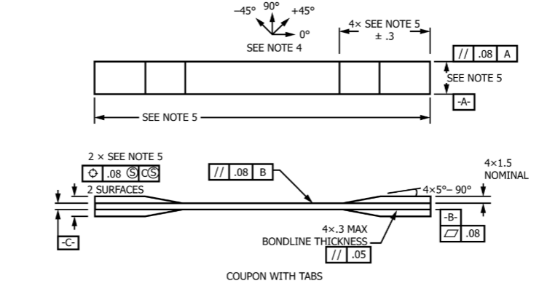
Figure 5.1.1 ASTM D3039 tensile testing coupon dimensions [8]
We will aim to test at least three coupons per material. A test plan for this section of material testing is shown in Table 5.1.1, as well as our testing plan spreadsheet.

Table 5.1.1 Material Coupon Testing matrix
Material | Layup Orientation | Tensile Strength [MPa] | Compressive Strength [MPa] | Shear Strength [MPa] | Mass
3K/6K Carbon Fiber | 0° | - | - | - | -
3K/6K Carbon Fiber | 45° | - | - | - | -
3K/6K Carbon Fiber | 0°-45°-90°-45°-0° | - | - | - | -
G12 Fiberglass | Biaxial Weave | - | - | - | -
3K Carbon Fiber  +  Nomex Core | 2x2 Twill Weave | - | - | - | -
3K Carbon Fiber  +  ASA Aero | 2x2 Twill Weave | - | - | - | -
3K Carbon Fiber  +  PETG/PLA | 2x2 Twill Weave | - | - | - | -
3K Carbon Fiber  +  XPS30 Foam | 2x2 Twill Weave | - | - | - | -

After completing this material coupon testing, we will choose two of our top materials based on strength-to-weight ratio and fabricate full sized rocket components from them. These components (such as fins, body tubes, nose cones, couplers, bulkheads, etc) will then be tested using makeshift testing fixtures to compare their strength to that of the components sent with the kit. A sample of this testing matrix is shown in Table 5.1.2 and in our testing spreadsheet.
Table 5.1.2 Testing matrix for full rocket components
Part/Material | Layup Orientation | Tensile Strength [MPa] | Compressive Strength [MPa] | Shear Strength [MPa] | Mass
Nosecone
Tomach Kit | G10 Fiberglass | - | - | - | -
Material 1 | - | - | - | - | -
Material 2 | - | - | - | - | -
Body Tubes
Tomach Kit | G10 Fiberglass | - | - | - | -
Material 1 | - | - | - | - | -
Material 2 | - | - | - | - | -
Couplers
Tomach Kit | G10 Fiberglass | - | - | - | -
Material 1 | - | - | - | - | -
Material 2 | - | - | - | - | -
Bulkheads
Tomach Kit | G10 Fiberglass | - | - | - | -
Material 1 | - | - | - | - | -
Material 2 | - | - | - | - | -
Fins
Tomach Kit | G10 Fiberglass | - | - | - | -
Material 1 | - | - | - | - | -
Material 2 | - | - | - | - | -

Through these two major testing types (material coupon tests and full-scale rocket components) we will be able to sufficiently narrow down and determine the best material for our rocket to optimize the strength-to-weight ratio of our components. Additionally, we will incorporate hoop stress testing for any body tubes incorporated into the recovery system to ensure that pressure buildup from the ejection charges does not cause our body tubes to fail.

Avionics Testing
Both avionics components (GPS tracker and barometric altimeter) will be tested initially on the ground using various methods to make sure that they function correctly on a base level. Some of these methods include using a syringe to create a vacuum and test the altimeter’s pressure sensors, testing the accelerometers using a drone, and using LED lights to simulate when the altimeter ignites the charges. For the GPS, we will test range by moving as far as possible from the device and recording the distance at which we lose connection. Lastly, the avionics bay will be structurally tested by dropping from different heights until it breaks, in which we can calculate the maximum energy it can absorb before failing.
After these ground tests, we will thoroughly test both components during a full-scale rocket launch in either February or March 2027. The full-scale launch will provide the data needed to determine that our avionics system is collecting all the data needed from our altimeter and our GPS tracking system works efficiently inside our completed rocket. This will also confirm that our ejection charges are ignited at the correct altitude. An avionics system testing matrix is shown in Table 5.1.2 as well as in our testing spreadsheet.
Table 5.1.3 Testing matrix for avionics system components
Component | Objective | Result
Altimeter | Test pressure sensor in vacuum to simulate altitude | -
Altimeter | Drone flight to confirm correct acceleration readings | -
Altimeter | Use LED’s to test timing of ejection charges | -
Altimeter | Full-scale launch to confirm data in real flight | -
GPS | Test GPS range on the ground | -
GPS | Full-scale launch to confirm connectivity during flight | -
Avionics Bay | Drop test to calculate maximum energy absorption | -

Recovery System Testing
Like the avionics system testing, we will conduct both ground testing and a full-scale launch to verify and validate the safety and reliability of our recovery system. We will run our tests with our competition rocket (or mock rocket) and add black powder to our ejection charge until we obtain the desired rocket separation. The amount of black powder will be informed with hand calculations. Starting with a small amount and building up will increase the safety of the tests, and all tests will be run with our advisor and mentor present. This will also validate our body tube hoop stress tests and verify that the tubes will not fail due to pressure build up. We will also make sure that our Nomex parachute protective cloth adequately shields the parachute from the charge, the Kevlar shock cord holds up, and that our packaging methods are sufficient.
A full-scale launch will verify all this ground testing and will make sure that our simulations to determine parachute size were correct. This will provide data such as altitude at drogue and main parachute deployment, descent velocity during each deployment, and structural damage at ground impact. The testing matrix is seen in Table 5.1.4 and the testing spreadsheet.
Table 5.1.4 Recovery system testing matrix
Component | Objective | Result
Ejection Charge | Determine amount of black powder needed for charges | -
Ejection Charge | Ignite using altimeter circuit | -
Body Tube | Verify hoop integrity of body tubes under pressure | -
Nomex Cloth | Ensure parachutes are protected during ejection | -
Kevlar Shock Cord | Verify shock cord strength during ejection | -
Drogue Parachute | Altitude deployed and descent velocity | -
Main Parachute | Altitude deployed and descent velocity | -

Requirements Verification

Appendix A3 lists the Mars, general, vehicle, recovery, and safety requirements from the handbook, including the technical notes that constrain the vehicle. The handbook asks for the requirement text at this proposal, with columns ready for the verification method, the status, and the person responsible. Those three columns are filled with a first assignment. Status is In Work except where the person is already named. The matrix will be updated at each milestone, and the performance rows are closed with RockSim rather than with the hand calculations in this report [9].

Schedule & Budget

Schedule
Figure 5.3.1 is the initial schedule from the October 19, 2026 proposal through the May 11, 2027 post-launch report. The dates are the Mars dates in the 2027 handbook calendar. The red bars are the critical path: flat plates by November 30, tubes by January 25, complex parts by March 8, and a vehicle that is 95 percent flight-ready on April 10. Travel to Kenosha is April 22, the launch at Richard Bong is April 24, and the rain date is April 25 [9].
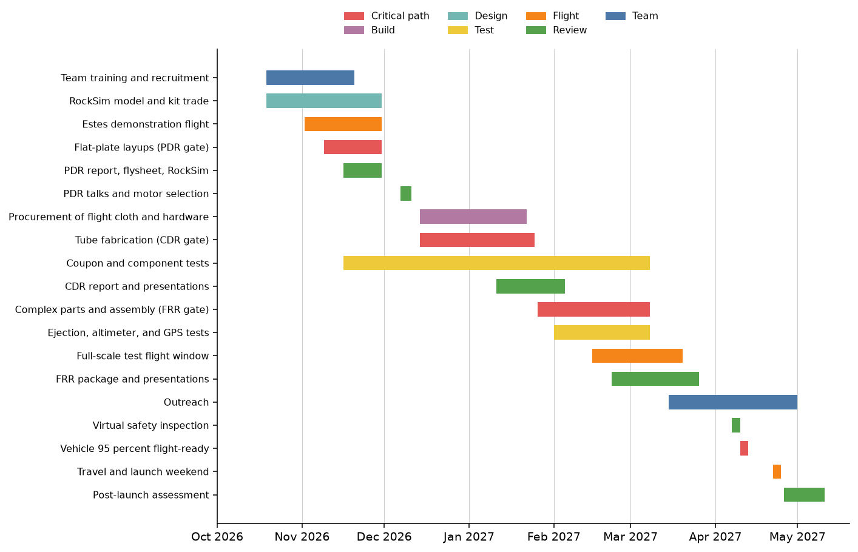Figure 1.1.1 NAU SpaceJacks team structure
Figure 5.3.1. Initial schedule. Red bars are the critical path.

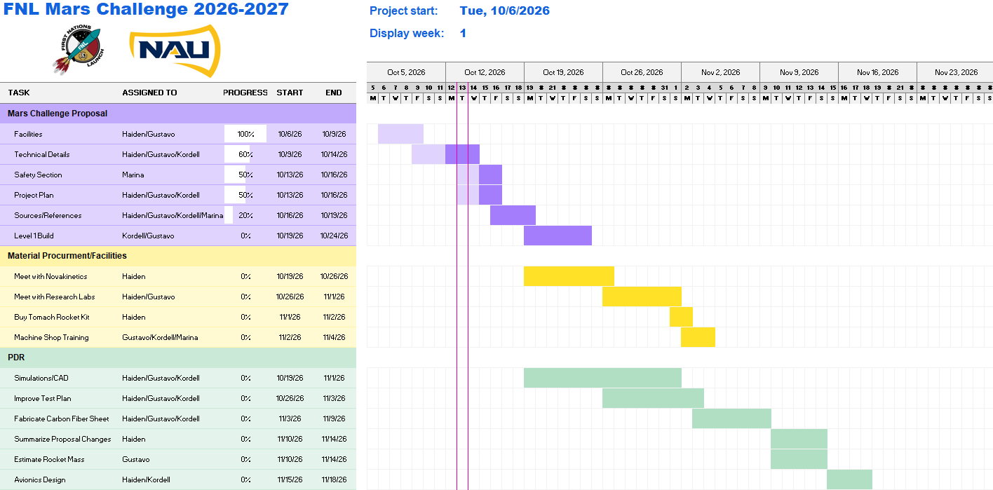Figure 1.1.1 NAU SpaceJacks team structure
Figure 5.3.2. Team schedule for the proposal and the opening Preliminary Design tasks. The chart is the one dated October 6, 2026, and the view shown is its first weeks. Figure 5.3.1 carries the same work through launch and the post-launch report.
Table 5.3.1. Milestone gates used to build the schedule.
Gate | Date | What is finished
Proposal and notice of intent | October 19, 2026 | This report, flysheet, and RockSim file
Award and kickoff | October 26–27, 2026 | Award decision; kickoff meeting
Estes flight and PDR package | November 30, 2026 | Demo video posted; flat plates infused; PDR report
PDR talks and motor freeze | December 7–11, 2026 | Final motor selection
CDR package | January 25, 2027 | Tubes infused; CDR report
CDR talks | February 1–5, 2027 | Present the tube work and the tests
FRR package | March 8, 2027 | Complex parts in assembly; tests discussed
FRR talks | March 22–26, 2027 | Present the flight configuration
Virtual safety inspection | April 7–9, 2027 | Inspection with Tripoli Wisconsin
Flight-ready gate | April 10, 2027 | Airframe 95 percent complete
Launch weekend | April 22–25, 2027 | Kenosha, then Kansasville; rain date April 25
Post-launch report | May 11, 2027 | PLAR, photos, and short video

Budget
Table 5.3.2 is the initial budget by the groups in Appendix C-1 of the handbook. The handbook’s planning figure for a funded team is $4,000. RockSim is already covered by the four licenses from the advisor, so the software line is zero. The Tomach price is the vendor price at the time of this proposal. The other lines are allowances, not quotes. NovaKinetics has offered cloth, epoxy, and bagging film in kind; the materials line is still carried in cash so the plan survives if that gift is smaller than the build. Travel is the line that puts the total above the funds already in hand [9], [16], [18].
Table 5.3.2. Initial budget.
Group | Item | Estimate (USD) | Basis
Software | RockSim, four licenses already provided | 0 | Advisor licenses in hand
Rocket parts | Madcow 4 in Tomach reference kit, ordered | 494 | Vendor price [16]
Rocket parts | COTS 75 mm motor tube, 54 mm adapter, spare cloth and core | 600 | Allowance beyond in-kind material
Challenge | Extra panels and tube trials before flight hardware | 250 | Allowance
Recovery | 18 in drogue, 60 in main, Kevlar, Nomex, links, eyebolts | 250 | Allowance
Avionics | Two barometric altimeters, batteries, arming switches | 180 | StratoLoggerCF lists at $54.95 [18]
Avionics | Non-licensed GPS tracker | 200 | Allowance for a Featherweight-class unit [19]
Test and PPE | Coupons, fixtures, respirators, gloves, glasses, bagging film | 400 | Allowance
Travel | Airfare allowance, four students, Arizona to Milwaukee | 2,200 | Planning allowance, not a booked fare
Travel | Ground transport, meals, and luggage | 400 | Allowance
Travel | Lodging if WSGC does not provide rooms | 600 | Confirm before CDR
Membership | TRA or NAR renewal if the mentor or a student needs it | 80 | Allowance
Total |  | 5,654
Funds in hand | WSGC project funding plus the received Jean Shuler grant | 4,500 | $4,000 + $500
Gap | To be closed before travel is booked | 1,154 | See the funding plan

Funding Plan
Through Northern Arizona University, we received a $500 Jean Shuler Mini Grant and have applied for a second. If we are awarded the second grant, we will have a total of $1000 from university grants to buy materials, supplies, and manufacturing tools for the FNL Challenge. This will help us buy the 4” Fiberglass Tomach kit, carbon fiber and fiberglass, epoxy, vacuum bags, and materials to assist with testing fixtures.

The handbook’s funded-project figure is $4,000, and Table 5.3.2 uses that number [9]. Added to the $500 Jean Shuler grant already received, committed cash is $4,500 against an initial estimate of $5,654. The difference is about $1,154, almost all of it travel. A second $500 Jean Shuler grant has been applied for and is not counted until it is awarded. The remaining gap will be taken to the department and, if needed, raised by the team before airfare is purchased. Motors are not in this budget because WSGC buys and issues them. In-kind cloth and epoxy from NovaKinetics will be logged at market value when it is issued, and the cash materials line will be reduced by that amount at the Preliminary Design budget update.

Sustainability
To encourage future students to pursue and engage in high-powered rocketry we will perform several outreach activities with our rocket and conduct STEM related activities. Once fabrication of the rocket is complete, we will take it to local elementary, middle, and high school classrooms here in Flagstaff and surrounding cities. Additionally, we will attend freshman level university classrooms here at Northern Arizona University to get young students interested in the high-powered rocketry club. There are also many local Flagstaff events, such as Science in the Square, which are geared toward STEM education and would be beneficial for us to attend.
We hope to maintain interest in this competition at NAU by providing resources for future teams and volunteering to mentor these teams once we graduate and enter industry. Additionally, building a strong connection with Novakinetics and research labs at NAU will create opportunities and resources for future students and competition teams.

The partnership side of that plan is specific. NovaKinetics and the Multifunctional Materials laboratory are the two relationships the next class will inherit, and Haiden will introduce the following year’s lead to both before this team graduates. Recruitment is aimed at the freshman mechanical engineering courses and at AISES and campus society events, with the goal of leaving a team of four to six rather than starting over from zero. Funding sustainability is the Jean Shuler mini-grant, renewed each year, plus the department relationship built while closing this year’s travel gap. Outreach is the school visits and Science in the Square already described, documented on the Appendix A-2 form so the events also count toward the outreach award [9].

Appendices

6.1 Appendix A1 – Machine Shop Training

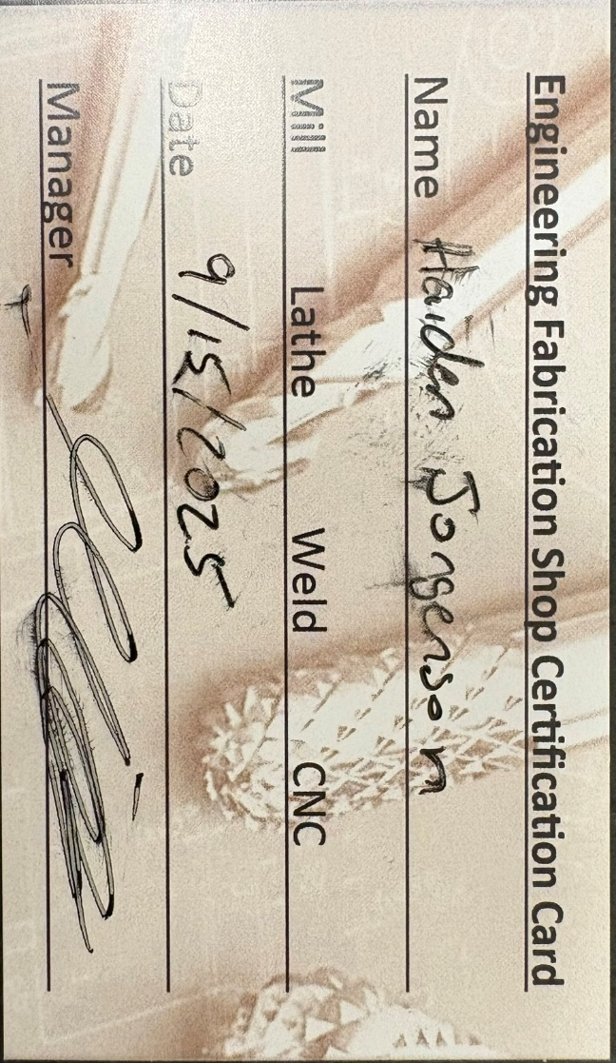
Figure 6.1.1 Machine shop basic training certification card for Haiden Jorgenson

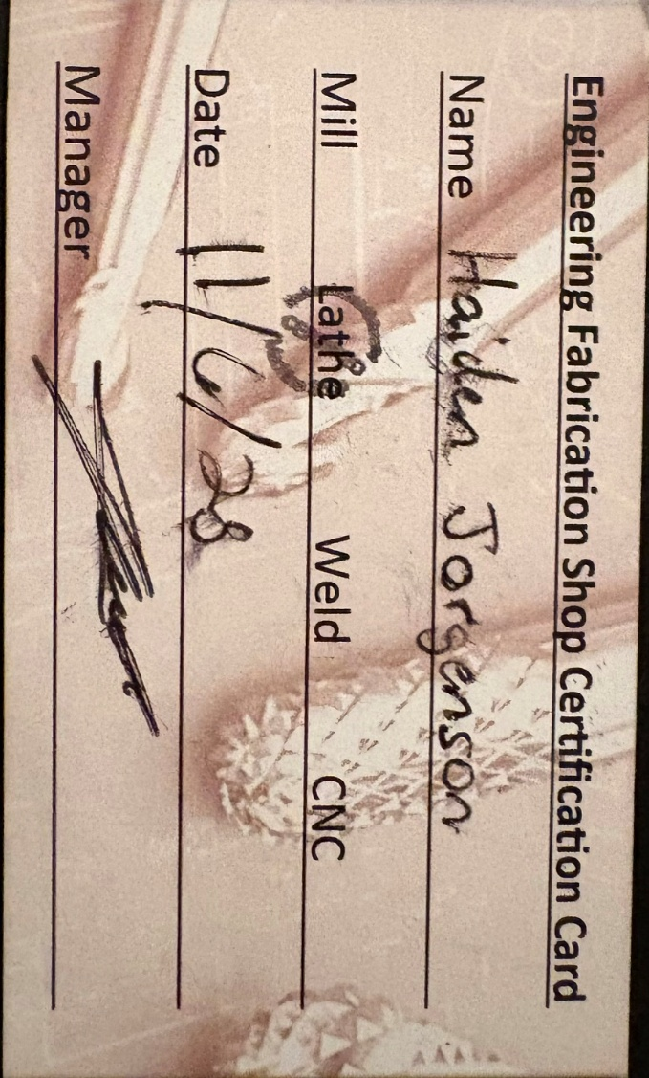
Figure 6.1.2 Machine shop advanced lathe training certification card for Haiden Jorgenson

Appendix A1 – IDEA Lab Equipment and Tools
Table 2.2.1 Innovation Design and Engineering Area (IDEA) Lab Equipment [1]
Machine | Specifications
Bambu 3D printers (enclosed/non-enclosed) | These are high-speed fused deposition modeling systems offering rapid prototyping capabilities with automated calibration and multi-material options.
Formlabs 3 | This is a desktop stereolithography printer that uses a precision laser to cure liquid resin into high-resolution parts with exceptionally smooth surface finishes.
J35 Stratasys | This is a PolyJet 3D printer capable of dispensing up to three materials simultaneously to produce realistic, high-fidelity functional prototypes.
Fortus 450 | This is an industrial-grade fused deposition modeling machine designed for manufacturing strong, accurate, and repeatable parts using advanced engineering thermoplastics.
Xtool P3 Laser cutter | This is a desktop laser cutting and engraving system engineered for precision processing of non-metallic materials such as wood, acrylic, and leather.

6.2 Appendix A2 – Machine Shop Tools & Equipment Descriptions
Table 6.2.1 NAU Machine Shop Equipment [2]
Tool/Machine | Description
Sharp Vertical Mills | The vertical mills are useful for manually machining any small parts for the avionics bay that may be made from light aluminum.
Harrison Lathes | Manual lathes will be useful to this project in a similar way to the manual mills and will be used to machine any circular parts that need to be made from plastics or soft metals.
HAAS TM-1P Toolroom CNC Mill | The CNC mill will be used when the geometry of the part needed to be machined is to complex to achieve with a normal, manual operation. This process is also quicker than manual machining but comes with additional cost.
HAAS TL-1 Toolroom CNC Lathes | The CNC lathe will be used if we need a complex, cylindrical to be machined precisely and quickly.
Horizontal/Vertical Bandsaw | Bandsaws will be used whenever material needs to be roughly cut to size.
Drill Press | A drill press can be used to create clearance and threaded holes for aluminum parts that may be utilized in our avionics bay.
Hydraulic Press | The hydraulic press will be useful if we need to produce any press fits in any components or tests any materials under compressive loading.
Hand Tools | The machine shop has a plethora of hand tools for any operations needed to be completed by hand. This will be an exceptionally useful resource when we are fabricating and building our rocket, testing machines, or fixtures.

Appendix A3 – Initial Requirements Verification
Table 6.3.1 is the initial requirements matrix for the 2026–27 Mars handbook. Identifiers are M for the Mars challenge, G for general requirements, V for the vehicle, R for recovery, S for safety, and N for the technical and project notes that act as requirements. Verification methods are the handbook’s set: test, analysis, demonstration, simulation, and inspection. Status is Completed only where the evidence already exists [9].
Table 6.3.1. Initial requirements verification matrix.
ID | Requirement | Verification | Owner | Status
M1 | Select one Appendix A-5 kit and fabricate to its dimensions. | Inspection | Gustavo Baquero | In Work
M2 | Fabricate airframes, couplers, nose cone and shoulder, bulkheads, centering rings, fins, and the avionics sled. | Demonstration | Airframe team | In Work
M3 | Motor-mount tube is commercial, not student-fabricated. | Inspection | Gustavo Baquero | In Work
M4 | Motor is an Aerotech motor from Appendix A-1. | Inspection | Haiden Jorgenson | In Work
M5 | Apogee between 3,500 and 4,000 ft AGL. | Simulation | Airframe team | In Work
M6 | Airframe cloth limited to carbon fiber and fiberglass. | Inspection | Gustavo Baquero | In Work
M7 | Polymers and light metal only as secondary structure. | Inspection | Airframe team | In Work
M8 | Honeycomb sandwich allowed only as secondary structure. | Inspection | Gustavo Baquero | In Work
M9 | Small components are 3D printed. | Demonstration | Gustavo Baquero | In Work
M10 | Larger components are made by resin infusion. | Demonstration | Gustavo Baquero | In Work
M11 | Any additional machining is done by the students. | Demonstration | Haiden Jorgenson | In Work
M12 | Off-campus tools are used only by trained students. Alternative methods are described in this proposal. | Demonstration | Haiden Jorgenson | In Work
M13 | Room-temperature cure is the selected cure variation. | Demonstration | Gustavo Baquero | In Work
M14 | PDR gate: flat composite plates have been made. | Demonstration | Gustavo Baquero | In Work
M15 | CDR gate: composite tubes have been made. | Demonstration | Gustavo Baquero | In Work
M16 | FRR gate: a complex shape is in assembly. | Demonstration | Airframe team | In Work
M17 | Every component is tested for its expected load. | Test | Airframe team | In Work
M18 | Component testing is discussed by the FRR. | Inspection | Haiden Jorgenson | In Work
M19 | A failed part may be replaced by COTS only with the point deduction. | Inspection | Haiden Jorgenson | In Work
M20 | Scoring includes milestones, flight success, altitude, airframe mass, and dimensions. | Demonstration | Haiden Jorgenson | In Work
M21 | A full-scale test flight is planned. It is recommended, not required. | Test | Recovery team | In Work
G1 | Team lead and advisor register with WSGC before the students. | Demonstration | Carson Pete | In Work
G2 | Advisor submits the Rocket Launch Team notice of intent. | Demonstration | Carson Pete | In Work
G3 | Team lead applies to First Nations Launch after the notice of intent. | Demonstration | Haiden Jorgenson | In Work
G4 | Every student is registered and applied by the CDR due date. | Demonstration | Haiden Jorgenson | In Work
G5 | Advisor and team lead submit the signed award acceptance. | Demonstration | Carson Pete | In Work
G6 | The full roster, including who travels, is identified by the CDR. | Inspection | Haiden Jorgenson | In Work
G7 | Mentor is certified for the motor impulse, with two electronic dual-deploy flights in that class, before PDR. | Demonstration | Stonn Billy | In Work
G8 | The team lead uploads PDF deliverables by each deadline. | Demonstration | Haiden Jorgenson | In Work
G9 | The provided report and presentation templates are used. | Inspection | Haiden Jorgenson | In Work
G10 | An Estes-class rocket is flown before PDR and the video URL is uploaded. | Demonstration | Haiden Jorgenson | In Work
G11 | The vehicle is at least 95 percent flight-ready two weeks before launch. | Inspection | Haiden Jorgenson | In Work
G12 | A stable RockSim file is submitted at each milestone and on a flash drive at launch. | Simulation | Airframe team | In Work
V1 | Commercial certified APCP motor from Appendix A-1, supplied by WSGC. Final choice at PDR. Later changes only for safety margin, with a penalty. | Simulation | Haiden Jorgenson | In Work
V2 | At least one commercial barometric altimeter for ejection and the official altitude. | Inspection | Avionics team | In Work
V3 | Each altimeter has its own battery and its own lockable exterior arming switch. | Inspection | Avionics team | In Work
V4 | Static margin at least 1.0 caliber at rail exit. | Simulation | Airframe team | In Work
V5 | Rail-exit velocity at least 52 ft/s. | Simulation | Airframe team | In Work
V6 | Thrust-to-weight ratio greater than 5:1. | Simulation | Airframe team | In Work
V7 | CG and CP marked on the outside in the flight-ready configuration. | Inspection | Marina McGarry | In Work
V8 | No forward canards, forward-firing motors, titanium-sponge motors, hybrids, staging, or clusters. | Inspection | Stonn Billy | In Work
V9 | No friction-fit motor retention. | Inspection | Stonn Billy | In Work
V10 | No Blue Tube, sonotube, or acrylic fins. | Inspection | Gustavo Baquero | In Work
V11 | No excessive metal. Light metal only where strength requires it. | Inspection | Gustavo Baquero | In Work
V12 | The vehicle stays below Mach 1. | Simulation | Airframe team | In Work
V13 | Ballast does not exceed 10 percent of unballasted pad weight. | Analysis | Airframe team | In Work
V14 | The shape is aerodynamic. No odd rocket. | Inspection | Gustavo Baquero | In Work
R1 | Dual deploy. Drogue at apogee with no more than 2 seconds of delay. Main between 300 and 1,000 ft AGL. No single-deployment release device. | Simulation | Recovery team | In Work
R2 | Drogue descent between 45 and 65 ft/s. | Simulation | Recovery team | In Work
R3 | Main descent between 15 and 20 ft/s. | Simulation | Recovery team | In Work
R4 | Recovery electronics are on their own circuits. | Inspection | Avionics team | In Work
R5 | Recovery electronics use commercial batteries. | Inspection | Avionics team | In Work
R6 | COTS altimeters are the primary ejection events at apogee and at main. | Inspection | Avionics team | In Work
R7 | Motor ejection is the apogee backup only. The drogue is packed in the booster. The delay comes from the simulated time to apogee. | Demonstration | Stonn Billy | In Work
R8 | A GPS tracker reports the tethered vehicle. Any untethered section gets its own tracker. A non-licensed tracker is preferred. | Test | Avionics team | In Work
S1 | A student safety officer monitors design, build, assembly, ground test, launch, and recovery, and keeps procedures and safety data sheets current. | Inspection | Marina McGarry | Completed
S2 | Launch and safety checklists are used. The final set is in the FRR. | Demonstration | Marina McGarry | In Work
S3 | Test flights follow the host club Range Safety Officer. The mentor contacts the club before the team attends. | Demonstration | Stonn Billy | In Work
S4 | Photographs of sealed construction are included in the FRR. | Inspection | Marina McGarry | In Work
S5 | A virtual inspection is held with the WSGC technical advisor at the FRR. | Demonstration | Haiden Jorgenson | In Work
S6 | Parts come from a reputable high-power vendor, or the reports contain a test or analysis of suitability. | Inspection | Gustavo Baquero | In Work
N1 | Students do the project except motor assembly, black powder, and electric matches, which the mentor does. | Demonstration | Stonn Billy | In Work
N2 | No more than four independent sections. Coupler shoulders are at least one body diameter. | Inspection | Gustavo Baquero | In Work
N3 | The rocket is recoverable and can fly again the same day without repair. | Demonstration | Recovery team | In Work
N4 | Team name and launch-day contact are on the airframe, readable without opening it. | Inspection | Marina McGarry | In Work
N5 | Competition ejection charges are provided by Tripoli Wisconsin. Ground-test charges match that canister type. | Demonstration | Stonn Billy | In Work
N6 | The team uses Tripoli Wisconsin pads only. The leading rail button is 1515 for the 10 ft rail. | Inspection | Gustavo Baquero | In Work
N7 | Range inspection, Range Safety Officer authority, mentor approval, and compliance with the safety rules are conditions of flight. | Demonstration | Marina McGarry | In Work

References
[1] “NAU Achieves R1 Research Designation - the NAU Review,” The NAU Review, Feb. 13, 2025. https://in.nau.edu/news/r1-research-designation/ (accessed Oct. 14, 2026).
[2] “NAU Engineering IDEA Lab,” Nau.edu, 2024. https://ceias.nau.edu/me/idealab/index.html (accessed Oct. 14, 2026).
[3] “Novakinetics Aerosystems & Kinetic Defense | Flagstaff Arizona,” Novakinetics Aerosystems & Kinetic Defense, Dec. 2020. https://novakinetics.com/ (accessed Oct. 08, 2026).
[4] C. Ciocanel, “Multifunctional Materials and Adaptive Systems Laboratory.” https://in.nau.edu/mechanical-engineering/multifunctional-materials-and-adaptive-systems-lab/ (accessed Oct. 07, 2026).
[5] Northern Arizona University, “Mechanical Engineering Machine Shop,” Mechanical Engineering | Northern Arizona University. https://in.nau.edu/mechanical-engineering/engineering-fabrication-lab/ (accessed Oct. 14, 2026).

[6] Apogee Components, Inc, “Peak of Flight Newsletter : Apogee Rockets, Model Rocketry Excitement Starts Here,” Apogeerockets.com, 2023. https://www.apogeerockets.com/Peak-of-Flight/Newsletter481 (accessed Oct. 14, 2026).
[7] “ASTM Compass,” compass.astm.org. https://compass.astm.org/ (accessed Oct. 14, 2026).
[8] “ASTM D3039 – Standard Test Method for Tensile Properties of Polymer Matrix Composite Materials,” Astm.org, 2026. https://compass.astm.org/content-access?contentCode=ASTM%7CD3039_D3039M-17R25%7Cen-US (accessed Oct. 14, 2026).
[9] Wisconsin Space Grant Consortium, “First Nations Launch 2027 Mars Challenge Handbook,” 2026. https://spacegrant.carthage.edu/live/files/6496-fnl27-handbook-mars (accessed Oct. 16, 2026).

[10] Tripoli Rocketry Association, “Tripoli High Power Safety Code.” https://www.tripoli.org/SafetyCode (accessed Oct. 16, 2026).

[11] National Association of Rocketry, “High Power Rocket Safety Code.” https://www.nar.org/content.aspx?page_id=22&club_id=114127&module_id=669238 (accessed Oct. 16, 2026).

[12] Federal Aviation Administration, 14 CFR Part 101, Subpart C, Amateur Rockets, §§ 101.22, 101.23, 101.25, and 101.27. https://www.law.cornell.edu/cfr/text/14/part-101/subpart-C (accessed Oct. 16, 2026).

[13] Bureau of Alcohol, Tobacco, Firearms and Explosives, 27 CFR 555.141, exemptions from the commerce-in-explosives rules (the current codification of the Part 55 rules cited in the handbook). https://www.law.cornell.edu/cfr/text/27/555.141 (accessed Oct. 16, 2026).

[14] Bureau of Alcohol, Tobacco, Firearms and Explosives, “Black Powder,” including the limits of the 27 CFR 555.141(b) exemption. https://www.atf.gov/explosives/tools-services-explosives-industry/explosive-products-and-devices/black-powder (accessed Oct. 16, 2026).

[15] National Fire Protection Association, NFPA 1127, Code for High Power Rocketry. https://www.nfpa.org/1127 (accessed Oct. 16, 2026).

[16] Madcow Rocketry, “4 in Fiberglass Tomach,” with the Pike XL and Broken Arrow XL kit pages used for the trade study. https://www.madcowrocketry.com/4-fiberglass-tomach/ Pike XL: https://www.madcowrocketry.com/4-fiberglass-pike-xl/ . Broken Arrow XL: https://www.madcowrocketry.com/4-fiberglass-broken-arrow-xl/ (accessed Oct. 16, 2026).

[17] ThrustCurve, AeroTech motor certification data for the Appendix A-1 Mars motors, including the K550W (1,539.1 N·s, 889 g propellant, 1,487 g loaded). https://www.thrustcurve.org/manufacturers/AeroTech/motors.html (accessed Oct. 16, 2026).

[18] PerfectFlite, “StratoLoggerCF” datasheet, barometric dual-deploy altimeter, listed at $54.95. http://www.perfectflite.com/Downloads/StratoLoggerCF%20info.pdf (accessed Oct. 16, 2026).

[19] Featherweight Altimeters, GPS tracker. Non-licensed tracker listed in Mars Handbook Appendix D-6. https://www.featherweightaltimeters.com/featherweight-gps-tracker.html (accessed Oct. 16, 2026).

[20] Gougeon Brothers, Inc., “Safety Data Sheet, WEST SYSTEM 105 Epoxy Resin,” SDS 105-2022a, Jan. 3, 2022. https://www.westsystem.com/app/uploads/2022/10/105-SDS.pdf (accessed Oct. 16, 2026).

[21] Gougeon Brothers, Inc., “Safety Data Sheet, WEST SYSTEM 205 Fast Hardener.” https://www.westsystem.com/app/uploads/2022/10/205-SDS.pdf (accessed Oct. 16, 2026).

[22] National Institute for Occupational Safety and Health, NIOSH Pocket Guide to Chemical Hazards, acetone. https://www.cdc.gov/niosh/npg/npgd0260.html (accessed Oct. 16, 2026).

[23] Northern Arizona University, Environmental Health and Safety. https://in.nau.edu/environmental-health-and-safety/ (accessed Oct. 16, 2026).

