RĪGAS TEHNISKĀ UNIVERSITĀTE
Datorzinātnes, informācijas tehnoloģijas un enerģētikas fakultāte

Studiju projekts

Autonoma robotizēta sistēma saules paneļa orientēšanai

Profesionālā bakalaura studiju programmas
“Elektrotehnoloģiju datorvadība”
3. kursa studenti:
Niks Lagzdiņš, Eduards Mareks Bērziņš, Gustavs Krūzmanis
Profesors: Dr.sc.ing. Pēteris Apse-Apsītis

Rīga 2026
Saturs
Atskaite kopā ar prototipa attēliem un darbības video ir atrodama projekta GitHub lapā: https://github.com/Gustavs-K/Autonomous-robotic-system-for-solar-panel-orientation

Materiālu saraksts 3
Elektriskā shēma 4
Darbības apraksts 5
Prototipa attēli 6
Kods 7

Materiālu saraksts

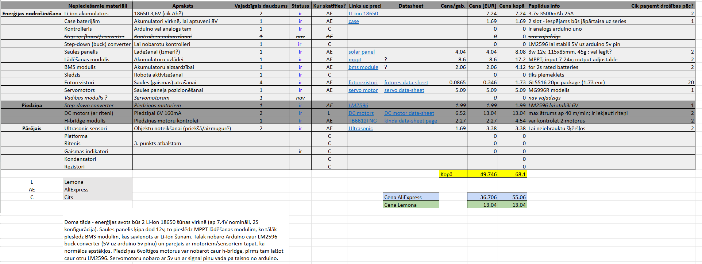

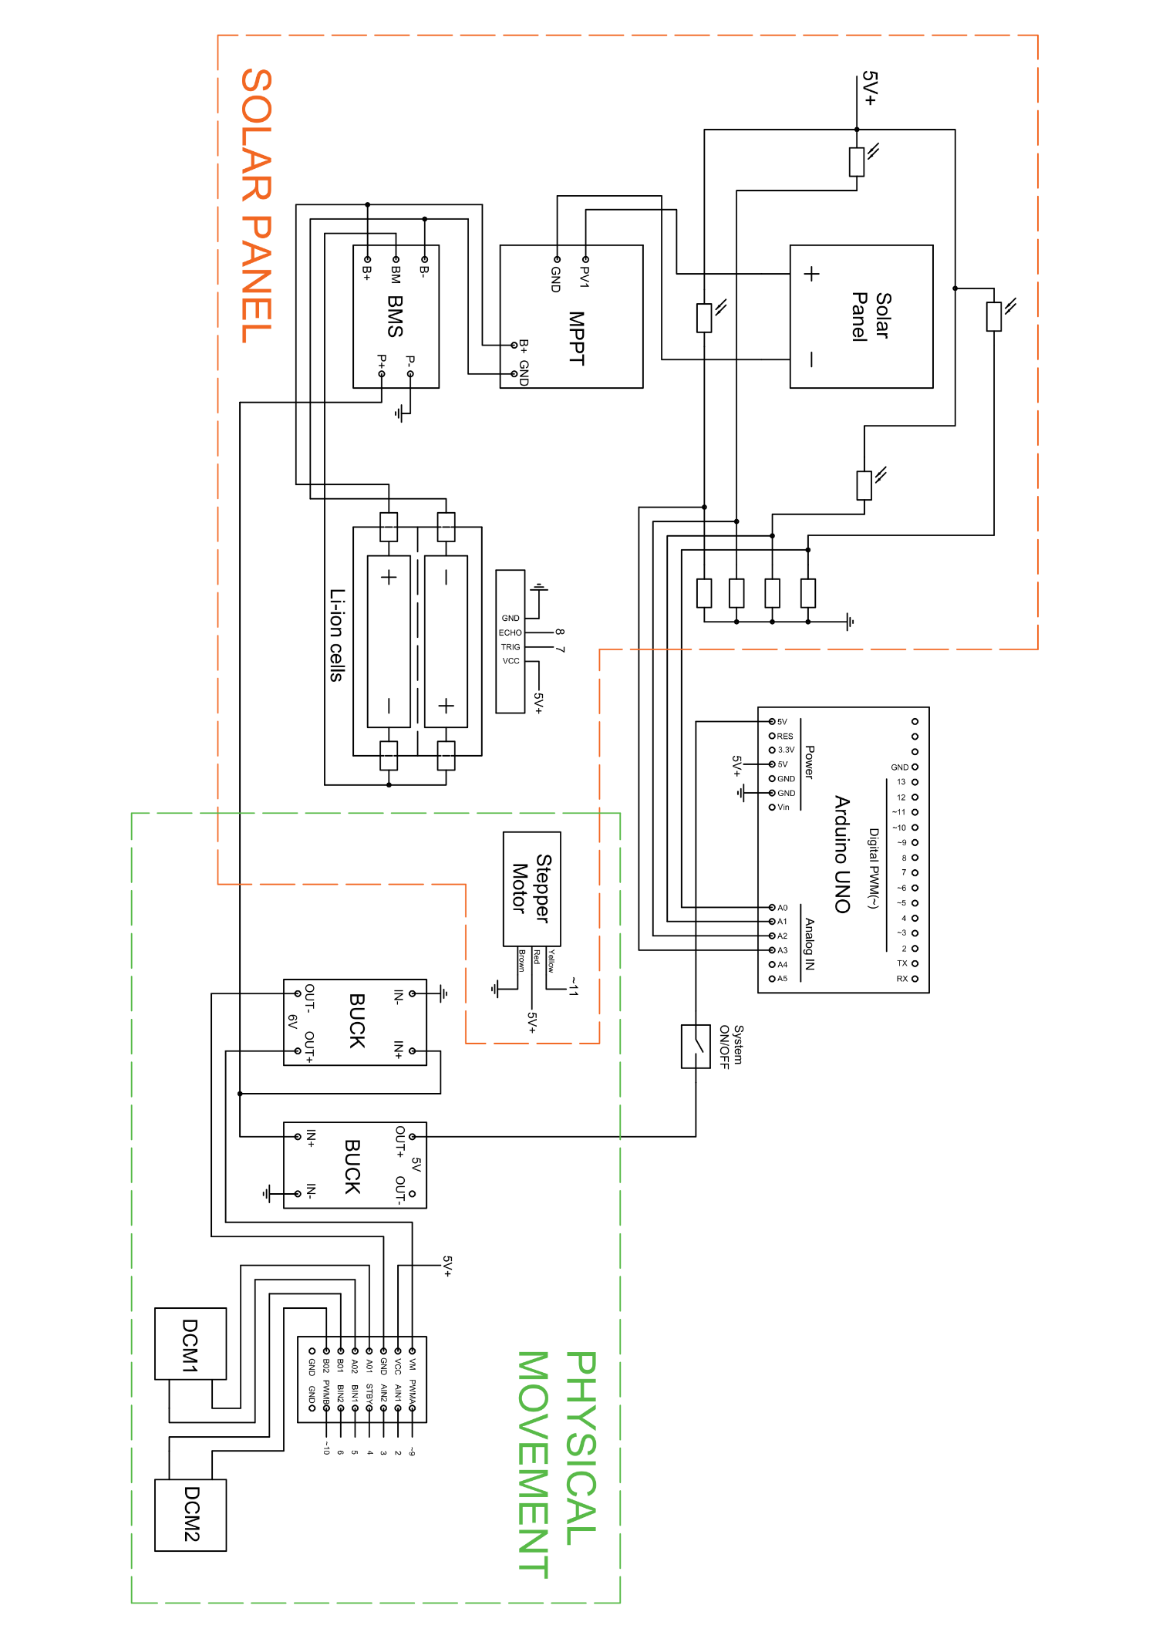
Elektriskā shēma

Darbības apraksts
Izstrādātā robota galvenais mērķis un funkcija ir meklēt viss spožāko gaismas avotu (sauli) un pagriezt tā saules paneli pret šo gaismas avotu, lai optimizētu saules paneļa elektrības ģenerēšanu.
Gaismas atrašanai tiek izmantoti 4 gaismas sensori (fotorezistori), kas ir izvietoti uz saules paneļa katras malas. Šie sensoriem apkārt ir izveidotas sienas, kas aizsedz gaismu, kad saules panelis nav pagriezts tieši pret gaismas avotu. Sensoru ievāktie dati tiek apstrādāti, lai uzlabotu sistēmas darbības stabilitāti.
Paneļa orientēšana notiek 2 veidos. Azimuts tiek mainīts ar visas platformas kustību, ko panāk ar riteņu darbību. Slīpums tiek pielāgots ar tam paredzēto servomotoru, kas kustina visu saules paneļa rāmi (kopā ar gaismas sensoriem).
Drošai darbībai, robots pielieto ultraskaņas sensoru, kas, gadījumā kad robots ir piebraucis pārāk tuvu kādam objekta, dos sistēmai signālu atvirzīties no tā.
Straujas gaismas pazušanas gadījumā, robots ieies meklēšanas režīmā, kurā tas braukās pa apkārtējo vidi meklējot jaunu leņķi uz gaismas avotu. Šīs funkcijas mērķis ir ierobežot laiku ko robots pavada ēnā.
Ilgstošas zemas apkārtējās gaismas gadījuma, robots ieies “aizmigušā” (hibernation) režīmā, līdz apkārtējās gaismas intensitāte atkal palalināsies. Šīs funkcijas galvenais mērķis ir ierobežot elektrības patēriņu nakts un citos zemas gaismas laikos un uzlabot sistēmas efektivitāti.

Prototipa attēli
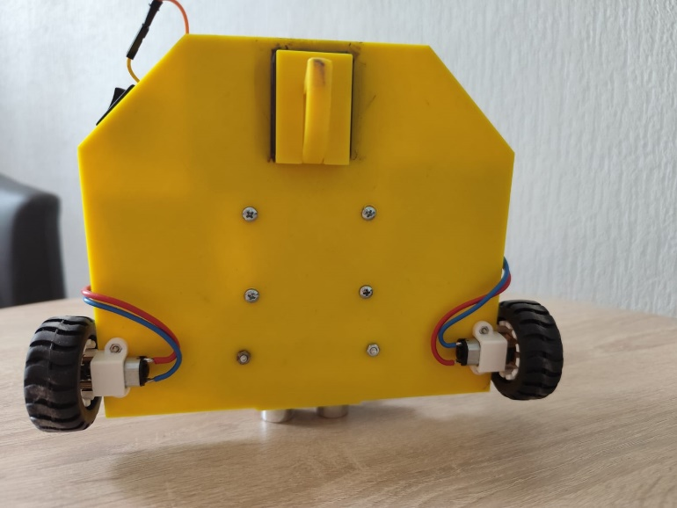
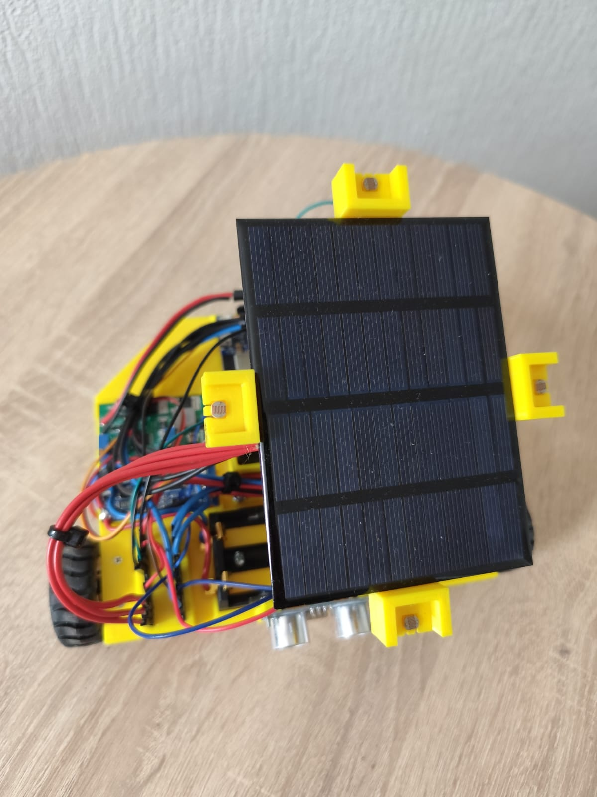
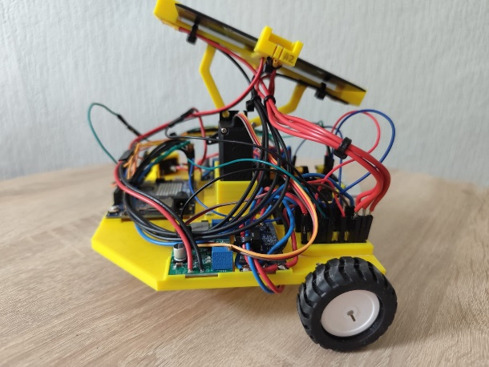
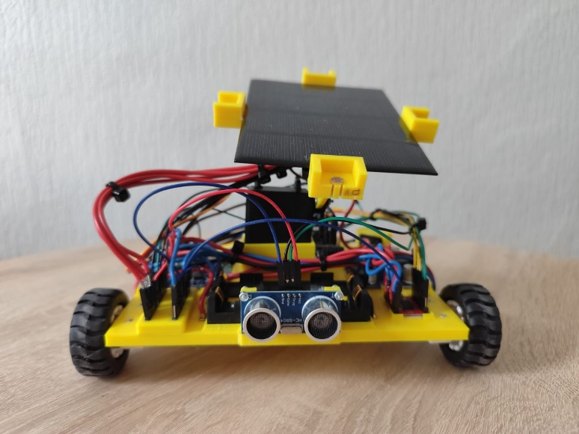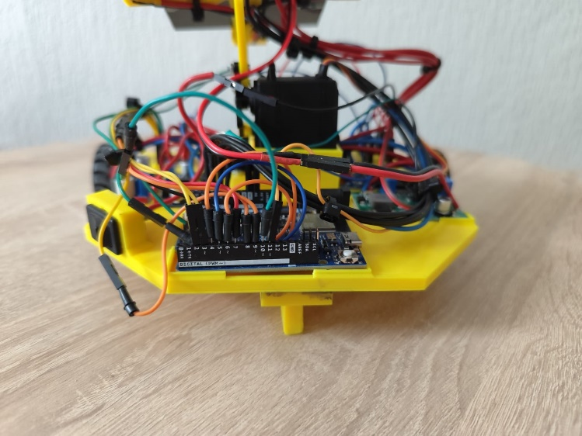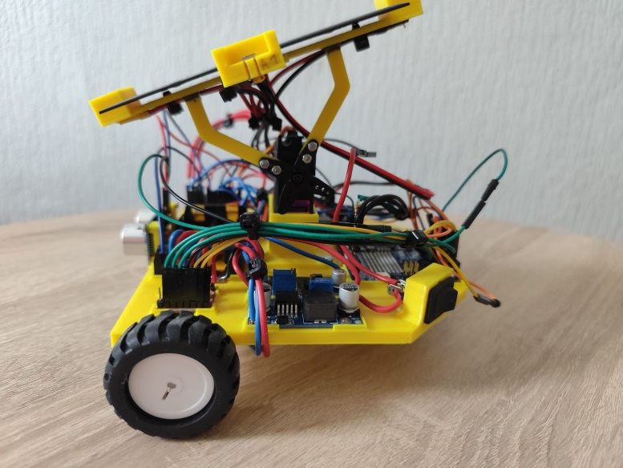

Kods
#include <Servo.h>

// --- 1. PIN CONNECTIONS ---
const int ldrFront = A0, ldrLeft = A1, ldrRight = A2, ldrBack = A3;
const int batteryPin = A4, servoPin = 11, STBY = 4;
const int trigPin = 7, echoPin = 8;
const int AIN1 = 3, AIN2 = 2, PWMA = 9;
const int BIN1 = 5, BIN2 = 6, PWMB = 10;

Servo myServo;

// --- 2. MOVEMENT SETTINGS ---
const int fullPower = 255;
const int wallDistance = 5;
const int recoilTime = 220;

// --- 3. INCREMENTAL & PRECISION SETTINGS ---
int currentPos = 90;
const int minServo = 65, maxServo = 115;
const int minMoveStep = 10;
const int minWheelBurst = 180;
const int globalThreshold = 45;

// --- ASYMMETRIC SMOOTHING ---
const float smoothUp = 0.7;
const float smoothDown = 0.15;

float smoothF = 0, smoothB = 0, smoothL = 0, smoothR = 0;

// --- 4. NON-BLOCKING & SHADE SETTINGS ---
unsigned long lastActionTime = 0;
const int decisionInterval = 400;

unsigned long motorStopTime = 0;
unsigned long servoDetachTime = 0;
bool motorsRunning = false;
bool servoAttached = false;

int baselineLight = 0;
bool hibernating = false;

void setup() {
Serial.begin(115200);
pinMode(trigPin, OUTPUT); pinMode(echoPin, INPUT);
pinMode(STBY, OUTPUT);
pinMode(AIN1, OUTPUT); pinMode(AIN2, OUTPUT); pinMode(PWMA, OUTPUT);
pinMode(BIN1, OUTPUT); pinMode(BIN2, OUTPUT); pinMode(PWMB, OUTPUT);
digitalWrite(STBY, HIGH);

myServo.attach(servoPin);
myServo.write(currentPos);
delay(600);
myServo.detach();

smoothF = analogRead(ldrFront);
smoothL = analogRead(ldrLeft);
smoothR = analogRead(ldrRight);
smoothB = analogRead(ldrBack);
baselineLight = (smoothF + smoothL + smoothR + smoothB) / 4;
}

void loop() {
// --- NON-BLOCKING HARDWARE CUTOFFS ---
if (motorsRunning && millis() >= motorStopTime) {
stopMotors();
motorsRunning = false;
}
if (servoAttached && millis() >= servoDetachTime) {
myServo.detach();
servoAttached = false;
}

// --- DECISION LOOP ---
if (millis() - lastActionTime >= decisionInterval) {

// 1. Read raw sensor data
int rawF = analogRead(ldrFront); int rawL = analogRead(ldrLeft);
int rawR = analogRead(ldrRight); int rawB = analogRead(ldrBack);

// 2. ANOMALY SAFEGUARD (OUTLIER REJECTION)
int totalRaw = rawF + rawL + rawR + rawB;
int avgOther;

avgOther = (totalRaw - rawF) / 3;
if (rawF < avgOther * 0.25) rawF = avgOther;

avgOther = (totalRaw - rawL) / 3;
if (rawL < avgOther * 0.25) rawL = avgOther;

avgOther = (totalRaw - rawR) / 3;
if (rawR < avgOther * 0.25) rawR = avgOther;

avgOther = (totalRaw - rawB) / 3;
if (rawB < avgOther * 0.25) rawB = avgOther;

// 3. Apply Asymmetric Smoothing Filter
smoothF = applySmoothing(rawF, smoothF);
smoothL = applySmoothing(rawL, smoothL);
smoothR = applySmoothing(rawR, smoothR);
smoothB = applySmoothing(rawB, smoothB);

int f = round(smoothF); int l = round(smoothL);
int r = round(smoothR); int b = round(smoothB);

int avgLight = (f + l + r + b) / 4;

if (avgLight > baselineLight) {
baselineLight = avgLight;
}

delay(10);
long dist = getDistance();

// --- TELEMETRY ---
Serial.print("DIST:"); Serial.print(dist);
if(dist == 999) Serial.print(" [!] GHOST READ");
Serial.print(" | LDR [F:"); Serial.print(f); Serial.print(" B:"); Serial.print(b);
Serial.print(" L:"); Serial.print(l); Serial.print(" R:"); Serial.print(r);
Serial.print("] | AVG:"); Serial.print(avgLight);
Serial.print(" BASE:"); Serial.println(baselineLight);

// --- WAKE UP LOGIC ---
if (hibernating) {
if (avgLight >= baselineLight * 0.85) {
hibernating = false;
Serial.println(" --- LIGHT RETURNED: WAKING UP ---");
} else {
lastActionTime = millis();
return;
}
}

// --- SHADE DETECTION / SCOUT LOGIC ---
if (avgLight < baselineLight * 0.8) {
Serial.println(" --- SHADE DETECTED: INITIATING SCOUT ---");
performDeepScout();
lastActionTime = millis();
return;
}

// --- NORMAL AVOIDANCE & TRACKING ---
if (dist <= wallDistance && dist > 0) {
executeRecoil();
}
else {
// --- UPDATED: Vertical (Servo) Limit Check ---
int vDiff = f - b;
if (abs(vDiff) > globalThreshold) {

// Figure out if we actually have physical room to move
bool canMoveUp = (f > b) && (currentPos < maxServo);
bool canMoveDown = (b > f) && (currentPos > minServo);

// ONLY attach and command the servo if it is not at its limit
if (canMoveUp || canMoveDown) {
if (!myServo.attached()) {
myServo.attach(servoPin);
servoAttached = true;
}

if (canMoveUp) currentPos += minMoveStep;
else if (canMoveDown) currentPos -= minMoveStep;

myServo.write(currentPos);
servoDetachTime = millis() + 150;
}
}

// Horizontal (Wheels)
int hDiff = l - r;
if (abs(hDiff) > globalThreshold) {
int burst = map(abs(hDiff), globalThreshold, 700, minWheelBurst, 400);
if (l > r) startMotorsNonBlocking(fullPower, -fullPower, burst);
else startMotorsNonBlocking(-fullPower, fullPower, burst);
}
}
lastActionTime = millis();
}
}

// --- ASYMMETRIC SMOOTHING FUNCTION ---
float applySmoothing(int raw, float currentSmooth) {
if (raw > currentSmooth) {
return (raw * smoothUp) + (currentSmooth * (1.0 - smoothUp));
} else {
return (raw * smoothDown) + (currentSmooth * (1.0 - smoothDown));
}
}

// --- DISTANCE LOGIC ---
long getDistance() {
digitalWrite(trigPin, LOW); delayMicroseconds(2);
digitalWrite(trigPin, HIGH); delayMicroseconds(10);
digitalWrite(trigPin, LOW);

long duration = pulseIn(echoPin, HIGH, 25000);
if (duration == 0) {
pinMode(echoPin, OUTPUT);
digitalWrite(echoPin, LOW);
delayMicroseconds(200);
pinMode(echoPin, INPUT);
return 999;
}
return (duration * 0.034 / 2);
}

// --- SCOUT LOGIC ---
void performDeepScout() {
unsigned long scoutStartTime = millis();

while (millis() - scoutStartTime < 60000) {
int f = analogRead(ldrFront); int l = analogRead(ldrLeft);
int r = analogRead(ldrRight); int b = analogRead(ldrBack);
int currentAvg = (f + l + r + b) / 4;

Serial.print("SCOUTING... CURRENT AVG: "); Serial.println(currentAvg);

if (currentAvg >= baselineLight * 0.85) {
Serial.println(" --- BETTER LIGHT FOUND! RESUMING ---");
stopMotors();
smoothF = f; smoothL = l; smoothR = r; smoothB = b;
return;
}

if (getDistance() < 15) {
executeRecoil();
} else {
moveRobotBlocking(fullPower * 0.8, (random(0,2)==0 ? -fullPower * 0.8 : fullPower * 0.8), 400);
delay(100);
moveRobotBlocking(fullPower, fullPower, 300);
delay(100);
}
}

Serial.println(" --- SCOUT FAILED. ENTERING HIBERNATION. ---");
stopMotors();
hibernating = true;
}

// --- MOVEMENT FUNCTIONS ---
void startMotorsNonBlocking(int rSpd, int lSpd, int burst) {
digitalWrite(AIN1, rSpd >= 0 ? LOW : HIGH);
digitalWrite(AIN2, rSpd >= 0 ? HIGH : LOW);
analogWrite(PWMA, abs(rSpd));
digitalWrite(BIN1, lSpd >= 0 ? LOW : HIGH);
digitalWrite(BIN2, lSpd >= 0 ? HIGH : LOW);
analogWrite(PWMB, abs(lSpd));

motorStopTime = millis() + burst;
motorsRunning = true;
}

void moveRobotBlocking(int rSpd, int lSpd, int burst) {
digitalWrite(AIN1, rSpd >= 0 ? LOW : HIGH);
digitalWrite(AIN2, rSpd >= 0 ? HIGH : LOW);
analogWrite(PWMA, abs(rSpd));
digitalWrite(BIN1, lSpd >= 0 ? LOW : HIGH);
digitalWrite(BIN2, lSpd >= 0 ? HIGH : LOW);
analogWrite(PWMB, abs(lSpd));
delay(burst);
stopMotors();
}

void executeRecoil() {
moveRobotBlocking(-fullPower, -fullPower, recoilTime);
}

void stopMotors() {
analogWrite(PWMA, 0); analogWrite(PWMB, 0);
}

