ORDERS ABOVE AVERAGE SALES
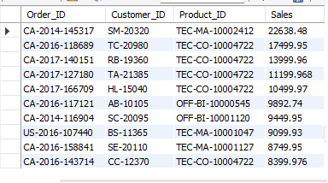

HIGHEST ORDER FOR EACH CUSTOMER
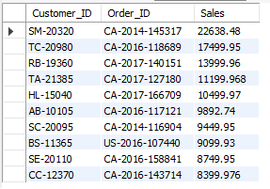

TOTAL SALES PER CUSTOMER


ROW NUMBER AND RANK
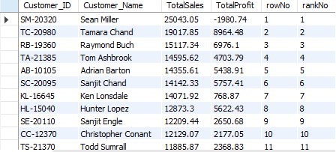

TOP 10 CUSTOMERS
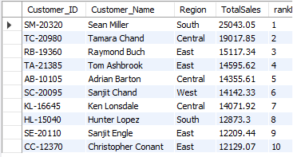

LOWEST CUSTOMERS BY SALES
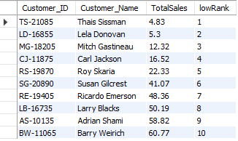

CUSTOMERS WITH SINGLE ORDER
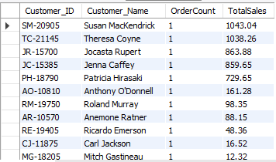

CUSTOMERS ABOVE AVERAGE CUSTOMER SALES
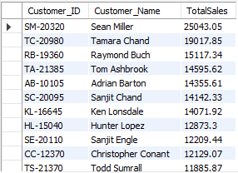

FINAL RESULT
