Task 1: Create a resource group
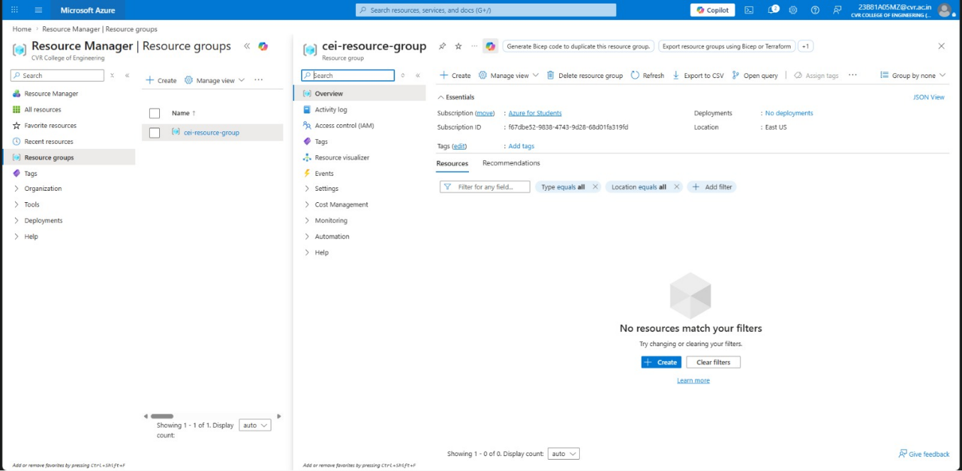
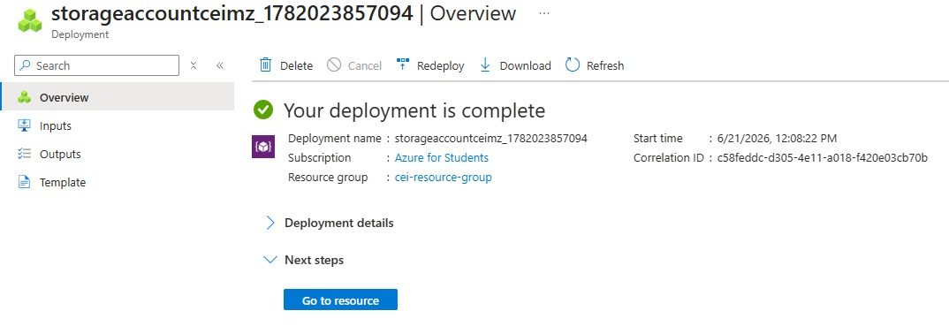

Task 2: Storage Setup
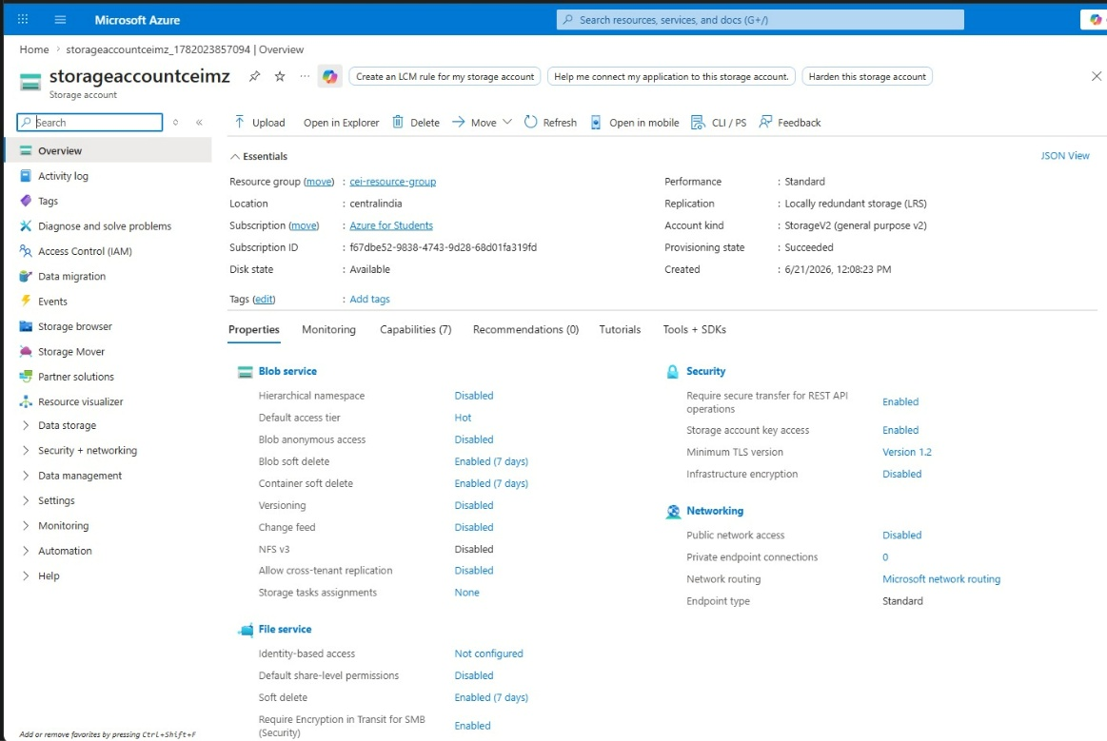
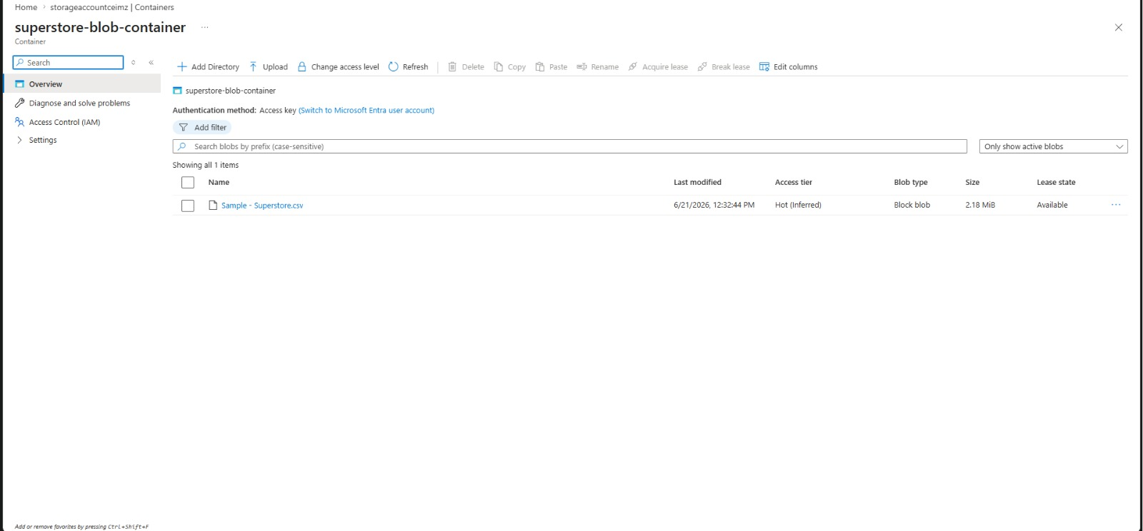

Task 3: ADF Basics
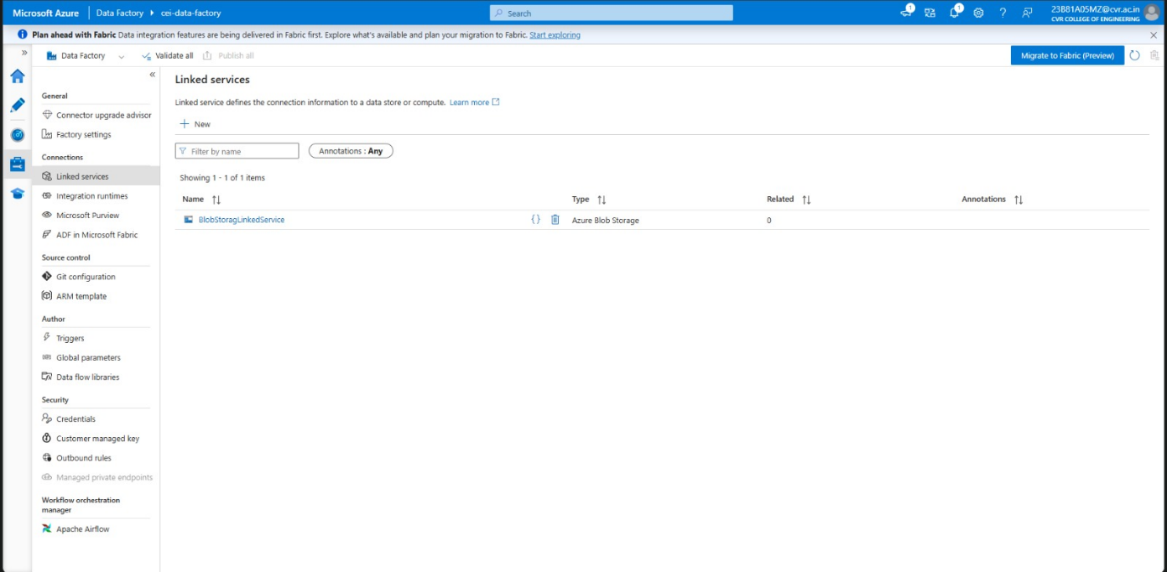
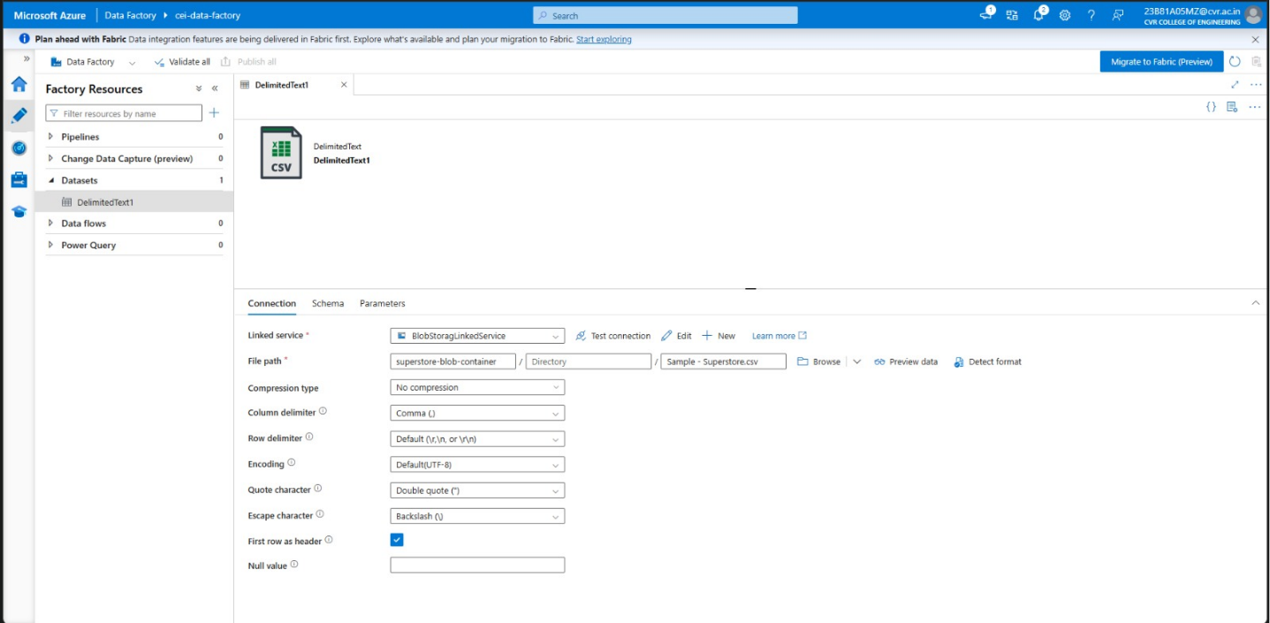

Task 4: Pipeline Development
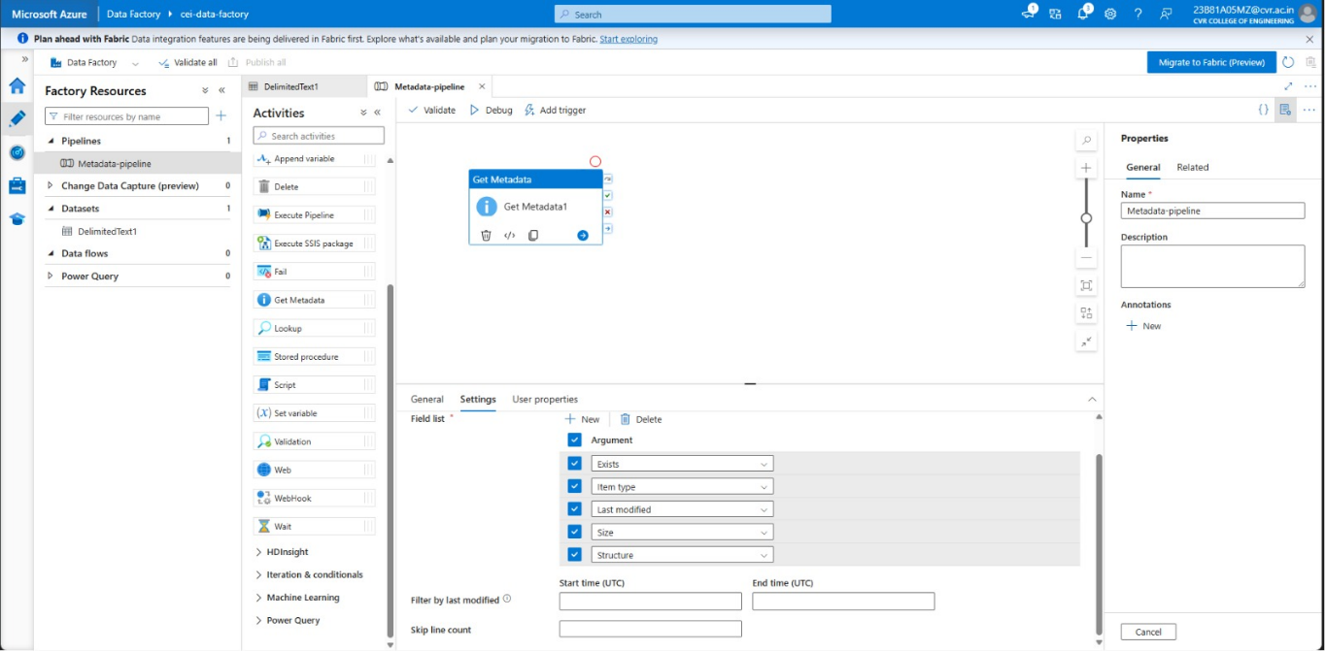
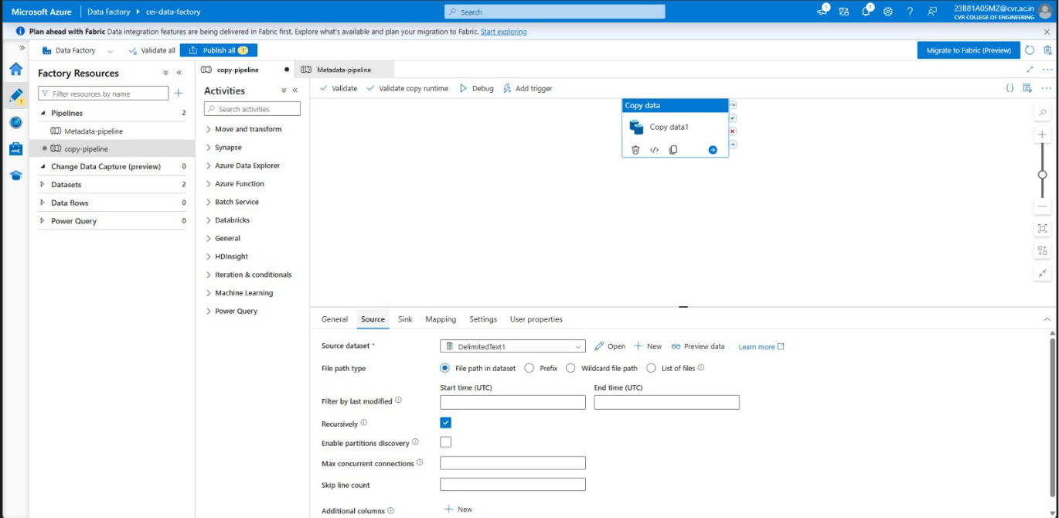
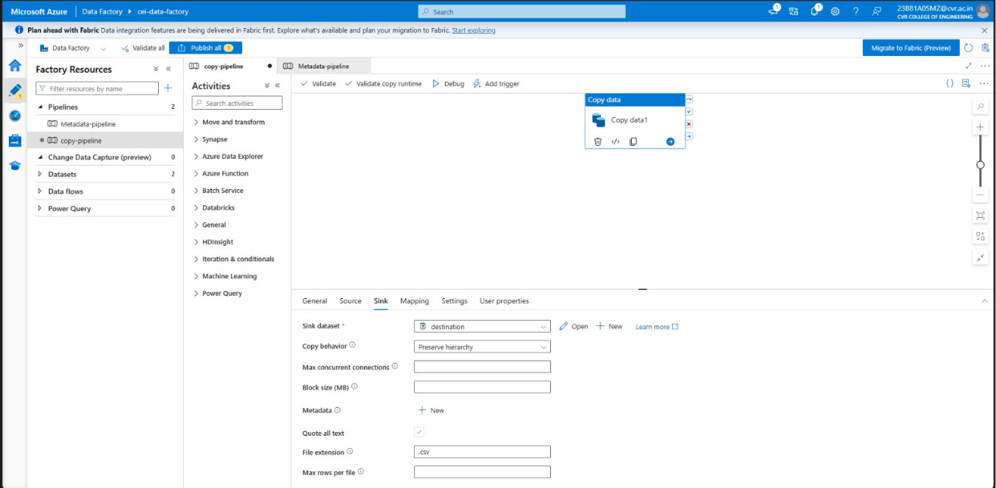
Task 5: Pipeline Execution
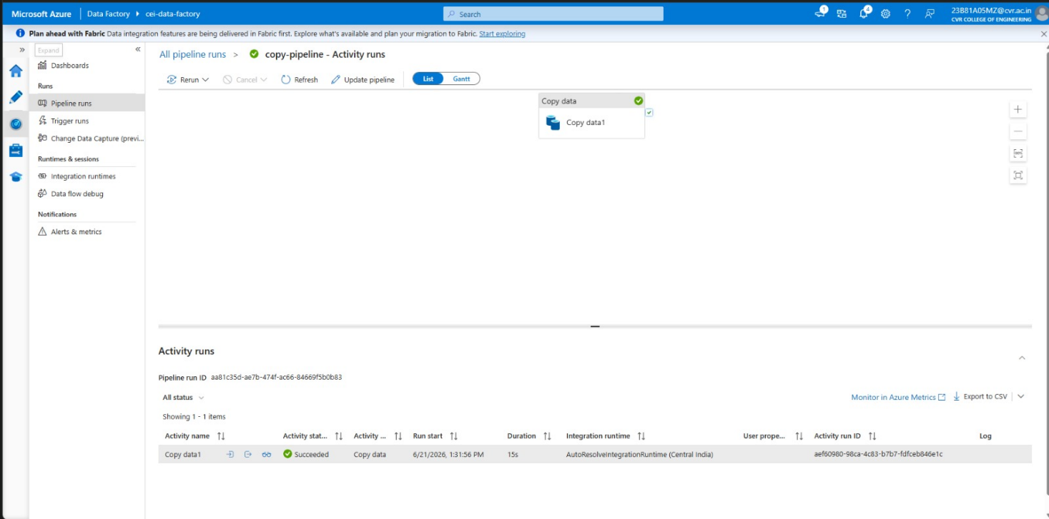
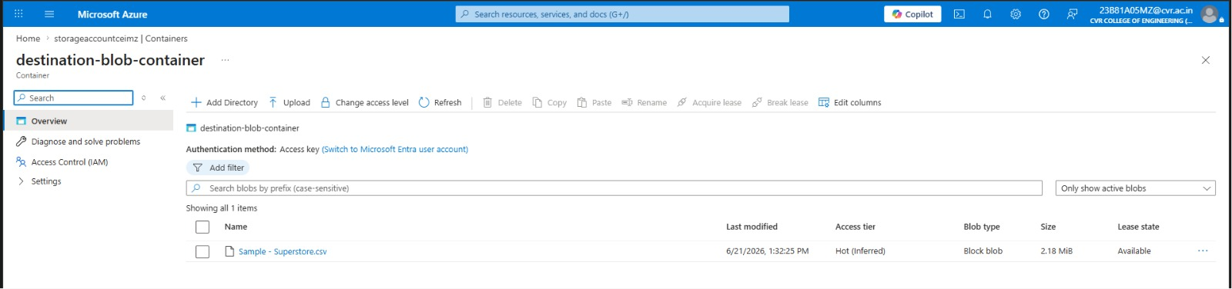

Task 6: IAM Roles
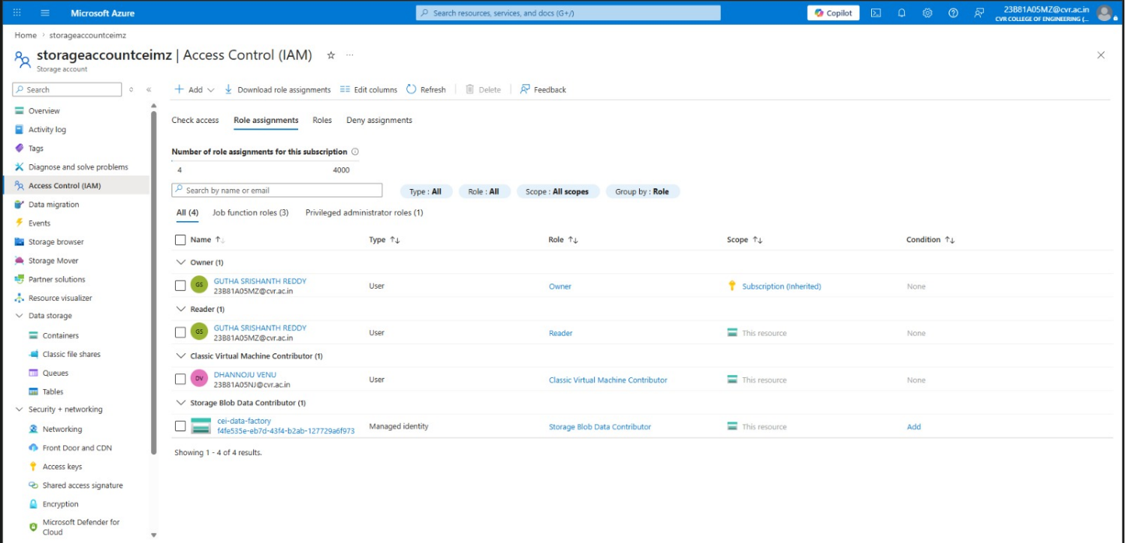

Mini Project (Final Task)
Build a complete pipeline that reads a CSV file from Blob Storage and processes it using Azure Data Factory.
Requirements:
- Source: CSV file in Blob
- Use: Linked Service + Dataset + Pipeline
- Process: Copy Data + Metadata check
- Destination: New file/location
Approach:
- Created a resource group named “cei-resource-group”
- Created a storage account “storageaccountceimz” and added a storage container
“superstore-blob-container” with the csv in it.
- Created a linked service to connect with ADF with the blog storage.
- Created dataset(source) and destination(sink).
- Created a metadata Pipeline to validate the source file.
- Created a new pipeline “copy-pipeline” to copy the file from source to sink.
- Executed the pipeline using Debug, Triggers (trigger now).
- Finally verified if the file was successfully moved from the source to the sink.

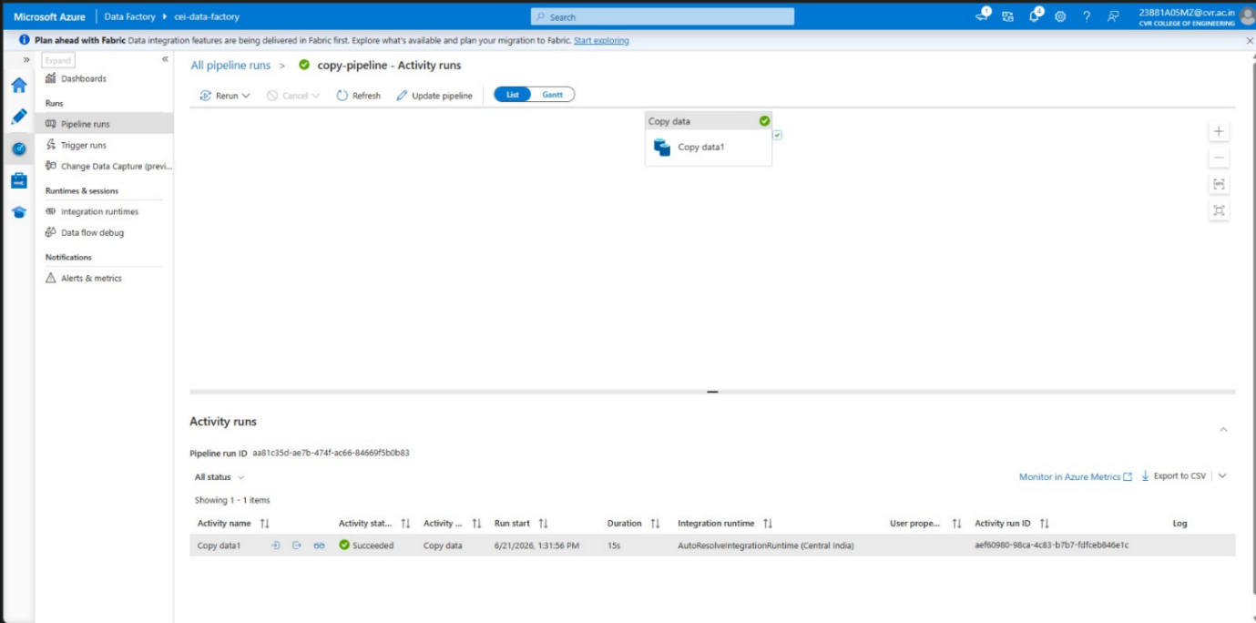
Pipeline executed successfully

