

**19CSE446  
IOT – INTERNET OF THINGS**

**SMART TERRACE PLANTATION SYSTEM**

**TEAM MEMBERS**

**TEAM NO : 22**

|  |  |  |  |
| --- | --- | --- | --- |
| **S.NO** | **NAME** | **ROLL NUMBER** | **PHONE NO** |
| **01** | **Sai Karthik** | **CB.EN.U4CSE22013** | **9177283507** |
| **02** | **Nishanth Sai** | **CB.EN.U4CSE22028** | **9676015937** |
| **03** | **Thumma Jahnavi** | **CB.EN.U4CSE22051** | **7729914266** |
| **04** | **Guna Vardhan** | **CB.EN.U4CSE22220** | **8143143426** |

**Table of Contents**

1. **Abstract**
2. **Introduction**
3. **Project Objectives  
    3.1 Main Objective  
    3.2 Sub-objectives**
4. **IoT System Architecture and Design  
    4.1 Problem Statement and Literature Survey  
    4.2 Proposed System Overview  
    4.3 Hardware Components  
    4.4 Software Architecture  
    4.5 Edge and Cloud Integration  
    4.6 Identification of Things  
    4.7 IoT Level Classification  
    4.8 Intelligence at Edge and Cloud**
5. **Data Analytics and User Interface  
    5.1 Analytics Metrics  
    5.2 UI Layout and Features**
6. **Implementation and Demo  
    6.1 Hardware Setup  
    6.2 System Pictures and Screenshots**
7. **Challenges and Solutions**
8. **Conclusion**
9. **References**

**PROJECT REPORT**

*SMART TERRACE PLANTATION SYSTEM*

**1. Abstract:**

The Smart Terrace Plantation System is an IoT and AI-based solution developed to simplify and automate urban terrace gardening. It monitors key parameters like soil moisture, temperature, humidity, and plant health using low-cost sensors and edge AI. Leveraging ESP32 microcontrollers, and a Raspberry Pi for real-time processing, the system ensures efficient irrigation and early disease detection. A web/mobile dashboard allows users to remotely monitor and control the plantation. This project emphasizes cost-effectiveness, energy efficiency, and scalability, offering a modern approach to sustainable urban farming.

**2. Introduction**

In today's urban lifestyle, terrace gardening has become an essential way to reconnect with nature, promote sustainability, and ensure food security. However, the challenges associated with manual maintenance such as inconsistent irrigation, undetected plant diseases, and lack of real-time monitoring hinder the efficiency and growth of terrace plantations. The Smart Terrace Plantation System addresses these issues by integrating modern technologies like the Internet of Things (IoT) and Artificial Intelligence (AI). This system automates irrigation based on environmental conditions, diagnoses plant health using edge-based image processing, and offers users remote control through a web or mobile interface. The goal is to make urban gardening easier, more efficient, and accessible for everyone.

**3. Project Objectives**

**3.1 Main Objective**

To design and develop a **Smart Terrace Plantation System** that automates irrigation and plant monitoring using IoT and AI.

**3.2 Sub-objectives**

* Monitor soil moisture, humidity, and temperature in real-time.
* Automatically irrigate based on soil moisture levels.
* Use edge AI for plant disease detection.
* Visualize data through a user-friendly dashboard**.**

**4. IoT System Architecture and Design**

**4.1 Problem Statement and Literature Survey**

Terrace gardening in urban environments faces inefficiencies due to manual irrigation and lack of continuous plant health monitoring. Studies and systems globally focus on large-scale agriculture, but terrace-specific smart systems are limited. This project aims to bridge that gap by applying IoT and AI to small-scale setups.

**4.2 Proposed System Overview**

We propose a comprehensive IoT system that combines sensor-based monitoring, edge AI, and cloud analytics. The system includes:

* **ESP32 end nodes** with sensors and actuators
* **Raspberry Pi edge node** for processing and disease detection
* **Cloud platforms** (Firebase/AWS) for analytics, control, and storage
* **Dashboard** for visualization and manual overrides
* **Websockets** for end to edge communication

**4.3 Hardware Components**

* **Sensors:** • Soil Moisture Sensor  
   • DHT11 (Temperature & Humidity)  
   • Camera Module for plant image capture
* **Actuators:** • Water pumps (12V DC)  
   • Relay Module
* **Devices:  
   •** ESP32 microcontrollers as end nodes  
   • Raspberry Pi as the edge node

**4.4 Software Architecture**

* **End Node (ESP32):  
   •** Written in Arduino IDE  
   • Reads sensor data and triggers pumps via relays  
   • Sends data using Websocket to the edge node
* **Edge Node (Raspberry Pi):** • Receives data  
   • Processes images using a MobileNet model  
   • Publishes data to AWS using MQTT/REST APIs
* **Cloud Platform:  
   •** Stores data  
   • Sends alerts to users  
   • Hosts real-time dashboard

**4.5 Edge and Cloud Integration**

The edge node handles real-time tasks like image classification and local decision-making. The cloud aggregates data, visualizes trends, and sends alerts. This division ensures both speed and scalability.

**4.6 Identification of Things**

All devices are uniquely identified using MAC addresses. Authentication tokens are used for secure cloud communication and access control.

**4.7 IoT Level Classification**

This system qualifies as **IoT Level 5**:

* Large number of sensors
* Intelligent edge device
* Cloud integration for monitoring and analytics
* Web and mobile UI for users

**4.8 Intelligence at Edge and Cloud**

* **Edge AI**: Raspberry Pi runs a lightweight MobileNet model to detect plant diseases on-site.
* **Cloud Intelligence**: Firebase/AWS analyzes long-term trends, forecasts irrigation needs, and sends alerts.

**5. Data Analytics and User Interface**

**5.1 Analytics Metrics**

* Soil moisture trends over time
* Daily water usage
* Correlation between temperature and irrigation frequency
* Plant health status reports

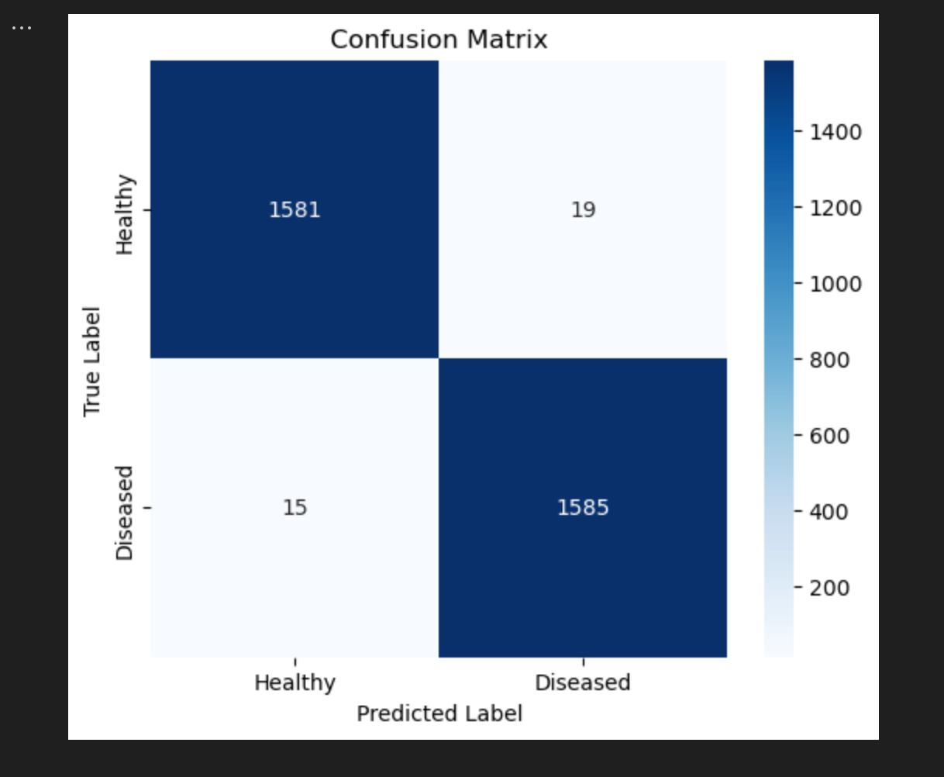

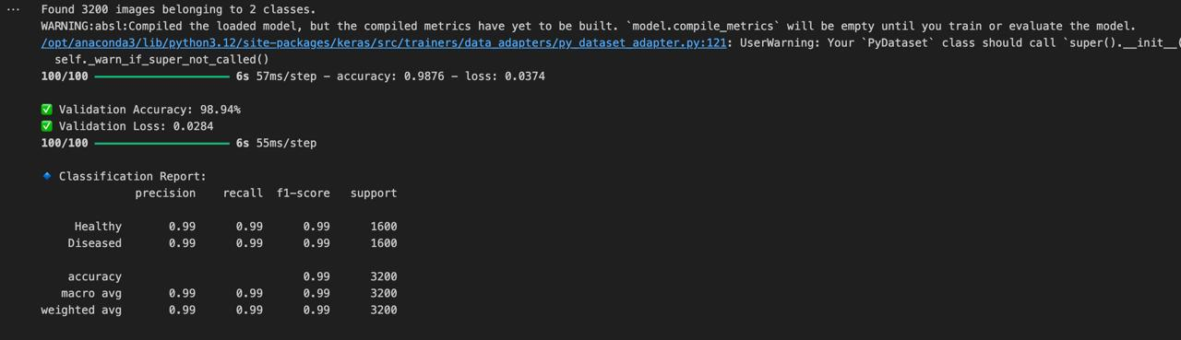

**5.2 UI Layout and Features**

* Dashboard with live sensor values
* Graphs showing historical data
* Plant image gallery and disease alerts
* Manual override to trigger irrigation

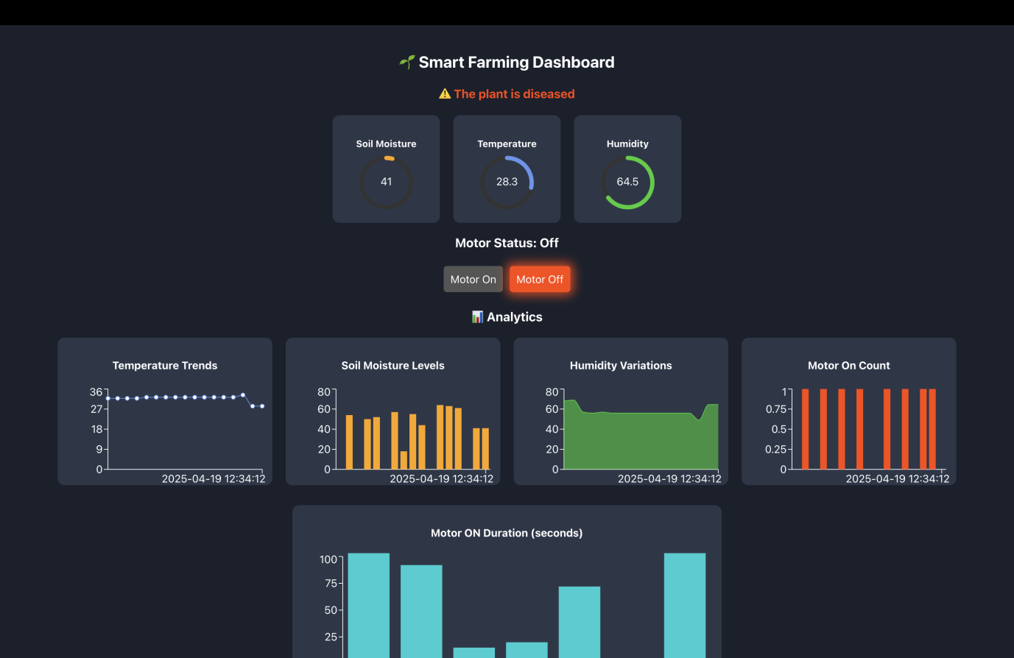

**6. Implementation and Demo**

**6.1 Hardware Setup**

Photos and circuit diagrams showcasing:

* Sensor and pump connection to ESP32
* Watering system in a terrace environment

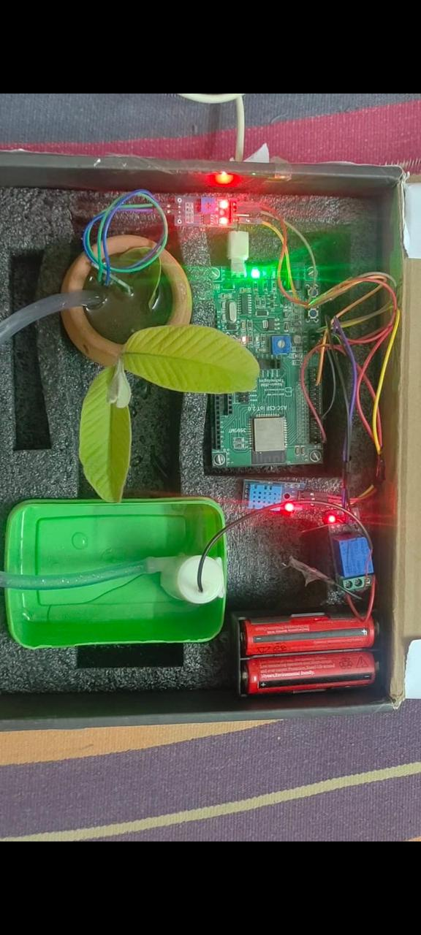

**6.2 System Pictures and Screenshots**

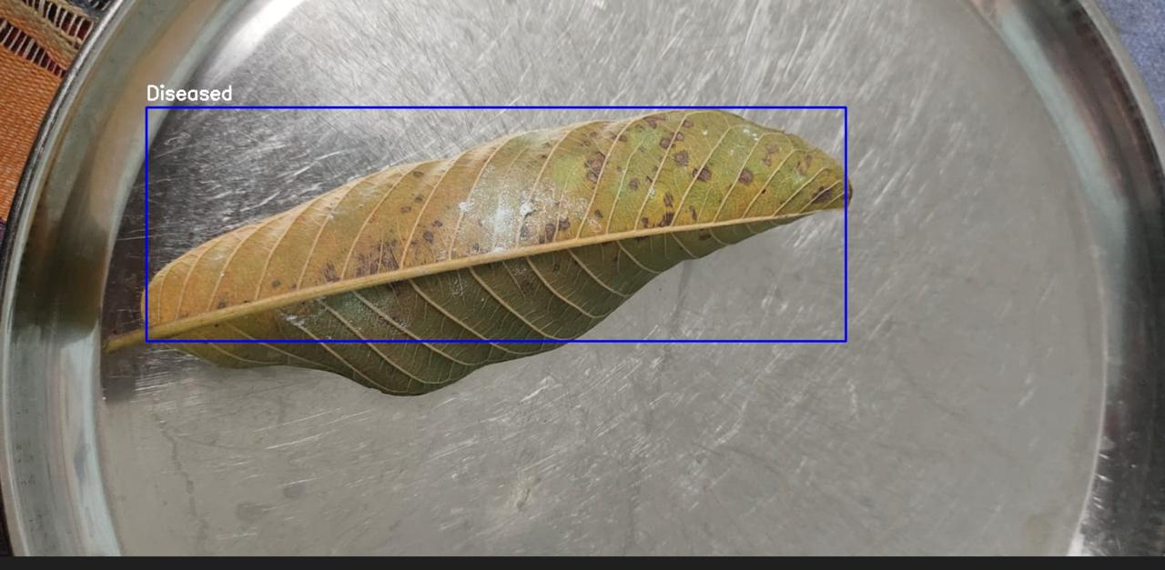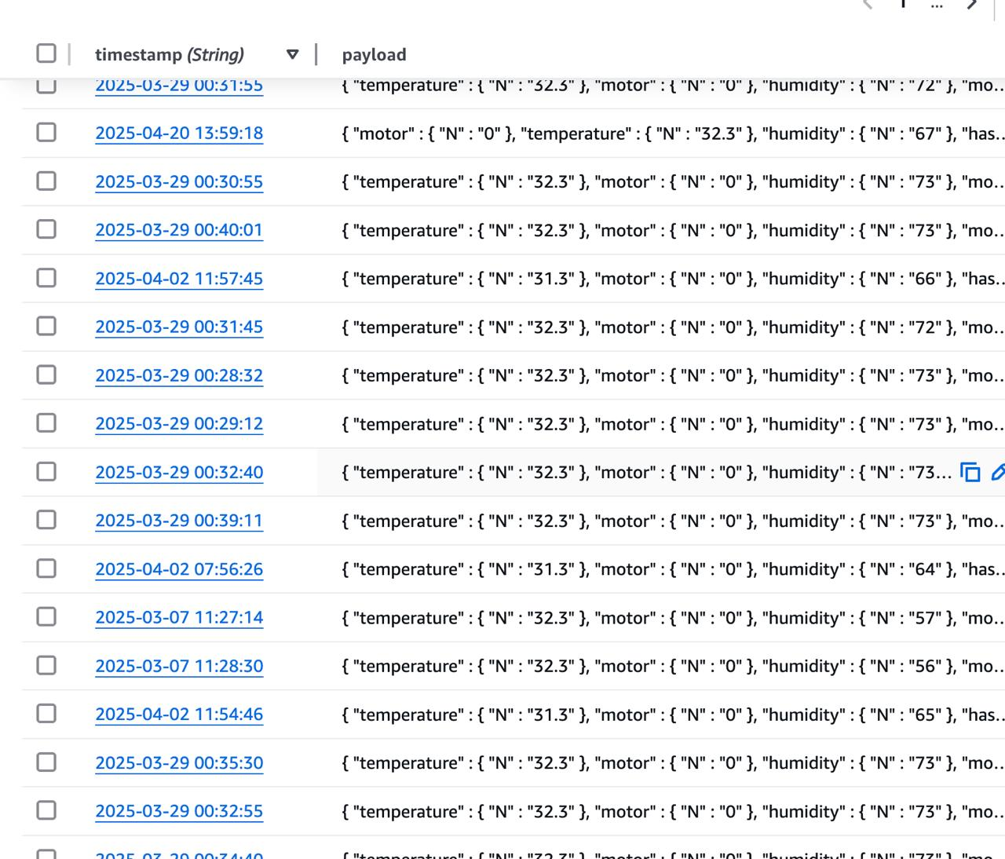

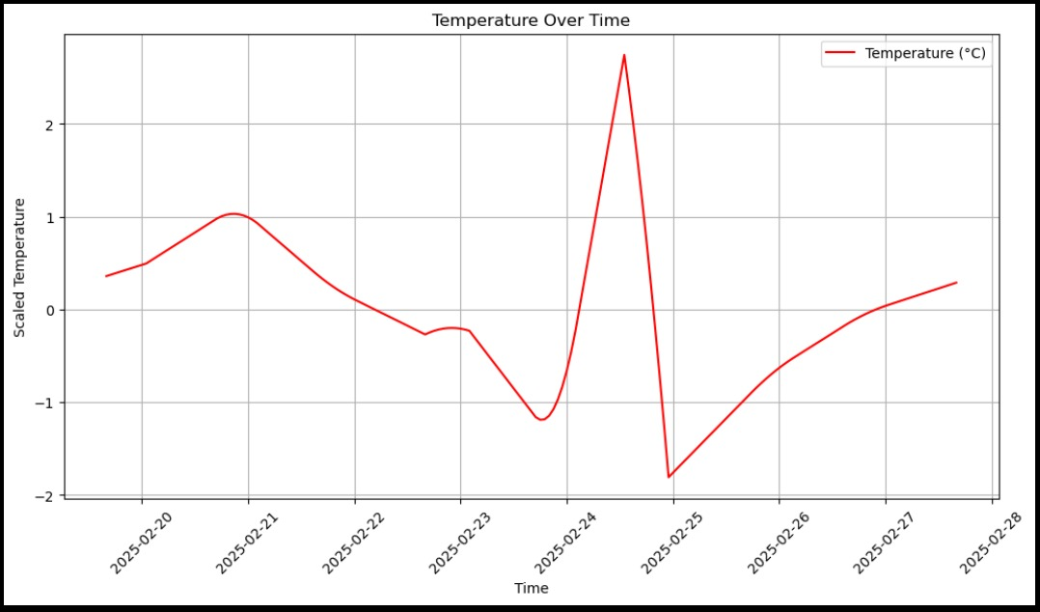

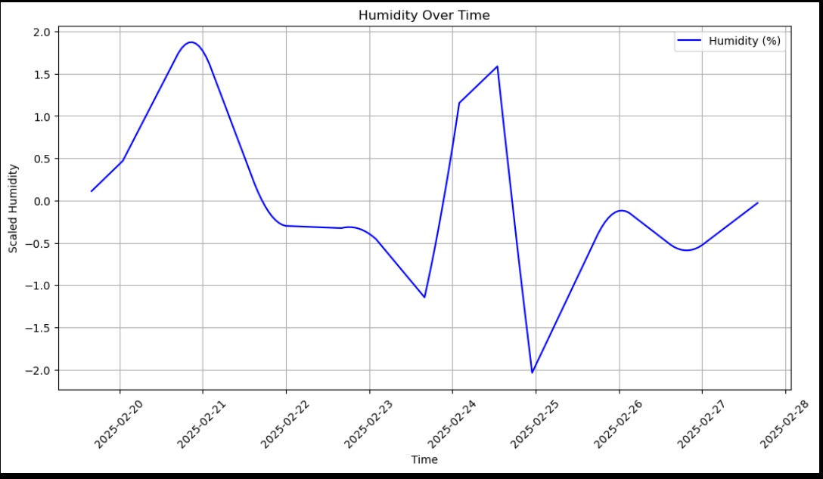

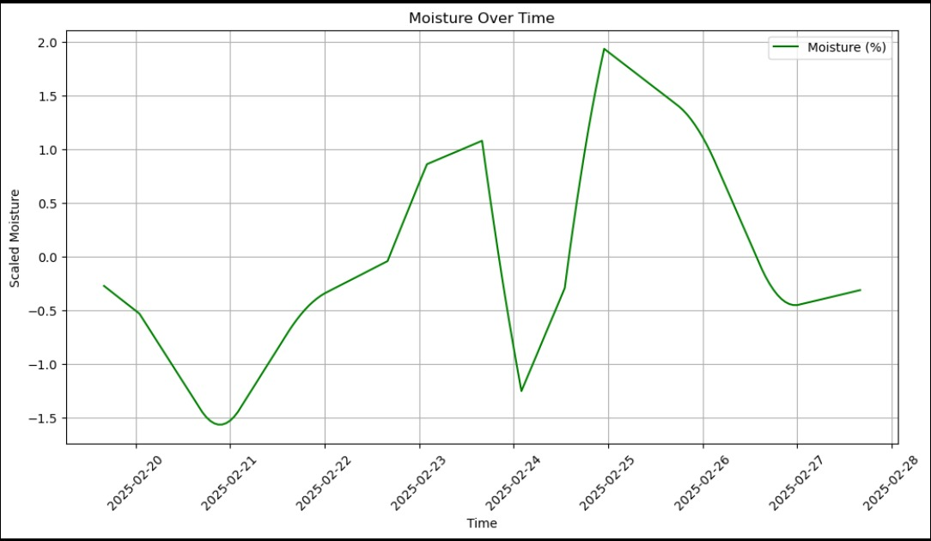

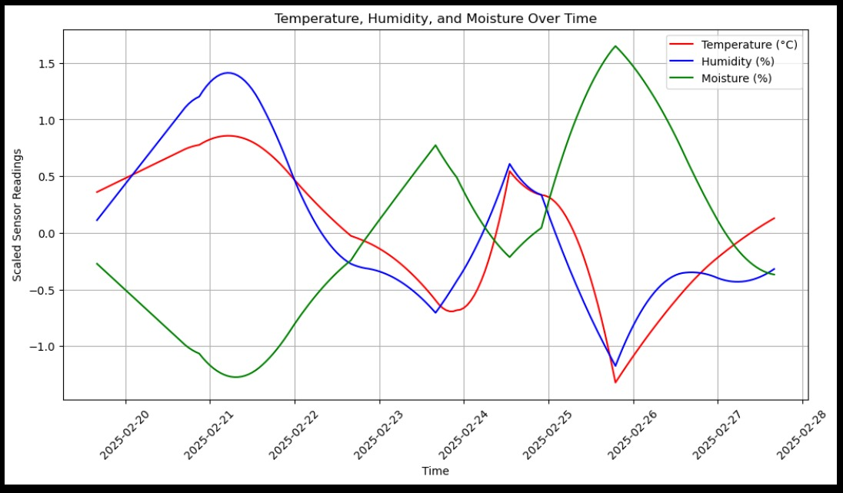

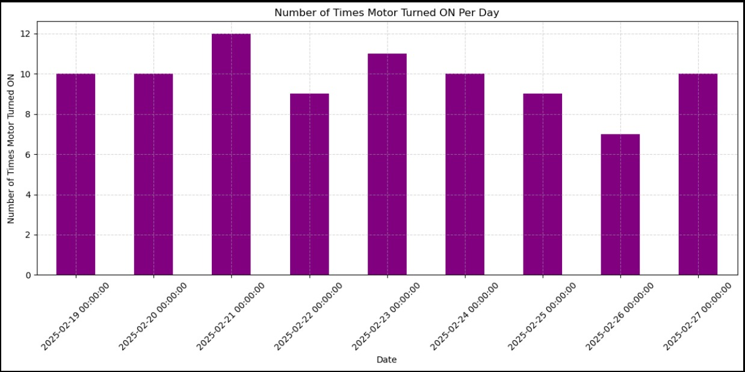

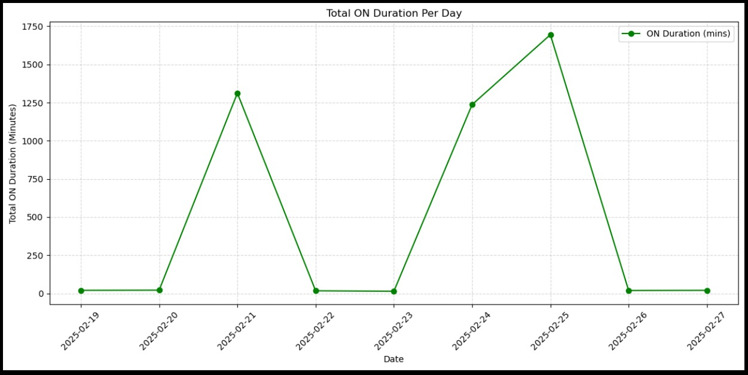

**7. Challenges and Solutions**

* **Limited processing on ESP32** → Offloaded AI to Raspberry Pi
* **Waterproofing electronics** → Used protective casing and silicone
* **Power fluctuations** → Added voltage regulator and battery backup

**8. Conclusion**

This system provides an efficient and smart way to manage terrace gardens using modern technologies like IoT and edge AI. It supports sustainable practices, reduces manual work, and empowers users with data-driven gardening.

**9. References**

* Arduino & Raspberry Pi Documentation
* AWS IoT Core & Firebase Docs
* MQTT Protocol Specs
* PlantVillage Dataset (Disease Detection)
* ThingsBoard / ReactJS / Flutter Docs

***Prepared by:*** *Team No. 22*  
***Institution:*** *Amrita Vishwa Vidyapeetham, Coimbatore, Tamil Nadu*  
***Guide****: Dr. Anantha Narayanan V****.***