SRS
Campus Smart Assisten
Written by Ari Guterman

1. Introduction
- Purpose: The purpose of this Software Requirements Specification (SRS) is to clearly define the functional and non-functional requirements for the Smart Campus Assistant. This document will serve as the primary guide for developers, stakeholders, and project managers to understand exactly what the system will do and how it will perform. Today the users need to find each relvent information by his own, searching for it in the web app.
- Project Scope: The Smart Campus Assistant is an AI-powered chatbot designed to help students and campus staff quickly find campus-related information. By leveraging Large Language Models (LLMs), the system processes user questions and provides answers based strictly on a predefined dataset containing FAQs (such as campus hours, available classes, and more). The scope of this project is explicitly limited to this defined data. The assistant will not engage in general purpose conversations or assist with tasks outside of its designated, campus specific knowledge base.
- Definitions & Acronyms:
  - FAQ: Frequently Asked Questions
  - LLM: Large Language Model

2. Stakeholders
- The Actors
  - Campus Student (Primary Actors): The everyday end-users of the system. They interact with the chatbot interface to ask questions about campus hours, classes, and other FAQs. They require a simple, intuitive user interface and have standard access permissions.
  - Campus Staff (Primary Actors): Professors, lecturers, and faculty members. They interact with the chatbot to ask questions just like students. Additionally, they hold specific, limited write permissions that allow them to update their own personal directory data (such as office hours and contact information) within the database.
  - System Admin (Administrative Actor): The technical or administrative staff responsible for maintaining the system. They have privileged access to update the predefined dataset (the FAQs), and manage user access if necessary.

  - LLM API (System Actor): An external service that processes the natural language input provided by the end-users. The Smart Campus Assistant sends the user's prompt and the defined campus data to this API, which returns a formulated response.

3. Functional Requirements & Use Cases
Functional Requirements:
- The system must provide a web-based chat interface that allows users to submit queries and view the system's responses.
- The system must restrict its generated responses strictly to the context retrieved from the campus database and must not generate information outside of this provided data.
- The system must provide an administrative function that allows authorized users to insert, update, or delete campus information in the database.
- The system must treat each user interaction as a stateless session and shall not save or use chat history from previous conversations in order to optimize the LLM context window.
- If the system cannot find relevant context in the campus database to answer a user's query, it must return a standard, predefined fallback message.
Use Case 1: Student Requests Specific Campus Data
- Actor: Campus Student, LLM Serivce
- Preconditions: The student is securely logged into the system and holds a valid session token.
- Main Flow:
- The student accesses the main chat interface.
- The student submits a query requesting their personal test dates and times.
- The system's displays a loading indicator.
- The system queries the campus database to retrieve the specific test schedule for that user.
- The system formats the retrieved data and user query, sending it to the LLM to generate response.
- The system displays the formatted test dates and associated data to the student in the chat interface.
- Alternate Flow: If the database returns no relevant context for the user's query in step 4, the system triggers a strict fallback prompt. The LLM generates a predefined refusal message, and the system displays this to the user

Use Case 2: Administrator Updates Campus Database
- Actor: System Admin
- Preconditions: The administrator is logged into the system
- Main Flow:
- The administrator accesses the secure database management interface.
- The administrator selects the option to enter new data or retrieve current data.
- The administrator inputs new campus data and submits the form.
- The system successfully saves the new data to the database.
- The system displays an "Accepted" success status message to the administrator.
- Alternate Flow If the data in step 4 is malformed, missing required fields, or fails validation, the system rejects the input and displays a "Rejected" error status detailing the issue.
Use Case 3: User Registration and Admin Approval
- Actors: Unregistered User , System Admin
- Precondition: The user does not currently have an active account in the system.
- Main Flow:
- The unregistered user navigates to the registration page.
- The user enters their email, a secure password, and their official Campus ID, then submits the form.
- The system validates the input format, securely hashes the password, and creates a new user record in the database with a "Pending Approval" status.
- The system displays a message to the user stating that their account is pending administrator review.
- The System Admin logs into the administrative dashboard and views a list of pending registrations.
- The Admin verifies the Campus ID and clicks "Approve" for the specific user.
- The system updates the user's status in the database to "Active" and assigns them the "Student" role.
- Alternate Flow: In step 6, if the Admin recognizes the Campus ID as invalid or unauthorized, they click "Reject." The system updates the status to rejected and the user is not granted access.
Use Case 4: Campus Staff Updates Personal Office Hours
- Actor: Campus Staff
- Preconditions: The staff member is securely logged into the system and holds a valid session token with "Staff" role privileges.
- Main Flow:
- The staff member navigates to their personal profile management interface on the web app.
- The staff member selects the option to edit their personal directory data (e.g., office hours or contact information).
- The staff member inputs their new available hours and submits the changes.
- The backend validates the time format and verifies that the JWT token matches the ID of the directory record being modified.
- The system securely updates the specific staff member's record in the database.
- The system displays a "Successfully Updated" confirmation message to the staff member.
- Alternate Flow (Authorization Failure): If the a staff member maliciously attempts to modify another professor's hours, the backend immediately rejects the request, prevents the database update, and displays an "Unauthorized Action" error message.

4. Non-Functional Requirements
- Performance:
  - Upon receiving a user query, the system must process the request and begin displaying a response in the chat interface within 10 seconds under normal server load.
- Security:
  - The system must utilize JSON Web Tokens (JWT) to securely manage user sessions and authenticate API requests between the frontend and the backend.
  - The system must implement strict user roles. Administrative endpoints, such as those used to modify the campus database, must strictly reject any requests that do not contain a valid Admin JWT.
- Reliability & Availability:
  - To ensure maximum reliability, data compliance, and minimal network latency for the target user base, the system's core infrastructure must be deployed in the AWS Middle East (Tel Aviv) Region

- System Models (UML Diagrams)
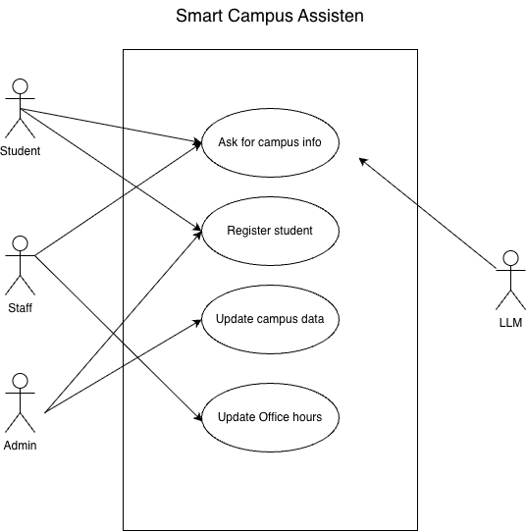
5.1 Use Case Diagram

5.2 Sequence Diagrams
