Image 1: Web Scraped table from <https://en.wikipedia.org/wiki/Fantasy_Premier_League>

Fantasy Premier League (FPL) is the official and largest free to play fantasy football game based on the top division of English Football, the Premier League. The online game allows users build and manage their own virtual teams using actual players from the English Premier League. By building a squad of actual EPL players and collecting points depending on their actual performance in games, the game lets spectators get involved with the sport.

With the Premier League season already kicking off and FPL points being racked up in already, on today’s blog, we’ll look at the previous FPL chart toppers and pull data on them.

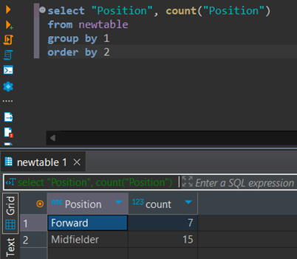

Image 2: Positions of FPL top point scorers

Of all the FPL seasons since its inception, 15/22 of the point chart toppers were from players listed as Midfielders. In FPL, Midfielders are historically rewarded more points for goals then their striking counter parts. Midfielders also attain clean sheet points for keeping the opposition from scoring goals. This can make it easier for top end Midfielders to rack up points, in most seasons at least. However, there are strikers who beat the odds and finish top of the points chart.

Image 3: Most frequent top points scorers. The crown amongst kings.

This is the sum of all points scored by FPL leading seasons. Premier League legend Thierry Henry accumulated the most points over his 3 FPL winning seasons for a forward. In the future, if Haaland manages to replicate his 272 points in his sole FPL winning season, he’ll eclipse Henry’s record of most points as a forward. He’d still be behind the leader of our table here, Mohamed Salah.

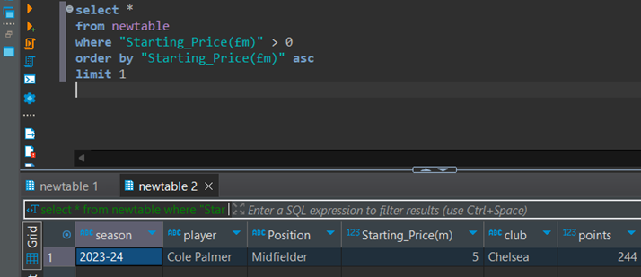

Image 4: Lowest of the Highs? Cole Palmer had the lowest starting price of any FPL top scorer.

Another player listed as a Midfielder, go figure. Cole Palmer topped the FPL points chart last season, but why was this season particularly strange? Cole Palmer became the player with the cheapest starting cost to accumulate the most points in a season. At £5m, the price seemed to be fairly set at the start of the season with him being a squad player at Manchester City the season prior. However, seeking the chance for more regular football, he moved to Chelsea where his star began to shine. Nevertheless, finishing top of the FPL points table was still very unexpected, considering Erling Haaland took the league by storm the year prior. The season Cole Palmer had, shows that price doesn’t necessarily correlate with who gets the most points.

Image 5: Most successful FPL clubs. Hello Leicester.

Lastly, the big 4 was a term popularised in the early 00s to describe what were generally seen as the best 4 teams in the country, Arsenal, Chelsea, Liverpool, Manchester United. These teams frequently finished at the top of the league (not Liverpool). There’s some correlation here as these teams are also have players finish top of the FPL charts most frequently too.

With the tabular data we have looked at today we can suggest a the FPL top scorer for the 2024/25 season will most likely be a Midfielder/Forward. Will likely be a player with one of the higher starting prices and could be from a a team that finishes in the top 4. Keeping that in mind, Erling Haaland looks like a safe bet, especially with his 4 goals to start the season. Unless Manchester City sell another promising youngster again before the trasnfer window closes!