

REQUIREMENTS DOCUMENT FOR THE VMU POWER-SPLIT MODE LOGIC

Team:
Bruna Fortes
Danilo Varini
Gustavo Silva
Hugo Cardoso
Marinel Almeida

APRIL
2026
1. INTRODUCTION 3
1.1 Adopted Conventions 3
1.2 Problem Statement 3
1.3 Purpose and Project Goals 4
1.3.1 Purpose 4
1.3.2 Project Goals 4
1.3.3 Forward Plan Alignment 5
2. USE CASE DIAGRAM 5
2.1 Actors 6
2.2 Main supervisory function 6
2.3 Operational use cases 6
2.4 Boundary conditions and out-of-scope behavior 7
2.5 Overall interpretation of the diagram 7
3. STATE DIAGRAM 8
3.1 Legend and Enumerated Transitions 9
3.1.1 Top-Level Transitions 10
3.1.2 Internal Transitions of Motion_mode_ICE 10
4. FUNCTIONAL REQUIREMENTS 11
4.1 High-level system functional requirements 11
4.1.1 [SysHLR01] Power-Split Supervisory Mode Selection 11
4.1.2 [SysHLR02] Deterministic Powertrain Enable Coordination 11
4.1.3 [SysHLR03] Calibratable and Hysteretic Transition Strategy 12
4.2 High-level software functional requirements 12
4.2.1 [SwHLR01] Initialization Behavior 12
4.2.2 [SwHLR02] Deterministic Output Mapping by Active Mode 12
4.2.3 [SwHLR03] Standstill Mode Transition Family 13
4.2.4 [SwHLR04] EV Mode Transition Family 13
4.2.5 [SwHLR05] Regenerative-Braking Transition Family 13
4.2.6 [SwHLR06] Engine-Supported External Exit Family 13
4.2.7 [SwHLR07] Start Mode Internal Transition Family 14
4.2.8 [SwHLR08] ICE Mode Internal Transition Family 14
4.2.9 [SwHLR09] Hybrid Mode Internal Transition Family 14
4.2.10 [SwHLR10] Initialization and Invalid-Mode Recovery Outside the Modeled Transition Set 15
4.3 Low-level software functional requirements 15
4.3.1 [SwLLR01] Standstill Mode to EV Mode 15
4.3.2 [SwLLR02] Standstill Mode to Start Mode 15
4.3.3 [SwLLR03] EV Mode to Regenerative-Braking Mode 16
4.3.4 [SwLLR04] EV Mode to Start Mode 16
4.3.5 [SwLLR05] EV Mode to Standstill Mode 16
4.3.6 [SwLLR06] Regenerative-Braking Mode to Start Mode 16
4.3.7 [SwLLR07] Regenerative-Braking Mode to Standstill Mode 17
4.3.8 [SwLLR08] Regenerative-Braking Mode to EV Mode 17
4.3.9 [SwLLR09] Start Mode to Regenerative-Braking Mode 17
4.3.10 [SwLLR10] ICE Mode to Regenerative-Braking Mode 18
4.3.11 [SwLLR11] Hybrid Mode to Regenerative-Braking Mode 18
4.3.12 [SwLLR12] Start Mode to EV Mode 18
4.3.13 [SwLLR13] ICE Mode to EV Mode 19
4.3.14 [SwLLR14] Hybrid Mode to EV Mode 19
4.3.15 [SwLLR15] Start Mode to Standstill Mode 19
4.3.16 [SwLLR16] ICE Mode to Standstill Mode 20
4.3.17 [SwLLR17] Hybrid Mode to Standstill Mode 20
4.3.18 [SwLLR18] Start Mode to Hybrid Mode 20
4.3.19 [SwLLR19] Start Mode to ICE Mode 20
4.3.20 [SwLLR20] ICE Mode to Start Mode 21
4.3.21 [SwLLR21] ICE Mode to Hybrid Mode 21
4.3.22 [SwLLR22] Hybrid Mode to Start Mode 21
4.3.23 [SwLLR23] Hybrid Mode to ICE Mode 22
5. NON-FUNCTIONAL REQUIREMENTS 22
5.1 [NfHLR01] Periodic Execution and Sample Time 22
5.2 [NfHLR02] Transition Stability and Hysteresis Preservation 22
5.3 [NfHLR03] Static Allocation and Bounded State Storage 22
5.4 [NfHLR04] Deterministic Outputs and Reproducibility 23
6. TRACEABILITY 23
6.1 Traceability Between Stakeholder Use Cases and System Requirements 23
6.2 Traceability Between System Requirements and High-Level Software Requirements 23
6.3 Traceability Between High-Level and Low-Level Software Requirements 24
6.4 Traceability Between Software Requirements and Stateflow Basis 24
7. CONCLUSION 25
8. REFERENCES 26
Appendix A - Glossary 27

1. INTRODUCTION

1.1 Adopted Conventions
To facilitate identification, allocation, and bidirectional traceability throughout this document, each requirement category uses a dedicated identifier convention:
- Use Cases are represented in the format [UC#];
- High-level system functional requirements are represented in the format [SysHLR#];
- High-level software functional requirements are represented in the format [SwHLR#];
- Low-level software functional requirements are represented in the format [SwLLR#];
- Non-functional requirements are represented in the format [NfHLR#];
- “#” represents the requirement number.

1.2 Problem Statement
Hybrid electric vehicles (HEVs) have become a key technology in the automotive industry’s transition toward lower-emission and more energy-efficient mobility [1]. By combining an internal combustion engine with one or more electric machines and a traction battery, HEVs can recover braking energy, operate in pure-electric mode at low speeds, and reduce fuel consumption and CO₂ emissions when compared to conventional powertrains. This makes them especially relevant in regions with strict emission regulations and dense urban driving cycles, where short trips and frequent stops favor the use of the electric machine, while the engine remains available for higher-power demands and longer trips.
Among the available HEV architectures, the power-split topology is widely adopted because it allows the supervisory controller to flexibly distribute torque between the engine, the motor, and the generator according to the driving conditions. This flexibility, however, also requires a mode-management strategy that decides when the vehicle should operate as a pure electric vehicle, when the engine should be started, when regenerative braking is admissible, and when hybrid operation is the most appropriate choice. The correctness of this supervisory decision directly affects fuel economy, drivability, battery life, and the consistency of the powertrain behavior across drive cycles, which justifies treating the mode logic as a dedicated requirement subject in this document.
The HEV_powersplit_adapted model uses a power-split supervisory function called Control/Mode Logic. This model-level supervisor decides the operating mode and the enable signals required by the surrounding plant. The decision is based on vehicle speed, requested power, battery state of charge, and engine speed.
The Stateflow chart contains the top-level states StandStill, EV_mode, RegenB_mode, and Motion_mode_ICE, with the internal substates Start_mode, ICE_mode, and Hybrid_mode. For software implementation and traceability, this hierarchical behavior is represented in software as six explicit operating modes corresponding to standstill, EV, regenerative braking, start, ICE, and hybrid behavior.
The engineering objective is to define a requirement baseline so that the power-split model and the future software implementation remain aligned to the same intended behavior. This document defines system requirements, software requirements, and non-functional requirements with explicit IDs so that vertical and horizontal traceability can follow from operational scenarios to model behavior and to the software that will be derived from it.

1.3 Purpose and Project Goals

1.3.1 Purpose
This document defines the requirements baseline for the VMU power-split mode logic used in the HEV_powersplit_adapted model and for the corresponding software implementation that will be derived from it. The baseline defines the intended system behavior, software behavior, and non-functional constraints for the VMU power-split mode logic. Figure 1 below illustrates the power-split hybrid drivetrain that is taken as the reference architecture in this document.
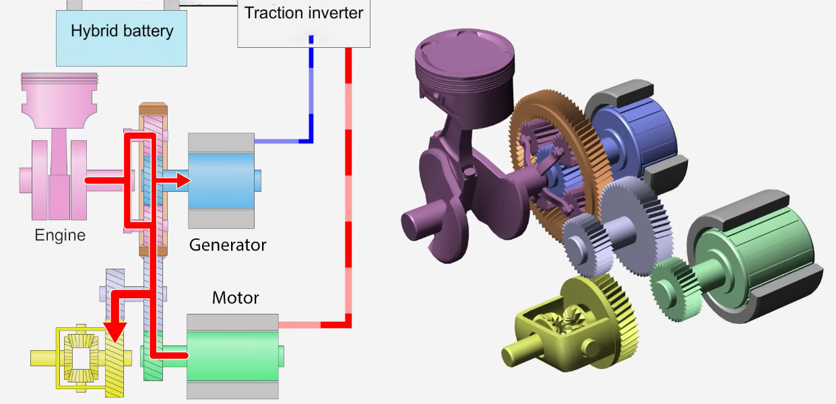
Figure 1: Power-split hybrid drivetrain model adopted as the reference architecture in this document. The internal combustion engine, the generator and the traction motor are linked through a planetary gear set, and electrical energy is exchanged with the battery through the traction inverter. Source: Authors.

1.3.2 Project Goals
The project goals for this baseline are to align the requirements with the current Stateflow chart, distinguish system, software, and non-functional requirements, and support traceability from use cases to model behavior and to the future software implementation.
- Reflect the actual states, transitions, inputs, outputs, and calibrations of the current power-split mode logic.
- Provide a clear split between system-level behavior, software behavior, and non-functional constraints.
- Support traceable development artifacts for the Simulink model, the future software implementation, and the planned functional, unit-test, and static-analysis evidence.
- Keep the scope limited to mode selection, transition criteria, and mode-dependent enable outputs; degraded mode handling, clutch sequencing, and detailed torque arbitration remain out of scope.

1.3.3 Forward Plan Alignment
The document is aligned with the project deliveries: requirements with IDs, Simulink modeling consistent with those requirements, the planned software implementation, and later test-coverage artifacts. The traceability structure also follows the Automotive SPICE V-cycle rationale by connecting operational scenarios, system requirements, software requirements, and implementation evidence.

2. USE CASE DIAGRAM
This section presents the use case view of Control/Mode Logic. The use cases remain at the actor-to-system level and describe the main supervisory situations handled by the powersplit mode logic, while the internal realization by states, substates, and transition guards is deferred to Sections 3 and 4.
Figure 2 represents the use case diagram of the VMU power-split mode logic. It uses one central function, Manage power-split operation modes, surrounded by a compact set of operational use cases that cover launch, EV propulsion, engine-supported propulsion, regenerative braking, engine-supported mode reselection, and return to standstill. Internal distinctions such as Start_mode, ICE_mode, and Hybrid_mode belong to the state-machine view in Section 3 and shall not appear as top-level use cases in this diagram.
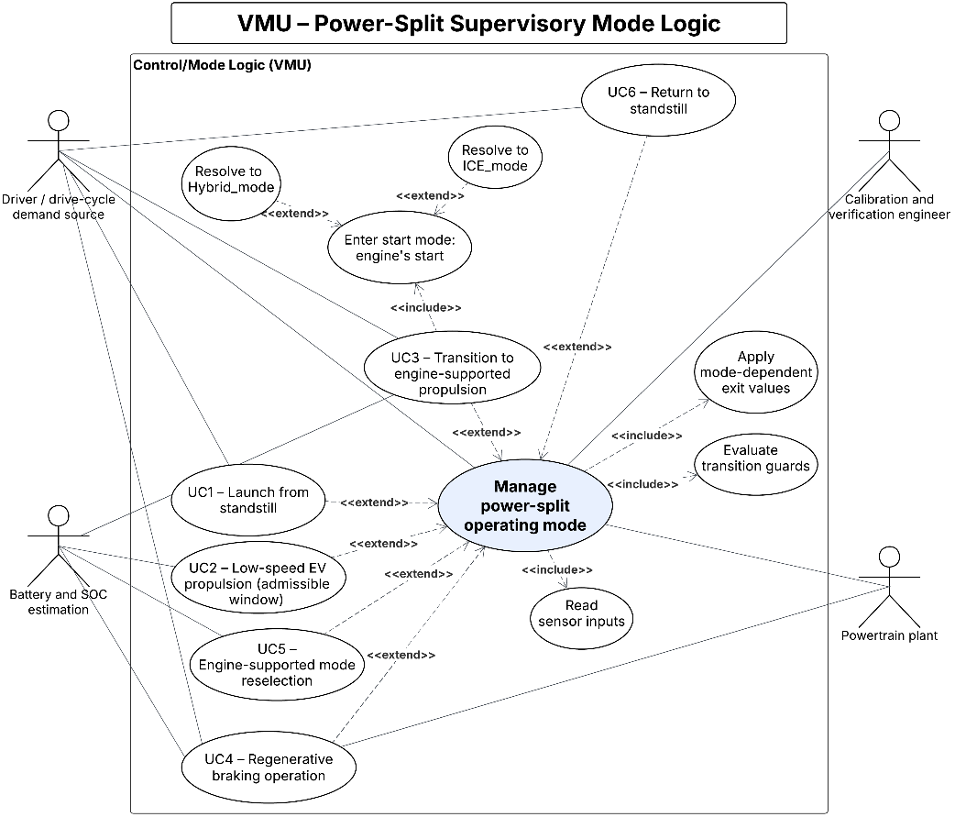
Figure 2: Use case diagram of the VMU power-split supervisory mode logic, showing the central function Manage power-split operating mode, the operational use cases UC1–UC6 with their include and extend relationships, and the actors that interact with the system. Source: Authors.
Table 1. Summary of the VMU use cases
Identifier | Use case summary
UC1 | Launch from standstill.
UC2 | Low-speed EV propulsion.
UC3 | Engine-supported propulsion when the EV window closes.
UC4 | Braking-driven energy recovery.
UC5 | Engine-supported mode reselection.
UC6 | Return to standstill.
For this project, UC1 to UC6 serve as the stakeholder-level operational expectations for the Control/Mode Logic scope. Because no separate stakeholder requirement specification is maintained for this bounded supervisor, the system requirements in Section 4 trace back to these use cases as the originating stakeholder source.

2.1 Actors
Driver / drive-cycle demand source - In the current model, the driver request is represented indirectly by vehicle speed and requested power rather than by raw pedal signals. These signals define whether propulsion or regenerative operation is being requested from the mode logic.
Battery state-of-charge information - The battery-related interface provides the state-of-charge information used by the mode logic to admit or reject EV operation, regenerative operation, and entry into engine-supported propulsion.
Powertrain plant - The surrounding powersplit plant consumes Mot_Enable, Gen_Enable, and ICE_Enable and translates those supervisory enables into the detailed propulsion, engine, motor, and generator behavior of the complete model.
Calibration and verification engineer - This actor tunes the named thresholds, reviews requirement links, and prepares the later functional, unit-test, and static-analysis artifacts expected by the project deliveries.

2.2 Main supervisory function
The central supervisory use case is Manage power-split operation modes. At each 0.1 s cycle, the VMU evaluates the current operating point and resolves one valid mode request for the surrounding plant using vehicle speed, requested power, battery state of charge, and engine speed.
This central function also coordinates the deterministic enable outputs associated with the resolved mode. The detailed realization of that decision in StandStill, EV_mode, RegenB_mode, Start_mode, ICE_mode, and Hybrid_mode belongs to the state-machine view and therefore is specified later rather than expanded here as separate top-level use cases.

2.3 Operational use cases
UC1 - Launch from standstill is the entry point into active propulsion. Starting from StandStill, the supervisor decides whether the vehicle may enter EV propulsion or whether it must immediately enter the engine-supported branch because the EV window is not valid.
UC2 - Low-speed EV propulsion represents operation in EV_mode while vehicle speed, battery state of charge, and requested power remain inside the limits defined by the model. This use case remains conditional and is reevaluated at every cycle.
UC3 - Engine-supported propulsion when the EV window closes captures the point at which the EV window (the speed, requested-power and battery-SOC region in which EV operation is admissible) is no longer satisfied, so that the supervisor must enter the engine-supported branch of the powersplit logic. The EV window is considered closed when at least one of the following conditions occurs: vehicle speed leaves the EV speed band, requested power exceeds the EV power limit, or battery SOC drops below the EV exit threshold. In the current model, this branch is entered through Start_mode and may later be realized as ICE_mode or Hybrid_mode according to engine speed, requested power, and battery state of charge.
UC4 - Braking-driven energy recovery captures entry into RegenB_mode and its return paths. In this scenario, negative requested power and the current vehicle speed range determine whether the supervisor shall stay in regenerative operation, return to EV propulsion, return to standstill, or re-enter engine-supported propulsion.
UC5 - Engine-supported mode reselection covers the continued reevaluation that runs inside the engine-supported branch after entry through Start_mode. This use case captures both the internal powersplit supervision (Start, ICE and Hybrid sub-states reselecting each other according to engine speed, requested power and battery state of charge) and the external exits of Motion_mode_ICE back to the regenerative-braking mode, the EV mode and the standstill mode. External exits are evaluated before internal transitions, so any admissible return path leaves the engine-supported branch instead of triggering an internal reselection.
UC6 - Return to standstill closes the cycle by bringing the supervisor back to the base state when vehicle speed falls below the stop threshold and requested power remains inside the neutral stop window, including returns from EV_mode, RegenB_mode, and the engine-supported branch.

2.4 Boundary conditions and out-of-scope behavior
The current Stateflow chart does not include a degraded state, a fault manager, friction-brake allocation logic, a detailed torque-split controller, or dedicated supervisory use cases for low-gear, high-gear, and top-gear powersplit conditions. Those behaviors are outside the Control/Mode Logic scope or are implemented in other parts of the surrounding plant model.
For that reason, this requirement document focuses only on the behavior actually present in Control/Mode Logic: selection of one valid supervisory mode, hysteretic transition criteria, request of engine-supported or regenerative operation when needed, and deterministic enable outputs. If degraded behavior is added later, it should enter the document as a separate requirement branch with its own explicit requirements and traceability.

2.5 Overall interpretation of the diagram
Taken as a whole, the powersplit use case view presents the VMU as a supervisory function that interprets the current operating point and coordinates the corresponding plant-level mode request. Its main role is to keep launch, EV propulsion, engine-supported propulsion, regenerative operation, engine-supported reselection, and return to standstill mutually consistent with the plant-facing enable outputs.
From a system-engineering perspective, this use case view stays at the stakeholder-facing level while still reflecting the powersplit-specific behavior of the implemented model. It therefore provides a cleaner source for the system requirements, while the finer distinctions between Start_mode, ICE_mode, and Hybrid_mode remain in the state-machine and software requirement sections where they belong.

3. STATE DIAGRAM
Figure 3 represents the state diagram implemented in Control/Mode Logic. It defines the supervisory behavior of the current HEV_powersplit_adapted model and executes with the discrete sample time HEV_Param.Control.Mode_Logic_TS = 0.1 s. At the top level, the chart contains StandStill, EV_mode, RegenB_mode, and Motion_mode_ICE. Motion_mode_ICE contains the internal states Start_mode, ICE_mode, and Hybrid_mode, with entry at Start_mode.
The chart outputs are supervisory enable requests associated with the active state: StandStill -> (0,0,0); EV_mode -> (1,0,0); RegenB_mode -> (1,0,0); Start_mode -> (1,1,0); ICE_mode -> (0,1,1); Hybrid_mode -> (1,1,1). These outputs are consumed elsewhere in the plant and therefore shall be interpreted as deterministic mode-dependent requests.
The transition guards evaluate vehicle speed [km/h], requested power [kW], battery state of charge [-], and engine speed [rpm] against the named calibration constants summarized below. The compact aliases used in the transition tables correspond to the model signals speed, P_dem, SOC/charge, and wEng/engine_speed. The numerical values used for these calibrations were chosen by the project team to match the operating envelope of the source model; the upper bound of the EV speed window (SPEED_EV_MAX) is supported by reference [1] in Section 8.
Constant | Value | Role in transitions
ENG_ON | 800 rpm | Engine-on threshold used by Motion_mode_ICE exits and by Start_mode transitions to ICE_mode or Hybrid_mode.
ENG_OFF | 790 rpm | Engine-off threshold used by ICE_mode and Hybrid_mode returns to Start_mode.
SPEED_STOP | 0.5 km/h | Standstill threshold used by returns to StandStill.
SPEED_REGEN | 5 km/h | Minimum speed threshold used for entry into RegenB_mode.
SPEED_EV_MAX | 35 km/h | Upper speed limit of the EV operating window and a boundary for engine-supported motion [1].
PDEM_REGEN | -5 kW | Requested-power threshold that admits regenerative braking operation.
PDEM_STOP_LOW | -1 kW | Lower bound of the neutral stop-demand window used by returns to StandStill.
PDEM_STOP_HIGH | 1 kW | Upper bound of the neutral stop-demand window used by returns to StandStill.
PDEM_HYB_IN | 50 kW | Requested-power threshold that forces EV_mode to leave for Motion_mode_ICE.
PDEM_HYB_OUT | 40 kW | Requested-power limit that allows Motion_mode_ICE to return to EV_mode.
PDEM_HYB_MID | 15 kW | Requested-power threshold used by Start_mode and ICE_mode transitions into Hybrid_mode.
PDEM_HYB_LOW | 10 kW | Requested-power threshold used by Hybrid_mode transition back to ICE_mode.
SOC_EV_IN | 0.37 [-] | State-of-charge threshold that admits EV_mode.
SOC_EV_OUT | 0.35 [-] | State-of-charge threshold that closes the EV window and provides SOC hysteresis.
SOC_MID | 0.30 [-] | State-of-charge split used by Start_mode and ICE_mode versus Hybrid_mode decisions.
SOC_LOW | 0.25 [-] | Low state-of-charge threshold that forces Hybrid_mode back to ICE_mode.
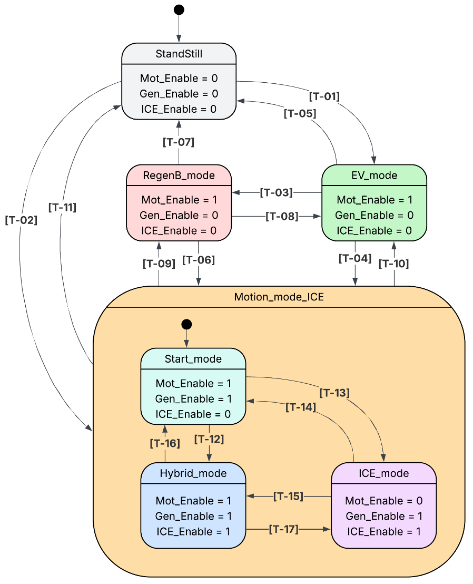
Figure 3: State diagram of Control/Mode Logic, showing the top-level states (StandStill, EV_mode, RegenB_mode, Motion_mode_ICE) and the internal sub-states of Motion_mode_ICE (Start_mode, ICE_mode, Hybrid_mode) together with the seventeen labelled transitions T1–T17 that drive the supervisory mode selection. Source: Authors.

3.1 Legend and Enumerated Transitions
The transition identifiers T1 to T17 follow the evaluation ordering used in the extracted Stateflow transition map for each source state. Unless noted otherwise, the transition conditions below use the compact model aliases speed [km/h], P_dem [kW], SOC = battery state of charge [-], and wEng = engine speed [rpm].

3.1.1 Top-Level Transitions
ID | Source State | Destination State | Transition Condition
T1 | StandStill | EV_mode | speed > SPEED_STOP && speed <= SPEED_EV_MAX && SOC >= SOC_EV_IN
T2 | StandStill | Motion_mode_ICE | speed > SPEED_STOP && (speed > SPEED_EV_MAX || SOC < SOC_EV_IN)
T3 | EV_mode | RegenB_mode | speed > SPEED_REGEN && P_dem <= PDEM_REGEN
T4 | EV_mode | Motion_mode_ICE | speed > SPEED_EV_MAX || P_dem >= PDEM_HYB_IN || SOC < SOC_EV_OUT
T5 | EV_mode | StandStill | speed <= SPEED_STOP && P_dem <= PDEM_STOP_HIGH && P_dem >= PDEM_STOP_LOW
T6 | RegenB_mode | Motion_mode_ICE | ((speed > SPEED_EV_MAX) && (P_dem >= PDEM_STOP_LOW)) || SOC < SOC_EV_OUT
T7 | RegenB_mode | StandStill | speed <= SPEED_STOP && P_dem <= PDEM_STOP_HIGH && P_dem >= PDEM_STOP_LOW
T8 | RegenB_mode | EV_mode | P_dem >= PDEM_STOP_LOW && speed > SPEED_STOP && speed <= SPEED_EV_MAX && SOC >= SOC_EV_OUT
T9 | Motion_mode_ICE | RegenB_mode | wEng > ENG_ON && speed > SPEED_REGEN && P_dem <= PDEM_REGEN
T10 | Motion_mode_ICE | EV_mode | wEng > ENG_ON && P_dem <= PDEM_HYB_OUT && P_dem >= PDEM_STOP_LOW && speed > SPEED_STOP && speed <= SPEED_EV_MAX && SOC >= SOC_EV_IN
T11 | Motion_mode_ICE | StandStill | speed <= SPEED_STOP && P_dem <= PDEM_STOP_HIGH && P_dem >= PDEM_STOP_LOW

3.1.2 Internal Transitions of Motion_mode_ICE
ID | Source State | Destination State | Transition Condition
T12 | Start_mode | Hybrid_mode | wEng > ENG_ON && SOC >= SOC_MID && (speed > SPEED_EV_MAX || P_dem >= PDEM_HYB_MID)
T13 | Start_mode | ICE_mode | wEng > ENG_ON && (SOC < SOC_MID || (speed <= SPEED_EV_MAX && P_dem < PDEM_HYB_MID))
T14 | ICE_mode | Start_mode | wEng <= ENG_OFF
T15 | ICE_mode | Hybrid_mode | P_dem >= PDEM_HYB_MID && SOC >= SOC_MID
T16 | Hybrid_mode | Start_mode | wEng <= ENG_OFF
T17 | Hybrid_mode | ICE_mode | P_dem <= PDEM_HYB_LOW || SOC < SOC_LOW

4. FUNCTIONAL REQUIREMENTS
This section defines the functional requirement baseline for the VMU power-split mode logic. The system requirements preserve the supervisory intent at vehicle-function level, the high-level software requirements organize the software behavior by state family, and the low-level software requirements capture each executable transition individually.

4.1 High-level system functional requirements

4.1.1 [SysHLR01] Power-Split Supervisory Mode Selection
Requirement statement (shall) | The VMU shall select exactly one operating mode from {standstill mode, EV mode, regenerative-braking mode, Start mode, ICE mode, and Hybrid mode} at each mode-logic execution cycle by evaluating vehicle speed [km/h], requested power [kW], battery state of charge [-], and engine speed [rpm].
Conditions / Applicability | Active whenever Control/Mode Logic is executed in nominal mode-management operation.
Stakeholder Priority | High
Rationale | Establishes the single-state supervisory decision expected by the model and the software.
Related UC(s) | UC1, UC2, UC3, UC4, UC5, UC6

4.1.2 [SysHLR02] Deterministic Powertrain Enable Coordination
Requirement statement (shall) | For each selected operating mode, the VMU shall command deterministic motor, generator, and engine enable requests according to the mode-dependent pattern defined by the model: standstill {0,0,0}, EV {1,0,0}, regenerative braking {1,0,0}, Start {1,1,0}, ICE {0,1,1}, and Hybrid {1,1,1}.
Conditions / Applicability | Applies in each healthy mode-logic cycle after the next mode has been resolved.
Stakeholder Priority | High
Rationale | Ensures supervisory mode selection and plant-facing enable outputs remain consistent.
Related UC(s) | UC1, UC2, UC3, UC4, UC5, UC6

4.1.3 [SysHLR03] Calibratable and Hysteretic Transition Strategy
Requirement statement (shall) | The VMU shall evaluate mode transitions using the named calibrations ENG_ON, ENG_OFF, SPEED_STOP, SPEED_REGEN, SPEED_EV_MAX, PDEM_REGEN, PDEM_STOP_LOW, PDEM_STOP_HIGH, PDEM_HYB_IN, PDEM_HYB_OUT, PDEM_HYB_MID, PDEM_HYB_LOW, SOC_EV_IN, SOC_EV_OUT, SOC_MID, and SOC_LOW while preserving the modeled hysteresis on battery state of charge and engine speed thresholds.
Conditions / Applicability | Applies to every transition decision in the mode logic.
Stakeholder Priority | High
Rationale | Keeps the requirement baseline aligned with the calibrated model and preserves the intended hysteresis behavior.
Related UC(s) | UC1, UC2, UC3, UC4, UC5, UC6

4.2 High-level software functional requirements
The high-level software requirements below organize the software representation by initialization, output mapping, state-family decision logic, and software-defined behaviors that remain outside the modeled transition set. In this section, the software modes correspond to standstill, EV, regenerative braking, start, ICE, and hybrid behavior represented by the model. These requirements act as parents for the transition-level low-level software requirements defined in Section 4.3.

4.2.1 [SwHLR01] Initialization Behavior
Requirement statement (shall) | The software shall initialize the active software mode to the standstill mode before the first normal mode-evaluation cycle.
Conditions / Applicability | Applies during software initialization and before the first periodic mode-evaluation cycle.
Derived from | SysHLR01
Stakeholder Priority | High
Rationale | Creates a deterministic starting point for the software representation of the state machine.
Related UC(s) | UC1, UC6

4.2.2 [SwHLR02] Deterministic Output Mapping by Active Mode
Requirement statement (shall) | The software shall command the enable outputs associated with the resolved active software mode according to the mode-to-output mapping of the source model.
Conditions / Applicability | Applies after each mode-resolution decision.
Derived from | SysHLR02
Stakeholder Priority | High
Rationale | Separates output assignment from transition selection and avoids duplicating output obligations in every low-level transition requirement.
Related UC(s) | UC1, UC2, UC3, UC4, UC5, UC6

4.2.3 [SwHLR03] Standstill Mode Transition Family
Requirement statement (shall) | While the active software mode is the standstill mode, the software shall evaluate exits to EV mode and Start mode in the priority order defined by the model.
Conditions / Applicability | Applies while the active software mode represents standstill behavior.
Derived from | SysHLR01, SysHLR03
Stakeholder Priority | High
Rationale | Captures the standstill decision family once and allocates the detailed guards to derived low-level requirements.
Related UC(s) | UC1

4.2.4 [SwHLR04] EV Mode Transition Family
Requirement statement (shall) | While the active software mode is EV mode, the software shall evaluate exits to regenerative-braking mode, Start mode, and standstill mode in the priority order defined by the model.
Conditions / Applicability | Applies while the active software mode represents EV behavior.
Derived from | SysHLR01, SysHLR03
Stakeholder Priority | High
Rationale | Captures the EV decision family once and allocates the detailed guards to derived low-level requirements.
Related UC(s) | UC2, UC3, UC4, UC6

4.2.5 [SwHLR05] Regenerative-Braking Transition Family
Requirement statement (shall) | While the active software mode is the regenerative-braking mode, the software shall evaluate exits to Start mode, standstill mode, and EV mode in the priority order defined by the model.
Conditions / Applicability | Applies while the active software mode represents regenerative-braking behavior.
Derived from | SysHLR01, SysHLR03
Stakeholder Priority | High
Rationale | Captures the regenerative-braking decision family once and allocates the detailed guards to derived low-level requirements.
Related UC(s) | UC2, UC3, UC4, UC6

4.2.6 [SwHLR06] Engine-Supported External Exit Family
Requirement statement (shall) | While the active software mode is Start, ICE, or Hybrid, the software shall evaluate exits to regenerative-braking mode, EV mode, and standstill mode before any internal transition within the engine-supported mode representation.
Conditions / Applicability | Applies while the active software mode represents Start, ICE, or Hybrid behavior.
Derived from | SysHLR01, SysHLR03
Stakeholder Priority | High
Rationale | Captures the common external-exit policy of Motion_mode_ICE and provides the parent requirement for the nine derived low-level exits.
Related UC(s) | UC2, UC4, UC6

4.2.7 [SwHLR07] Start Mode Internal Transition Family
Requirement statement (shall) | While the active software mode is Start and no higher-priority engine-supported external exit is active, the software shall evaluate internal transitions to Hybrid mode and ICE mode in the priority order defined by the model.
Conditions / Applicability | Applies while the active software mode is Start and the external-exit family does not trigger.
Derived from | SysHLR01, SysHLR03
Stakeholder Priority | High
Rationale | Captures the internal Start_mode decision family and provides the parent requirement for the derived low-level transitions.
Related UC(s) | UC3, UC5

4.2.8 [SwHLR08] ICE Mode Internal Transition Family
Requirement statement (shall) | While the active software mode is ICE and no higher-priority engine-supported external exit is active, the software shall evaluate internal transitions to Start mode and Hybrid mode in the priority order defined by the model.
Conditions / Applicability | Applies while the active software mode is ICE and the external-exit family does not trigger.
Derived from | SysHLR01, SysHLR03
Stakeholder Priority | High
Rationale | Captures the internal ICE_mode decision family and provides the parent requirement for the derived low-level transitions.
Related UC(s) | UC3, UC5

4.2.9 [SwHLR09] Hybrid Mode Internal Transition Family
Requirement statement (shall) | While the active software mode is Hybrid and no higher-priority engine-supported external exit is active, the software shall evaluate internal transitions to Start mode and ICE mode in the priority order defined by the model.
Conditions / Applicability | Applies while the active software mode is Hybrid and the external-exit family does not trigger.
Derived from | SysHLR01, SysHLR03
Stakeholder Priority | High
Rationale | Captures the internal Hybrid_mode decision family and provides the parent requirement for the derived low-level transitions.
Related UC(s) | UC3, UC5

4.2.10 [SwHLR10] Initialization and Invalid-Mode Recovery Outside the Modeled Transition Set
Requirement statement (shall) | The software shall treat initialization to the standstill mode and recovery from an invalid active-mode value as software-defined behaviors outside the 23 modeled transitions.
Conditions / Applicability | Applies during initialization and whenever the stored active mode does not match a valid software mode.
Derived from | SysHLR01
Stakeholder Priority | High
Rationale | Separates startup and defensive recovery behavior from the modeled transition set while keeping the implementation behavior explicit in the requirement baseline.
Related UC(s) | UC1, UC6

4.3 Low-level software functional requirements
The low-level software requirements below provide one requirement per executable transition. The three chart-level exits from Motion_mode_ICE are allocated in software as one requirement per active software mode in the start, ICE, and hybrid branches, so the low-level section contains 23 transition requirements. This count excludes initialization to the standstill mode and recovery from an invalid active-mode value, because those behaviors are software-defined and are not modeled transitions.

4.3.1 [SwLLR01] Standstill Mode to EV Mode
Requirement statement (shall) | When the active software mode is the standstill mode and speed > SPEED_STOP && speed <= SPEED_EV_MAX && SOC >= SOC_EV_IN, the software shall transition to EV mode.
Conditions / Applicability | Applies while the active software mode is the standstill mode. This is the highest-priority matching exit.
Derived from | SwHLR02, SwHLR03
Stakeholder Priority | High
Rationale | Implements the admissible EV launch path from standstill.
Related UC(s) | UC1, UC2

4.3.2 [SwLLR02] Standstill Mode to Start Mode
Requirement statement (shall) | When the active software mode is the standstill mode and speed > SPEED_STOP && (speed > SPEED_EV_MAX || SOC < SOC_EV_IN), the software shall transition to Start mode.
Conditions / Applicability | Applies while the active software mode is the standstill mode, after the higher-priority EV exit has been excluded. Entry into Motion_mode_ICE is represented in software by Start mode.
Derived from | SwHLR02, SwHLR03
Stakeholder Priority | High
Rationale | Implements the direct launch path into engine-supported propulsion when the EV window is not valid.
Related UC(s) | UC1, UC3

4.3.3 [SwLLR03] EV Mode to Regenerative-Braking Mode
Requirement statement (shall) | When the active software mode is EV mode and speed > SPEED_REGEN && P_dem <= PDEM_REGEN, the software shall transition to the regenerative-braking mode.
Conditions / Applicability | Applies while the active software mode is EV mode. This is the highest-priority EV exit.
Derived from | SwHLR02, SwHLR04
Stakeholder Priority | High
Rationale | Implements entry into regenerative braking from EV operation.
Related UC(s) | UC4

4.3.4 [SwLLR04] EV Mode to Start Mode
Requirement statement (shall) | When the active software mode is EV mode and (speed > SPEED_EV_MAX || P_dem >= PDEM_HYB_IN || SOC < SOC_EV_OUT), the software shall transition to Start mode.
Conditions / Applicability | Applies while the active software mode is EV mode, after the higher-priority regenerative-braking exit has been excluded. Entry into Motion_mode_ICE is represented in software by Start mode.
Derived from | SwHLR02, SwHLR04
Stakeholder Priority | High
Rationale | Implements the EV exit to engine-supported propulsion when the EV window closes or demand increases.
Related UC(s) | UC3

4.3.5 [SwLLR05] EV Mode to Standstill Mode
Requirement statement (shall) | When the active software mode is EV mode and speed <= SPEED_STOP && P_dem <= PDEM_STOP_HIGH && P_dem >= PDEM_STOP_LOW, the software shall transition to the standstill mode.
Conditions / Applicability | Applies while the active software mode is EV mode, after the higher-priority regenerative-braking and engine-supported exits have been excluded.
Derived from | SwHLR02, SwHLR04
Stakeholder Priority | High
Rationale | Implements the EV return to standstill in the neutral stop-demand window.
Related UC(s) | UC6

4.3.6 [SwLLR06] Regenerative-Braking Mode to Start Mode
Requirement statement (shall) | When the active software mode is the regenerative-braking mode and (((speed > SPEED_EV_MAX) && (P_dem >= PDEM_STOP_LOW)) || SOC < SOC_EV_OUT), the software shall transition to Start mode.
Conditions / Applicability | Applies while the active software mode is the regenerative-braking mode. This is the highest-priority regenerative-braking exit. Entry into Motion_mode_ICE is represented in software by Start mode.
Derived from | SwHLR02, SwHLR05
Stakeholder Priority | High
Rationale | Implements the return from regenerative braking to engine-supported propulsion when the EV window is no longer valid.
Related UC(s) | UC3, UC4

4.3.7 [SwLLR07] Regenerative-Braking Mode to Standstill Mode
Requirement statement (shall) | When the active software mode is the regenerative-braking mode and speed <= SPEED_STOP && P_dem <= PDEM_STOP_HIGH && P_dem >= PDEM_STOP_LOW, the software shall transition to the standstill mode.
Conditions / Applicability | Applies while the active software mode is the regenerative-braking mode, after the higher-priority engine-supported exit has been excluded.
Derived from | SwHLR02, SwHLR05
Stakeholder Priority | High
Rationale | Implements braking completion into standstill from the regenerative-braking mode.
Related UC(s) | UC6

4.3.8 [SwLLR08] Regenerative-Braking Mode to EV Mode
Requirement statement (shall) | When the active software mode is the regenerative-braking mode and P_dem >= PDEM_STOP_LOW && speed > SPEED_STOP && speed <= SPEED_EV_MAX && SOC >= SOC_EV_OUT, the software shall transition to EV mode.
Conditions / Applicability | Applies while the active software mode is the regenerative-braking mode, after the higher-priority engine-supported and standstill exits have been excluded.
Derived from | SwHLR02, SwHLR05
Stakeholder Priority | High
Rationale | Implements the return from regenerative braking to EV propulsion.
Related UC(s) | UC2, UC4

4.3.9 [SwLLR09] Start Mode to Regenerative-Braking Mode
Requirement statement (shall) | When the active software mode is Start mode and wEng > ENG_ON && speed > SPEED_REGEN && P_dem <= PDEM_REGEN, the software shall transition to the regenerative-braking mode.
Conditions / Applicability | Applies while the active software mode is Start mode. This is the highest-priority external exit from the engine-supported mode representation.
Derived from | SwHLR02, SwHLR06
Stakeholder Priority | High
Rationale | Allocates the chart-level Motion_mode_ICE to RegenB exit to the Start-mode software branch.
Related UC(s) | UC4, UC5

4.3.10 [SwLLR10] ICE Mode to Regenerative-Braking Mode
Requirement statement (shall) | When the active software mode is ICE mode and wEng > ENG_ON && speed > SPEED_REGEN && P_dem <= PDEM_REGEN, the software shall transition to the regenerative-braking mode.
Conditions / Applicability | Applies while the active software mode is ICE mode. This is the highest-priority external exit from ICE mode.
Derived from | SwHLR02, SwHLR06
Stakeholder Priority | High
Rationale | Allocates the chart-level Motion_mode_ICE to RegenB exit to the ICE-mode software branch.
Related UC(s) | UC4, UC5

4.3.11 [SwLLR11] Hybrid Mode to Regenerative-Braking Mode
Requirement statement (shall) | When the active software mode is Hybrid mode and wEng > ENG_ON && speed > SPEED_REGEN && P_dem <= PDEM_REGEN, the software shall transition to the regenerative-braking mode.
Conditions / Applicability | Applies while the active software mode is Hybrid mode. This is the highest-priority external exit from Hybrid mode.
Derived from | SwHLR02, SwHLR06
Stakeholder Priority | High
Rationale | Allocates the chart-level Motion_mode_ICE to RegenB exit to the Hybrid-mode software branch.
Related UC(s) | UC4, UC5

4.3.12 [SwLLR12] Start Mode to EV Mode
Requirement statement (shall) | When the active software mode is Start mode and wEng > ENG_ON && P_dem <= PDEM_HYB_OUT && P_dem >= PDEM_STOP_LOW && speed > SPEED_STOP && speed <= SPEED_EV_MAX && SOC >= SOC_EV_IN, the software shall transition to EV mode.
Conditions / Applicability | Applies while the active software mode is Start mode, after the higher-priority regenerative-braking exit has been excluded. External exits are evaluated before internal Start-mode transitions.
Derived from | SwHLR02, SwHLR06
Stakeholder Priority | High
Rationale | Allocates the chart-level Motion_mode_ICE to EV exit to the Start-mode software branch.
Related UC(s) | UC2, UC5

4.3.13 [SwLLR13] ICE Mode to EV Mode
Requirement statement (shall) | When the active software mode is ICE mode and wEng > ENG_ON && P_dem <= PDEM_HYB_OUT && P_dem >= PDEM_STOP_LOW && speed > SPEED_STOP && speed <= SPEED_EV_MAX && SOC >= SOC_EV_IN, the software shall transition to EV mode.
Conditions / Applicability | Applies while the active software mode is ICE mode, after the higher-priority regenerative-braking exit has been excluded. External exits are evaluated before internal ICE-mode transitions.
Derived from | SwHLR02, SwHLR06
Stakeholder Priority | High
Rationale | Allocates the chart-level Motion_mode_ICE to EV exit to the ICE-mode software branch.
Related UC(s) | UC2, UC5

4.3.14 [SwLLR14] Hybrid Mode to EV Mode
Requirement statement (shall) | When the active software mode is Hybrid mode and wEng > ENG_ON && P_dem <= PDEM_HYB_OUT && P_dem >= PDEM_STOP_LOW && speed > SPEED_STOP && speed <= SPEED_EV_MAX && SOC >= SOC_EV_IN, the software shall transition to EV mode.
Conditions / Applicability | Applies while the active software mode is Hybrid mode, after the higher-priority regenerative-braking exit has been excluded. External exits are evaluated before internal Hybrid-mode transitions.
Derived from | SwHLR02, SwHLR06
Stakeholder Priority | High
Rationale | Allocates the chart-level Motion_mode_ICE to EV exit to the Hybrid-mode software branch.
Related UC(s) | UC2, UC5

4.3.15 [SwLLR15] Start Mode to Standstill Mode
Requirement statement (shall) | When the active software mode is Start mode and speed <= SPEED_STOP && P_dem <= PDEM_STOP_HIGH && P_dem >= PDEM_STOP_LOW, the software shall transition to the standstill mode.
Conditions / Applicability | Applies while the active software mode is Start mode, after the higher-priority regenerative-braking and EV exits have been excluded. This is the third external exit checked before internal Start-mode transitions.
Derived from | SwHLR02, SwHLR06
Stakeholder Priority | High
Rationale | Allocates the chart-level Motion_mode_ICE to StandStill exit to the Start-mode software branch.
Related UC(s) | UC5, UC6

4.3.16 [SwLLR16] ICE Mode to Standstill Mode
Requirement statement (shall) | When the active software mode is ICE mode and speed <= SPEED_STOP && P_dem <= PDEM_STOP_HIGH && P_dem >= PDEM_STOP_LOW, the software shall transition to the standstill mode.
Conditions / Applicability | Applies while the active software mode is ICE mode, after the higher-priority regenerative-braking and EV exits have been excluded. This is the third external exit checked before the remaining internal ICE-mode transitions.
Derived from | SwHLR02, SwHLR06
Stakeholder Priority | High
Rationale | Allocates the chart-level Motion_mode_ICE to StandStill exit to the ICE-mode software branch.
Related UC(s) | UC5, UC6

4.3.17 [SwLLR17] Hybrid Mode to Standstill Mode
Requirement statement (shall) | When the active software mode is Hybrid mode and speed <= SPEED_STOP && P_dem <= PDEM_STOP_HIGH && P_dem >= PDEM_STOP_LOW, the software shall transition to the standstill mode.
Conditions / Applicability | Applies while the active software mode is Hybrid mode, after the higher-priority regenerative-braking and EV exits have been excluded. This is the third external exit checked before the remaining internal Hybrid-mode transitions.
Derived from | SwHLR02, SwHLR06
Stakeholder Priority | High
Rationale | Allocates the chart-level Motion_mode_ICE to StandStill exit to the Hybrid-mode software branch.
Related UC(s) | UC5, UC6

4.3.18 [SwLLR18] Start Mode to Hybrid Mode
Requirement statement (shall) | When the active software mode is Start mode and wEng > ENG_ON && SOC >= SOC_MID && (speed > SPEED_EV_MAX || P_dem >= PDEM_HYB_MID), the software shall transition to Hybrid mode.
Conditions / Applicability | Applies while the active software mode is Start mode, after all higher-priority external exits have been excluded. This is the highest-priority remaining internal Start-mode transition.
Derived from | SwHLR02, SwHLR07
Stakeholder Priority | High
Rationale | Implements the internal Start_mode transition to Hybrid mode.
Related UC(s) | UC3, UC5

4.3.19 [SwLLR19] Start Mode to ICE Mode
Requirement statement (shall) | When the active software mode is Start mode and wEng > ENG_ON && (SOC < SOC_MID || (speed <= SPEED_EV_MAX && P_dem < PDEM_HYB_MID)), the software shall transition to ICE mode.
Conditions / Applicability | Applies while the active software mode is Start mode, after all higher-priority external exits and the higher-priority internal Hybrid-mode transition have been excluded.
Derived from | SwHLR02, SwHLR07
Stakeholder Priority | High
Rationale | Implements the internal Start_mode transition to ICE mode.
Related UC(s) | UC3, UC5

4.3.20 [SwLLR20] ICE Mode to Start Mode
Requirement statement (shall) | When the active software mode is ICE mode and wEng <= ENG_OFF, the software shall transition to Start mode.
Conditions / Applicability | Applies while the active software mode is ICE mode, after all higher-priority external exits have been excluded. This is the highest-priority remaining internal ICE-mode transition.
Derived from | SwHLR02, SwHLR08
Stakeholder Priority | High
Rationale | Implements the engine-off return from ICE mode to Start mode.
Related UC(s) | UC3, UC5

4.3.21 [SwLLR21] ICE Mode to Hybrid Mode
Requirement statement (shall) | When the active software mode is ICE mode and P_dem >= PDEM_HYB_MID && SOC >= SOC_MID, the software shall transition to Hybrid mode.
Conditions / Applicability | Applies while the active software mode is ICE mode, after all higher-priority external exits and the higher-priority internal Start-mode return have been excluded.
Derived from | SwHLR02, SwHLR08
Stakeholder Priority | High
Rationale | Implements the internal ICE_mode transition to Hybrid mode.
Related UC(s) | UC3, UC5

4.3.22 [SwLLR22] Hybrid Mode to Start Mode
Requirement statement (shall) | When the active software mode is Hybrid mode and wEng <= ENG_OFF, the software shall transition to Start mode.
Conditions / Applicability | Applies while the active software mode is Hybrid mode, after all higher-priority external exits have been excluded. This is the highest-priority internal transition from Hybrid mode.
Derived from | SwHLR02, SwHLR09
Stakeholder Priority | High
Rationale | Implements the internal Hybrid_mode return to Start mode when engine speed falls to the engine-off threshold.
Related UC(s) | UC3, UC5

4.3.23 [SwLLR23] Hybrid Mode to ICE Mode
Requirement statement (shall) | When the active software mode is Hybrid mode and (P_dem <= PDEM_HYB_LOW || SOC < SOC_LOW), the software shall transition to ICE mode.
Conditions / Applicability | Applies while the active software mode is Hybrid mode, after all higher-priority external exits and the higher-priority internal Start-mode return have been excluded.
Derived from | SwHLR02, SwHLR09
Stakeholder Priority | High
Rationale | Implements the internal Hybrid_mode transition back to ICE mode.
Related UC(s) | UC3, UC5

5. NON-FUNCTIONAL REQUIREMENTS
This section defines non-functional constraints that apply to the same mode-logic baseline. These requirements complement Section 4 by constraining timing, stability, resource usage, and deterministic behavior of the implementation.

5.1 [NfHLR01] Periodic Execution and Sample Time
Requirement statement (shall) | The software shall execute at a fixed periodic rate of 0.1 s consistent with the mode-logic sample-time calibration and resolve the next mode within the same sample period.
Conditions / Applicability | Applies to every periodic execution of the mode-logic software during nominal operation.
Stakeholder Priority | High
Rationale | Preserves the timing semantics of the source model and prevents backlog between control cycles.
Related UC(s) | UC1, UC2, UC3, UC4, UC5, UC6

5.2 [NfHLR02] Transition Stability and Hysteresis Preservation
Requirement statement (shall) | The software shall preserve the modeled hysteresis at the battery-state-of-charge boundary (entry at SOC_EV_IN, exit at SOC_EV_OUT) and at the engine-speed boundary (engine on at ENG_ON, engine off at ENG_OFF) while evaluating source-state exits in deterministic priority order.
Conditions / Applicability | Applies to all mode-transition evaluations, especially near calibrated boundaries.
Stakeholder Priority | High
Rationale | Prevents oscillation near thresholds and keeps the software behavior aligned with the Stateflow chart.
Related UC(s) | UC1, UC2, UC3, UC4, UC5, UC6

5.3 [NfHLR03] Static Allocation and Bounded State Storage
Requirement statement (shall) | The mode-logic implementation shall use only fixed-size pre-allocated storage, without dynamic memory allocation, recursion, or variable-length storage.
Conditions / Applicability | Applies to the mode-logic software components and the associated runtime data structures.
Stakeholder Priority | High
Rationale | Supports predictable resource usage and straightforward embedded deployment.
Related UC(s) | UC1, UC2, UC3, UC4, UC5, UC6

5.4 [NfHLR04] Deterministic Outputs and Reproducibility
Requirement statement (shall) | Given the same initial mode and the same input sequence, the software shall produce the same sequence of operating modes and enable outputs across repeated executions of the same release baseline.
Conditions / Applicability | Applies to repeated runs of the same software baseline under the same nominal build configuration.
Stakeholder Priority | High
Rationale | Supports repeatable analysis, debugging, and regression comparison.
Related UC(s) | UC1, UC2, UC3, UC4, UC5, UC6

6. TRACEABILITY
The traceability tables below connect the use cases, the system requirements, the software requirement hierarchy, and the Stateflow transition basis that supports the supervisory behavior. This keeps the document organized now while leaving space for a later coverage table that will link these requirements to the future software implementation.

6.1 Traceability Between Stakeholder Use Cases and System Requirements
Use Cases / System requirements | SysHLR01 | SysHLR02 | SysHLR03
UC1 | x | x | x
UC2 | x | x | x
UC3 | x | x | x
UC4 | x | x | x
UC5 | x | x | x
UC6 | x | x | x

6.2 Traceability Between System Requirements and High-Level Software Requirements
System requirement | Supporting high-level software requirement(s)
SysHLR01 | SwHLR01, SwHLR03, SwHLR04, SwHLR05, SwHLR06, SwHLR07, SwHLR08, SwHLR09, SwHLR10
SysHLR02 | SwHLR02
SysHLR03 | SwHLR03, SwHLR04, SwHLR05, SwHLR06, SwHLR07, SwHLR08, SwHLR09

6.3 Traceability Between High-Level and Low-Level Software Requirements
High-level software requirement | Derived low-level software requirement(s)
SwHLR01 | No derived transition requirement; covered directly by the initialization behavior.
SwHLR02 | Supports SwLLR01 to SwLLR23 by defining the mode-to-output mapping used after each transition.
SwHLR03 | SwLLR01 to SwLLR02
SwHLR04 | SwLLR03 to SwLLR05
SwHLR05 | SwLLR06 to SwLLR08
SwHLR06 | SwLLR09 to SwLLR17
SwHLR07 | SwLLR18 to SwLLR19
SwHLR08 | SwLLR20 to SwLLR21
SwHLR09 | SwLLR22 to SwLLR23
SwHLR10 | No derived low-level transition requirement; covers initialization to the standstill mode and invalid-mode recovery outside the 23 modeled transitions.

6.4 Traceability Between Software Requirements and Stateflow Basis
Software requirement | Stateflow basis
SwHLR01 | Chart entry to StandStill
SwHLR02 | Mode-dependent output mapping
SwHLR03 | StandStill exit family
SwHLR04 | EV exit family
SwHLR05 | RegenB exit family
SwHLR06 | Motion_mode_ICE external exits
SwHLR07 | Start_mode internal exits
SwHLR08 | ICE_mode internal exits
SwHLR09 | Hybrid_mode internal exits
SwHLR10 | Software-defined behavior outside the modeled transition set
SwLLR01 | T1: StandStill -> EV_mode
SwLLR02 | T2: StandStill -> Motion_mode_ICE/Start_mode
SwLLR03 | T3: EV_mode -> RegenB_mode
SwLLR04 | T4: EV_mode -> Motion_mode_ICE/Start_mode
SwLLR05 | T5: EV_mode -> StandStill
SwLLR06 | T6: RegenB_mode -> Motion_mode_ICE/Start_mode
SwLLR07 | T7: RegenB_mode -> StandStill
SwLLR08 | T8: RegenB_mode -> EV_mode
SwLLR09 | Derived from T9: Motion_mode_ICE/Start_mode -> RegenB_mode
SwLLR10 | Derived from T9: Motion_mode_ICE/ICE_mode -> RegenB_mode
SwLLR11 | Derived from T9: Motion_mode_ICE/Hybrid_mode -> RegenB_mode
SwLLR12 | Derived from T10: Motion_mode_ICE/Start_mode -> EV_mode
SwLLR13 | Derived from T10: Motion_mode_ICE/ICE_mode -> EV_mode
SwLLR14 | Derived from T10: Motion_mode_ICE/Hybrid_mode -> EV_mode
SwLLR15 | Derived from T11: Motion_mode_ICE/Start_mode -> StandStill
SwLLR16 | Derived from T11: Motion_mode_ICE/ICE_mode -> StandStill
SwLLR17 | Derived from T11: Motion_mode_ICE/Hybrid_mode -> StandStill
SwLLR18 | T12: Start_mode -> Hybrid_mode
SwLLR19 | T13: Start_mode -> ICE_mode
SwLLR20 | T14: ICE_mode -> Start_mode
SwLLR21 | T15: ICE_mode -> Hybrid_mode
SwLLR22 | T16: Hybrid_mode -> Start_mode
SwLLR23 | T17: Hybrid_mode -> ICE_mode

7. CONCLUSION
This document establishes the requirements baseline for the VMU power-split mode logic used in the HEV_powersplit_adapted model. It defines the expected supervisory behavior for mode selection, transition evaluation, and mode-dependent enable outputs, while keeping the specification aligned with the reference Stateflow chart.

The resulting requirement set provides a traceable basis for the next development activities, including software implementation, model-to-code alignment, unit testing, and functional verification. By linking use cases, system requirements, software requirements, and Stateflow transition behavior, the document supports consistent development within the defined project scope.

8. REFERENCES
[1] U.S. DEPARTMENT OF ENERGY; U.S. ENVIRONMENTAL PROTECTION AGENCY. Hybrid technology. fueleconomy.gov, [n.d.]. Available at: https://www.fueleconomy.gov/feg/hybridtech.shtml. Accessed on: 3 May 2026.

Appendix A - Glossary
Term | Definition
Vehicle speed (speed) | Vehicle-speed input used by Control/Mode Logic to detect standstill, EV eligibility, regenerative entry, and exits from engine-supported operation.
Requested power (P_dem) | Requested-power input used to distinguish propulsion demand, regenerative demand, neutral stop demand, and hybrid-entry thresholds.
Battery state of charge (SOC / charge) | Battery state-of-charge input used to admit or reject EV operation and to select ICE or Hybrid behavior inside Motion_mode_ICE.
Engine speed (wEng / engine_speed) | Engine-speed input used for engine-on and engine-off hysteresis in Motion_mode_ICE.
StandStill | Top-level Stateflow state representing the stationary mode with Mot_Enable = 0, Gen_Enable = 0, and ICE_Enable = 0.
EV_mode | Top-level Stateflow state representing electric propulsion availability with Mot_Enable = 1, Gen_Enable = 0, and ICE_Enable = 0.
RegenB_mode | Top-level Stateflow state representing regenerative braking behavior with Mot_Enable = 1, Gen_Enable = 0, and ICE_Enable = 0.
Motion_mode_ICE | Top-level grouped Stateflow state for engine-supported operation containing Start_mode, ICE_mode, and Hybrid_mode.
Start_mode | Internal Motion_mode_ICE state entered before ICE_mode or Hybrid_mode, with Mot_Enable = 1, Gen_Enable = 1, and ICE_Enable = 0.
ICE_mode | Internal Motion_mode_ICE state for engine-supported operation with Mot_Enable = 0, Gen_Enable = 1, and ICE_Enable = 1.
Hybrid_mode | Internal Motion_mode_ICE state for hybrid operation with Mot_Enable = 1, Gen_Enable = 1, and ICE_Enable = 1.
Standstill software mode | Software-mode representation corresponding to StandStill in the model.
EV software mode | Software-mode representation corresponding to EV_mode in the model.
Regenerative-braking software mode | Software-mode representation corresponding to RegenB_mode in the model.
Start software mode | Software-mode representation corresponding to Motion_mode_ICE/Start_mode in the model.
ICE software mode | Software-mode representation corresponding to Motion_mode_ICE/ICE_mode in the model.
Hybrid software mode | Software-mode representation corresponding to Motion_mode_ICE/Hybrid_mode in the model.
Mot_Enable | Binary supervisory output that enables the motor path according to the selected mode.
Gen_Enable | Binary supervisory output that enables the generator path according to the selected mode.
ICE_Enable | Binary supervisory output that enables the engine path according to the selected mode.
ENG_ON | Engine-speed threshold of 800 rpm used to allow transitions out of Start_mode and common Motion_mode_ICE exits.
ENG_OFF | Engine-speed threshold of 790 rpm used to reset ICE_mode or Hybrid_mode back to Start_mode.
SPEED_STOP | Vehicle-speed threshold of 0.5 used for standstill detection.
SPEED_REGEN | Vehicle-speed threshold of 5.0 used for regenerative entry conditions.
SPEED_EV_MAX | Vehicle-speed threshold of 35.0 used for EV eligibility and engine-supported-operation entry.
PDEM_REGEN | Requested-power threshold of -5.0 used to enter regenerative operation.
PDEM_HYB_IN | Requested-power threshold of 50.0 used to leave EV_mode or RegenB_mode for engine-supported operation.
PDEM_HYB_OUT | Requested-power threshold of 40.0 used to allow return from Motion_mode_ICE to EV_mode.
PDEM_HYB_MID | Requested-power threshold of 15.0 used in Start_mode and ICE_mode transition decisions.
PDEM_HYB_LOW | Requested-power threshold of 10.0 used to return from Hybrid_mode to ICE_mode.
SOC_EV_IN | SOC threshold of 0.37 used to enter or return to EV_mode.
SOC_EV_OUT | SOC threshold of 0.35 used to leave EV_mode or RegenB_mode for engine-supported operation.
SOC_MID | SOC threshold of 0.30 used to select Hybrid_mode instead of ICE_mode.
SOC_LOW | SOC threshold of 0.25 used to leave Hybrid_mode for ICE_mode.
SysHLR | High-level system requirement category used for externally visible system behavior.
SwHLR | High-level software requirement category used for mode-logic implementation behavior.
NfHLR | Non-functional requirement category covering timing, resource, stability, and determinism constraints of the software.
VMU | Vehicle Management Unit role represented in this project by the power-split supervisory mode logic and the future software implementation derived from it.

