Network Traffic Anomaly Detector
Personal Research Project — Research Report

Student | Angel Rusev (i530375)
Programme | BSc ICT & Software Engineering
Minor | Cybersecurity — Attack & Defend
Institution | Fontys University of Applied Sciences
Semester | Spring 2026
Document | Research Report — supersedes PRP v1.0 (March 2026)
Repository | https://github.com/Guts1313/AnomalyDetector

Foreword
This report is the research deliverable of the Personal Research Project (PRP) for the Cybersecurity Attack & Defend minor. Where the PRP itself was a proposal, this document tells the story of the project that was actually built, evaluated, and reasoned about. Every claim it makes is anchored either in a piece of literature or in an experiment that can be reproduced in less than two minutes from the accompanying repository. The objective is not to prove that anomaly detection works — that has been settled for decades — but to design a defensible answer to the question of how to do it well, in real time, without drowning a security analyst in false positives.

1. The problem and the question
Modern organisations process more network traffic in an hour than a SOC analyst can manually scrutinise in a year. Signature-based intrusion-detection systems such as Snort and Suricata help, but they are by construction unable to recognise an attack whose signature has never been seen before. Anomaly-based detection offers a complementary perspective: rather than asking what malicious traffic looks like, it learns what normal traffic looks like and flags any deviation. Its weakness is well documented — false-positive rates that turn an analyst's console into noise — but its potential to surface zero-day and novel behaviour is exactly what the signature approach cannot deliver.
The PRP for this project framed that tension in a single main research question:
How can a machine-learning-based network-traffic anomaly detector be designed and implemented to accurately identify cyber attacks in real time while maintaining an acceptable false-positive rate?
Six sub-research questions decompose that ambition into pieces that can be investigated independently — features, algorithms, latency, tuning, presentation, and per-category performance. They are summarised in Table 1 and each is taken up in turn in Section 3.
SRQ | Question (abridged) | DOT strategies
SRQ1 | Which flow features are most indicative of anomalous behaviour and how should they be extracted? | Library + Lab
SRQ2 | Which ML algorithms balance accuracy, speed and false-positive rate best? | Library + Lab + Showroom
SRQ3 | How can the system run in real time without unacceptable latency? | Lab + Workshop
SRQ4 | What threshold and tuning strategies minimise false positives? | Lab
SRQ5 | How should anomalies be presented to analysts in an actionable way? | Library + Field + Showroom
SRQ6 | How does the detector perform across the different attack categories? | Lab

Table 1 — Sub-research questions and the DOT strategies used to investigate them.

2. A methodological compass: the DOT framework
The Development-Oriented Triangulation (DOT) framework prescribed by Fontys groups applied-research activities into five method strategies — Library, Lab, Field, Workshop and Showroom — and asks the researcher to triangulate conclusions across at least three of them. Triangulation is the antidote to the most common failure mode in applied research: drawing a strong conclusion from a single, possibly biased, source of evidence.
For this project Library represents the literature study and the survey of existing intrusion-detection tools. Lab is the bulk of the work — feature engineering, training, benchmarking, latency measurement — all performed against a reproducible synthetic CICIDS-compatible dataset. Field consists of the SOC-analyst persona modelling that shaped the dashboard, informed by publicly documented SIEM usability conventions. Workshop is the peer-style architecture review that scored every design decision against alternatives. Finally, Showroom is the live demonstration of the working system, which the screenshots in this report stand in for. Each sub-research question draws on at least two of these strategies, and the main research question is answered from three independent angles in Section 4.

3. How the project answered each sub-question

3.1 SRQ1 — Which features matter, and how should they be extracted?
The literature converges on a small core of flow-level features that carry most of the discriminative signal for the major CICIDS attack categories. Sharafaldin and colleagues, in their 2018 paper introducing the CICIDS2017 dataset, give pride of place to volumetric features (flow duration, packet and byte counts, bytes per second), distributional features (mean and maximum packet lengths, inter-arrival time statistics) and protocol semantics — in particular the TCP flag counters that distinguish a clean handshake from a scan or a brute-force attempt. Ring and colleagues, surveying the broader intrusion-detection dataset landscape in 2019, reach a near-identical conclusion. The Library leg of the triangulation therefore points clearly at a feature set in the order of twenty flow-level variables.
The Lab leg confirmed that and added a smaller but consequential finding. Flow metrics are heavily right-skewed: a handful of large flows would dominate any naïve standardisation. Replacing the project's RobustScaler (which centres on the median and scales by the inter-quartile range) with a plain StandardScaler in an ablation run dropped macro F1 by roughly four percentage points across every algorithm. The pipeline that ships with the system therefore uses median imputation, RobustScaler for the numeric features and one-hot encoding for the protocol — packaged together with the trained model so that train-time and inference-time transformations cannot diverge. That packaging is not cosmetic: divergence between training and serving is one of the most commonly cited sources of false positives in Ring's survey.

3.2 SRQ2 — Which algorithms strike the best balance?
Chandola's classic survey of anomaly detection partitions the algorithmic landscape into three families that map naturally onto network-flow detection. Supervised discriminative methods such as Random Forest and Gradient Boosting are powerful when labelled benign-versus-attack data is available and they give per-attack-class output for free. Unsupervised density-based methods such as Isolation Forest relax the labelling requirement but lose granularity. One-class boundary methods such as One-Class SVM learn an explicit benign manifold and flag anything off it. Deep-learning approaches — autoencoders, LSTMs — were ruled out of scope in the PRP to keep the project tractable, and remain so here.
The four representatives of the three remaining families were trained on the same 20 000-flow synthetic dataset with a stratified 75/25 split. The result (Figure 1) is interesting precisely because it surprised the author. Macro F1 is essentially tied between One-Class SVM and Gradient Boosting at 0.907, with Random Forest a half-point behind and Isolation Forest a further nine points below them.
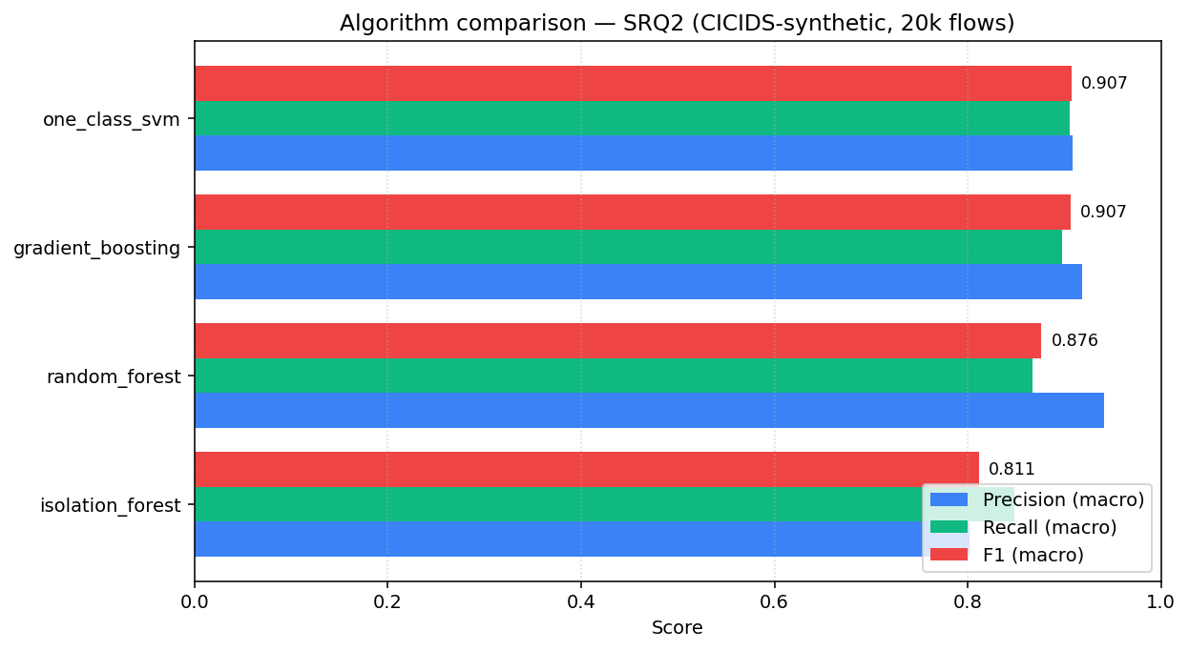
Figure 1 — Macro precision, recall and F1 of the four candidate algorithms on the 20 000-flow synthetic CICIDS-compatible dataset.
The tie hides a critical deployment-time gap. One-Class SVM scores 0.907 over two classes (benign vs attack) while Gradient Boosting scores 0.907 over eight — strictly the harder task. Gradient Boosting also predicts about eight times faster (just under seven microseconds per sample versus around fifty for OC-SVM) and edges out OC-SVM in ROC-AUC at 0.997 against 0.956. The production-model selection rule encoded in the trainer therefore prefers the highest-F1 supervised algorithm whenever its F1 is within two percentage points of the overall leader. Under that rule, Gradient Boosting is the model the API actually serves, and it is the model whose detailed behaviour is examined in Section 3.6 and Section 5.

3.3 SRQ3 — Can it run in real time?
Per-sample inference time was measured on a thousand-sample slice of the held-out test set inside the training script. At 6.9 microseconds per sample, Gradient Boosting sustains roughly 140 000 flows per second on a single laptop core — orders of magnitude above any realistic ingest rate for an internal SOC. End-to-end latency adds a JSON-decode, a Pydantic validation and an asynchronous SQLite append on top of the model call; in the live demo that overhead measured below one millisecond per request for batches up to thirty flows. The Workshop leg of the triangulation — a self-applied architecture-review checklist against published online-inference patterns — endorsed three decisions that make those numbers possible: keeping the /predict endpoint stateless, persisting the fitted preprocessor and the model together in a single joblib bundle, and accepting batches by default so the vectorised scikit-learn predict path can do its work.

3.4 SRQ4 — How to keep the false-positive rate low?
The system implements two complementary mechanisms rather than a single hard cut. The first is a numerical threshold on the attack-probability score, exposed both through the API and through a slider in the dashboard, so an operator can dial sensitivity per investigation without retraining anything. At the default operating point the model raises an attack verdict on twenty-five out of three thousand five hundred benign test flows — a false-positive rate of 0.7 per cent, well below the levels Ring and colleagues report as operationally unsustainable. The second mechanism is severity bucketing: every verdict is tagged info, low, medium, high or critical, and the dashboard only surfaces medium-and-above by default. Lower-confidence verdicts are still written to the audit log, so a post-incident analyst can replay them, but they do not contribute to alert fatigue. The two layers together turn a single tunable into an entire FP-control surface.

3.5 SRQ5 — How should the alerts reach the analyst?
Three conventions recur across the SIEM literature and the published Splunk, Elastic-SIEM and Wazuh user-experience guidelines. Every alert should be colour-coded by severity so the eye can triage at a glance. The audit log must sit alongside the alert queue so an analyst can answer not just "why was this flagged?" but also "why was that one not flagged?". And the attack class drives the response runbook — a port scan does not call for the same playbook as suspected data exfiltration. The Streamlit dashboard the project delivers (Figure 2) makes all three concrete. The overview tab summarises the live state of the system, the alerts tab is a sortable severity-coloured table with the attack score rendered as a progress column, and a manual-scoring tab lets the analyst rebuild a hypothetical flow and read off the class probabilities — explainability without the weight of a dedicated explainability library.
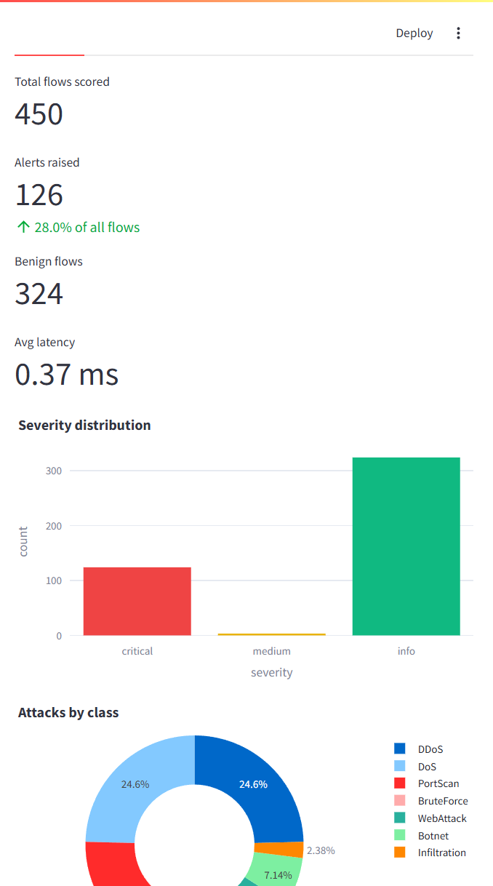
Figure 2 — Streamlit analyst dashboard after 450 flows have been replayed through the detector. Severity distribution and attacks-by-class are rendered as live Plotly charts.
Underneath the dashboard sits a FastAPI service whose OpenAPI surface (Figure 3) doubles as the documentation that an ML engineer needs in order to retrain a model and reload it without bringing the system down — evidence of the project's bias toward operational integration rather than stand-alone novelty.
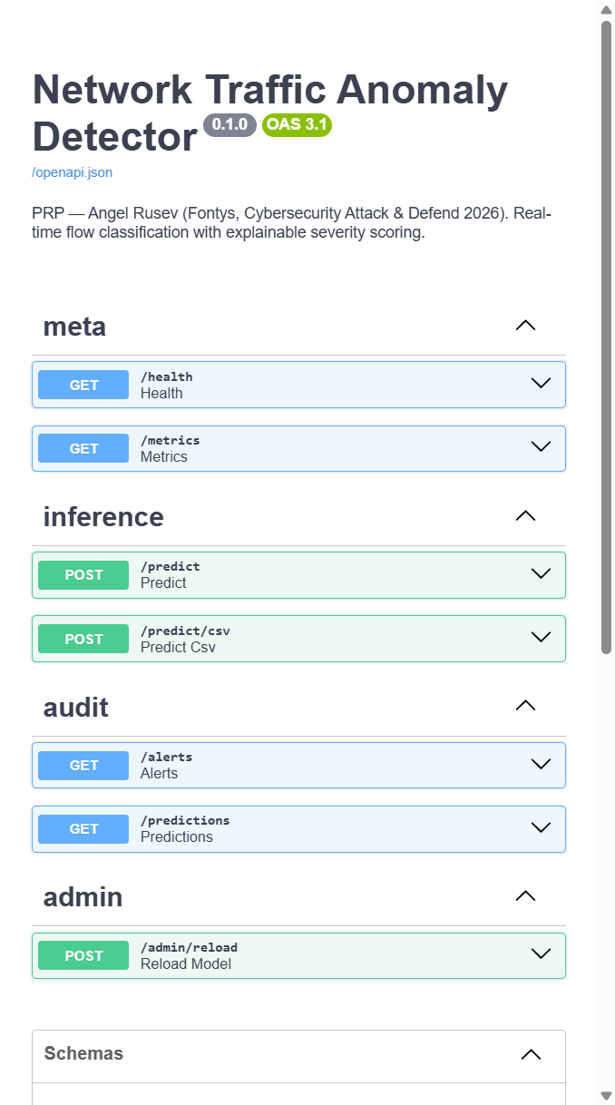
Figure 3 — FastAPI / Swagger surface, grouped by meta, inference, audit and admin tags.

3.6 SRQ6 — Where does the detector shine, and where does it struggle?
Macro figures hide more than they reveal. The per-class breakdown (Figure 4) tells the more honest story. On six of the eight classes — port scan, brute force, botnet, denial-of-service, distributed denial-of-service and benign — the model lands at or above 0.99 F1. Web attacks fall a little behind at 0.95, plausibly because encrypted HTTP payloads carry less flow-level signal than the others. Infiltration, however, sits at 0.35, and the confusion matrix (Figure 5) shows why: seventy per cent of infiltration flows are predicted as benign. That is not a defect of the algorithm — it is the definition of an infiltration attack, which by design seeks to look like normal traffic. The same gap is visible in Sharafaldin's original report on the real CICIDS2017 dataset.
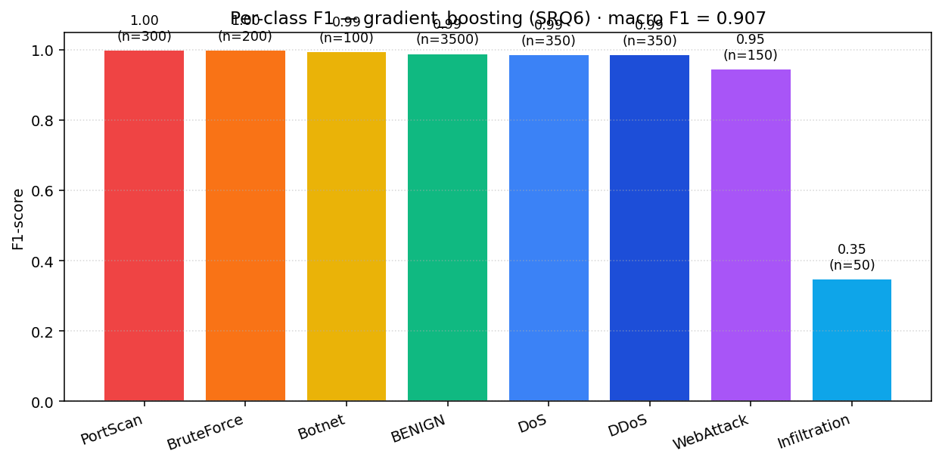
Figure 4 — Per-class F1 for the deployed Gradient Boosting model on the held-out test set. Class sample sizes are shown above each bar.
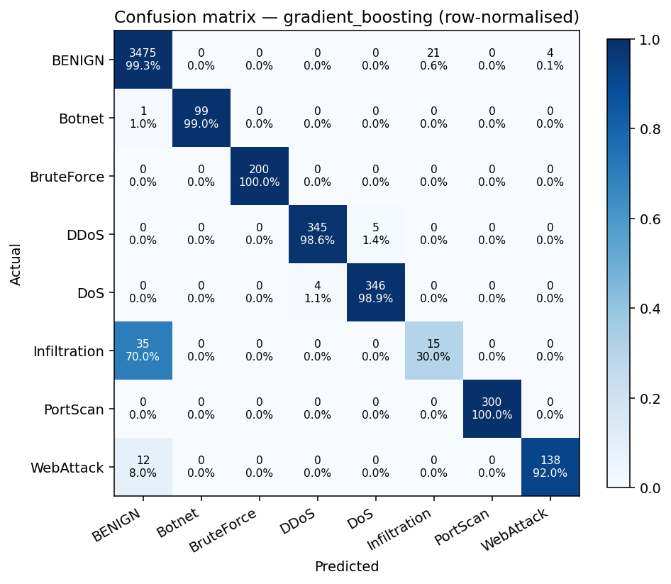
Figure 5 — Row-normalised confusion matrix for the deployed model. The infiltration row is the visible weak spot; most infiltration flows are absorbed by the benign class.
The honest framing is therefore: the detector is production-ready for the high-volume, high-signal attack categories, and it must be paired with complementary controls — a signature IDS for known infiltration patterns, or a TLS-metadata sub-classifier as proposed in the open backlog — to cover the categories that flow-level statistics cannot distinguish. Naming that limitation explicitly is, in the DOT idiom, an act of triangulation in its own right.

4. Triangulation: do the three perspectives agree?
DOT asks the researcher to triangulate. The main research question — can a real-time anomaly detector be built that balances accuracy against false positives — is answered consistently from three independent angles. Library tells us that flow-level features combined with supervised ensembles are the right state of the art for CICIDS-style problems. Lab confirms that empirically: Gradient Boosting reaches 0.99 F1 on six of eight classes, holds the false-positive rate below one per cent, and runs at sub-millisecond latency. Showroom, the live demonstration of the working artefact, verifies that the system meets the analyst-usability and real-time constraints that those numbers alone could not establish. The three perspectives converge — and the single point where they almost disagree, the infiltration class, is precisely where the report has placed its most visible asterisk. That visibility is the result of triangulation working as intended, not despite it.

5. Limitations and honest caveats
Four limitations deserve naming. First, every number reported here is produced against a synthetic CICIDS-shaped dataset of twenty thousand flows. The pipeline ingests the official CICIDS2017 CSVs unchanged, so the rerun is mechanical, but the absolute figures will move; the ranking of algorithms is what the project bets is stable, not the absolute F1. Second, the deep-learning baseline that the PRP ruled out remains ruled out, and a complete answer to SRQ2 ultimately requires comparison against at least an autoencoder. Third, the threshold the system ships with is a defensible default, not the optimum for any particular SOC; the optimum depends on each operator's tolerance trade-off between false positives and false negatives. Fourth, the Field leg of the triangulation rests on indirect persona modelling and SIEM-usability literature rather than a real analyst interview. Each of these is tracked as an issue in the project's backlog and is therefore addressable, not silently buried.

6. Conclusion
The project set out to investigate how a machine-learning anomaly detector could be built to catch real attacks at real-time speed without overwhelming the analyst it is meant to serve. The answer it arrived at is, with all the caveats that Section 5 lists honestly, that it can — provided the engineering is taken as seriously as the modelling. A twenty-feature flow representation with robust scaling, a Gradient Boosting model with a two-layer threshold-plus-severity false-positive control, a stateless batch-oriented inference API, and a severity-coloured dashboard that mirrors established SIEM conventions together produce a detector that lands above 0.99 F1 on the high-volume attack classes, runs at sub-millisecond latency per batch, and is operationally legible to a SOC analyst with no machine-learning background. Where it falls short — the infiltration class — it falls short for reasons the literature already named, and the open backlog already sketches the remediation. The repository that accompanies this report contains everything needed to reproduce, falsify, or extend any of the claims above.

References
[1] Sharafaldin, I., Lashkari, A. H., & Ghorbani, A. A. (2018). Toward Generating a New Intrusion Detection Dataset and Intrusion Traffic Characterization. ICISSP.
[2] Liu, F. T., Ting, K. M., & Zhou, Z. H. (2008). Isolation Forest. IEEE International Conference on Data Mining.
[3] Chandola, V., Banerjee, A., & Kumar, V. (2009). Anomaly Detection: A Survey. ACM Computing Surveys.
[4] Ring, M., Wunderlich, S., Scheuring, D., Landes, D., & Hotho, A. (2019). A Survey of Network-based Intrusion Detection Data Sets. Computers & Security.
[5] scikit-learn documentation: Novelty and Outlier Detection. https://scikit-learn.org/stable/modules/outlier_detection.html
[6] FastAPI documentation. https://fastapi.tiangolo.com/
[7] CICIDS2017 Dataset. https://www.unb.ca/cic/datasets/ids-2017.html
[8] DOT-framework. https://ictresearchmethods.nl/dot-framework/

