Network Traffic Anomaly Detector
Technical Design Document
User stories, architecture, data, API and runtime design

Student | Angel Rusev
Programme | BSc ICT & Software Engineering
Minor | Cybersecurity — Attack & Defend
Institution | Fontys University of Applied Sciences
Semester | Spring 2026
Document | Technical Design Document v1.0 — companion to the Research Report
Repository | https://github.com/Guts1313/AnomalyDetector

Table of contents
Table of contents 1
1. Introduction and scope 3
2. Personas and stakeholders 3
3. User stories 3
4. Architecture overview 7
5. Component design 8
6. Data design 9
7. API specification 11
8. Runtime behaviour 11
9. Non-functional requirements and security 12
10. Deployment view 13
11. Testing strategy 13
12. Traceability matrix 14
References 15

1. Introduction and scope
This Technical Design Document (TDD) is the engineering companion to the Research Report. Where the research document argues why the detector is built the way it is, this document specifies what is built: the user stories the system satisfies, the architecture that realises them, the data it handles, the API it exposes, and the runtime behaviour that ties the pieces together. It is written to be read by an engineer who has to extend, operate, or review the system, and every design statement is traceable to a user story and to code in the accompanying repository.
The scope is the detector itself — a stateless FastAPI inference service, a serialised model bundle, a SQLite audit store, two analyst front-ends (React and Streamlit), and the containerised attack/defend laboratory that drives real offensive traffic through the same inference path. Model research, dataset generation and the per-class evaluation are covered in the Research Report and only summarised here where the design depends on them.

2. Personas and stakeholders
The design serves four personas. The SOC analyst is the primary user of the running system; the ML engineer maintains the model; the NOC operator keeps the service healthy; and the security student or researcher drives the attack/defend laboratory. Table 1 maps each persona to the goals the design must satisfy.
Persona | Goal | Touch-points
SOC analyst | Triage, investigate and explain alerts in real time. | React/Streamlit dashboards, /alerts, /predictions
ML engineer | Retrain, evaluate and hot-reload the model safely. | scripts/train, /admin/reload, /metrics
NOC operator | Keep the service healthy and detect drift. | /health, /metrics, Docker healthchecks
Security student / researcher | Exercise the detector with real attack traffic. | Examples tab, lab attacker/defender containers

Table 1 — Personas and the goals the design must satisfy.

3. User stories
The backlog is organised into six epics, prioritised with MoSCoW and sized in story points. The cards below are the canonical statements; each carries a role, a “so that” benefit, Given/When/Then acceptance criteria, and links to the functional requirements (FR) and sub-research questions (SRQ) it traces to. The same FR/SRQ tags reappear in the traceability matrix in §13.
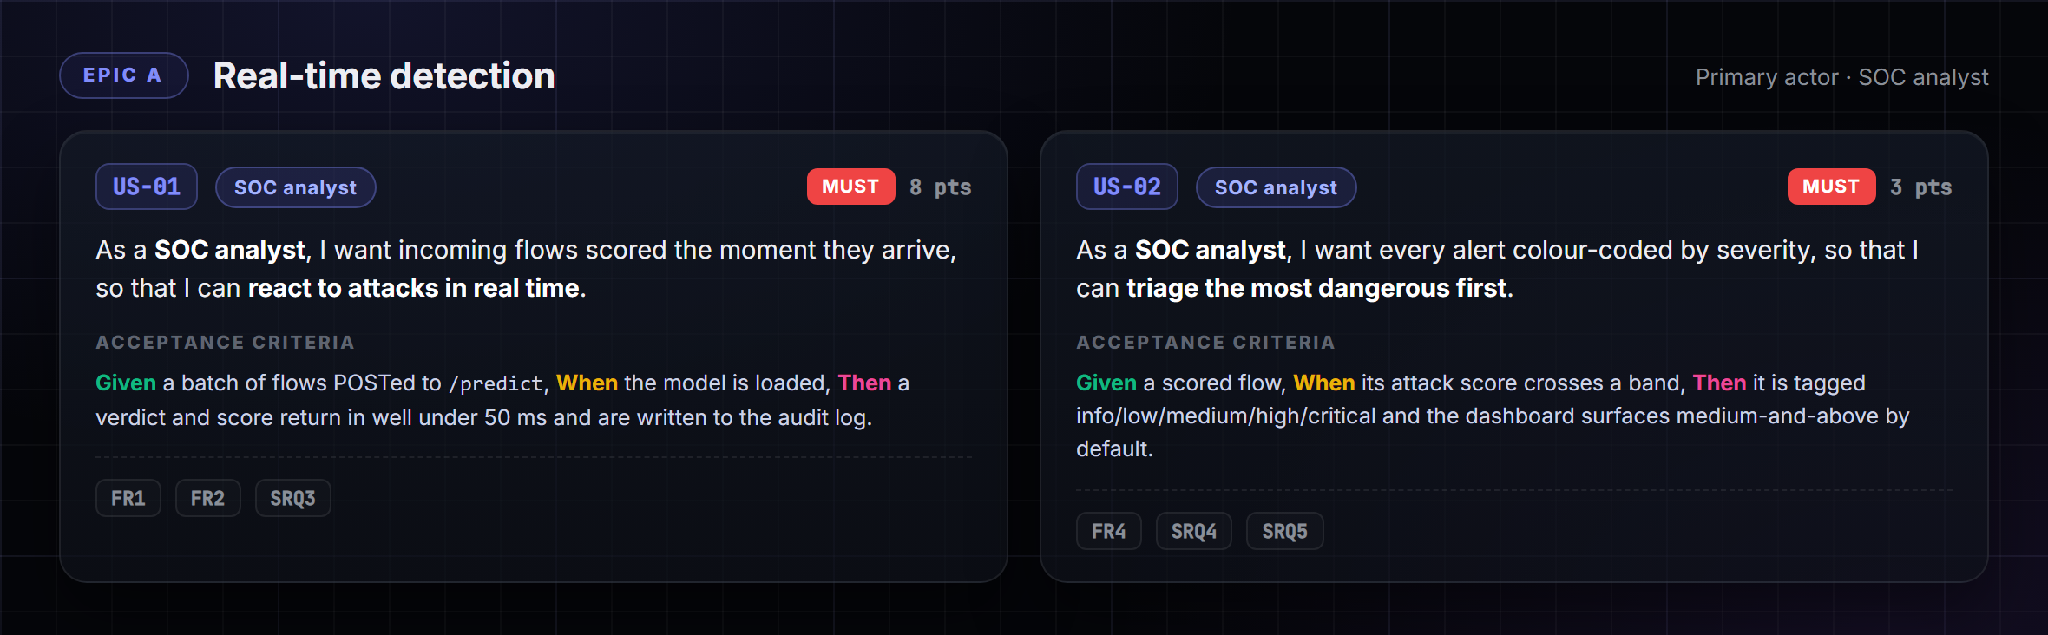
Figure 1 — Epic A — Real-time detection (US-01, US-02).
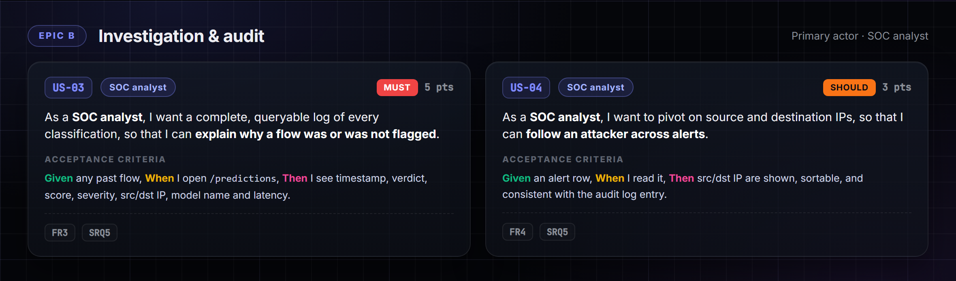
Figure 2 — Epic B — Investigation and audit (US-03, US-04).
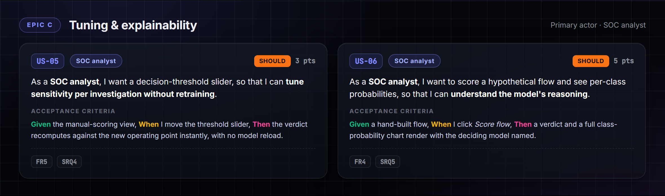
Figure 3 — Epic C — Tuning and explainability (US-05, US-06).
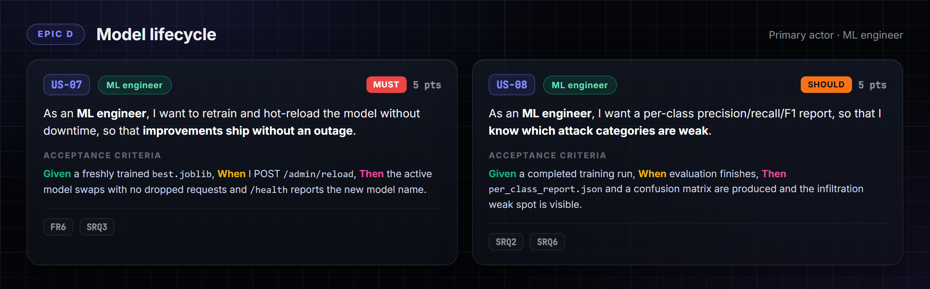
Figure 4 — Epic D — Model lifecycle (US-07, US-08).
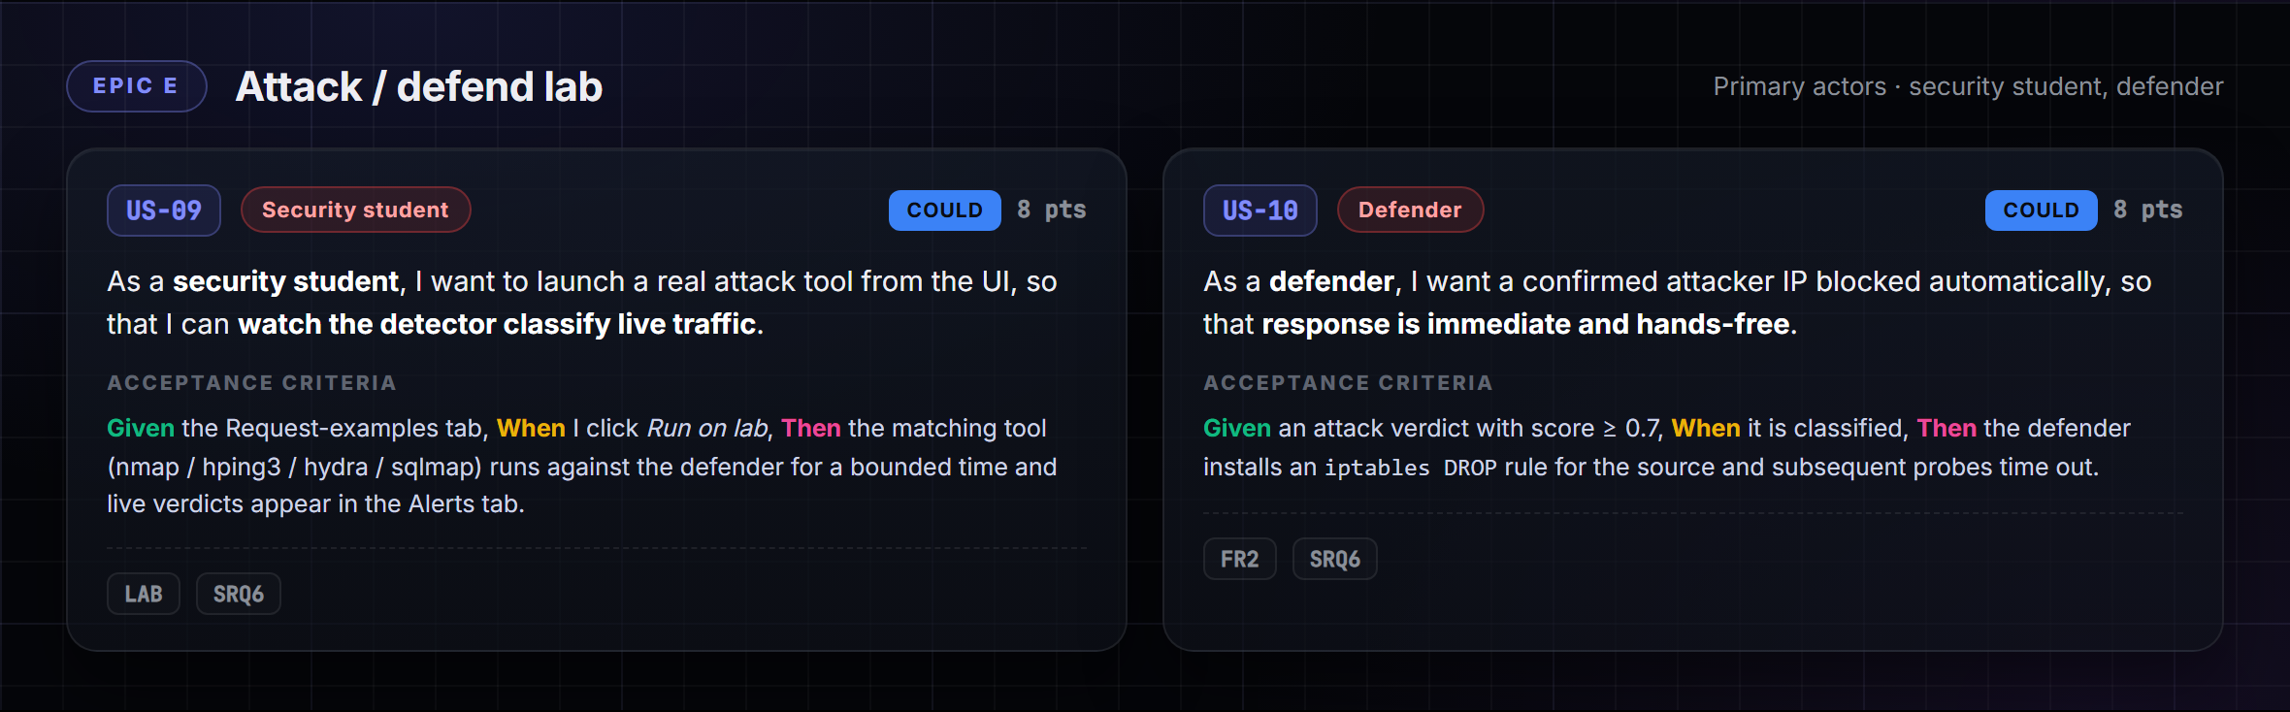
Figure 5 — Epic E — Attack / defend lab (US-09, US-10).
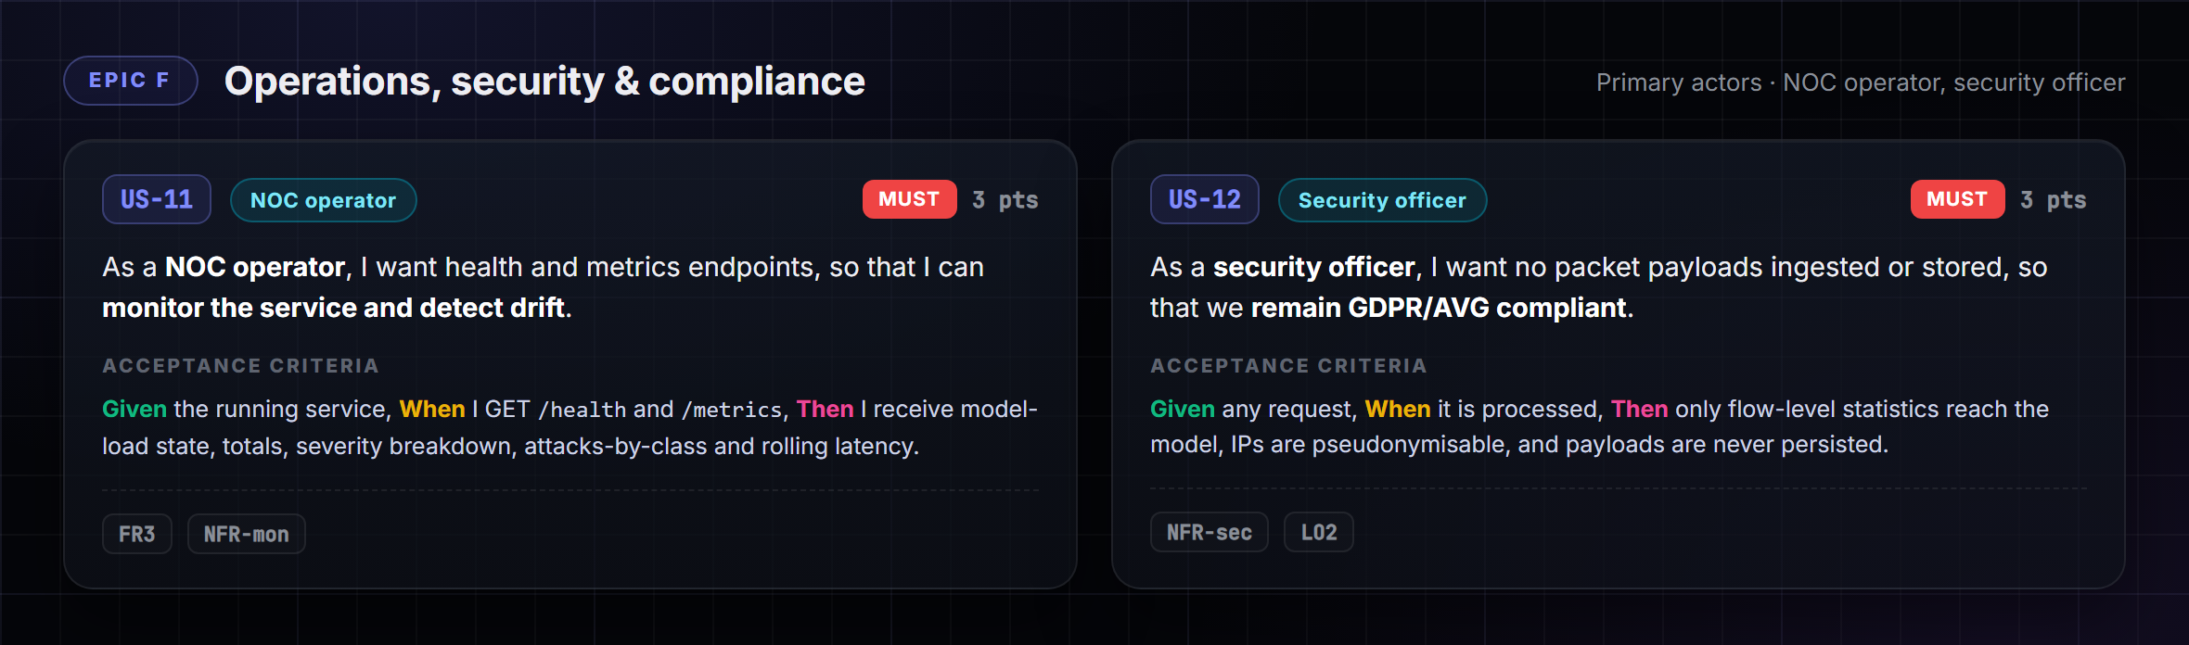
Figure 6 — Epic F — Operations, security and compliance (US-11, US-12).
Table 2 summarises the backlog so it can be read at a glance and sorted by priority. The Must-have stories form the walking skeleton — real-time scoring, severity triage, the audit trail, hot-reload, monitoring and the privacy guarantee — and were delivered first; the Could-have lab stories were the final, highest-value-per-risk increment.
ID | Story (abridged) | Role | Priority | Pts
US-01 | Score incoming flows in real time | SOC analyst | Must | 8
US-02 | Colour-code alerts by severity | SOC analyst | Must | 3
US-03 | Queryable audit log of every classification | SOC analyst | Must | 5
US-04 | Pivot on source/destination IPs | SOC analyst | Should | 3
US-05 | Decision-threshold slider, no retrain | SOC analyst | Should | 3
US-06 | Manual scoring with class probabilities | SOC analyst | Should | 5
US-07 | Retrain and hot-reload without downtime | ML engineer | Must | 5
US-08 | Per-class evaluation report | ML engineer | Should | 5
US-09 | Launch a real attack from the UI | Security student | Could | 8
US-10 | Auto-block a confirmed attacker IP | Defender | Could | 8
US-11 | Health and metrics endpoints | NOC operator | Must | 3
US-12 | No payloads stored (GDPR) | Security officer | Must | 3

Table 2 — Product backlog summary (MoSCoW + story points).

4. Architecture overview
The system is a small set of cooperating containers around one inference service. Figure 7 is the C4 level-1 context: the detector sits between offline flow-feature sources and the human roles it serves, and can forward a severity feed to an upstream SIEM. Figure 8 opens the box one level further into containers.
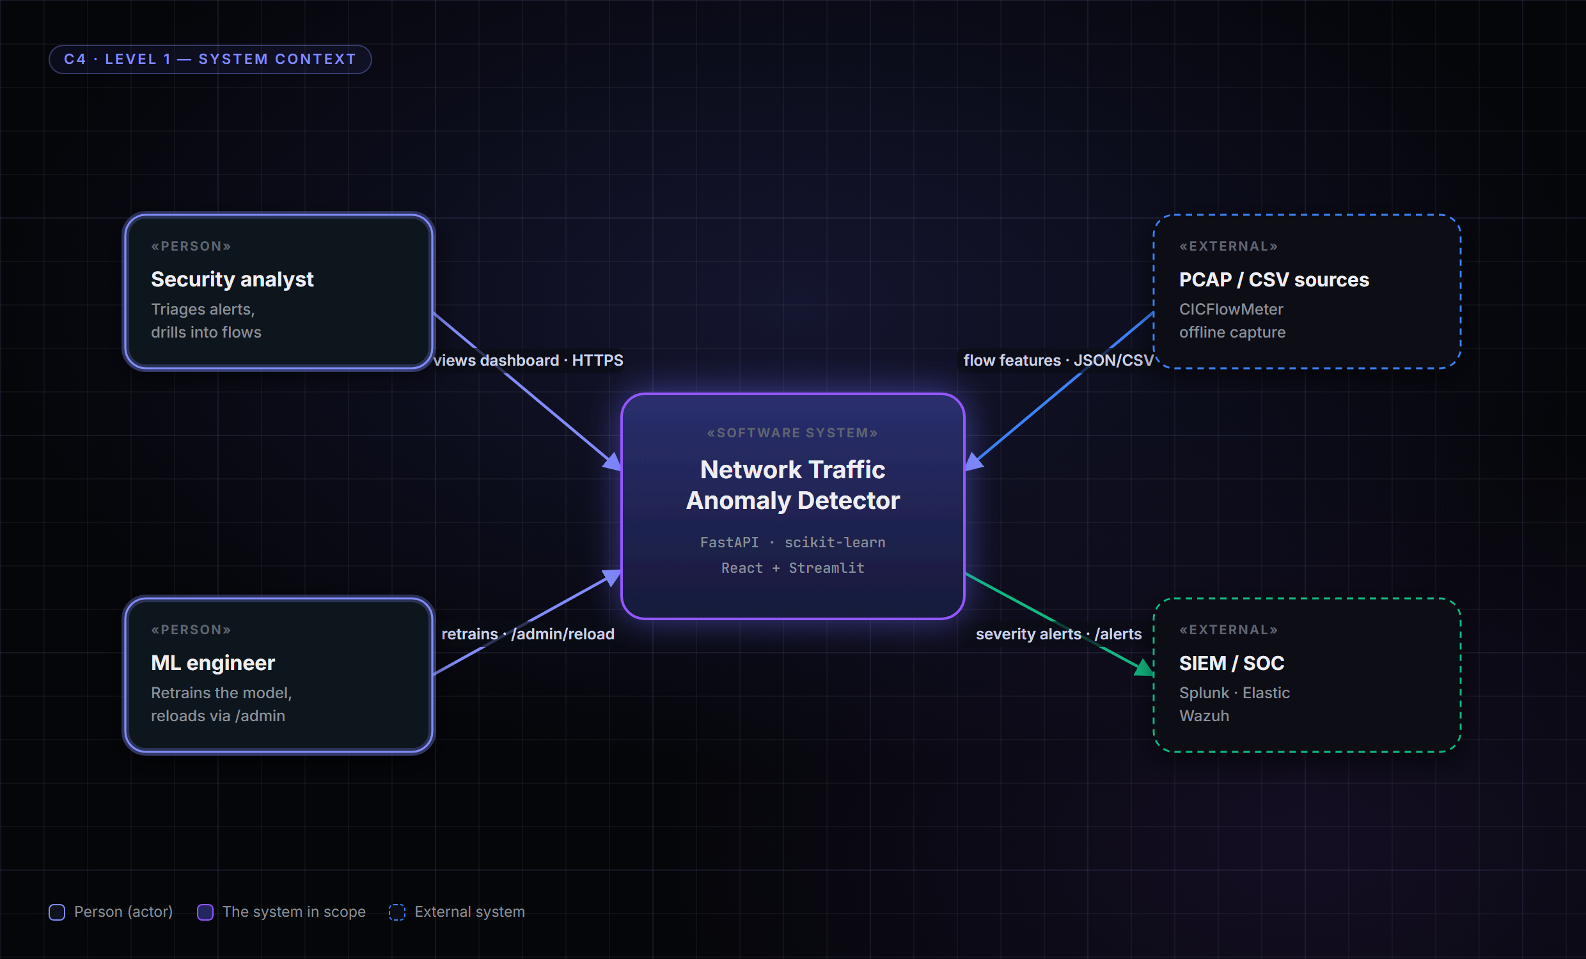
Figure 7 — C4 level-1 context — the detector between flow sources, the analyst, the ML engineer and an optional SIEM.
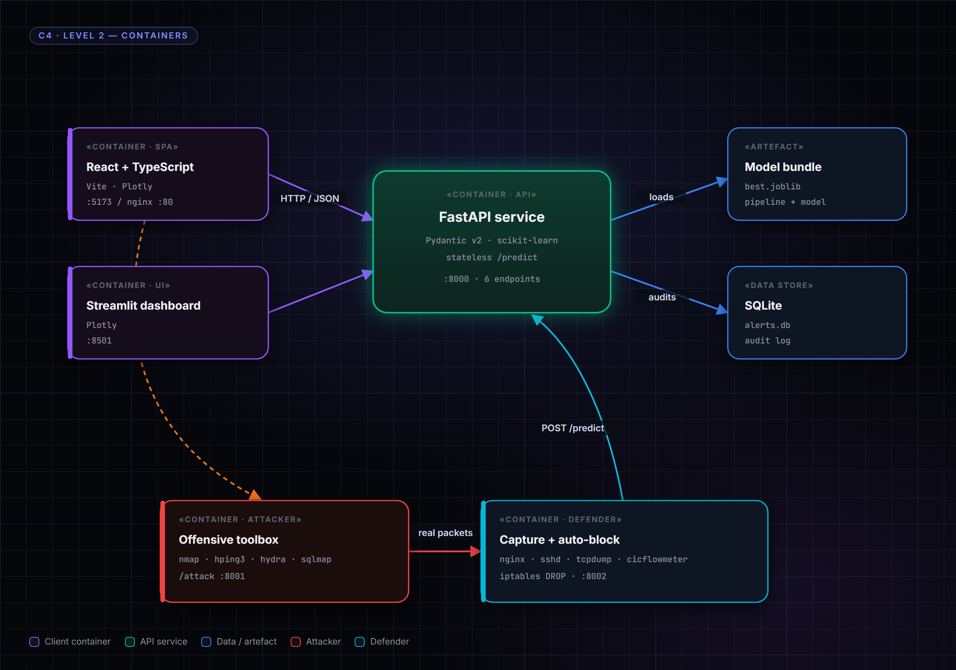
Figure 8 — C4 level-2 containers — the stateless FastAPI hub, its model bundle and SQLite store, the React and Streamlit clients, and the attacker/defender lab.
Three architectural rules are load-bearing and are referenced throughout the design:
- Stateless inference — /predict holds no per-request state; the audit write happens after the verdict, off the critical path (US-01).
- One serialised bundle — the fitted preprocessing pipeline and the model travel together in best.joblib, so train-time and serve-time transforms cannot diverge (US-07).
- Batch-first — /predict always accepts a list of flows so the vectorised scikit-learn path does the work (US-01).

5. Component design
Table 3 lists the runtime components, their responsibility, and the primary user stories each one realises. The boundaries are deliberately sharp: the API never renders UI, the dashboards never touch the model, and the lab containers reach the model only through the same public /predict contract a real client would use.
Component | Responsibility | Realises
FastAPI service (api/main.py) | HTTP surface, request validation, verdict + severity, audit write. | US-01, US-02, US-11
ModelRegistry (models/registry) | Load best.joblib; hot-swap on /admin/reload. | US-07
FeaturePipeline (features/) | Median impute → RobustScaler → one-hot; drop IPs/ports. | US-01, US-12
AlertStore (api/store.py) | SQLite persistence of every classification. | US-03, US-04
React SPA / Streamlit | Severity-coloured dashboards, manual scoring, examples. | US-02, US-05, US-06
Lab attacker (lab/attacker) | Run nmap/hping3/hydra/sqlmap behind /attack. | US-09
Lab defender (lab/defender) | Capture, extract, classify, iptables auto-block. | US-09, US-10

Table 3 — Components, responsibilities and the user stories they realise.

6. Data design
The model consumes a fixed twenty-feature flow vector and nothing else; IPs and ports are carried only as analyst labels and are dropped by the ColumnTransformer before the model sees them — the design-level enforcement of the privacy guarantee in US-12. Table 4 is the feature schema; Figure 9 shows how each attack category expresses those features, which is why the trees can separate them.
Group | Features
Volumetric | flow_duration, total_fwd/bwd_packets, total_length_fwd/bwd_packets, flow_bytes_per_s, flow_packets_per_s
Distributional | fwd/bwd_packet_length_max/mean, flow_iat_mean, flow_iat_std, fwd/bwd_iat_total
TCP flags | fin/syn/rst/psh/ack_flag_count
Protocol | protocol (one-hot)
Labels (dropped) | src_ip, dst_ip, src_port, dst_port

Table 4 — The canonical feature schema (features/schema.py).
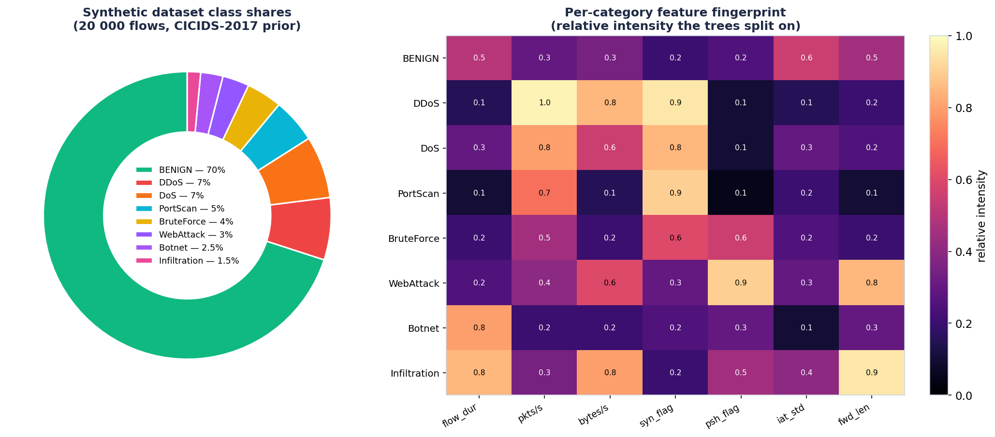
Figure 9 — Dataset class shares and per-category feature fingerprint — the signal the model keys on per attack class.
Persistence is a single SQLite table written after each verdict. Table 5 is its shape; it is what backs the audit and investigation stories (US-03, US-04) and the post-incident replay runbook.
Column | Type | Purpose
id | INTEGER PK | Row identity.
ts | TEXT (ISO) | Classification timestamp (Amsterdam tz).
verdict | TEXT | BENIGN or attack category.
score | REAL | Attack probability.
severity | TEXT | info / low / medium / high / critical.
src_ip / dst_ip | TEXT | Analyst labels (pseudonymisable).
model | TEXT | Deciding model name (traceability).
latency_ms | REAL | Per-request inference latency.

Table 5 — The predictions audit table (api/store.py).

7. API specification
The HTTP surface is intentionally small — six endpoints across four tags — and is fully OpenAPI-documented at /docs. Table 6 is the contract.
Method & path | Tag | Purpose | Story
GET /health | meta | Model-load state + version. | US-11
GET /metrics | meta | Totals, severity, attacks-by-class, latency. | US-11
POST /predict | inference | Score a batch of flows; optional threshold. | US-01, US-05
POST /predict/csv | inference | Score an uploaded CICIDS-format CSV. | US-01
GET /alerts | audit | Severity-filtered alert feed. | US-02, US-04
GET /predictions | audit | Full audit log for triage. | US-03
POST /admin/reload | admin | Hot-reload a new model bundle. | US-07

Table 6 — API surface mapped to user stories.
A representative request and response for the core scoring path (US-01) — a batch of one flow, scored at the default operating point:
POST /predict
{ "flows": [ { "protocol": "TCP", "flow_duration": 120000,
"syn_flag_count": 1, "flow_packets_per_s": 50, ... } ],
"threshold": 0.5 }
200 OK
{ "results": [ { "verdict": "Infiltration", "score": 0.812,
"severity": "high", "model": "gradient_boosting",
"probabilities": { "Infiltration": 0.81, "BENIGN": 0.14, ... } } ] }

8. Runtime behaviour
The most instructive runtime path is the attack/defend loop, because it exercises every component end to end. Figure 10 is the sequence: a click on the frontend drives the attacker container, real packets cross the bridge to the defender, the defender extracts a flow and posts it to /predict, the model returns a verdict, and on a confident attack the defender installs an iptables block — while the verdict simultaneously surfaces as a severity-coloured row in the analyst's Alerts tab. This single diagram realises US-09 and US-10 and demonstrates US-01 through US-03 in passing.
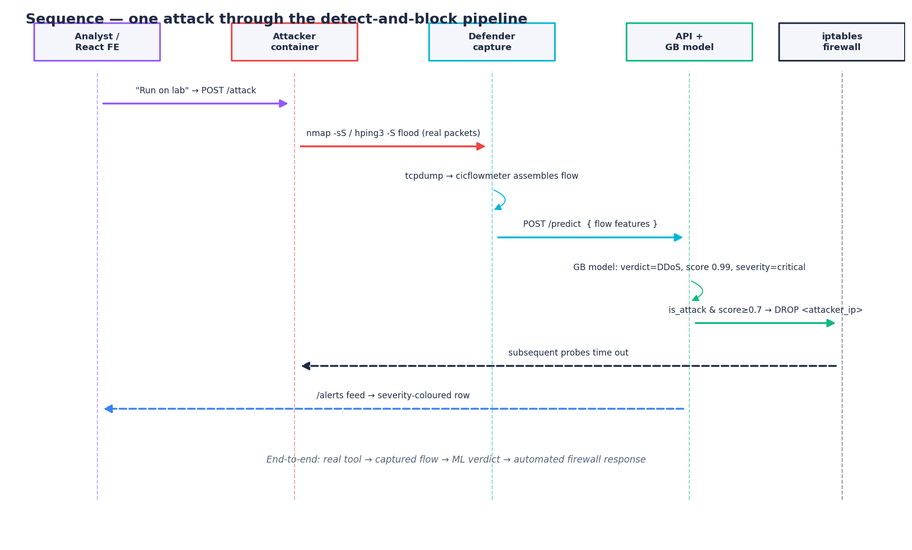
Figure 10 — Sequence — one attack through the detect-and-block pipeline: real tool → captured flow → /predict verdict → automatic iptables block → analyst alert.
The ordinary analyst path is a strict subset of the above: a client posts a batch to /predict, the FeaturePipeline transforms it, the model emits per-class probabilities, the service derives a severity band, writes the audit row asynchronously, and returns the verdict. Because the audit write is off the critical path, a slow disk degrades durability of the log, never the latency of the verdict — the design choice behind US-01's sub-50-millisecond acceptance criterion.

9. Non-functional requirements and security
Table 7 records the non-functional targets and where each is enforced. Security is treated as a design input, not an afterthought: the detector is itself threat-modelled with STRIDE in the Research Report, and the two controls most visible in this design are the no-payload feature schema (US-12) and the non-root, read-only-model container posture.
NFR | Target | Enforced by
Performance | Sub-50 ms verdict per analyst batch | Stateless /predict, batch-first, off-path audit
Monitoring | Every classification observable | /metrics, /health, SQLite audit
Security | No PII in the inference path | schema.py, ColumnTransformer(remainder=drop)
Compliance | GDPR/AVG: pseudonymisable, on-host, revocable | IPs not features; delete alerts.db
Reliability | No-downtime model swap | /admin/reload + ModelRegistry
Usability | Triage at a glance | Severity colour-coding, audit beside queue

Table 7 — Non-functional requirements and their enforcement points.

10. Deployment view
Everything ships as Docker images orchestrated by Compose. The API and dashboard are split into two images so they can scale independently and keep small; both run as dedicated non-root users and mount the model directory read-only. The lab is a separate Compose file with two privileged-capability containers (NET_RAW for capture, NET_ADMIN for iptables) scoped to their own network namespace so the host firewall is never touched — the trust boundary of the offensive stories US-09 and US-10.
- ad-api — FastAPI + model bundle, port 8000, non-root user detector.
- ad-dashboard — Streamlit, port 8501, non-root user dash.
- React SPA — built static assets served by nginx (prod) or Vite (dev), proxying /api.
- ad-attacker / ad-defender — the lab, brought up on demand from lab/docker-compose.yml.

11. Testing strategy
Layer | What is tested | Where
Unit — features | Pipeline robustness to NaN/inf, RobustScaler behaviour. | tests/test_features.py
Unit — API | Happy path, attack flow, threshold, 422 on bad input. | tests/ (API surface)
Integration | Train → serve → smoke-test on a small dataset. | CI pipeline
Model eval | Per-class precision/recall/F1, confusion matrix. | scripts/train, per_class_report.json
Lab (manual) | Run-on-lab → verdict → iptables block lands. | lab/ + /blocks endpoint

Table 8 — Test strategy across the layers.

12. Traceability matrix
The matrix closes the loop from need to verification: every user story maps to the component that realises it, the endpoint that exposes it, and the test or evidence that confirms it. It is the single artefact a reviewer can use to check that nothing in the backlog is unbuilt and nothing built is unjustified.
Story | Component | Endpoint / surface | Verified by
US-01 | FastAPI + FeaturePipeline | POST /predict | API tests; latency benchmark
US-02 | Severity logic + dashboards | /alerts | API tests; dashboard
US-03 | AlertStore | GET /predictions | API tests; audit table
US-04 | AlertStore + dashboards | /alerts rows | Dashboard review
US-05 | Threshold param + slider | POST /predict?threshold | API tests; manual scoring
US-06 | Manual scoring view | POST /predict | Frontend; class-prob chart
US-07 | ModelRegistry | POST /admin/reload | Reload smoke test
US-08 | Training + evaluation | scripts/train | per_class_report.json
US-09 | Lab attacker | POST :8001/attack | Manual lab run
US-10 | Lab defender | iptables + /blocks | /blocks shows DROP
US-11 | Metrics/health | GET /health, /metrics | API tests
US-12 | FeaturePipeline schema | (all) | schema.py; no payload stored

Table 9 — Traceability: story → component → endpoint → verification.

References
[1] Research Report — Network Traffic Anomaly Detector (companion document).
[2] C4 model for software architecture. https://c4model.com/
[3] Sharafaldin, I., Lashkari, A. H., & Ghorbani, A. A. (2018). Toward Generating a New Intrusion Detection Dataset. ICISSP.
[4] FastAPI documentation. https://fastapi.tiangolo.com/
[5] scikit-learn: Novelty and Outlier Detection. https://scikit-learn.org/stable/modules/outlier_detection.html
[6] OWASP API Security Top 10 (2023). https://owasp.org/API-Security/

