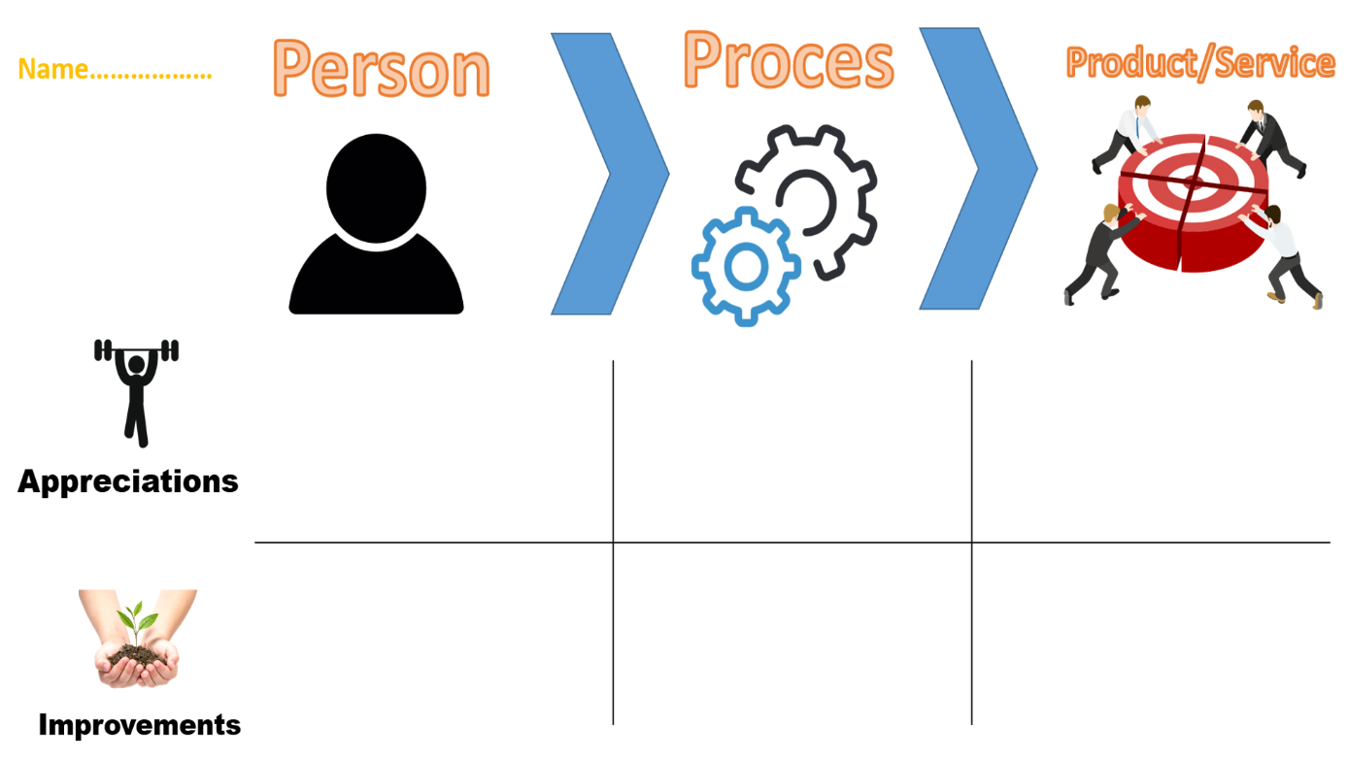

My advice for him is to keep it up.

His final products are working well and look finished in terms of back-end.

Not so much to advice here as he is working on very challenging personal assignments and is already writing clean and readable code.

Danila is working purposefully on his personal development in terms of both professional and technical skills and he has a good understanding of how to maintain the slope of his learning curve.

I would advise him to give himself some more rest from time to time and to keep things up in this regard since he is doing more than good.

Danila is very curious and constantly looking to do cool new projects which challenge him, despite his previous experience. His attitude to extend his knowledge is something I believe will serve him good purpose in his career if he keeps it up.