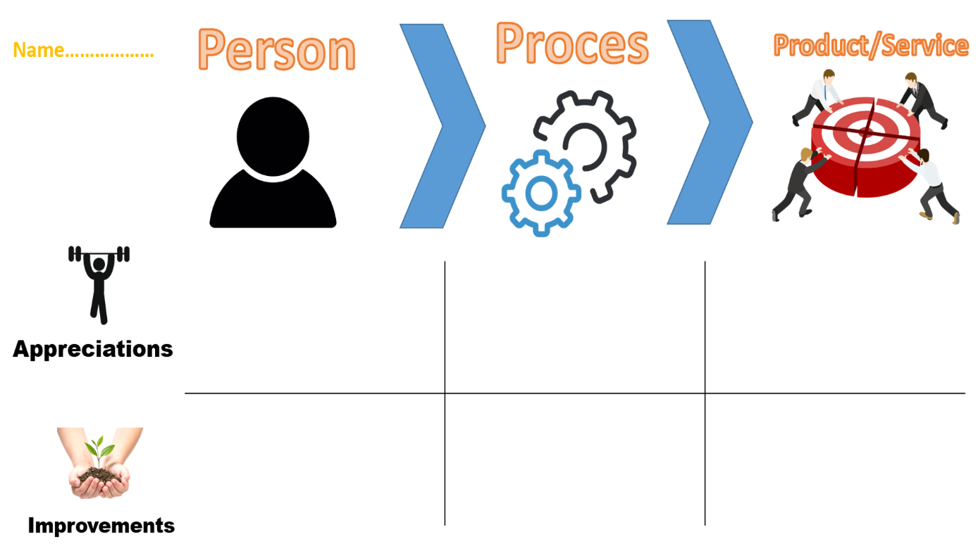

Here I would only recommend to separate code not only by different classes but also try to put different classes in separate directories where it is possible (it makes the project directory cleaner and easier to find various files inside).

His final products look good. All the things about it are described earlier.

Not so much to advice here as he is try harding implementing different extra features to his assignments and learning writing clean and readable code.

Angel is always pushing his limits in doing tasks to improve faster in terms code. And it is very cool that he is able to learn quickly taking in consideration his previous mistakes if they occur.

In terms of professionals skills Angle is experienced he knows how to communicate and give a good foundation to his arguments. Also he Is ready to take responsibility and tries to find out all the details about the assignments beforehand not to get in a situation he did smth that was wrong. So I would just recommend to improve further on in this direction.

Angel is always open to new ideas, and he is hardworking. He doesn’t hesitate to ask questions if he stumbles into issues also he tries to improve every time he receives a feedback that smth is wrong (so he ready for negative feedback which is smth that many people can’t handle)