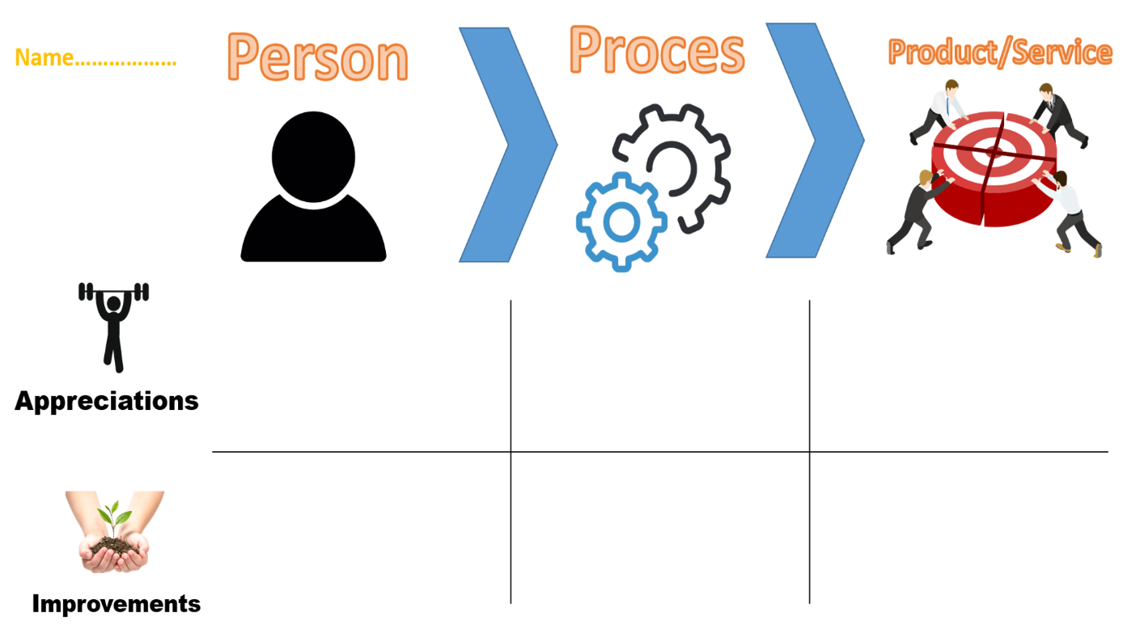

I haven’t seen his work yet. Would recommend not to be shy and talk more.

I haven’t seen his work yet. But he is visiting every meeting.

The workflow should be more even. Everyday something should be done and not everything only right before the deadline.

Ivan can do a lot of work and learn needed information to do something. But usually, it happens near the deadline which is bad for a team work.

I would recommend being more responsible with work and stop being lazy about work

Ivan is a fast leaner, and he can understand stuff quite quickly.