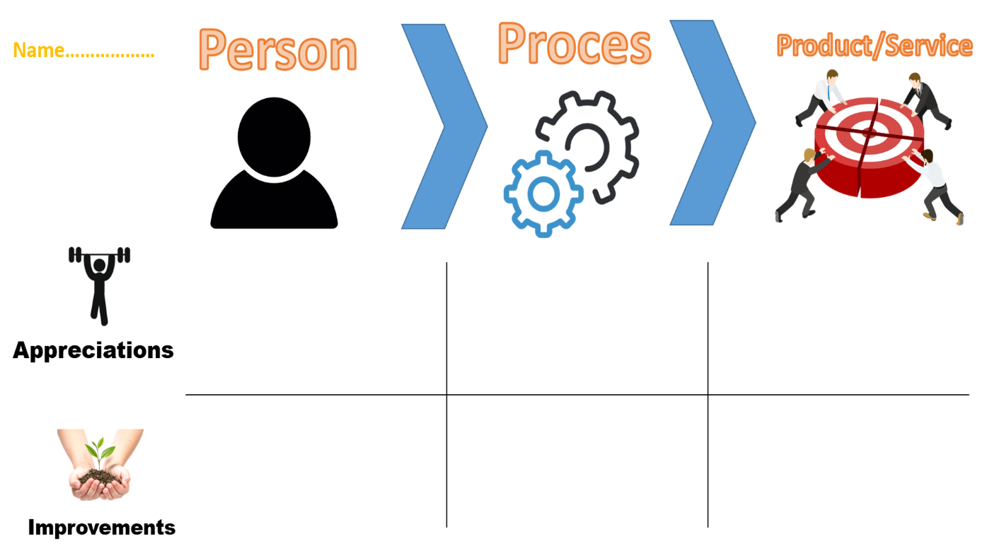

The same as above.

I haven’t seen his work yet. But meetings are not always visited. And no reason given for that, so just talk more so that teem knows what is going on.

I’m not sure about the work process

I’m not sure about the work process.

I would recommend not hesitate to ask any questions and always say if any issues occur during the project work. And if there is no possibility to visit the meeting for example.

Ivaylo is doing what he is asked to and he asks if has some questions