E-commerce web page report

Izhan Ahmed - N0917295

I hereby declare that I am the sole author of this report and that all third-party items including code have been adequately acknowledge and referenced.

Table of contents

1. Introduction
2. Planning Process
   1. Site mapping
   2. Site layout, initial design, and justifications
   3. Colour panel and themes
3. Design and main features
   1. Features implemented and implementation process
   2. Challenges encountered
4. References and sources

Link to the site: <https://udon.ads.ntu.ac.uk/web/soft20181/N0917295/Assessment-1/>

Introduction:

I have created an E-commerce website that advertises laptops to students, this is because University students will often search for laptops they should buy and is fit for them. For information gathered from websites, I’ve linked them in the referencing. I also gathered images accordingly to the information to show off the laptop’s advantages.

Planning:

Sitemap:

Site layout:

Original layout for home page:

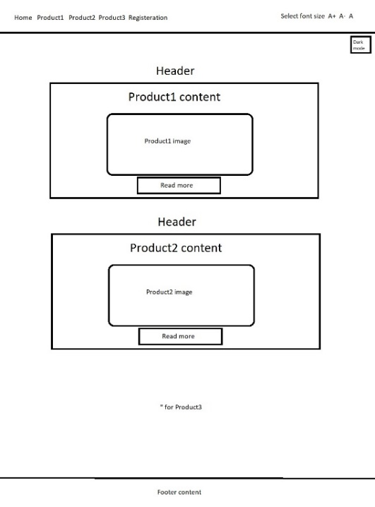

Layout for product page:

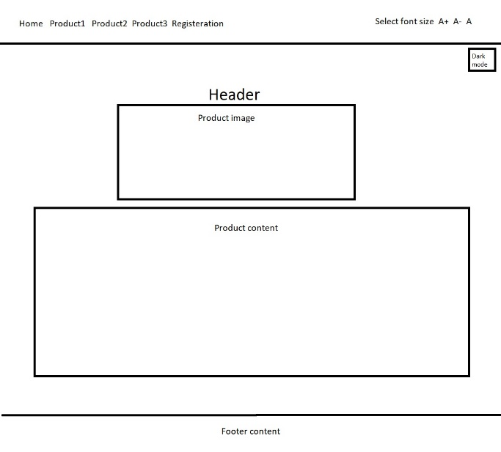

Layout for registration page:

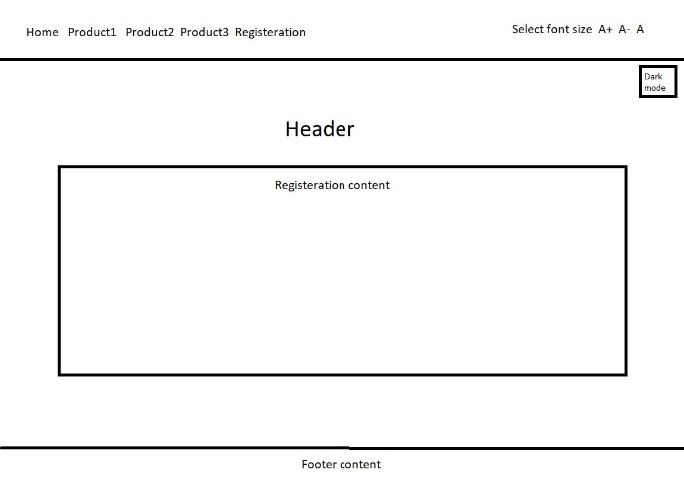

However, I decided to change the homepage product content view to a slide show as many well-known laptop sites have slideshows showing off their laptops. (Currys and LaptopDirects) I also changed the text size change to a drop down as it takes up less space of the navbar, allowing the size change itself to have more space for affect.

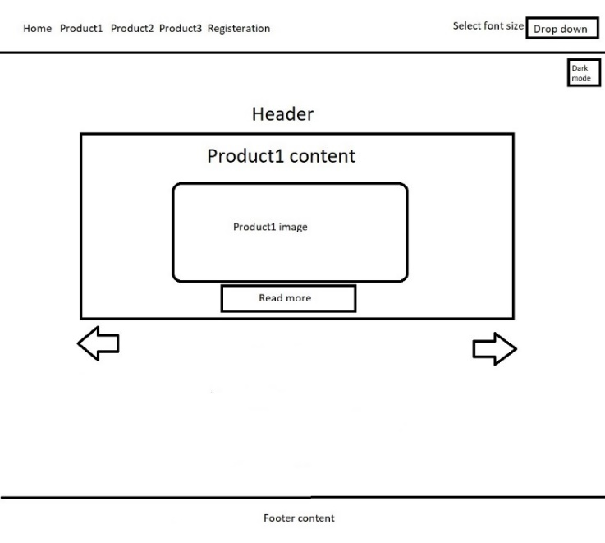

Layout for screen when screen size is 600px or lower:

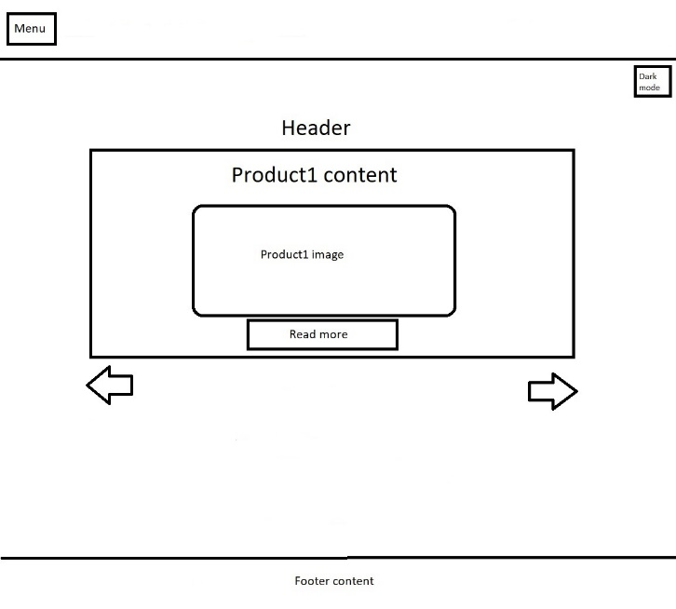

When the screen size is under 600px, the font size change drop down is removed as an even smaller size would be too hard to read on the smaller screen, but the bigger font size would take up too much space for where content could be. Therefore, I decided it was appropriate to remove it. It also has a menu icon which can be clicked to extend and open the navigation bar to browse different pages on the site.

Colour panel and theme:

The colour panel and theme I have chosen follows a “Minimal” theme from Wix which is often used in online electronic stores. It has a clean and sharp design which gives off a futuristic impression and I thought this would be perfect for a laptop site that is trying to sell the best technology to its user. (Wix)

Design and main features:

The structure of the website will have a Navigation bar at the top with links to the pages on the site, including the Home page, product pages and the register page. This is for ease of access to users so that they can navigate around pages when needed. The Navbar is styled in the Style.css sheet from lines 37 – 66. It has auto and hidden for horizontal overflow so that the navbar content does not go off the page creating a scrollbar. It has a nowrap set for whitespaces so that whitespaces in the webpage are collapsed and doesn’t take up necessary space and finally a display flex for the content of the navbar to take up the entire space.

The navbar will have a select font size drop down to allow changes to the navigation bar font size. Lines 117 – 157 in the Java.js file have the font size change functionality defined. There is a function named “increaseFont” which accepts a value from a drop down, the value is either large, small, or normal font size. Depending on the option chosen, an ID is placed on the navbar fonts which has the new font size defined which changes the font size. There are also if statements to check whether certain text ID’s exists on the page as there will be an error for not being able to read null ID’s.

The selected option is stored in the local API in called “fontSize” for the user to have their preferences saved for when they come back to the site, this is loaded from the lines in 160 - 198. I have chosen to have an option that allows font size to be changed to allow users to experience different page speeds, accessibility, and usability. This is via change in font size allowing content to take up less/more space as well as increase readability for certain users with certain conditions.

Just underneath it will be a toggle dark/light mode button. This is designed in the Java.js file, lines 200 – 219. There are two functions defined for this feature, one being “addDarkMode” and the other is “removeDarkMode“. “addDarkMode” applies a class called “dark-mode” and “activeDark” to the background colour and navbar active tab which makes the colour change from white to a dark grey. “removeDarMode” removes the mentioned classes from the background and active navbar tab, turning it back into a white.

The EventListener in lines 222 – 227 checks which function is currently stored in the API, if the API has dark mode set on; then clicking the toggle button will take off dark mode and vice versa. I have decided to add a dark/light mode button because the background of the website is extremely bright and may cause discomfort for certain users with sensitive eyes or other issues. It can also help make images stand out. However, research has also found that dark text on light background can sometimes be hard to read so dark mode can fix that issue. I created the Dark Mode function with the help of a YouTube video as I needed to understand the logic of assigning two functions to a single button. (Kevin Powell, YouTube, 2019)

It will have user-friendly features implemented on every page being the toggle dark/light mode button and change font size button, which is stored in the API. If the user wants to enter the site again their previous preferences are saved for efficiency. They won’t have to go out their way to choose their preferences again as they’re already saved for them.

In lines 238 – 303 in Style.css, the menu button for screens that are smaller than 600px is defined. It has a “menuIcon” class with display:inline-block which allows for the content to be on the same line but adjustable width and height. ”navLinks” has a display:none and “navbar a” has display block so it can be hidden and appear when the user wants it to, this will happen when the checkbox is clicked allowing for it to be visible from display:block in line 250.

The “main features” will be set on every page on the site.

Home page:

The Home page has a brief description of the laptops with images showing off their features as shown in the page design layout, these images can be increased to a larger size when clicked on. Each product has its information stored in a different grid. I decided to lay it out like this because it helps organise the content and form a basic structure for the users so that they have an easy time looking around the page and the different products. They have a read more button for ease of access and accessibility by providing buttons next to the product so that the users do not have to scroll up to the top of the page each time they want to navigate to another page.

The home page and product pages also have a feature that allows users to enlarge pictures when they click on them. This function is defined in the Java.js file from lines 18 – 89, there is an if statement that checks whether the animateImage ID’s exist in the html file and decides to perform the animateImage Java. This is because the html file cannot run if there is an undefined variable in the Javascript file. The images originalwidth is stored so that the image can be returned to its normal size, the function enlargeImage increases its width constantly until it reaches either 50% or 25% of the screen depending on the screen size so it can stop and not infinitely expand as well as, so it does not expand out of its section box. It also has a media function to check the screen size and increase the picture size according to the screen size.

The Home page has a slide show feature which allows for the user to slide between different product content by clicking the arrows. The function is implemented in the Java.Js file from lines 230 – 250. The function works by assigning the slides to a number and a swap function which adds or takes away a number depending on if the left arrow or right arrow is clicked. If the left is clicked, then it takes away 1 from the slides in the swap function, changing it to the product on the left. If the right arrow is clicked then 1 is added to the slide in the swap function, making the slide content switch to whatever is on the right side. (W3Schools)

The show content function assigns numbers to slides and if the number is not being displayed on the screen, the style display none is applied to it so that other slides do not appear, they will only appear once their slide is selected.

Product pages:

The product pages on the site are extremely similar to the home page, they have a header with the name of the product followed up by an image of it which can be increased in size with the enlargeImage function. It will also have a detailed guide on why the user should buy the laptop.

Register page:

The registration page has a form that can be completed by entering the users details, it also has a required pattern set on it so that limitations are set on the details entered. In line 44 and 46 from Registration.html, there is a restriction that only allows alphabetical characters with a minimum of 3 characters and maximum of 10.

There is also an optional information details for users to enter details that will make their account have increased security such as Date of birth and phone number. In lines 92 -112 from Java.Js, the optional information has an if statement check the optional ID exists in the page to run its Java function, if it does then optional is set to hidden by adding the “hide” class which has display set to none. This function works similarly to the dark/light mode button where it has two functions, one for showing the form and the other hides it, this works by adding and removing the “hide” class in their respective functions and stores the selected option in the API.

When the optional information button is clicked, it checks the API to see whether the form is hidden or not, if it is hidden then it performs the “showForm” function. If the form is visible, then the “hideForm” function is performed.

Challenges encountered:

The main challenges I felt like I encountered were trying to discover an efficient method to perform JavaScript code if an Id did not exist on the page, such as “animateImage” not existing on the register page so I had to write a large if statement to correct this. I was not able to find a good enough working solution to this problem.

Other problems I encountered were the logic of two function on a single button as the button would not update and not perform the second function assigned to it. To get around this issue I had to create a locale storage API that saved whether a function had been ran, depending on what has saved in the API, the appropriate function would occur. I used this for the optional information and dark mode button in my web page.

References:

Currys, HP 14a-na0502sa 14" Chromebook - Intel® Pentium® Silver, 128 GB eMMC, White: <https://www.currys.co.uk/gbuk/computing/laptops/laptops/hp-14a-na0502sa-14-chromebook-intel-pentium-silver-128-gb-emmc-white-10208592-pdt.html>

Wix, Website designer: <https://editor.wix.com/website/builder?referral=split%20page&vertical=online-store&structureId=920d6d4e861dfb385da1016c&industryId=0e72b2a150d4b1ffad033c6a&categoryName=Online%20Electronics%20Store#!/builder/story/641e8bdd-a86f-4567-8f21-bb875f95860f:991fbf3d-bd27-458a-bf2f-733ab6066b00>

W3Schools, CSS slideshow: <https://www.w3schools.com/w3css/w3css_slideshow.asp>

CreativeBloq, Best student laptops in 2021: <https://www.creativebloq.com/news/best-laptops-for-students>

Acer slim Homepage image: <https://www.techradar.com/uk/reviews/acer-swift-3-2020>

Acer Product page image: <https://www.u-buy.co.uk/product/1AEN7VHA0-acer-swift-3-thin-light-laptop-14-full-hd-ips-100-srgb-display-amd-ryzen-7-5700u-octa-core-processor-8gb-lpddr4x-512gb-nvme-ssd>

Mac OSBigSur Homepage image: <https://www.apple.com/newsroom/2020/11/macos-big-sur-is-here/>

Macbook Product page image: <https://www.u-buy.co.uk/product/3QRHZXU-2020-apple-macbook-air-with-apple-m1-chip-13-inch-8gb-ram-256gb-ssd-storage-silver>

Surface Pro Portable Home page image: <https://www.newegg.com/global/uk-en/matte-black-microsoft-surface-pro-7-vat-00016/p/N82E16834736091>

Surface Pro Product page image: <https://www.u-buy.co.uk/product/3O4KK6-microsoft-surface-pro-7-12-3-touch-screen-10th-gen-intel-core-i5-8gb-memory-128gb-ssd-latest-model-p>

Kevin Powell, Youtube, 2019: <https://www.youtube.com/watch?v=wodWDIdV9BY>