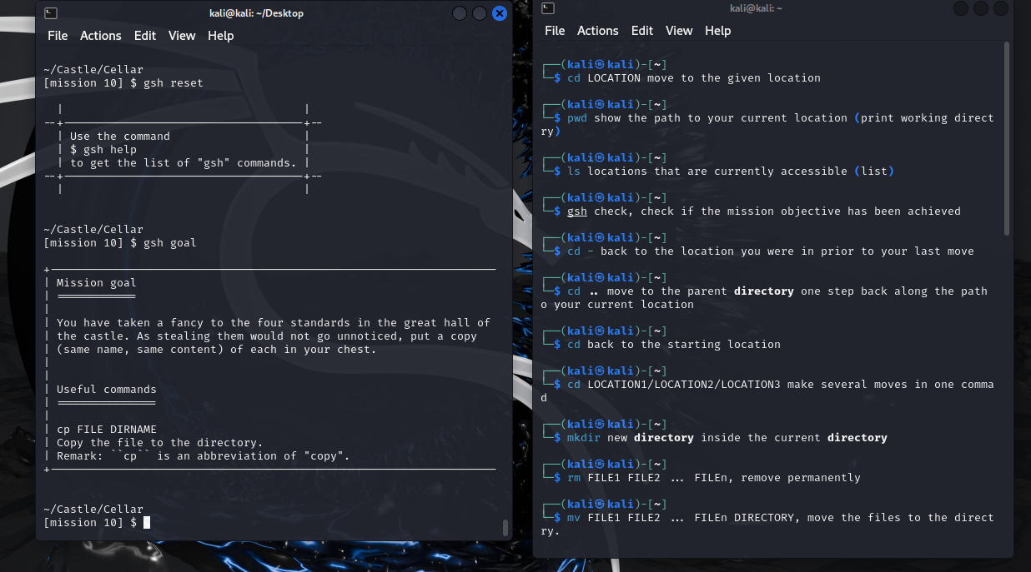

**Commands used**: (UPPERCASE words appearing in commands are meta-variables: you need to replace them by appropriate (string) values.

**Level 1)** ‘cd LOCATION’: move to the given location

**Level 2)** ‘pwd’: show the path to your current location (print working directory)

**Level 3)** ‘ls’: locations that are currently accessible (list)

**Level 4)** ‘cd –‘: back to the location you were in prior to your last move

**Level 5)** ‘cd ..’: move to the parent directory one step back along the path to your current location

**Level 5)** ‘cd’: back to the starting location

**Level 6)** ‘cd LOCATION1/LOCATION2/LOCATION3: make several moves in one command

**Level 7)** ‘mkdir’: make a new directory inside the current directory

**Level 8)** ‘rm FILE1 FILE2 … FILEn’: remove permanently

**Level 8)** ‘mv FILE1 FILE2 … FILEn DIRECTORY’: move the files to the directory

**Level 9)** ‘ls -A’: list all the files of the current directory.

**Level 9)** The "*" character stands in for any sequence of characters (including an empty sequence). The "?" character stands in for any single character. Those wildcards can be used to denote lists of existing files / directories in the current working directory.