Individual Weekly Report for Abhishikth Kota
  - Joule
  - June 30, 2025

Accomplishments
- Identified tools to download and set up necessary for development of the app.
- Brainstormed features that I would want to be the center focus of the app.
- Scoured the app store for similar apps and take some notes about their features.
- Read a couple pages of “The Swift Programming Language” to brief myself on swift.

Weekly Activities
Activity / Task / Work | Hours | Status
Read “The Swift Programming Language” | 8 | In progress
Looked into what tools I would need to develop the app for iOS | 1 | Complete
Set up the tools (Xcode and Figma) | 2 | Complete
Brainstormed features that would be the center focus of the app | 2 | In progress
Scoured app store and did some research on similar existing apps | 1 | In progress
Worked on one page proposal | 1 | Complete
Attended both in person class for the first week of the quarter | 5 | Complete
 |  | Select work status
 |  | Select work status
 |  | Select work status
Weekly Total | 20
Previous Weekly Cumulative Total (Carry Over)
Current Cumulative Total | 20

Plans for Next Week
Activity / Task / Work | Est Hours
Get started on developing some UI elements for the app in Figma | 5
Get started on making a basic app with a splash screen that can be run on iOS | 5
Figure out how to set up my iPhone to test my app in real time in parallel to the simulator | 2
Read more of the “The Swift Programming Language” book to learn swift | 8

Response to Feedback
So far people think that I have a good idea and a good reason to pursue this idea. People think that this an exciting and useful app they would want to use.

Other Reflections
Some reflections I have is maybe keeping in mind that this app could also be ported to android so think ahead which frameworks to use to make that possibility easier in the future. I also realized that I would want to split up the learning and experiment part of the development process for this app better if I were to redo the work.

Comments, Issues, Notes, Anything Else?
None as of now!

Evidence of Work
XCode Setup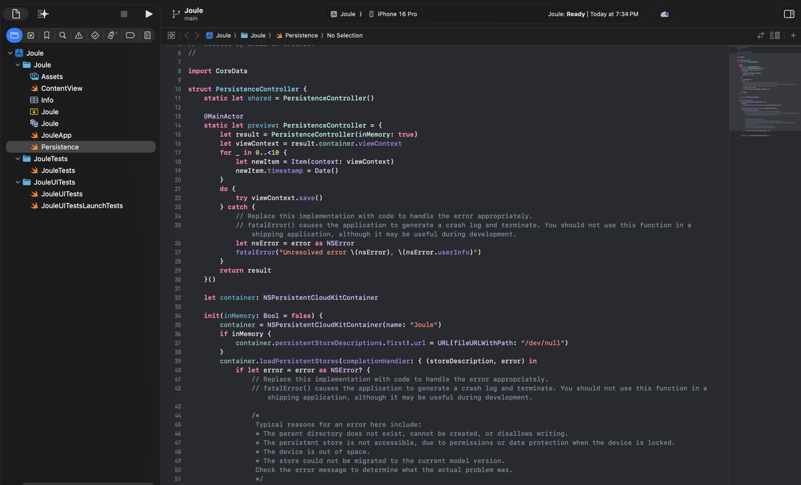
This image show’s my project being setup in XCode
Figma Setup 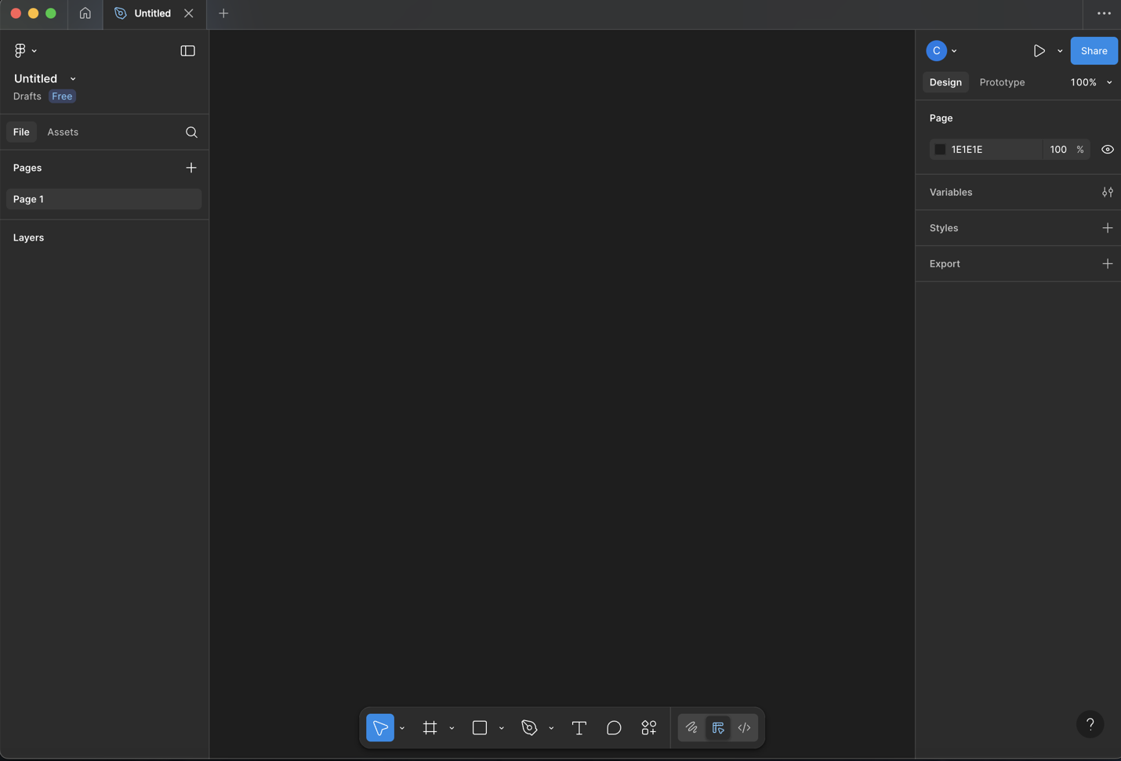
This image shows me logged in to Figma and having set it up.

“The Swift Programming Language” Notes
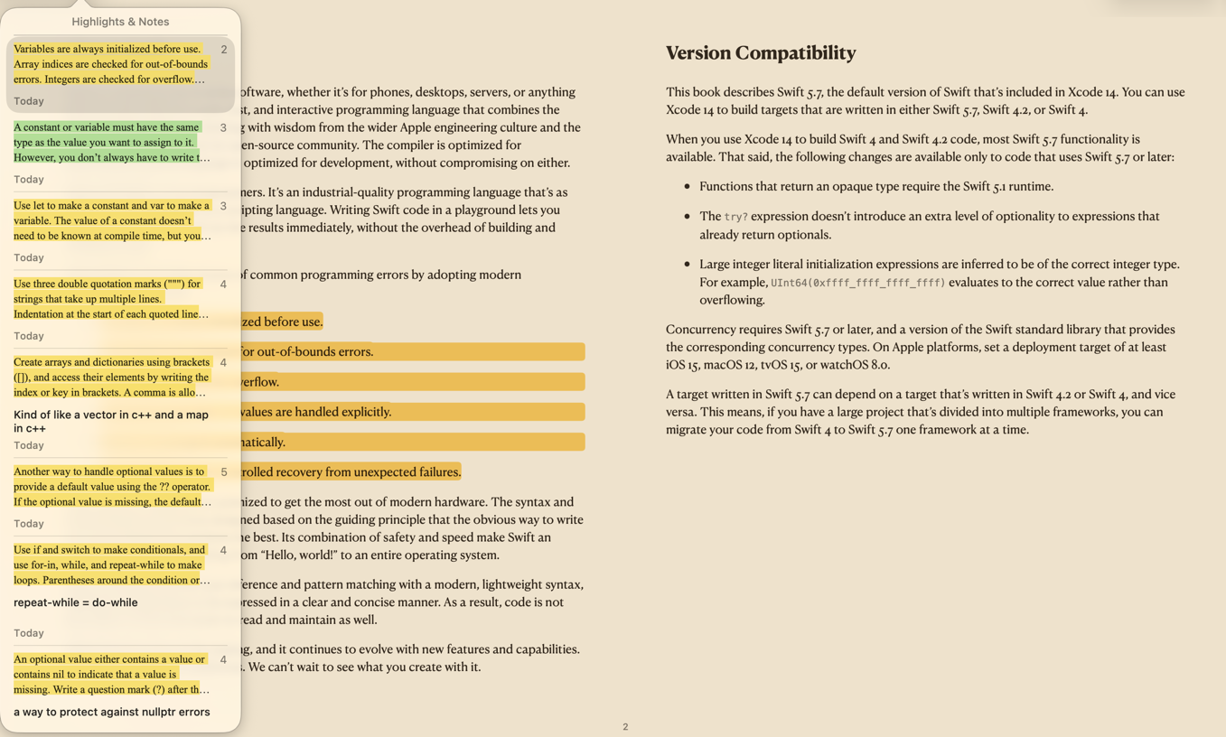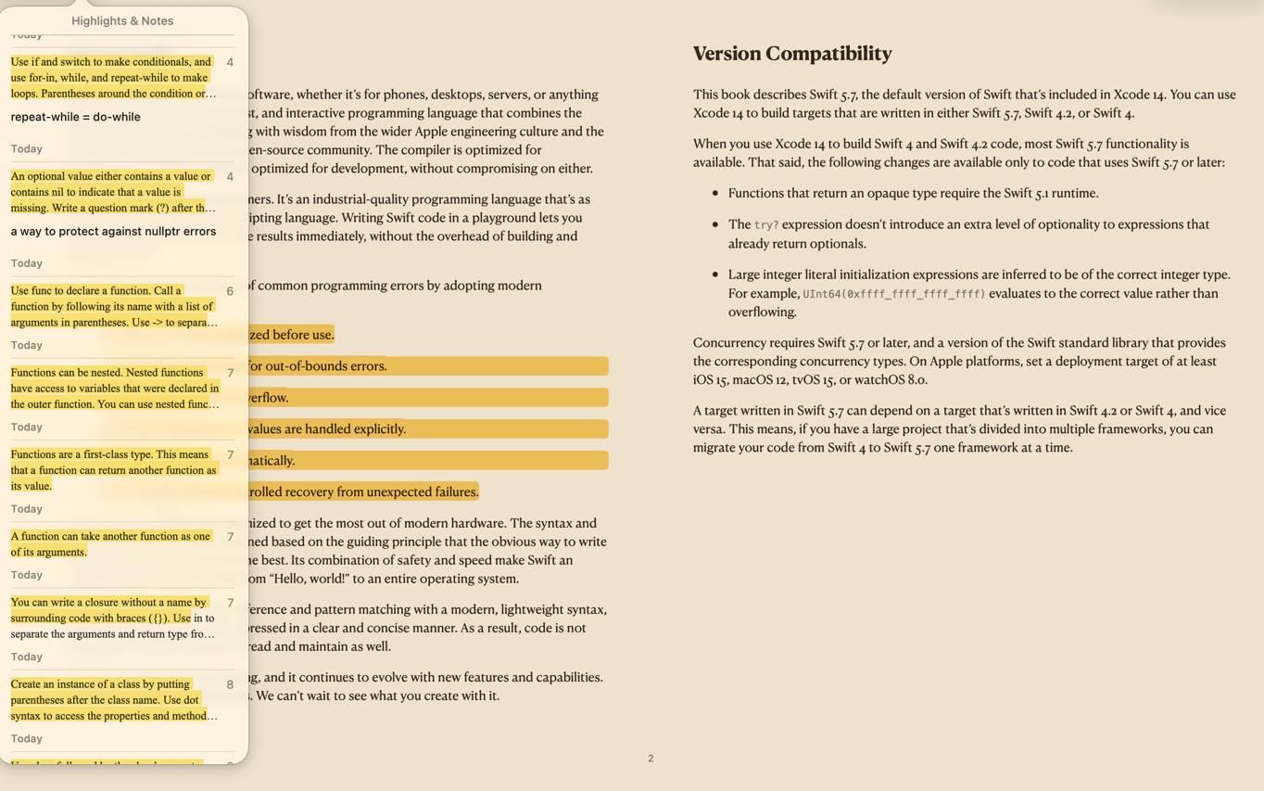
The above two photos are examples of the notes I took. The highlights and notes show that I have been highlighting and adding notes on pages that I find crucial information to learn swift.

Brainstorming Notes
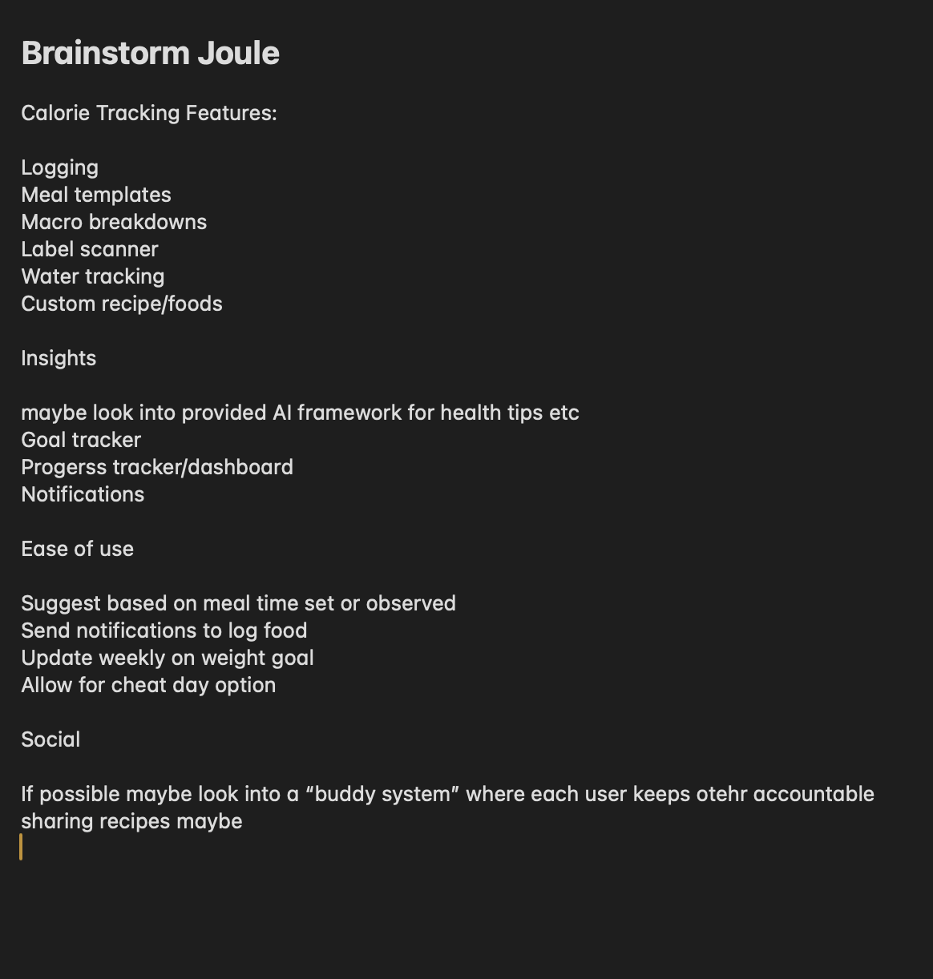
This image is my brainstorming for the features I plan to implement in the app.

