**STOCK PAIR ANALYZER**

**Date:** 7th June 2024

**Submitted by:** GUTTHA MANI TEJA

22KQ1A02C8

**Details of Project:** I’m implementing this project by using Python Programming Language.

**Code**

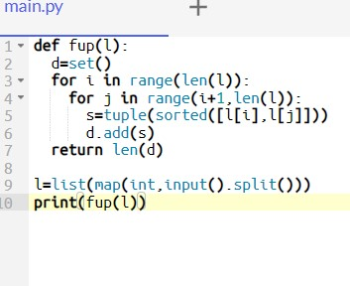

**Input and Output**

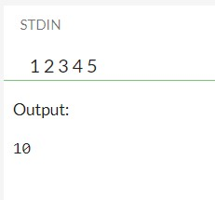

**Explanation:**

**This code snippet defines a function fup(l) that calculates the number of unique pairs in a list l that can be formed by selecting two elements from the list. The function achieves this by iterating through the list and creating a set of sorted tuples of pairs to ensure uniqueness.**

**Here's a breakdown of how the code works:**

**- The function fup(l) takes a list l as input.**

**- It initializes an empty set d to store unique pairs.**

**- It then iterates through the list using two nested loops to generate pairs of elements.**

**- For each pair, it sorts the elements, creates a tuple, and adds it to the set d.**

**- Finally, the function returns the count of unique pairs in the set.**

**In the main part of the code:**

**- It reads a list of integers as input.**

**- It calls the fup function with the input list.**

**- It prints the count of unique pairs obtained from the list.**

**This code is useful for counting the number of distinct pairs that can be formed by selecting two elements from the given list. It ensures uniqueness by using a set to store the pairs. Let me know if you need more clarification on any part of the code!**

In this Program I have implemented project name which is nothing but hello world, in which I have taken it as an input from user and displayed the output.

**Conclusion:**

Finally I have got the desired output 10