EE2T21 bonus assignment 1

Christian van den Berg, Marijn Adriaanse & Guus Dohmen

### The assignment:

The goal of the assignment is to simulate the S&W protocol and to do several experiments with this simulation. In order to do this we have chosen to use python as our programming language, due to the familiarity and ease of use.

### How to run the program:

The program is configured to run all 3 experiments, as described in the assignment, at once. Therefor there is no configuration needed on the user side. However, we have added the possibility to manually define P1, P2 and the input list of integers.

One can use *python SnW.py*  in order to run all experiments at once.

To run a custom experiment, one can use the following command: *python(3) SnW.py*  *<infile> <p1> <p2>*, in which *<infile>* refers to the file path of the input data file, and *<p1>* and *<p2>* refer to the probabilities p1 and p2, respectively.

The input data file is a *.txt*  file, in which each new row is treated as a new integer. An example of this can be found in the code repository.

### Experiment 1

In experiment one both P1 and P2 were zero. This means that we had an errorless data transmission. Therefor we expect a linear relationship between the number of integers to be transmitted and the number of transmissions. This is also what we found, as can be seen in the following graphChart, line chart

### Experiment 2

In experiment 2, the chance of an error happening in the acknowledgement is left at 0 and the number of symbols is constant at 200. The goal of this experiment is to see the influence of the error probability in the message on the number of iterations the protocol has to do. Therefor, P1 is varied from 0 to 1 with a step size of 0.05. The results of this experiment can be seen in the graph below. The relation between P1 and the number of iterations is an exponential function. This can be expected, since every message has a chance of P1 to get corrupted.

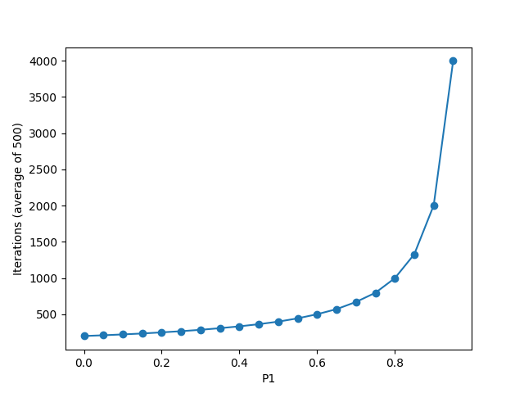

### Experiment 3

In experiment 3, P1=P2=P. Both P1 and P2 were varied, whilst the number of symbols was left constant at 100. This means that both the message and the acknowledgement signals had the same chance to be corrupted. Due to this, one would still expect an exponential relation between the error rate and the number of iterations, however this is expected to be steeper than the exponential function in experiment 2. The results of this experiment can be seen in the following graph:

