Project 1: Hive – SCD_Type2_ Incremental Data Load

Author : Devendra Kumar Rajendran

-------------------------------------------------------------------------------------------------------------------------------

**Database : incr_load2 used for SCD Type 2 practise**

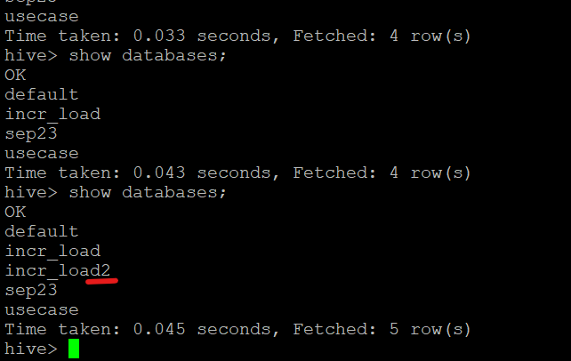

**Tables :**

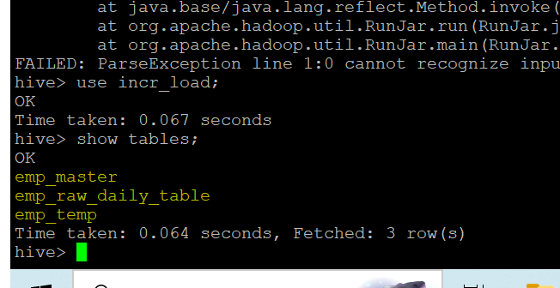

**Shell Script & HQL Files Path :**

**Location path: /home/Dell/bin**

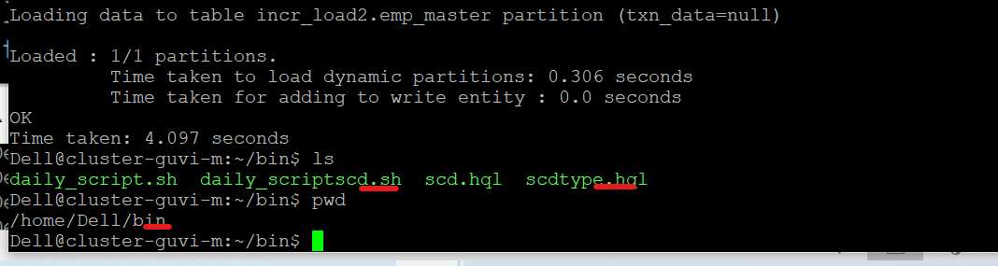

**Files Path :**

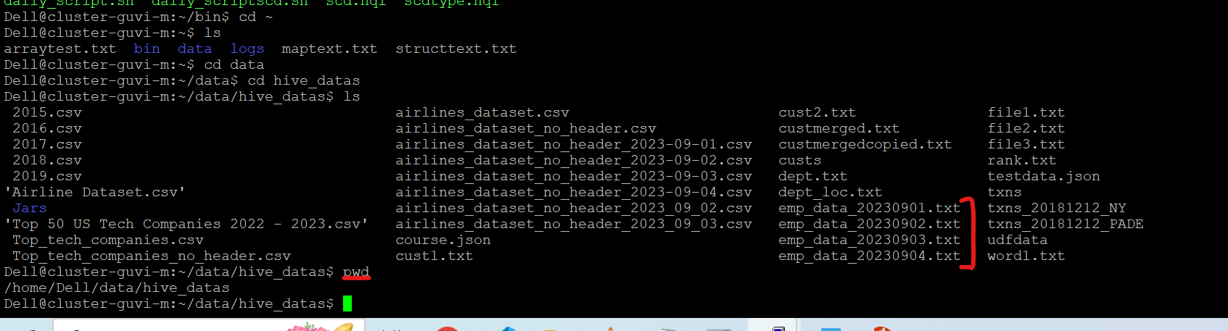

**Results :**

**Day 1 : File Uploaded**

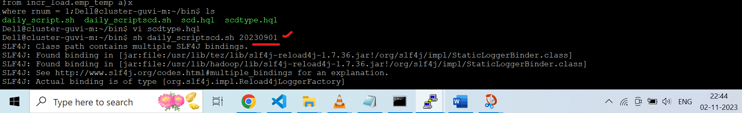

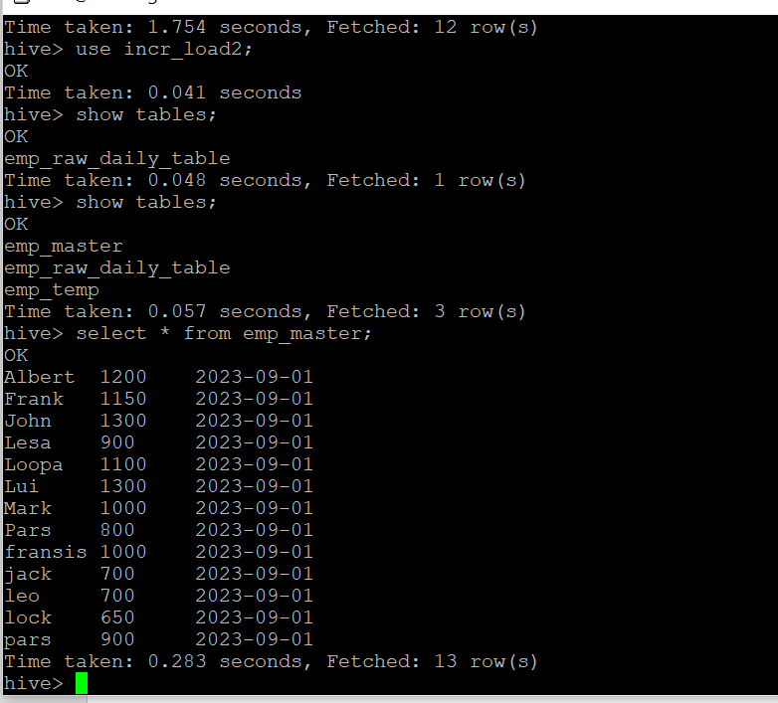

**Day 2 : File Uploaded**

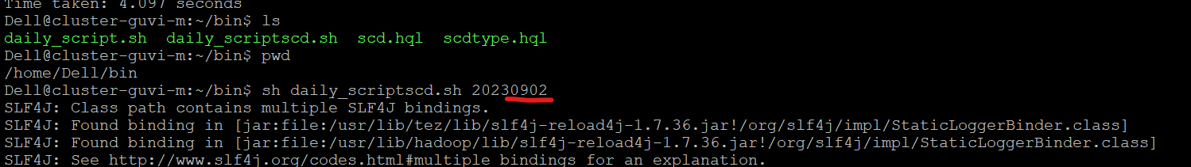

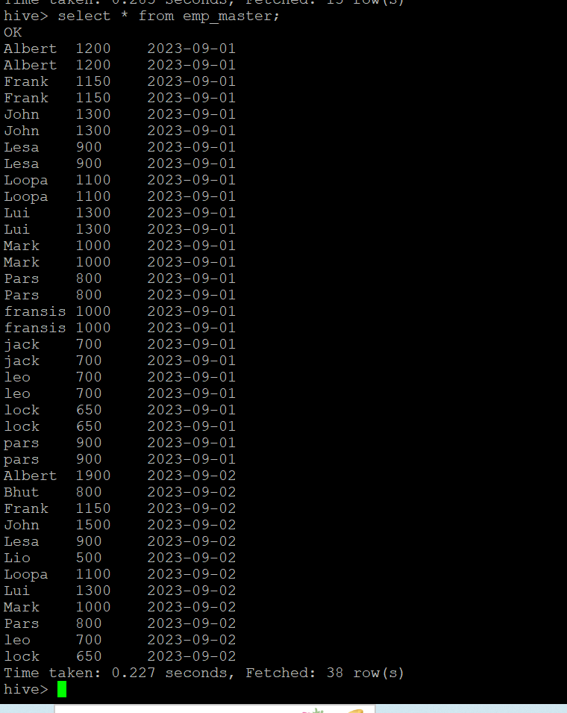

**Day 3 : File Uploaded**

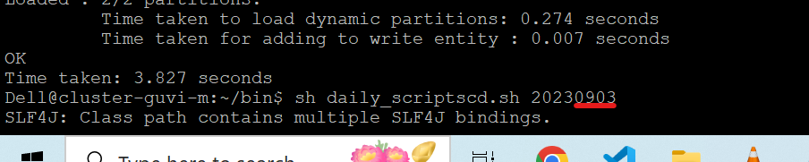

**Note : Day 3 file data has been uploaded, and results are given below . The latest 3 records of Mr . Albert details of wages for day 2 and day 3 displayed here .**

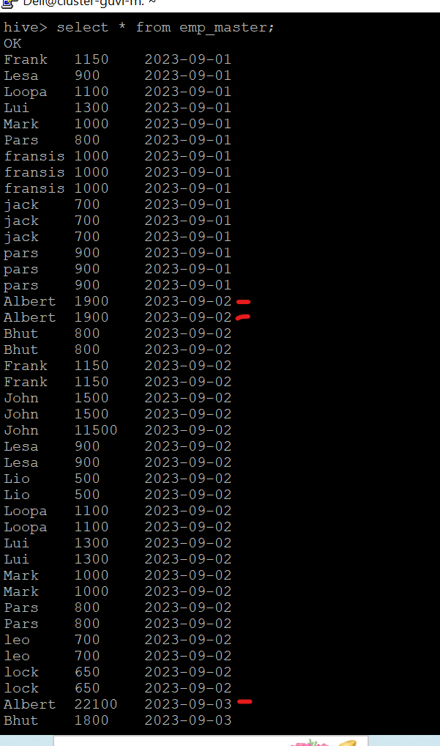 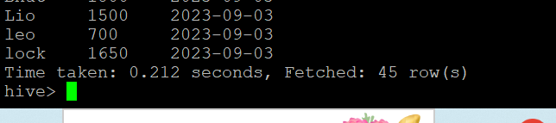

**Day 4 : File Uploaded :**

**Note :** Day 4 file data’s are having the dates of 20230902 and 20230903 only, and not having day wages and date. Hence output showing latest 3 records.

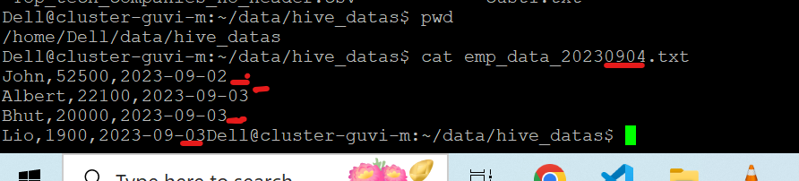

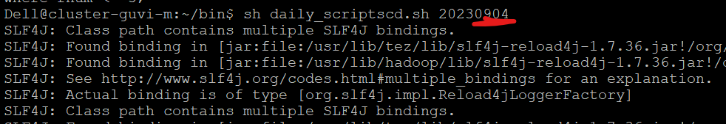

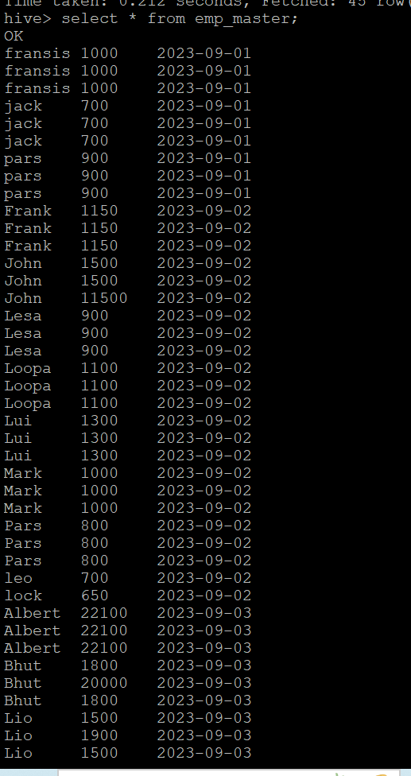 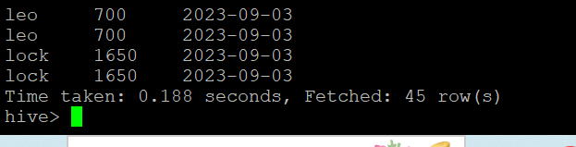



Command : describe formatted emp_master ;





