# Gitlab安装使用手册

## 一、参考网址：

<https://gitlab.com/gitlab-org/omnibus-gitlab/blob/master/README.md#installation>

## 二、安装gitlab版：6.9.2

### 2.1 下载rpm发行文件名

下载地址：[gitlab-6.9.2_omnibus.1-1.el6.x86_64.rpm](http://www.t00y.com/file/66695594%5dgitlab-6.9.2_omnibus.1-1.el6.x86_64.rpm)

### 2.2 安装邮件服务器

#sudo yum install postfix ( # sendmail or exim is also OK)

### 2.3 一键安装gitlab

#sudo rpm -i gitlab-6.9.2_omnibus.1-1.el6.x86_64.rpm (# this is the .rpm you downloaded)

### 2.4 开启gitlab

#sudo gitlab-ctl reconfigure

### 2.4 开启防火墙的http和ssh 请求

#sudo lokkit -s http -s ssh

### 2.4 查看运行状况

#sudo gitlab-ctl status

run: nginx: (pid 3012) 53s; run: log: (pid 3011) 53s  
run: postgresql: (pid 2857) 87s; run: log: (pid 2856) 87s  
run: redis: (pid 2759) 98s; run: log: (pid 2758) 98s  
run: sidekiq: (pid 2967) 60s; run: log: (pid 2966) 60s  
run: unicorn: (pid 2938) 66s; run: log: (pid 2937) 66s

说明安装成功。

### 2.4 登录gitlab

通过浏览器访问：[http://localhost](http://localhost/)   或者  [http://ip](http://ip/)

## 三、gitlab的使用

### 3.1 注册并登录

点击sign in 注册并登录

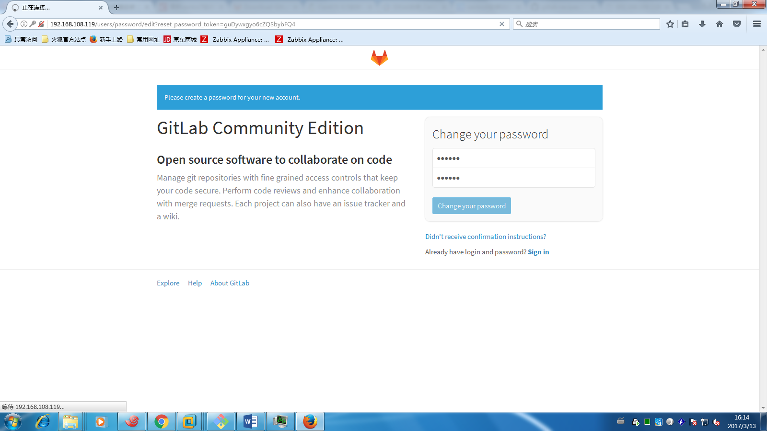

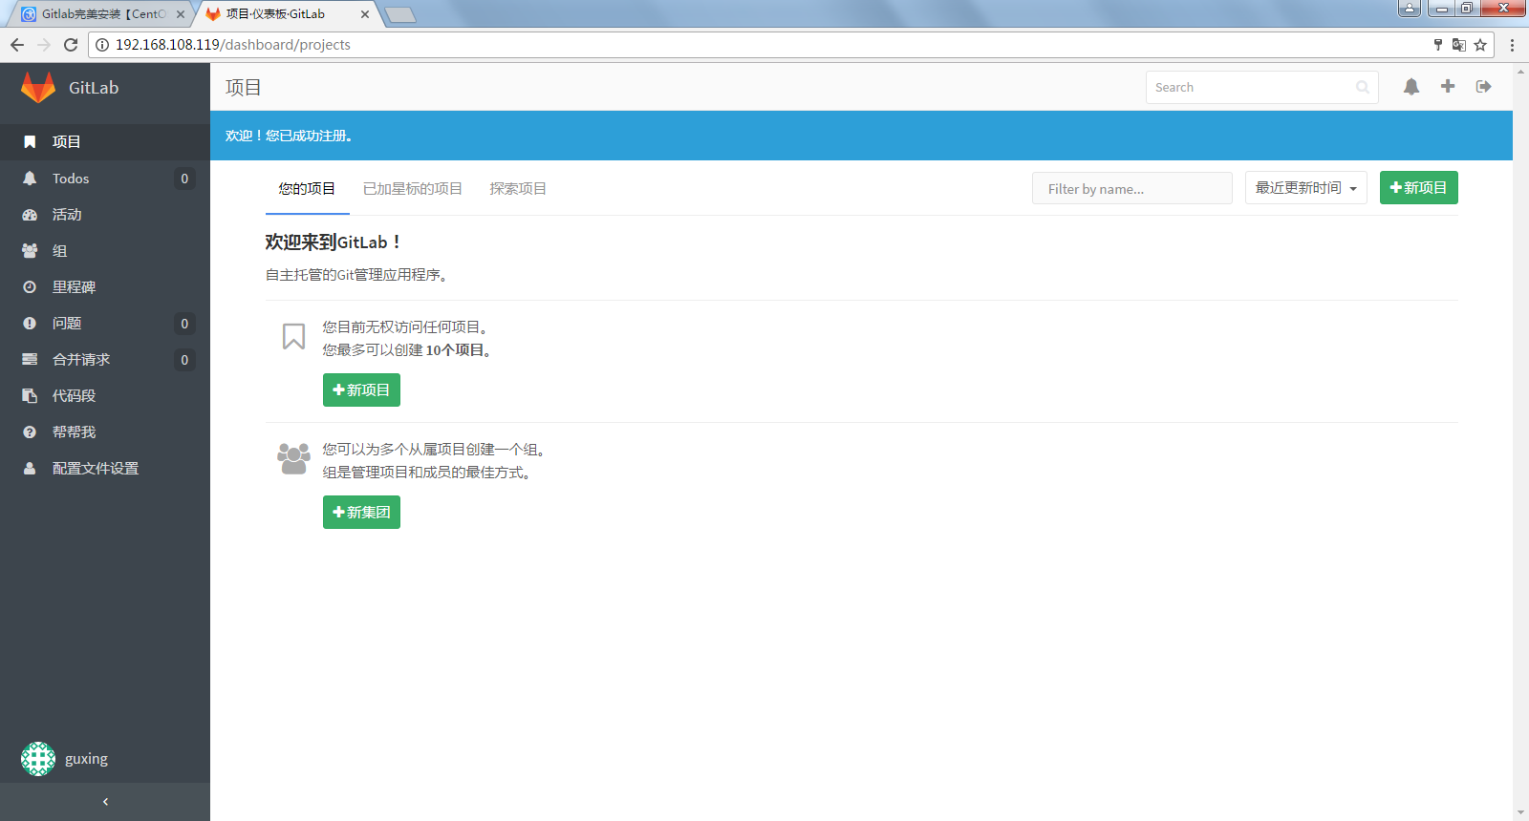

### 3.2 添加ssh key

点击Pfofile settings——→SSHkeys

将客户端id_rsa.pub内的文本内容复制到这里进行添加key

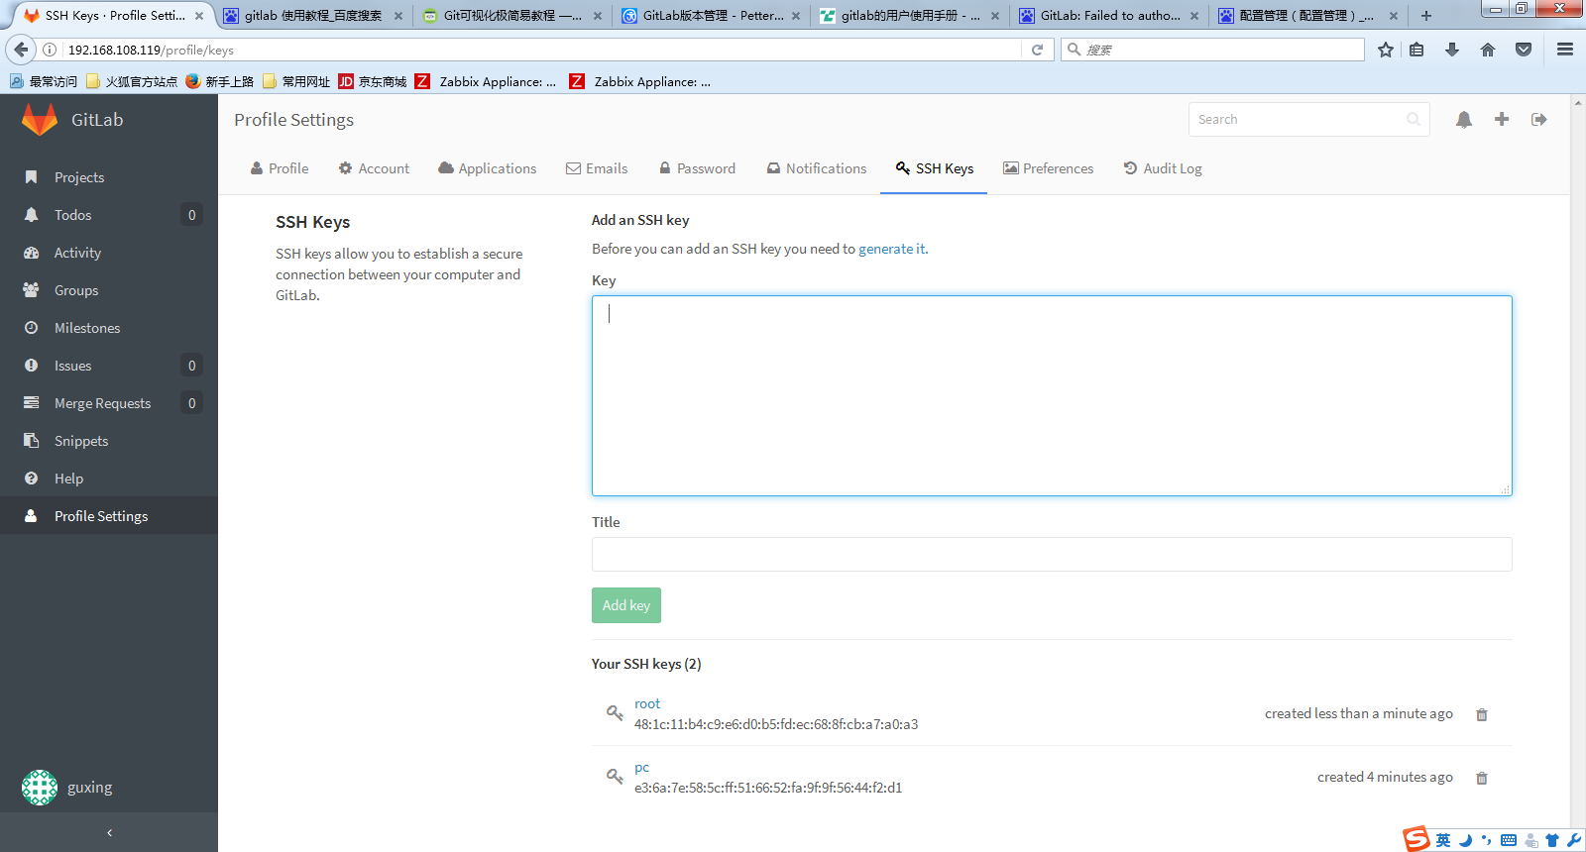

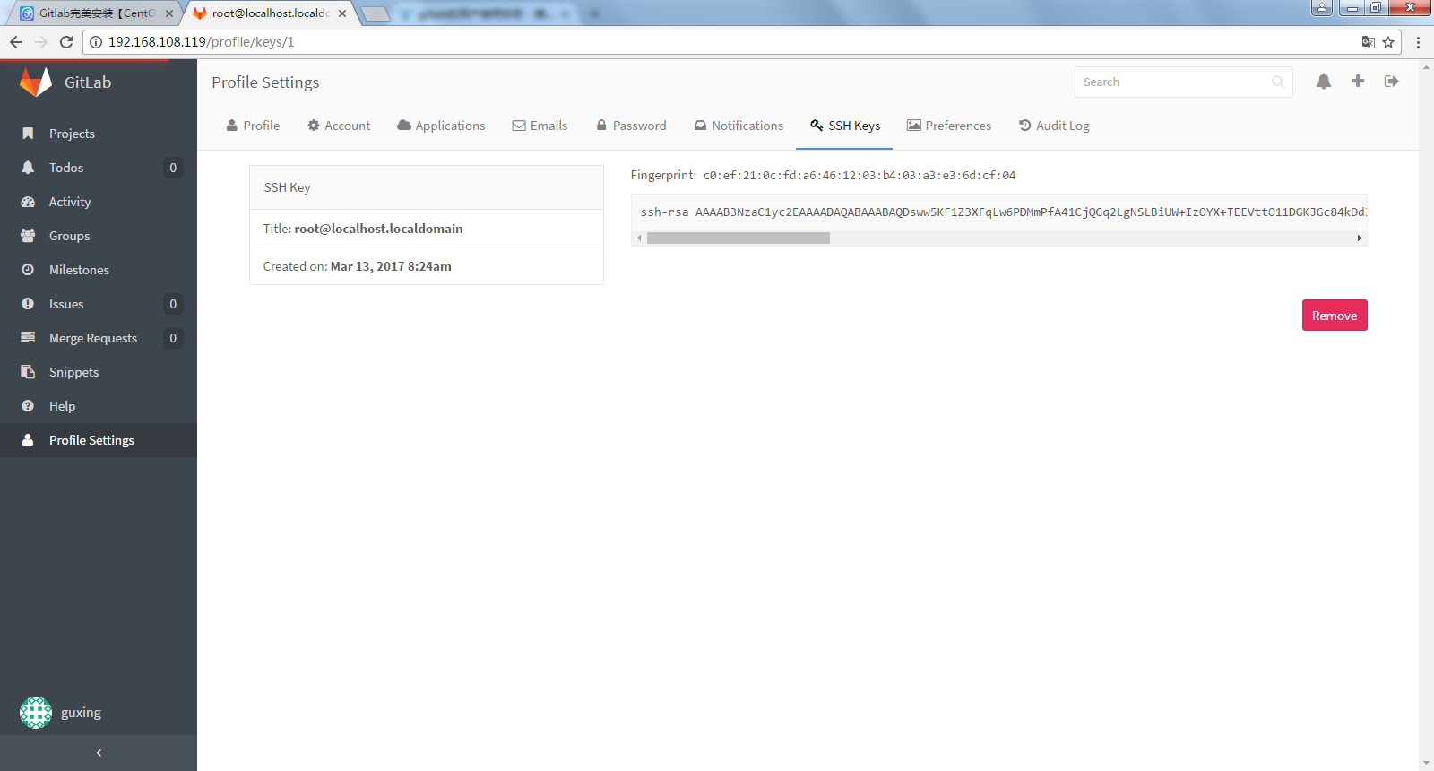

### 3.3 创建新的仓库

**3.3.1 Add a new project**

**Projects--→＋New project**

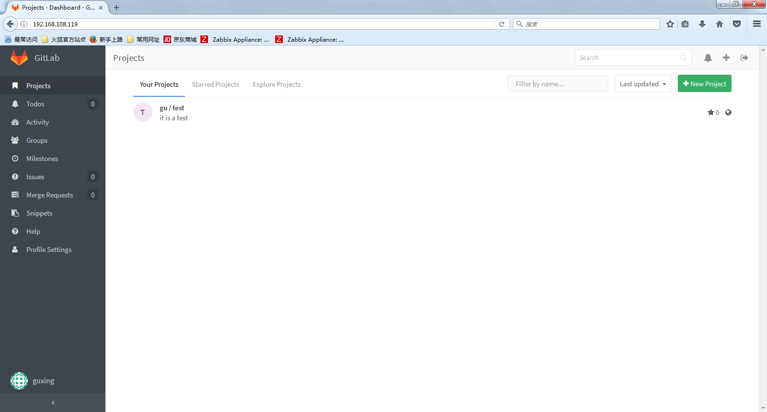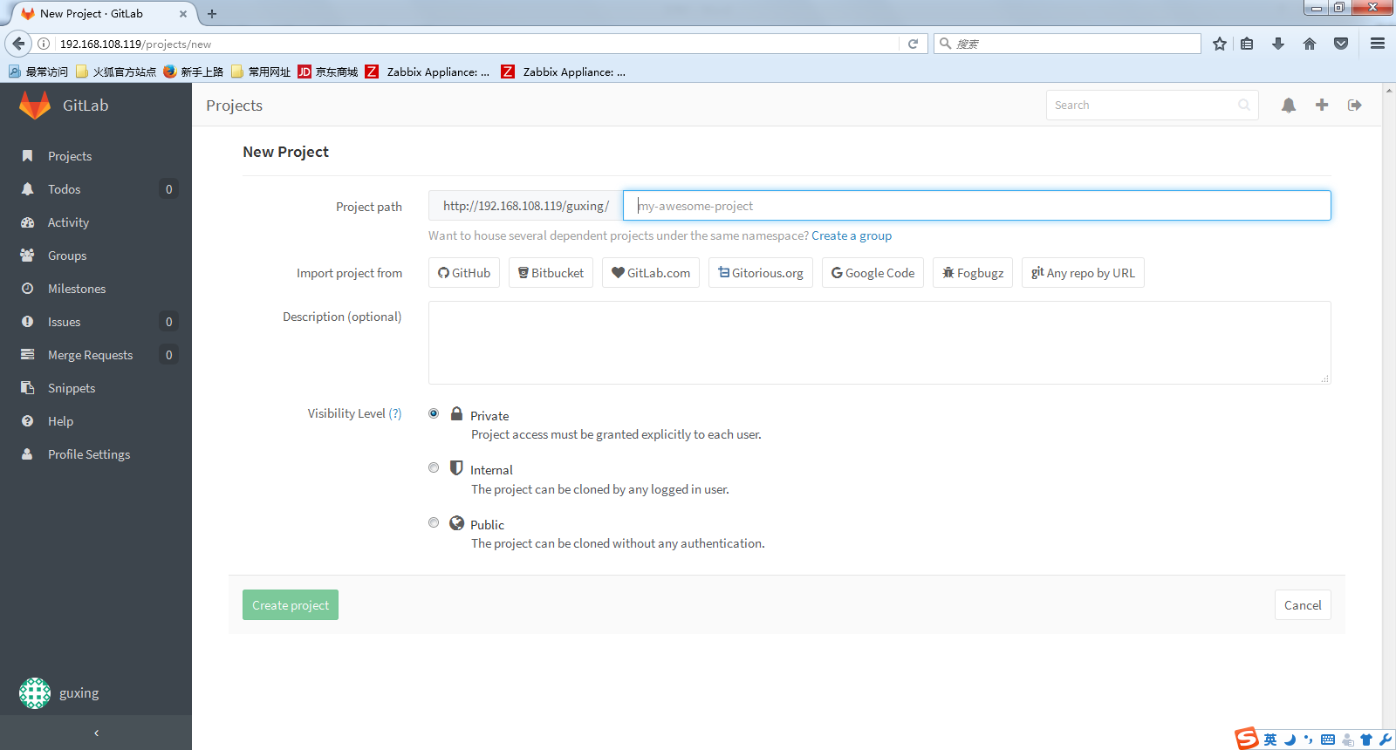

**3.3.2 Git global setup**

git config --global user.name "gu"

git config --global user.email "guxing1995@126.com"

**3.3.3 Create a new repository**

git clone git@localhost:guxing/test.git

cd test

touch README.md

git add README.md

git commit -m "add README"

git push -u origin master

**3.3.4 Existing folder or Git repository**

cd existing_folder

git init

git remote add origin git@localhost:guxing/test.git

git add .

git commit

git push -u origin master