Jira

安装数据库

#rpm –ivh (common/libs/client/server).rpm

#service mysqld start

#grep 'temporary password' /var/log/mysqld.log

#mysql –u root –p

配置数据库

>create user 'jirauser'@'localhost' identified by ' P@ssw0rd';

> create database jira character set utf8 collate utf8_bin;

>grant select,insert,update,delete,create,drop,alter,index on jira.* to 'jirauser'@'localhost' identified by ' P@ssw0rd';

> flush privileges;

5.7修改密码update user set authentication_string=password('root') where user='root' ;

安装jira

#chmod +x atlassian-jira-software-7.3.3-x64.bin

# ./atlassian-jira-software-7.3.3-x64.bin

上传MySQL驱动

<https://dev.mysql.com/downloads/connector/j/>

配置

localhost：8080

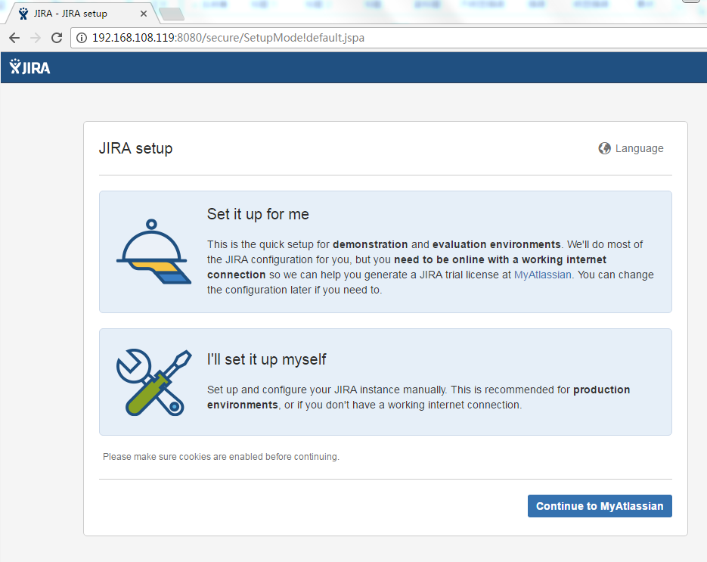

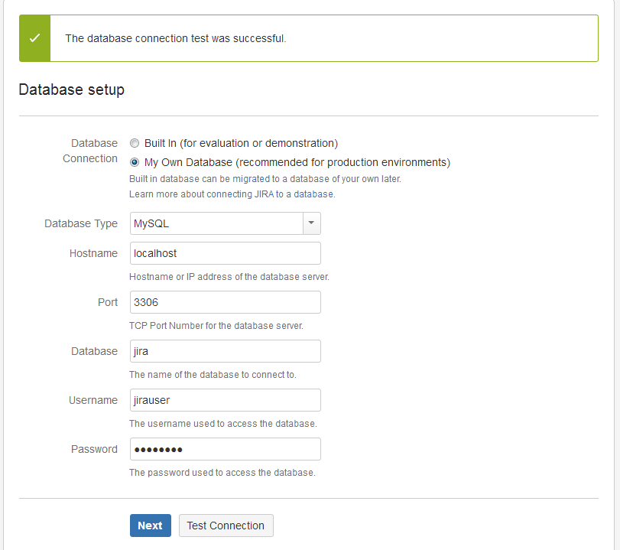

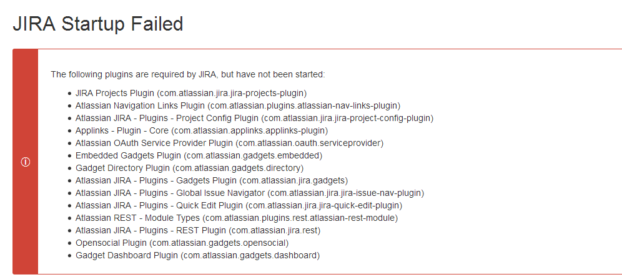The following plugins are required by JIRA, but have not been started:

* JIRA Projects Plugin (com.atlassian.jira.jira-projects-plugin)
* Atlassian Navigation Links Plugin (com.atlassian.plugins.atlassian-nav-links-plugin)
* Atlassian JIRA - Plugins - Project Config Plugin (com.atlassian.jira.jira-project-config-plugin)
* Applinks - Plugin - Core (com.atlassian.applinks.applinks-plugin)
* Atlassian OAuth Service Provider Plugin (com.atlassian.oauth.serviceprovider)
* Embedded Gadgets Plugin (com.atlassian.gadgets.embedded)
* Gadget Directory Plugin (com.atlassian.gadgets.directory)
* Atlassian JIRA - Plugins - Gadgets Plugin (com.atlassian.jira.gadgets)
* Atlassian JIRA - Plugins - Global Issue Navigator (com.atlassian.jira.jira-issue-nav-plugin)
* Atlassian JIRA - Plugins - Quick Edit Plugin (com.atlassian.jira.jira-quick-edit-plugin)
* Atlassian REST - Module Types (com.atlassian.plugins.rest.atlassian-rest-module)
* Atlassian JIRA - Plugins - REST Plugin (com.atlassian.jira.rest)
* Opensocial Plugin (com.atlassian.gadgets.opensocial)
* Gadget Dashboard Plugin (com.atlassian.gadgets.dashboard)

遇到上述问题，需要在/opt/atlassian/jira/bin/startup.sh 中最后一行添加

export JAVA_OPTS =“$ JAVA_OPTS -Datlassian.plugins.enable.wait = 300”

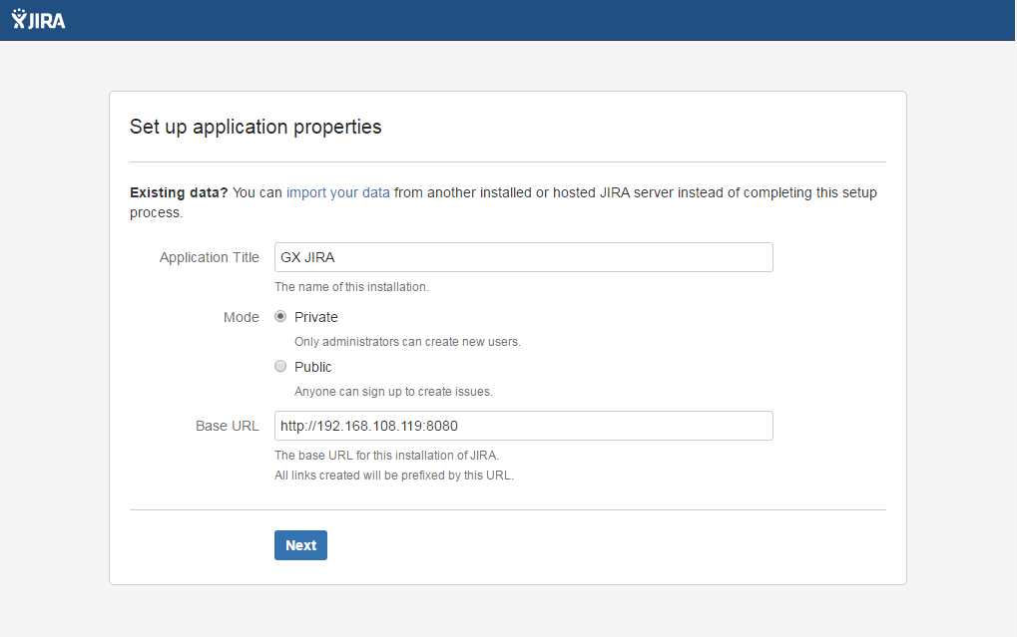

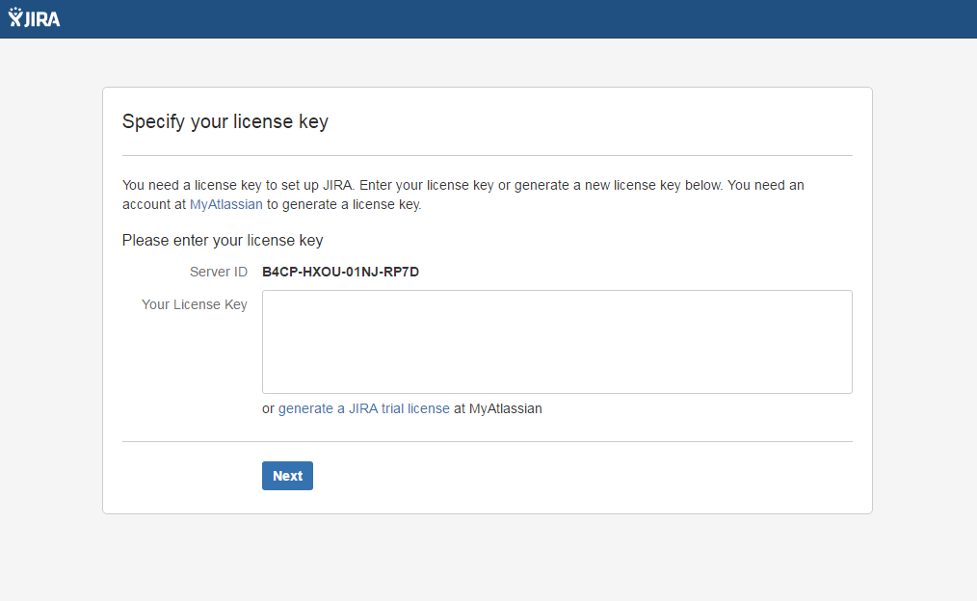

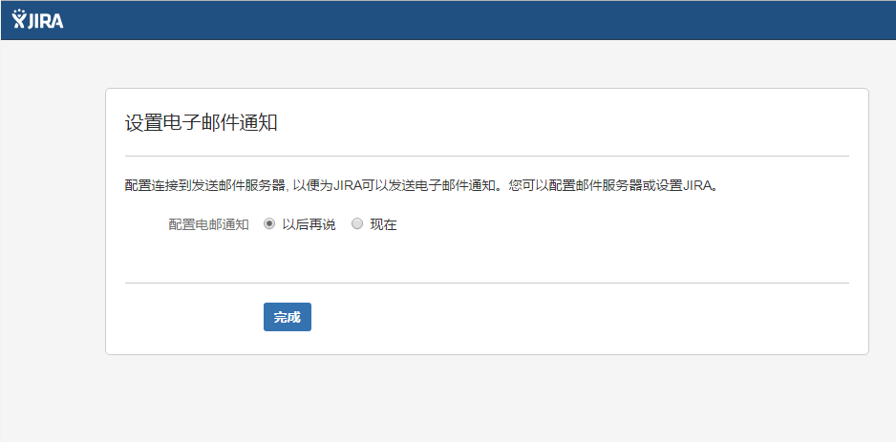

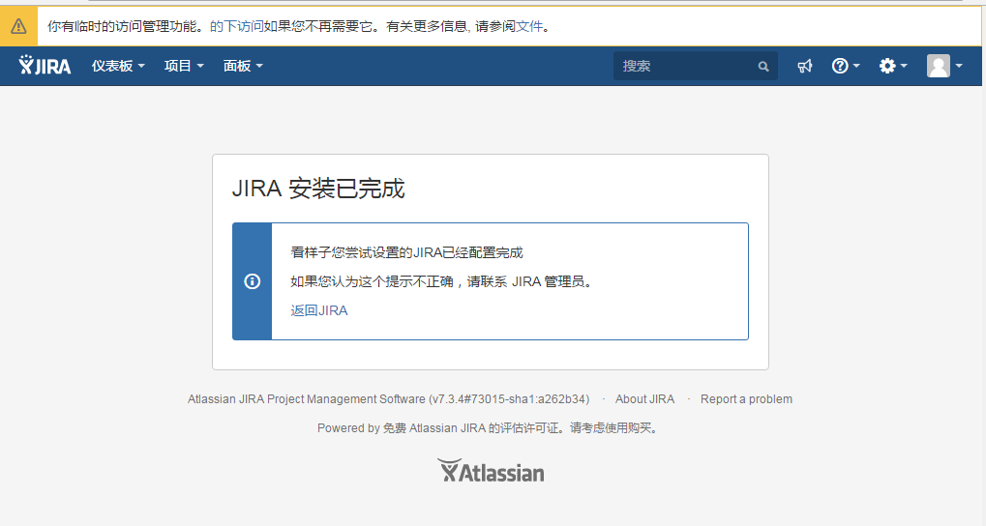

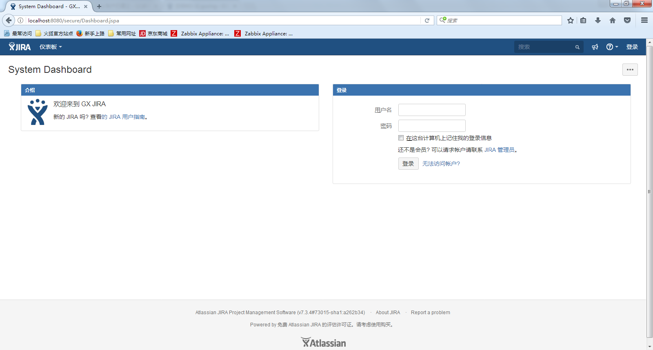

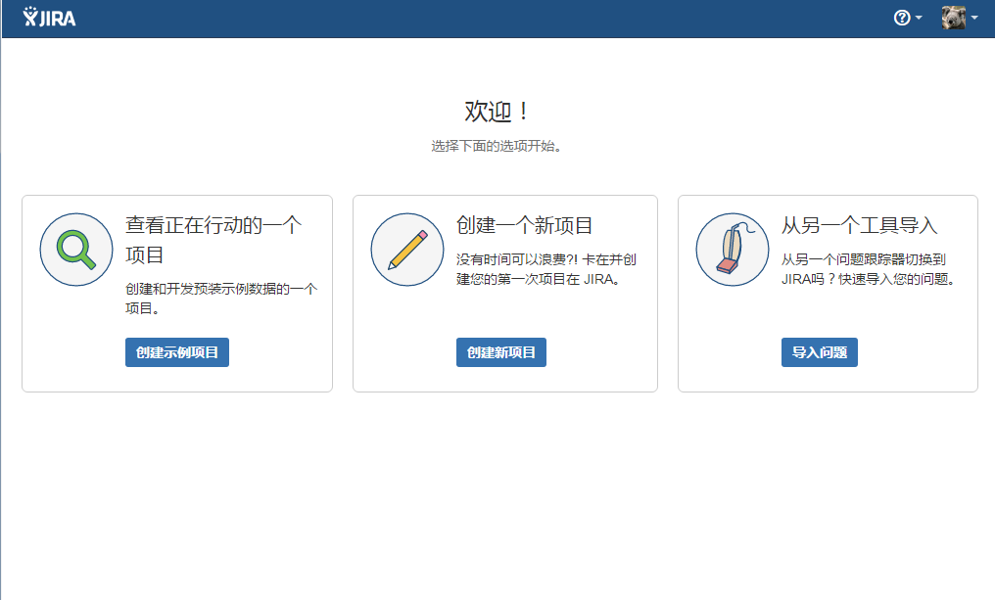

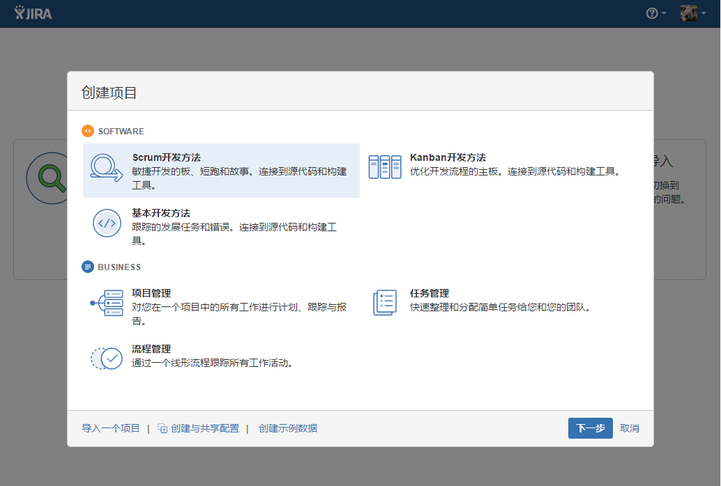

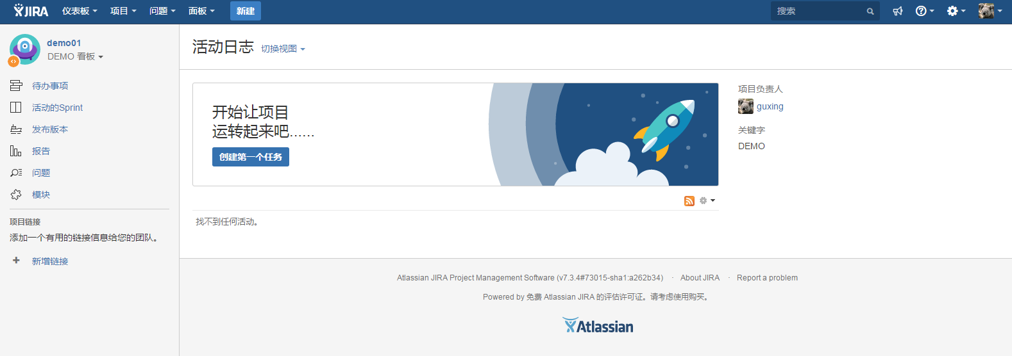

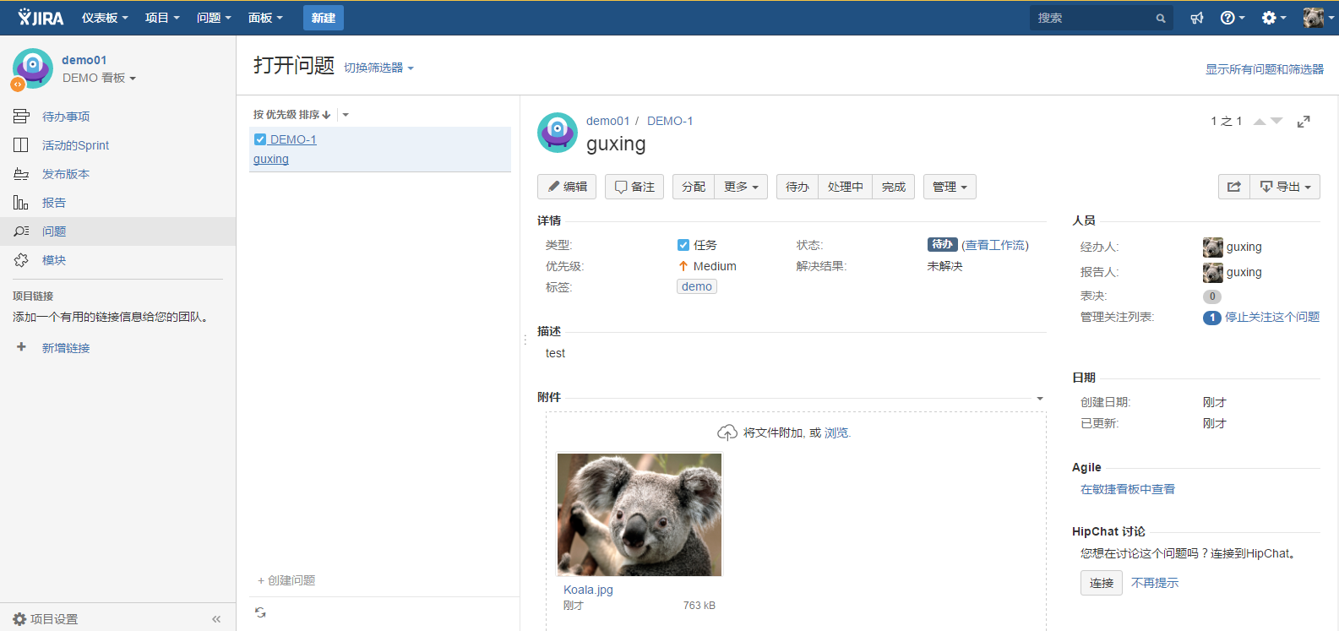

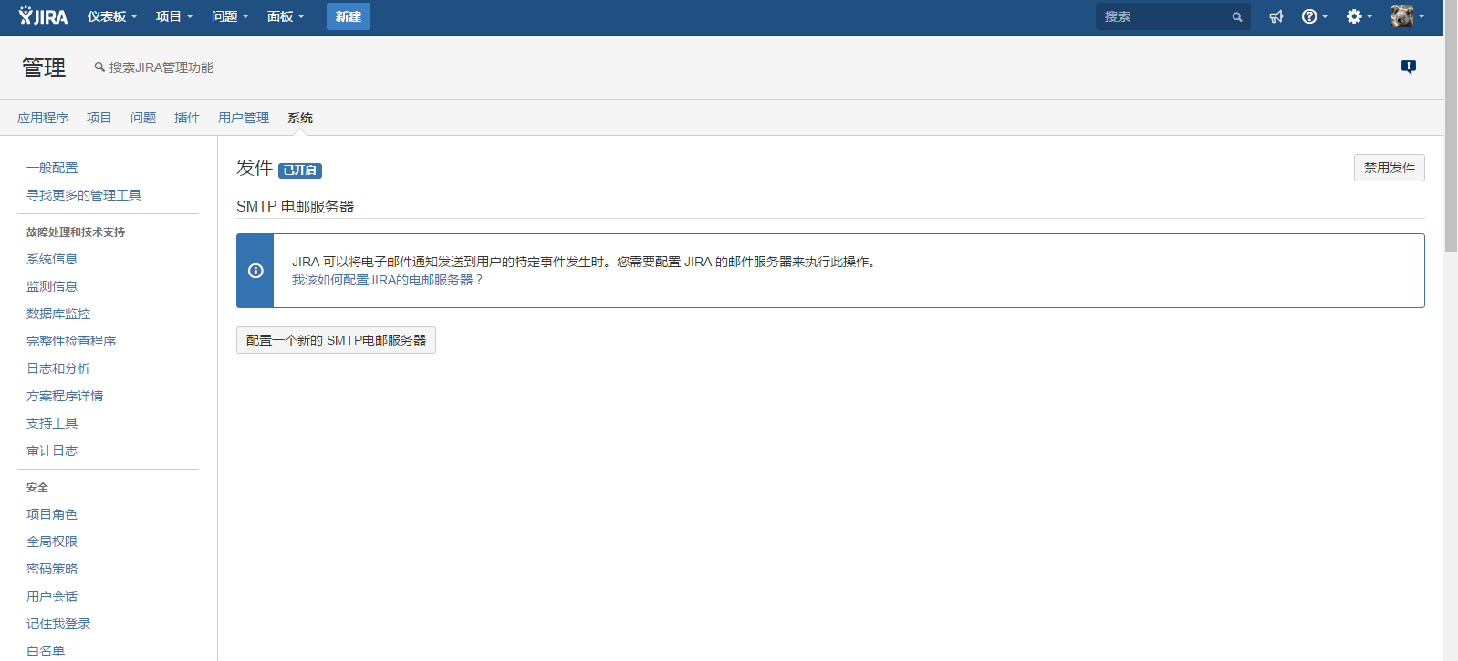

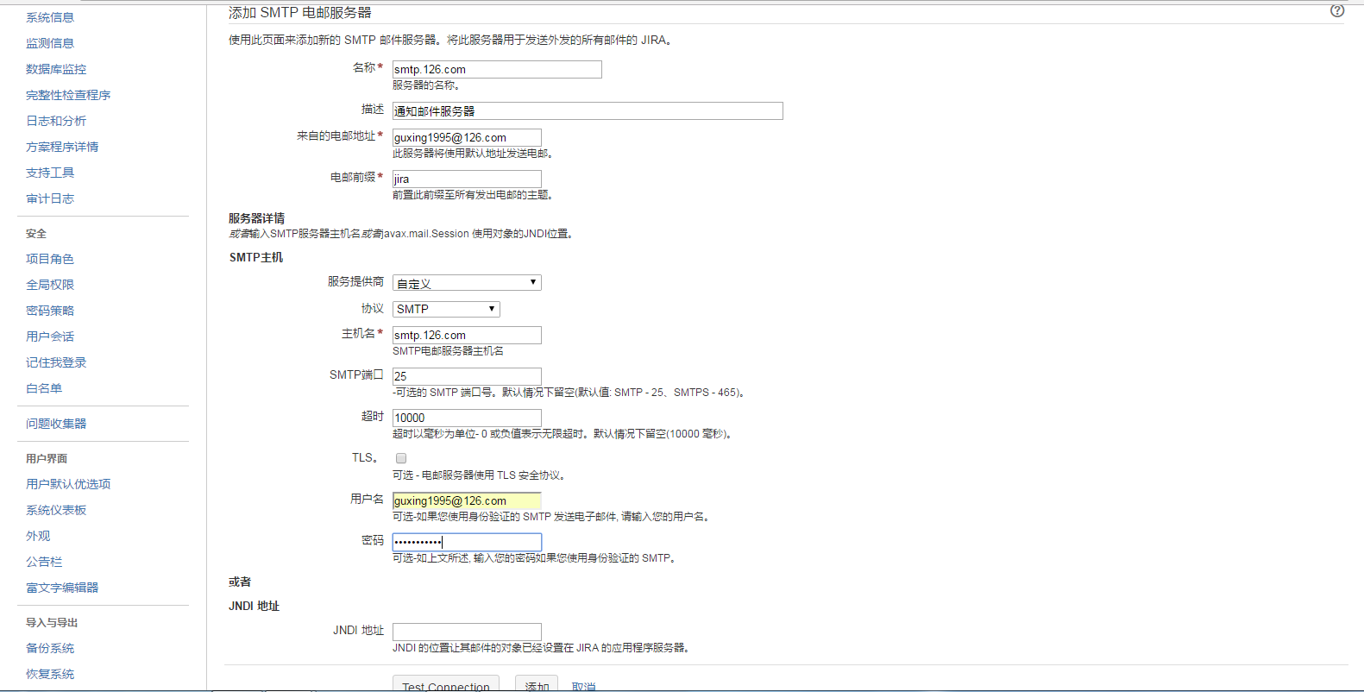

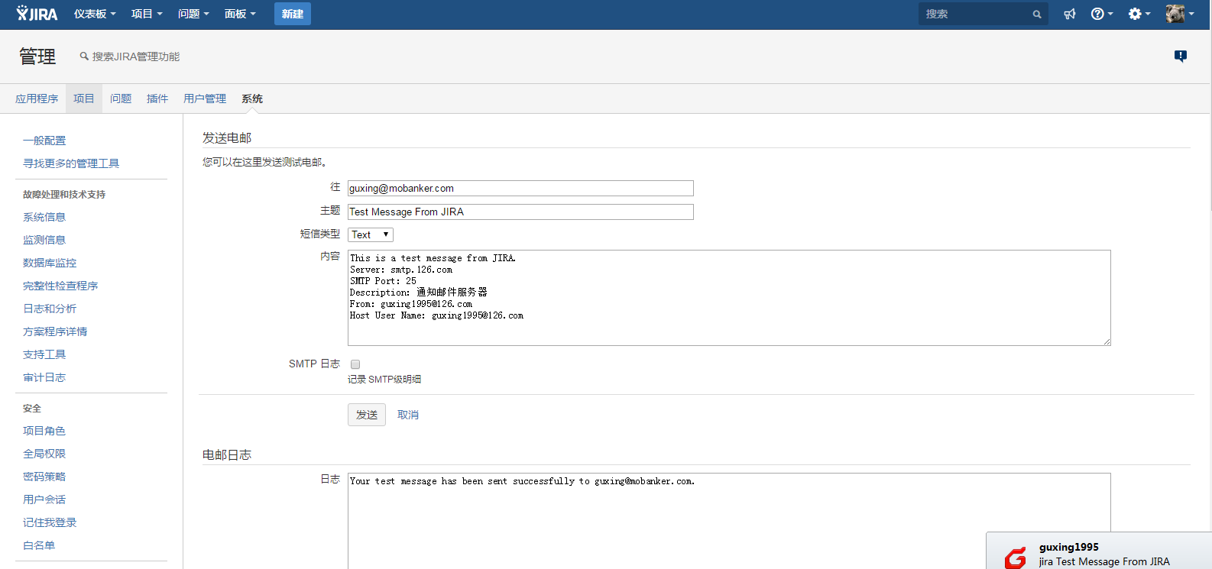

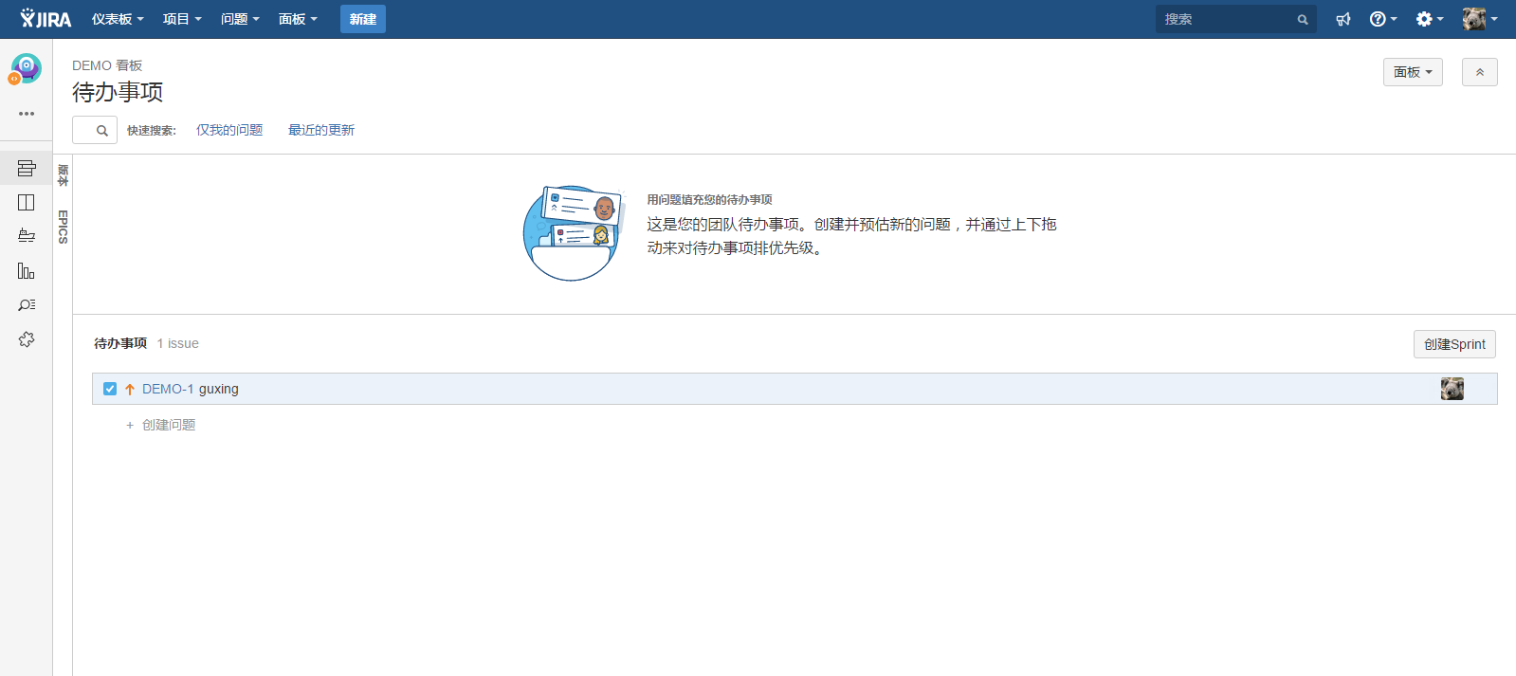

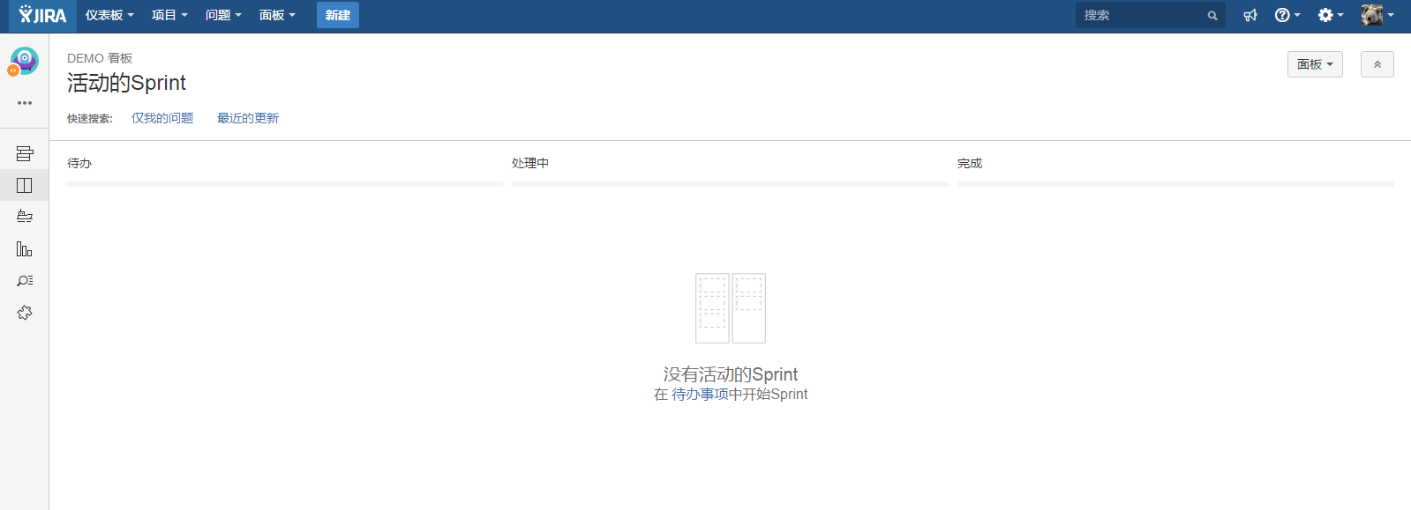

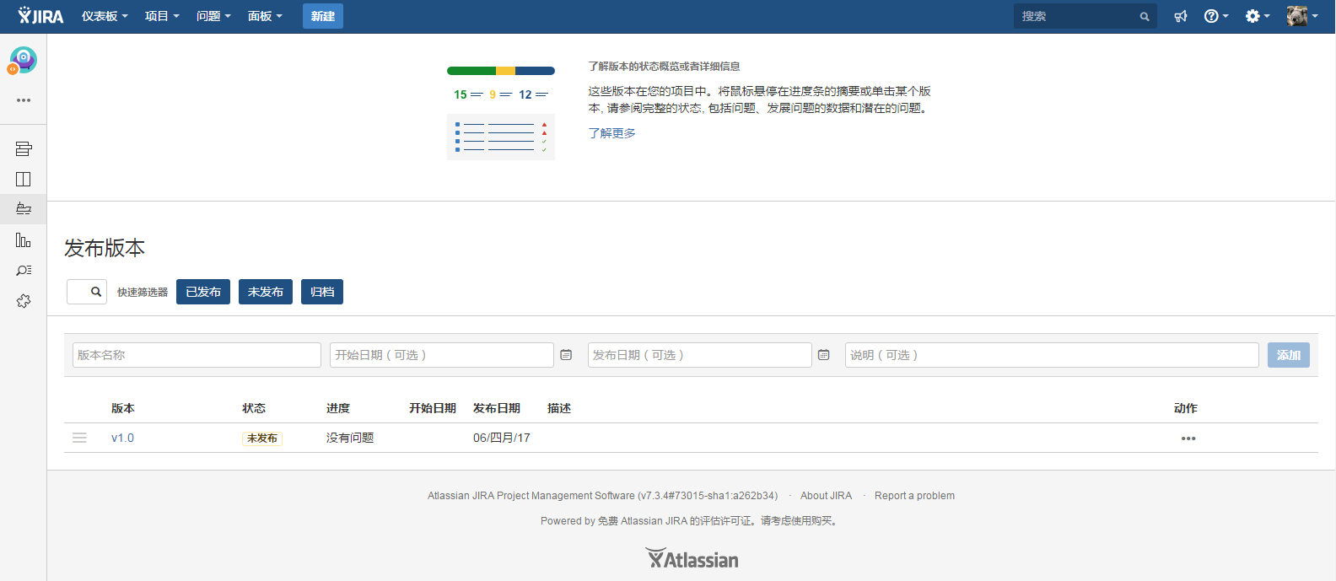

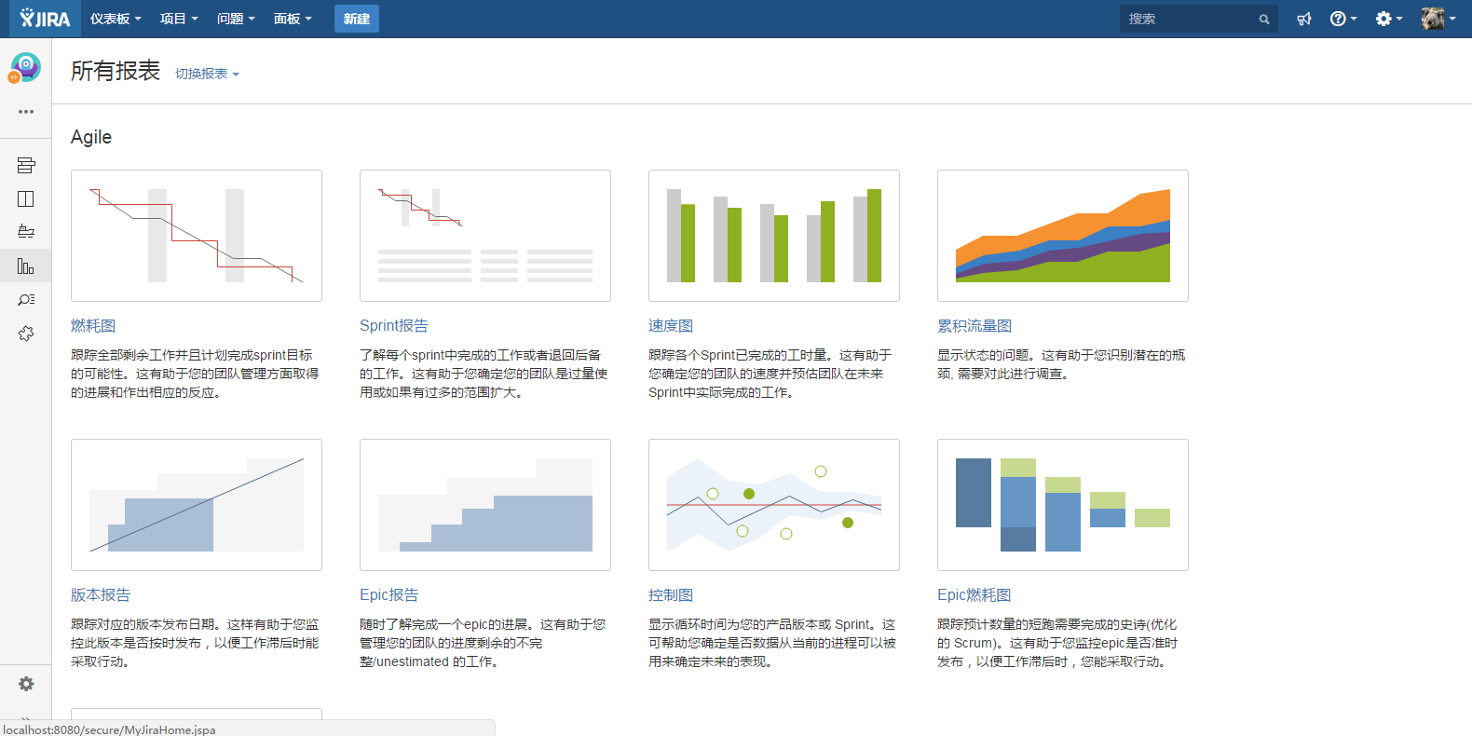

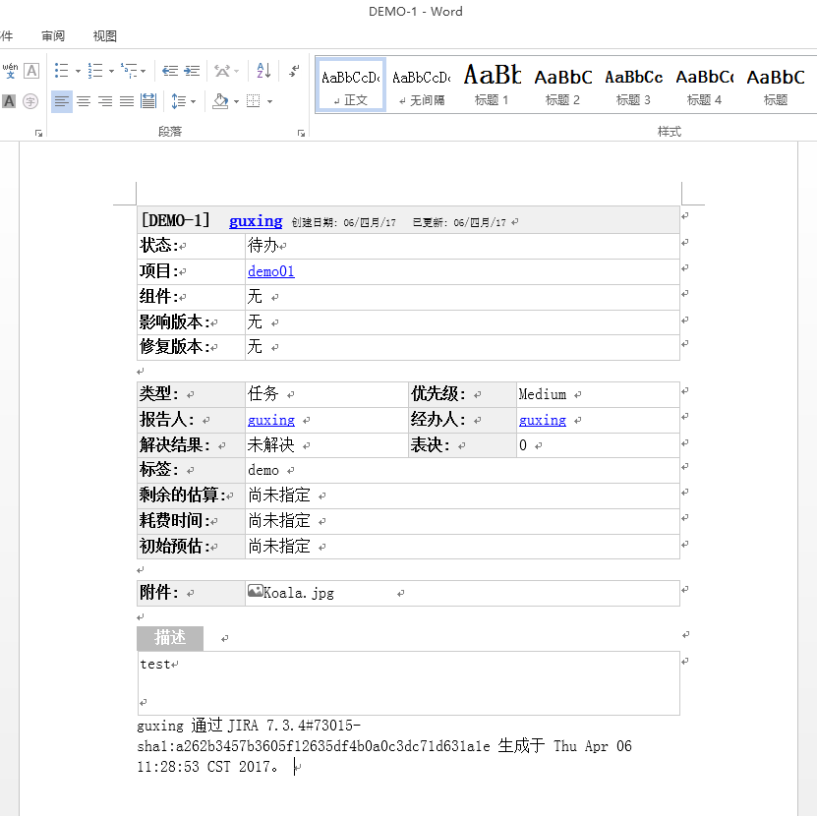

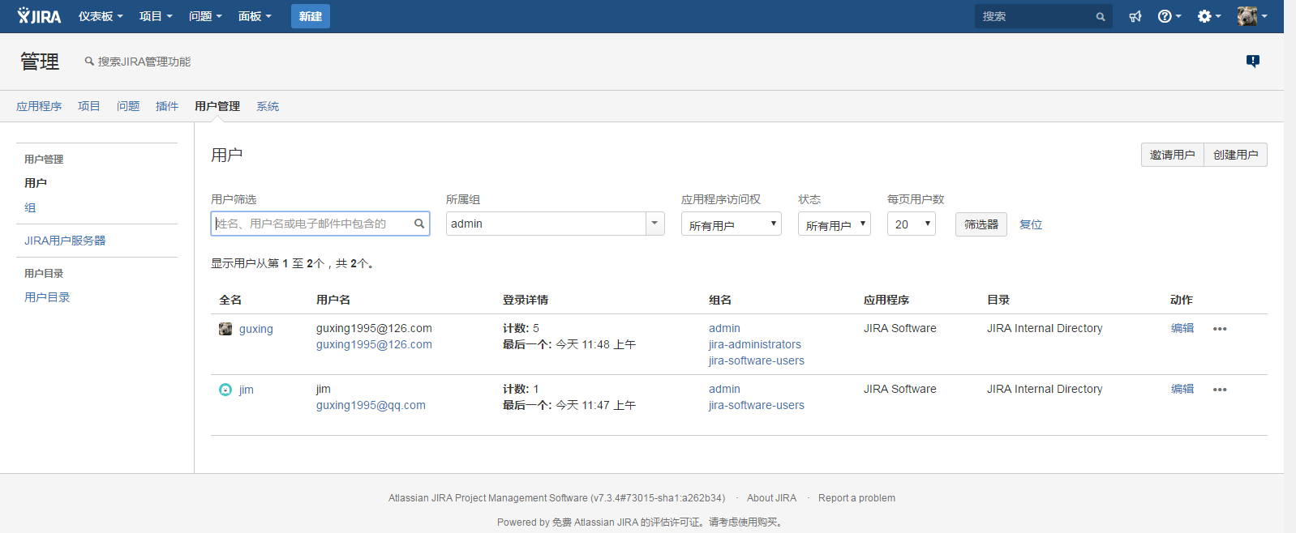

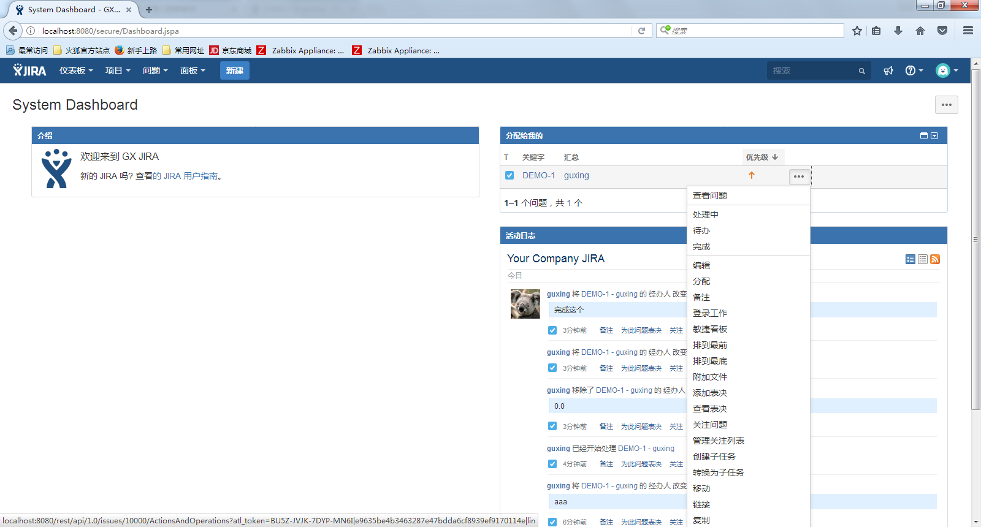

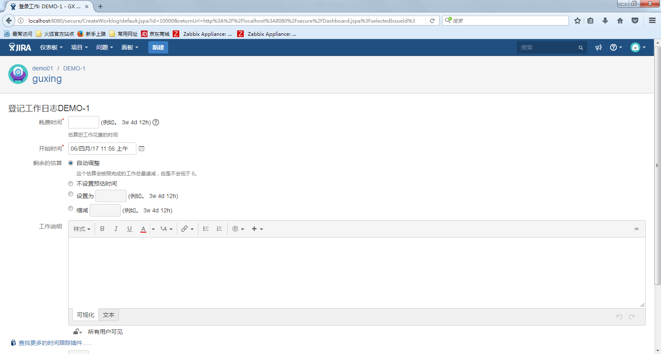

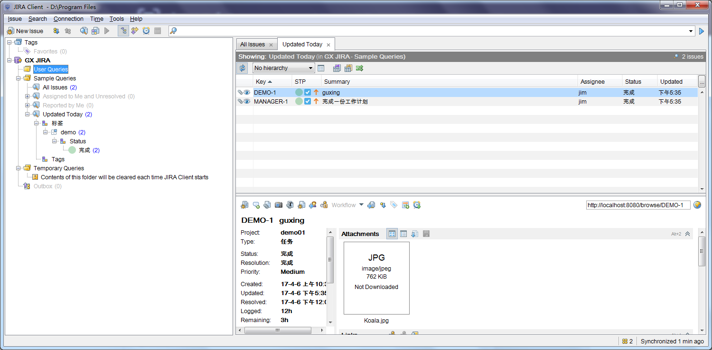

AAABcg0ODAoPeNp9Uc1vgjAUv/evINllO0DAwYwmTeag2TCKBHTzsEuHT+yihbwWN//7obhM50fSQ

9/r6+/r3bzBzOiVaNieYXe6bqvrOYYfjI2W7bRJjgByUZQloDUQGUgFbCa0KCRl0ZglcRKmjETV6

gNwNJ8oQEVNh3wK5NZJN64wW3AFAddAt/Cm7Zr2A9kDjzclRHwF1B8Nhyzxw97g94l9lwI3B/+8+

hC/kJpnmg25WNK8+hYydzod7zFf1Q0rK1YkBVwDhgF9cv3YfJmOJqbtRH0zidtBI7LEYlZl2toWp

irm+osjWDWqWAPVWEEzdtn7mYTOGak1Sg2Sy+yCmStqToLc89S+BmGQssgcdLx7t91ySV3Qo8YV2

FRz1IB0zpcKyAhzLoXiO3/PU+Ij7O7/l7VsuF9rKdvJ1lEAUHvEEoXaZxeAylCUO8x+mPSMdE9u3

DaruXvvGmzNl9WOq1F7KfxzsR6SH/77w2zqH5VZ/AAwLAIUOyiIFD6dINn+gD/pcdqK1+RVAywCF

DpO1FnChvLCsSPGYvQLGYTeu29/X02i2

Mn6i

AAABdA0ODAoPeNp9UcluwjAQvfsrIvXSHhKFJRSQLJUmVhUKARGgi3pxwxBcgRONHQp/35BQFcoi+

eAZj982Ny8wMzopGrZj2K12rdmuNQzXGxtVu3JPYgSQiyRNAa2eiEAqYDOhRSIpC8ZsNBz5ISNBt

voEHMwnClBRs0K+BHLrpDvMMFpwBR7XQHfwpl037QbZA4+3KQR8BdQd9Pts5Pqd3u8T26QCtwf/n

PwQN5GaR5r1uVjSONsIGVdaLechXuUNK0pWJARcA/oefZw472Z32n027723odkPGn4pMsVklkXa2

hWmSub6myNYOapYA9WYQTl22fuZhM4ZyTVKDZLL6IKZK2pOgtzz5L56vheywOy1nFq90ayTvKBHj

SuwoeaoAemcLxWQAcZcCsULf0+vxEUo7v+XtSy5p7mU3WT1KADIPWKKQu2z80BFKNICs+uPOka4J

zduy9XcfbQNtubLrOAq1V4K/1ysh+SH//4wy/oHIU78SDAtAhUAlPMtva39zKv6tuTzBQZaGozF4

p0CFF8KoXpx67Tkrf7rDwVxgXSotZWKX02i6