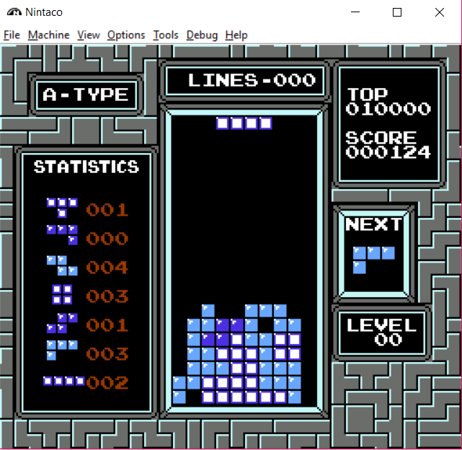

“Holes” in the board

The current Tetrimo piece being played

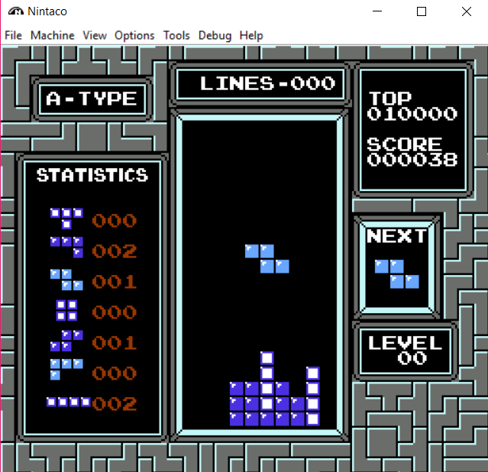

The current score

The next Tetrimo piece to be played

The number of lines cleared so far

The current Level (increased by 1 every 10 lines cleared).

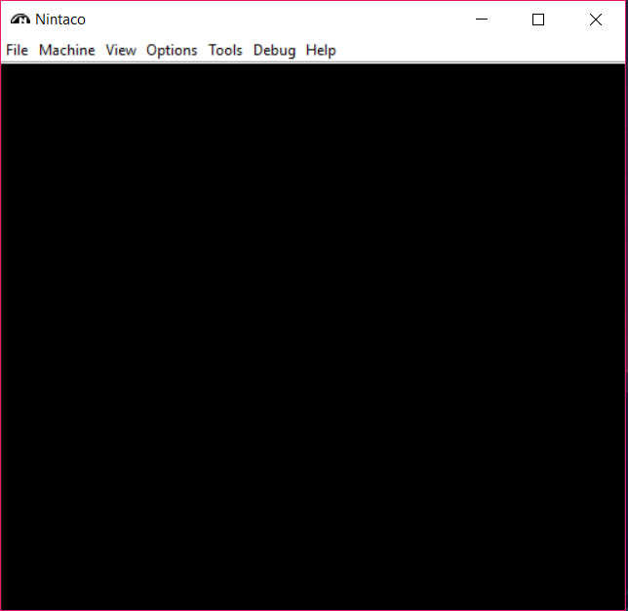

The User interface of the Nintaco Emulator

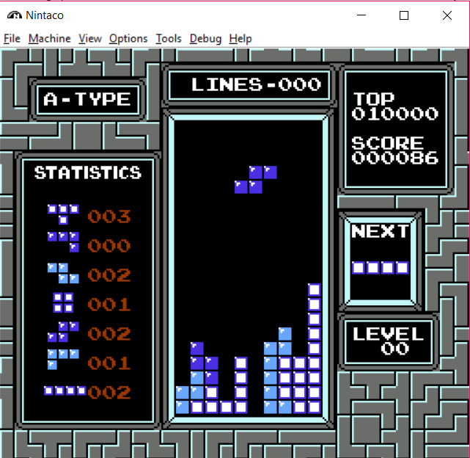

“Wells” with depth 3

(AKA: deep wells)

A “Well” with depth 4

(AKA: deep wells)

A “Well” with depth 2



Stack Height is 5

(since the highest column is 5 cells above the floor level)



number of filled cells in each row

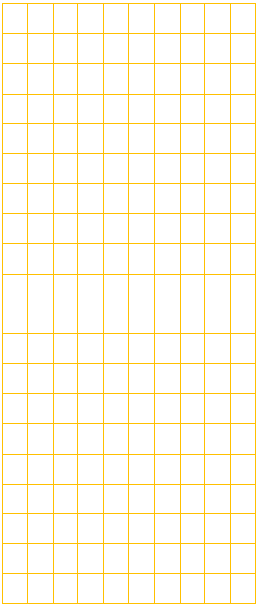

|  |  |  |  |  |  |  |  |  |  |
| --- | --- | --- | --- | --- | --- | --- | --- | --- | --- |
|  |  |  |  |  |  |  |  |  |  |
|  |  |  |  |  |  |  |  |  |  |
|  |  |  |  |  |  |  |  |  |  |
|  |  |  |  |  |  |  |  |  |  |
|  |  |  |  |  |  |  |  |  |  |
|  |  |  |  |  |  |  |  |  |  |
|  |  |  |  |  |  |  |  |  |  |
|  |  |  |  |  |  |  |  |  |  |
|  |  |  |  |  |  |  |  |  |  |
|  |  |  |  |  |  |  |  |  |  |
|  |  |  |  |  |  |  |  |  |  |
|  |  |  |  |  |  |  |  |  |  |
|  |  |  |  |  |  |  |  |  |  |
|  |  |  |  |  |  |  |  |  |  |
|  |  |  |  |  |  |  |  |  |  |
|  |  |  |  |  |  |  |  |  |  |
|  |  |  |  |  |  |  |  |  |  |
|  |  |  |  |  |  |  |  |  |  |
|  |  |  |  |  |  |  |  |  |  |
|  |  |  |  |  |  |  |  |  |  |

|  |
| --- |
| 0 |
| 0 |
| 0 |
| 0 |
| 0 |
| 0 |
| 0 |
| 0 |
| 0 |
| 0 |
| 0 |
| 0 |
| 0 |
| 0 |
| 0 |
| 1 |
| 2 |
| 5 |
| 6 |
| 6 |

|  |  |  |  |  |  |  |  |  |  |
| --- | --- | --- | --- | --- | --- | --- | --- | --- | --- |
| 1 | 2 | 3 | 4 | 5 | 6 | 7 | 8 | 9 | 10 |

|  |
| --- |
| 20 |
| 19 |
| 18 |
| 17 |
| 16 |
| 15 |
| 14 |
| 13 |
| 12 |
| 11 |
| 10 |
| 9 |
| 8 |
| 7 |
| 6 |
| 5 |
| 4 |
| 3 |
| 2 |
| 1 |



Row indices



Column indices

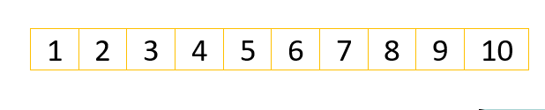

cell at coordinates  
[3,4]

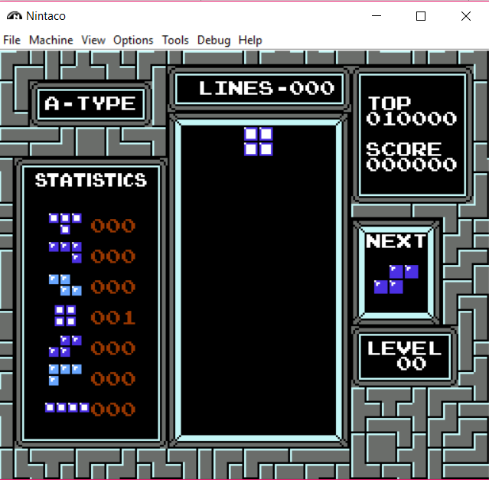



|  |
| --- |
| 1 |
| 2 |
| 3 |
| 4 |
| 5 |
| 6 |
| 7 |
| 8 |
| 9 |
| 10 |
| 11 |
| 12 |
| 13 |
| 14 |
| 15 |
| 16 |
| 17 |
| 18 |
| 19 |
| 20 |