**Ex3- Client&Host Sockets:  
  
In this exercise we asked for to program a TCP client&server socket in Python.  
  
At first, we wrote our Host's socket to be open for listening to our client socket, giving it our IP and Port.**

serverSocket = socket(AF_INET, SOCK_STREAM) # first of all, we create our server socket using SOCK_STREAM  
serverSocket.bind(("192.168.1.155", 80)) # which related to TCP. Than we are binding between our IP address  
serverSocket.listen(1) # and the port which the message sent in. and finally open our serverSocket  
#f or listening until something will happen.

**Than we create our client Socket in an infinity loop.  
In our client Socket we accept the incoming connection request from the server.**

while True:  
 print('Ready to serve...')  
 connectionSocket, addr = serverSocket.accept() # The accept method of Python's socket class,  
 # accepts an incoming connection request from a TCP server

**Now, according to what we asked for, we using in try&except method to see if the message we would like to send in sent or not.**

**Try:  
In the try part we are sending the "OK" message and the message content.**

try:  
 message = connectionSocket.recv(1024) #First of all, we are giving a range of 1024 bits for  
 filename = message.split()[1] # the message we would like to send.  
 f = open(filename[1:]) # we are spliting our message and then take the exact  
 outputdata = f.read() # we want in our outputdata  
 connectionSocket.send("\nHTTP/1.1 200 OK\n\n".encode()) # sending the ok message if everything went OK  
 for i in range(0, len(outputdata)): # like OK message for a regular HTTP request  
 connectionSocket.send(outputdata[i].encode()) # in Wireshark. and finally send our message content  
 connectionSocket.send("\r\n".encode()) # and close our client server

**Exception:  
If the try part went wrong (can be a wrong file name, connection issues etc.) we are going into the except part which send a 404 message.**

except IOError: # if something went wrong in our try part  
 err="404 NOT FOUND" # we are sending a "404 not found" message  
 connectionSocket.send(err.encode()) # as required and than closing our client server  
 connectionSocket.close()

**Does it actually work?  
  
Now let us use Wireshark to see if every went OK or we might have a 404 problem (we will see both of the cases).**

**First of all, we create an html file which is content is "HelloWorld", it look like this:**

<!DOCTYPE html>  
<html lang="en">  
<head>  
 <meta charset="UTF-8">  
 <title>Title</title>  
</head>  
 <body>  
Hello World  
 </body>  
</html>

**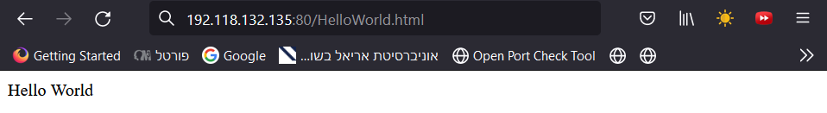  
Now let us see if the Wireshark captured these html file:  
first we run our python program, than we insert this URL  
into our browser :** 192.118.132.135:80/HelloWorld.html

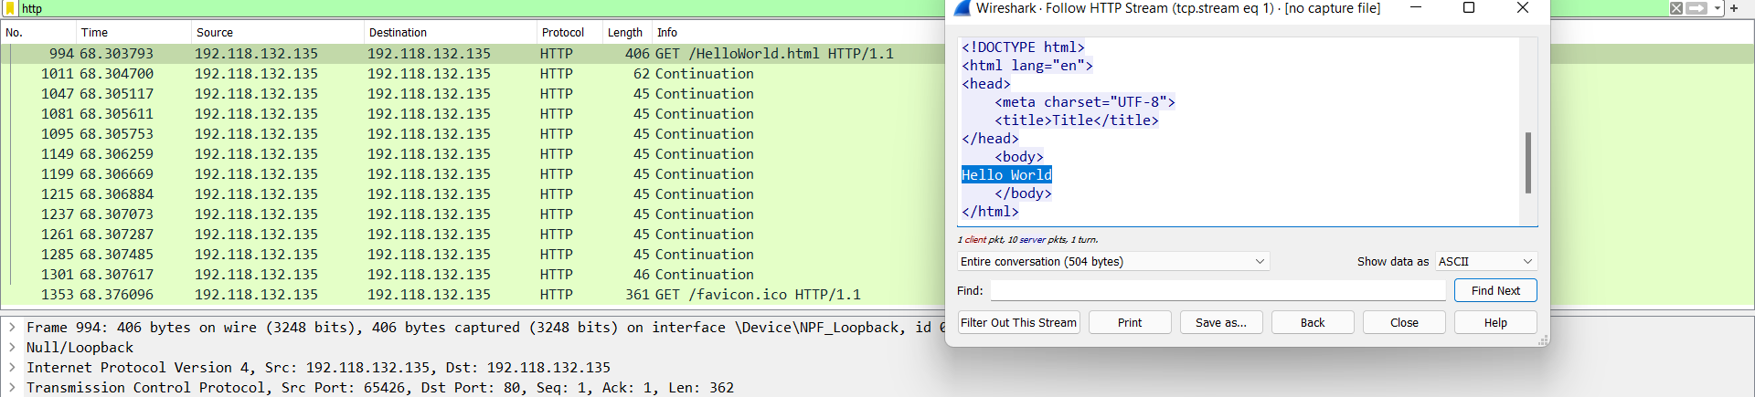**And as we can see everything is ok, and we got our Hello World message, but does the Wireshark capture it?  
Yes it did!**

**As we can see, we see the html file which has been created, we see the HTTP/1.1 message the right port that we gave etc.   
  
Now, we will change the file name in the URL and see if we could capture a 404 problem:**

**Again, we ran our Python program but in this time, we put a different name in the URL into our browser:  
http://192.118.132.135/HelloAmitDvir.html**

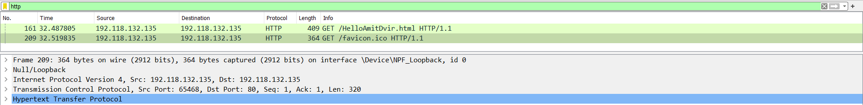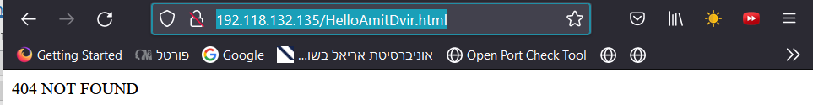**And we got the "404 not found" message:  
  
  
And in the Wireshark we got only the traffic in this fictive URL but not the html file in it:**