# Protocol – UDP Client/Server Time Application

## 1) Summary

The application implements a UDP server (port 27015) and a UDP client. The client sends different time-related requests; the server processes them according to a request code and returns a textual response.

## 2) Transport Layer

• Transport protocol: UDP  
• Server port: 27015  
• Reliability: No guarantee of delivery/order; the client/server must handle missing packets (timeouts, etc.).

## 3) Message Structure

Request (Client → Server):  
Byte 0 : RequestCode (1..13)  
Byte 1 : PayloadLength  
Byte 2.. : Payload (if any)  
  
Response (Server → Client):  
Text string (e.g. "2025-08-25 13:47:05").

## 4) Request Codes

|  |  |  |
| --- | --- | --- |
| Code | Name | Description |
| 1 | GetTime | Full date and time: YYYY-MM-DD HH:MM:SS |
| 2 | GetTimeWithoutDate | Time only: HH:MM:SS |
| 3 | GetTimeSinceEpoch | Seconds since 1.1.1970 |
| 4 | GetClientToServerDelayEstimation | Server's GetTickCount() value |
| 5 | MeasureRTT | Server's GetTickCount() value for RTT measurement |
| 6 | GetTimeWithoutDateOrSeconds | Time without seconds: HH:MM |
| 7 | GetYear | Year only: YYYY |
| 8 | GetMonthAndDay | Month and day: MM DD |
| 9 | GetSecondsSinceBeginingOfMonth | Seconds since beginning of month |
| 10 | GetWeekOfYear | Week number of the year |
| 11 | GetDaylightSavings | 1 if DST is active, 0 otherwise |
| 12 | GetTimeWithoutDateInCity | Time in supported cities or UTC if unsupported |
| 13 | MeasureTimeLap | Measure time between two consecutive requests |

## 5) Wireshark Screenshots

**Request 1 – GetTime**  
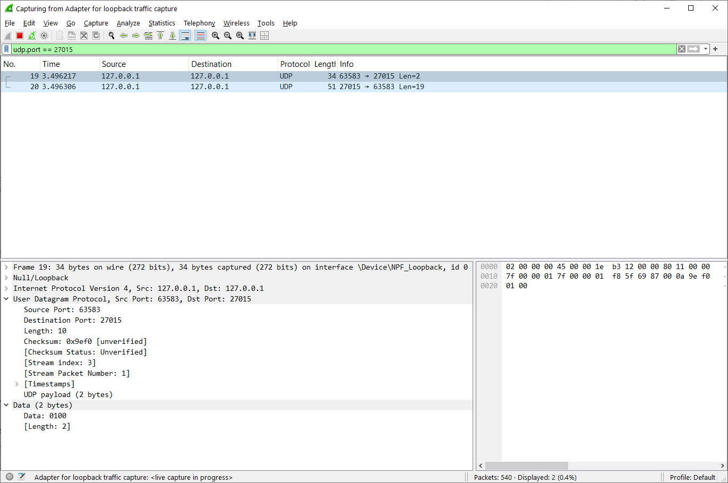

**Response 1 – GetTime**

**Request 2 – GetTimeWithoutDate**

**Response 2 – GetTimeWithoutDate**

**Request 3 – GetTimeSinceEpoch**

**Response 3 – GetTimeSinceEpoch**

**Request 4 - GetClientToServerDelayEstimation**

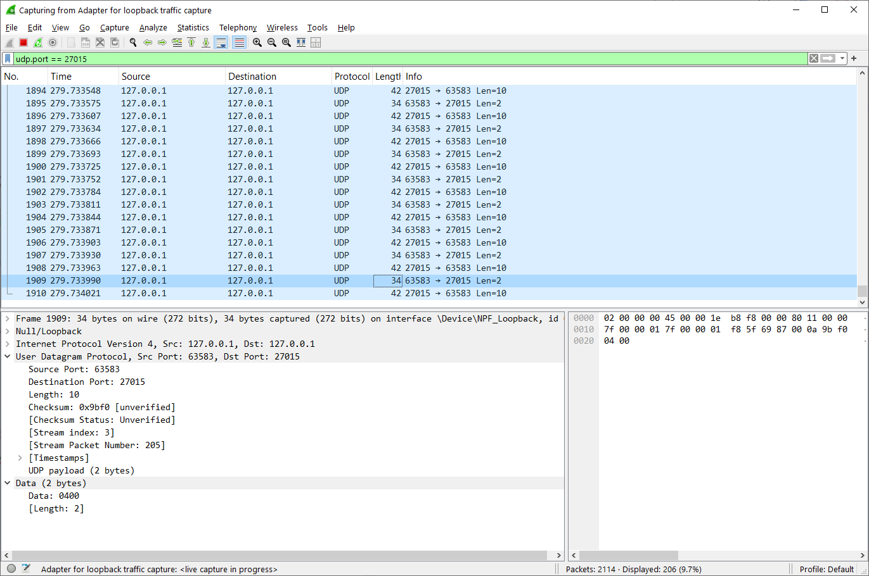

**Response 4 - GetClientToServerDelayEstimation**

**Request 5 – MeasureRTT**

**Response 5 – MeasureRTT**

**Request 6 – GetTimeWithoutDateOrSeconds**

**Response 6 – GetTimeWithoutDateOrSeconds**

**Request 7 – GetYear**

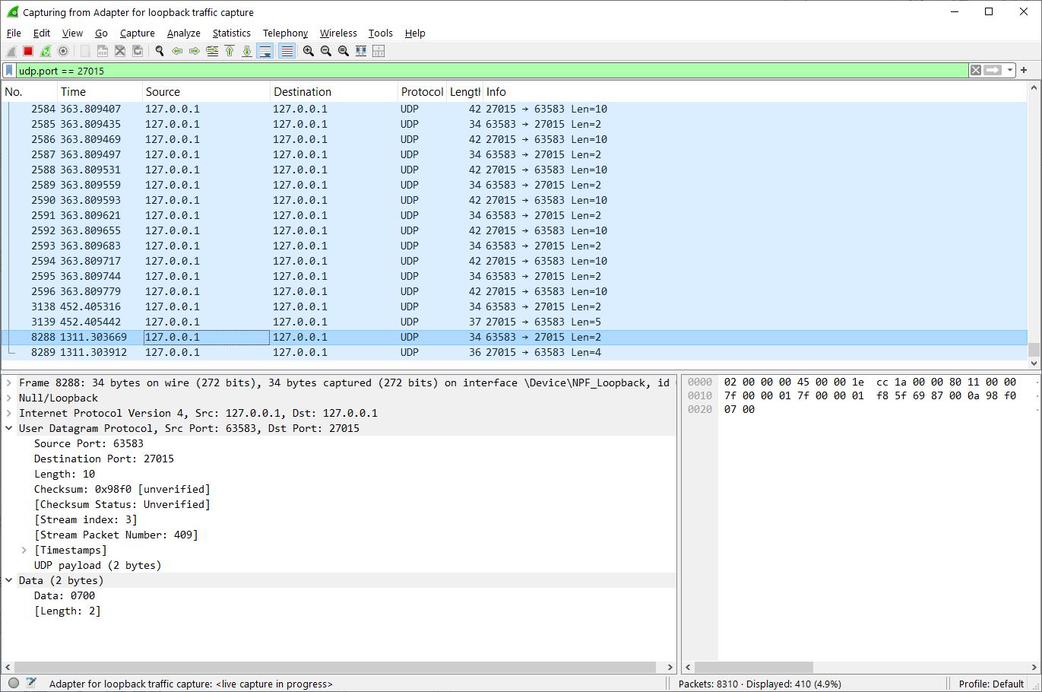

**Response 7 – GetYear**

**Request 8 – GetMonthAndDay**

**Response 8 – GetMonthAndDay**

**Request 9 – GetSecondsSinceBeginingOfMonth**

**Response 9 – GetSecondsSinceBeginingOfMonth**

**Request 10 – GetWeekOfYear**

**Response 10 - GetWeekOfYear**

**Request 11 – GetDaylightSavings**

**Response 11 – GetDaylightSavings**

**Request 12 – GetTimeWithoutDateInCity (sent “nyc” as the string)**

**Response 12 – GetTimeWithoutDateInCity**

**Request 13 - MeasureTimeLap (call once to start, once to stop)**

**  
  
Response 13 (right away) MeasureTimeLap**

**Request 13 –** **MeasureTimeLap (Second call)**

**Response 13 –** **MeasureTimeLap (after Second call)**

## 6) Theoretical Questions

A. Could the client or the server get 'stuck'?  
Yes, since UDP does not guarantee delivery. If there is no timeout defined, the client may wait forever for a reply. Suggested fix: use receive timeout/retries.

For example – if after 5 seconds the client is not receiving any response, he will send the request again.  
  
B. What does the average value in the ClientToServerDelayEstimation represent from the 4 delay that we have learned?  
It represents **the average difference between consecutive GetTickCount values returned by the server**, i.e., **the propagation delay**.