

ISHIMWE KAREKEZI GUY GAEL
AndrewID: iguygael
MS EAI
Email: iguygael@andrew.cmu.edu
Tel: (+250) 784595484

Course: DIAML

DIAML Assignment 5

Libraries
import numpy as np
import pandas as pd
import seaborn as sns
import scipy
import matplotlib
import sklearn
import torch
import random
import torch.nn as nn
from matplotlib import pyplot as plt
from pandas import DataFrame
from scipy import stats
from IPython.display import display
import yfinance as yf
from sklearn.decomposition import PCA
from scipy.spatial.distance import squareform
from scipy.cluster.hierarchy import linkage, dendrogram
from scipy.cluster.hierarchy import fcluster
from statsmodels.tsa.seasonal import STL
from statsmodels.graphics.tsaplots import plot_acf, plot_pacf
from statsmodels.tsa.stattools import adfuller
from statsmodels.tsa.arima.model import ARIMA
from sklearn.metrics import mean_squared_error
from sklearn.metrics import mean_absolute_error
from sklearn.preprocessing import MinMaxScaler

Q1)

1.1.
PCA is a dimensionality reduction technique that is often used in data analysis for finding patterns in large amounts of data.[1], So PCA makes the data smaller, simpler, and still meaningful.
Importance of PCA in Financial Data Analysis
In financial markets, PCA is very useful for:
1. Reducing Noise: There are many temporary things in the data that are not important or noise. PCA looks for market forces such as is the overall market rising or is the banking industry falling, leaving behind small, random variables.[1]
2. Identifying Principal Components: Instead of tracking each stock individually, PCA generates new principal components that are only found in the data. For example, PC1 might contain the market factor, and PC2 might contain the business cycle factor. These new components are what the models use.
Why We Use Log Returns?
Before using PCA on stock prices, we don’t calculate Simple Returns. Instead, we use Logarithmic Returns (Log Returns). There are three main reasons:
1. Time-Additivity
Simple Returns: They are not additive. If you want to know how much the price has changed from Monday to Wednesday, you have to multiply the daily returns.
Log Returns: They are additive. Calculating the weekly return is easy: you just add up the Log Returns of all five days of the week.
Benefits of PCA: PCA works best when the data is in additive mode, because it looks for new variables (PCs) to add up to give the overall difference.
2. Numerical Symmetry
Simple Returns: They are not symmetrical. Ex: From $100 to 90$ it is -10%. But from $90 to 100$ to get back to where it was, it is +11.11%.
Log Returns: They are symmetrical. When Log Returns are used, losing a certain amount and regaining it both give the same Log Returns, only one is negative and the other is positive.
Benefits to PCA: This allows PCA to treat both decreases and increases in the same way, making the analysis of variance more effective in balancing the effects.
3. Statistical Normality
Log Returns tend to approximate the distribution of data in a normal distribution.
Benefits to PCA: PCA works best when the data used is close to a normal distribution. This helps prevent outliers from giving us too much power in the analysis.

1.2.
Coding part
Steps or explanations:
For the coding part of this question, the main objective was to extract the closing prices for the 30 constituents of the Dow Jones Industrial Average for 2 years using Y-finance APIs. Secondly, we had to compute the Pearson correlation matrix for daily log returns of closing prices.
Results:
Now the daily log returns
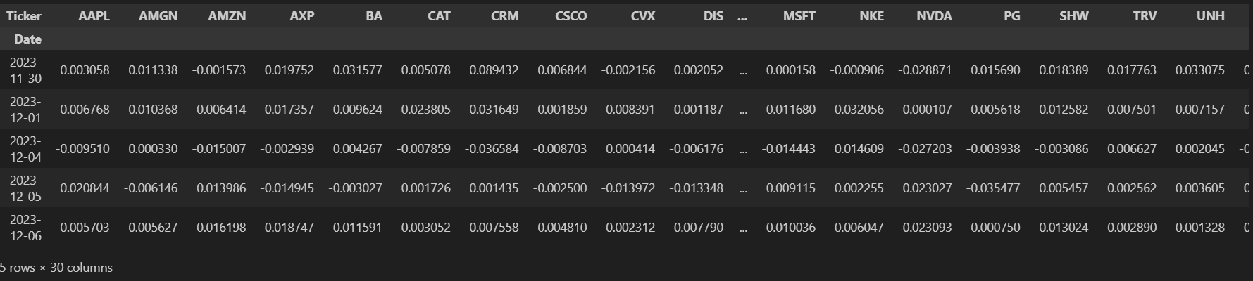
The Pearson correlation
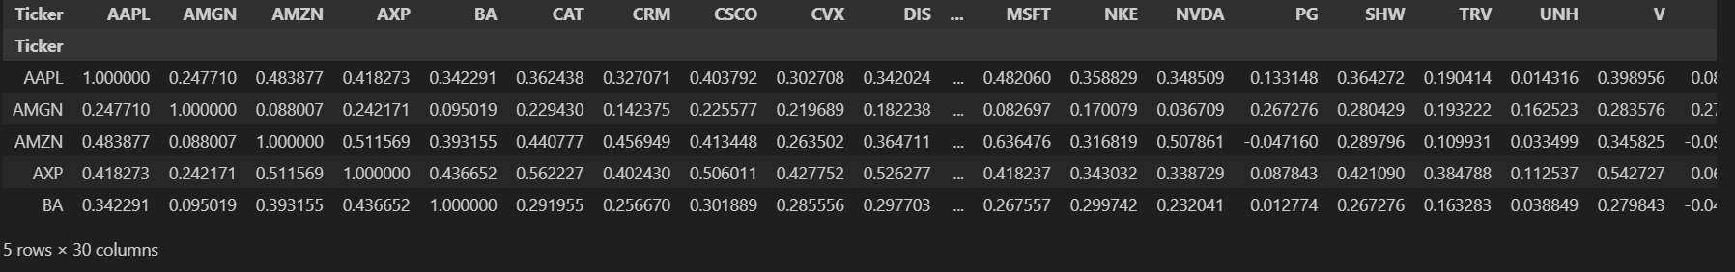
Pearson Correlation Heatmap
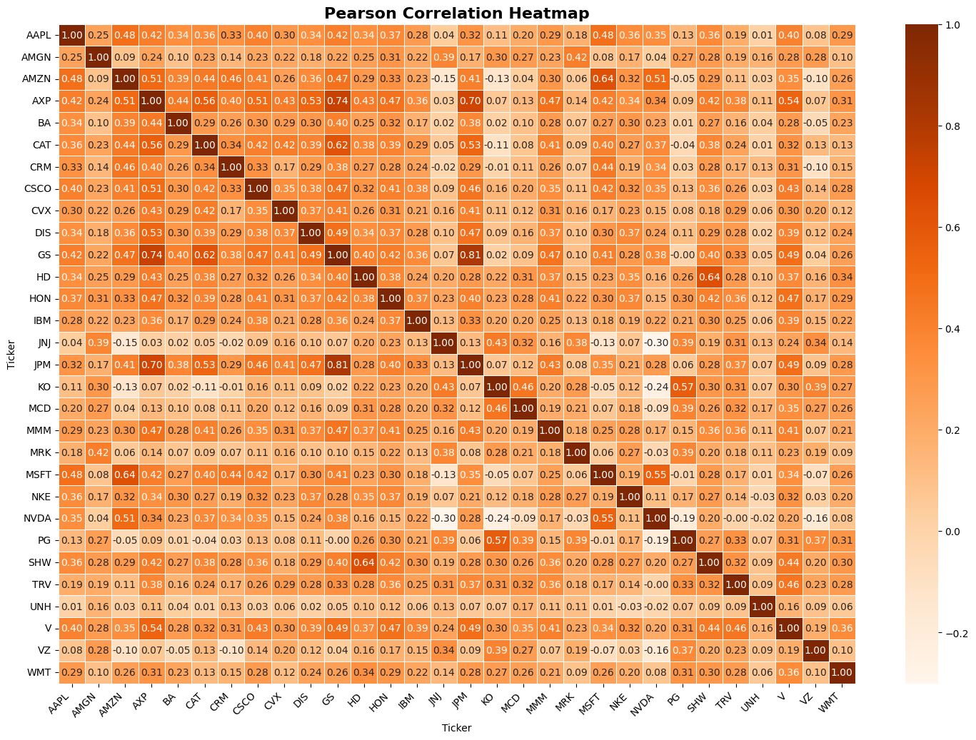

Qualitative answer:
The above Pearson heatmap shows that DJIA stocks naturally fall into groups based on their alignment.
Clusters with strong positive correlation are highlighted by similar sectors, such as Financials like JPM and GS are highly correlated with 0.81, going together because of shared economic pressures. Consumer Staples such as PG show strong positive correlations within defensives, while Industrials such as CAT correlate strongly within their sector group.
For diversification, low-correlated defensive stocks are linked with highly correlated cyclical stocks. For example, combining highly cyclical stocks with PG or JNJ to have a more stable portfolio.

1.3.
Objective:
The main goal for this sub-question is to extract principal components and visualize the loadings for PC1 and PC2. Finally, we must check if the loading pattern of PC1 supports the hypothesis that it represents the market factor.

Results
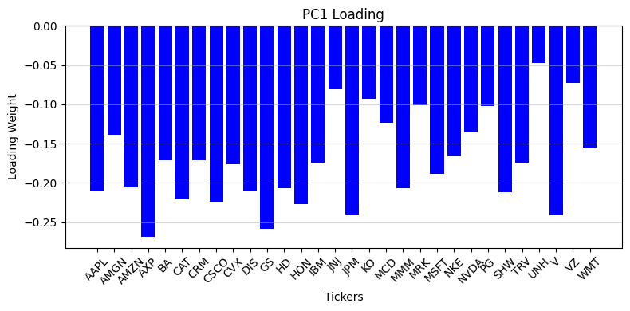
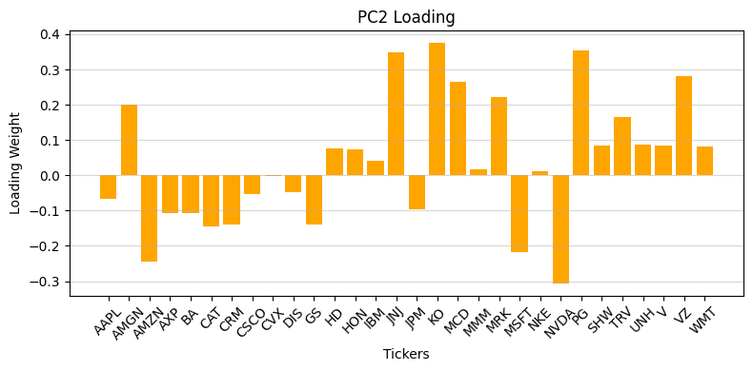
Qualitative answer:
Does the loading pattern of PC1 support the hypothesis that it represents the "Market Factor"?
Yes, the loading pattern of PC1 strongly supports the "Market Factor" hypothesis because all 30 DJIA stocks have negative and relatively high loading weights on PC1. This demonstrates that they're all reacting to the same big news about the economy like a report on jobs or inflation. This synchronized movement is called Systematic Risk, and PC1 is the single biggest reason why the entire investment portfolio goes up or down.[2]

Discuss the economic interpretation of the contrast found in PC2

PC2 demonstrates a clear economic difference between defensive sectors and cyclical or growth sectors, where defensive and rate-sensitive stocks like KO, MCD, PG, and healthcare names such as UNH and JNJ have strong positive weights.
Highly cyclical or growth sectors, such as BA, CAT (Industrials) and technology stocks like AAPL, NVDA, and MSFT, all have strong negative weights. Financials like JPM and Healthcare like AMGN are also clearly negative.
This shows sector rotation:
When PC2 is positive, investors tend to support defensive stocks, while when PC2 is negative, investors lean toward growth or cyclical stocks.

1.4.
Steps/ explanations
The objective here was to find the variance explained by each component and display that using a scree plot.
Results
- Variance explained by each component
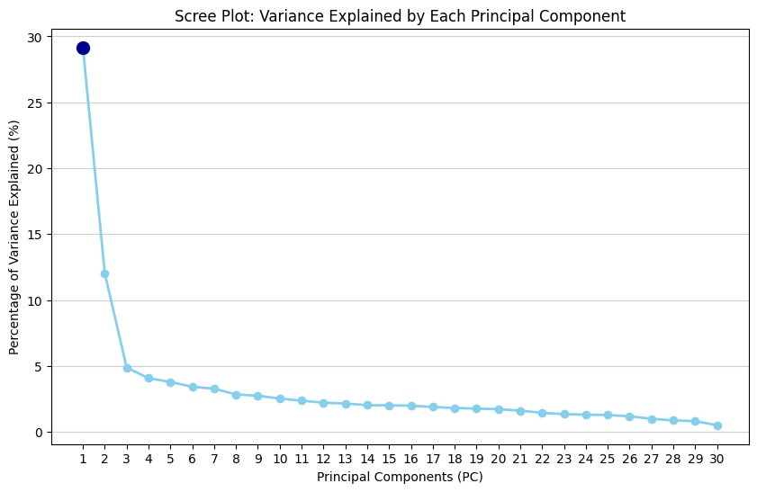
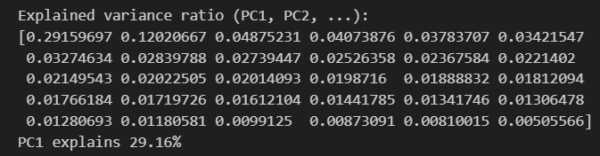
Qualitative answer:
The scree plot demonstrates PC1 dominance, which explains 29.16% of the total variance alone. This confirms our early loadings results, which showed that market factor is the highest source of risk.

- Cumulative explained variance plot
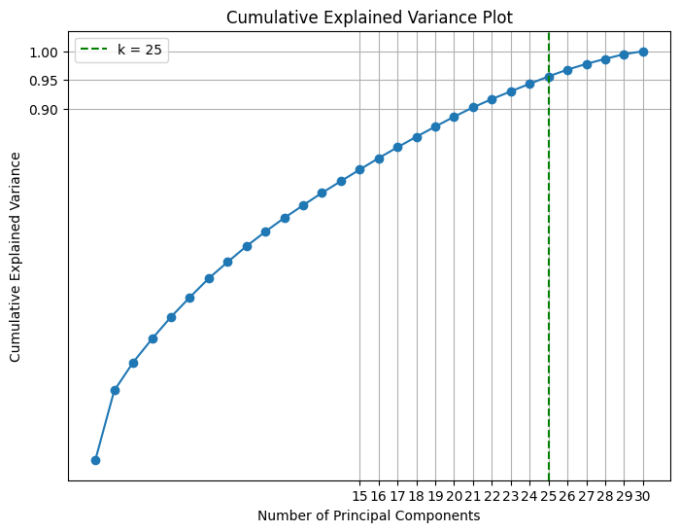
Qualitative answer:
The curve rises for the first principal components but starts becoming steady with diminishing gains as more components are added. The curve reaches the 95% threshold at k=25, which means we only need 25 components to preserve at least 95% of the information in the dataset. After this component, all other components provide little to no information.
what this k value implies about the integration versus fragmentation of the Dow Jones constituents?
Analysis of the DJIA stock index showed that about 29.16% comes from the general market, while the other half (70.84%) comes from the specificities of small-cap markets and company divisions.
The analysis showed that to capture 95% of the relevant information, 25 PCA components are needed. This means that most of the information is not very repetitive.
All of this suggests that the DJIA is correlated but not very complete, so stocks still have their own unique behaviour. This makes diversifying investments based on economic sectors still useful.

Q2)

2.1.
Matrix Seriation: This is a data visualization technique used to rearrange the rows and columns of a matrix at the same time to group similar items together[3].

Key visual elements of a Cluster map

Heat Map Matrix: The primary grid in which data values are represented by the colour of each cell.[4]
Dendrograms are tree-like structures that display hierarchical row and column clustering.[4]
Row and Column Labels: Data point identifiers.[4]

Legend: demonstrates how colours map to numerical values.[4]

Cluster Blocks: These are the reordered groups along the diagonal. They show grouped regions that are results from reordering similar rows or columns based on clustering.[4]

Reordering helps reveal block-diagonal pattern in financial markets because when the matrix is ​​placed in a new row, stocks with strong correlations are grouped together, making the heatmap appear as diagonally plotted areas. This area groups stocks that operate in the same economic sector, such as financials, industrials, or consumer staples. This makes the true market structure clearer and easier to understand.

2.2.
Coding part:
Steps:
The goal was to construct a hierarchically clustered heatmap of the correlation matrix.
Results:
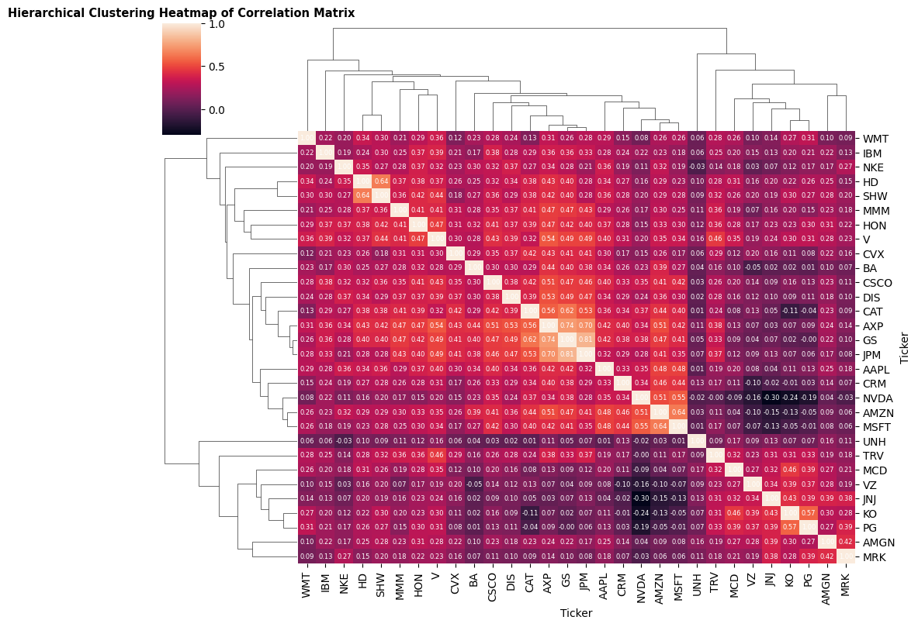
Qualitative answer:
The hierarchical clustering heatmap shows how stocks with similar concerns are grouped together to form clusters along the diagonal.
This happens because the rows and columns are reordered based on the stock's correlations, causing related companies to be closer together in the table.
Three most distinct blocks from our heatmap:
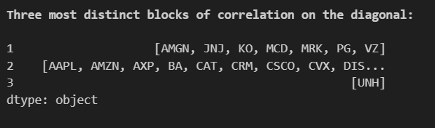
Qualitative answer:
Cluster 1: AMGN, JNJ, KO, MCD, MRK, PG, VZ
Cluster 2: AAPL, AMZN, AXP, BA, GS, JPM, CAT, MSFT, CRM, NVDA, DIS, CSCO, CVX, SHW, MMM, NKE, IBM, HON, V, HD, TRV
Cluster 3: UNH

2.3.
Goal:
To create scatter plot with PC1 against PC2, colouring and labelling each stock according to its cluster.
Results:
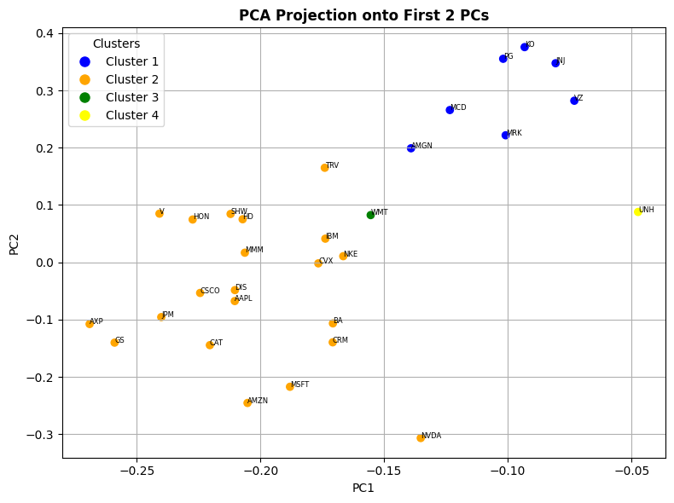
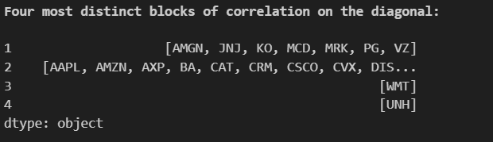

Members of each of the four clusters

Cluster 1 (Blue) contains tickers such as AMGN, JNJ, KO, MCD, MRK, PG, VZ which are generally consumer staples (Coca-Cola, P&G), Healthcare (Merck, Amgen, J&J), and Telecom companies (Verizon) which are most of the time are defensive stocks. Their returns are stable and less sensitive to economic shifts, investors run to them when they are worried about the economy.
Cluster 2 (Orange) is a huge group containing tickers such as AAPL, AMZN, AXP, BA, GS, JPM, CAT, MSFT, CRM, NVDA, DIS, CSCO, CVX, SHW, MMM, NKE, IBM, HON, V, HD, TRV. This huge group contains technology (Apple, Salesforce), Industrials (Caterpillar, HON, MMM, and BA), and Financials (Amex, JPM). These sectors are very sensitive to economic cycles and when the economy is good, these stocks rise together, however, when the economy is bad, these stocks fall together.
Cluster 3 (Green) contains only WMT (Walmart) which is extremely defensive and has stable movements, meaning it is very less sensitive to changes in technology and industrial sectors. Although WMT is a consumer staple, its unique business model and large size isolated it from the other defensive stocks (Cluster 1).
Cluster 4 (Yellow) contains an outlier which is UNH (UnitedHealth) group which can be associated to the fact that UNH is an insurance company, its stock prices move based on government policy, insurance premiums, and so on. Therefore, news that hurts drug companies like price caps on medicine may not affect an insurer like UNH. UNH is sometimes considered as a super defensive stock.

Q3)

3.1.
Explanations
We use the monthly price series of Procter & Gamble Co (PG), which is considered one of the longest-running stocks on the DJIA. We conducted exploratory analysis of the long-term trend, seasonality, and overall behaviour of the series. Then, we performed an ADF test to check stationarity.
Results
- Stationarity check using ADF test
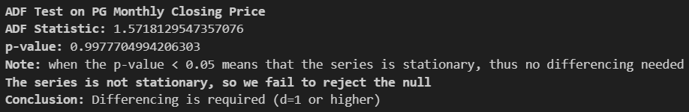
Qualitative answer:
The ADF test on PG shows that the series is not stationary as the p-value (0.99) is greater than 0.05. Therefore, we need differencing for the ARIMA/SARIMA model.
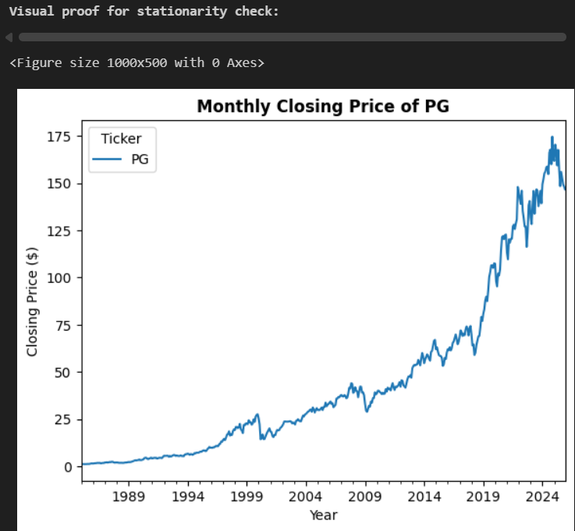
The above graph is the visual proof that our PG series is not stationary as its variance is not constant which can be shown by the fluctuations in closing prices, where it is much larger in recent years.
Long term trend: The PG long-term trend can be shown by plot demonstrating PG monthly closing prices, where we see a very strong increase, especially after 2000 and after 2020. The increasing frequency of changes in recent years also reflects the volatility clustering that is common in financial markets.
Seasonality/Behaviour: We used a boxplot to check seasonality or behaviour of the series.
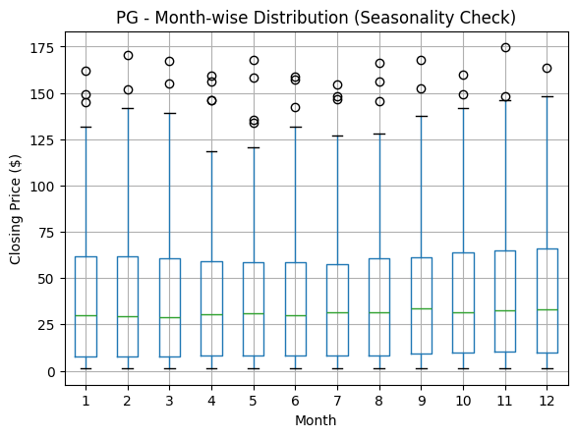
PG does not reflect the nature of recurring monthly periods, as month-to-month prices and their variances are similar across 12 months, except for small fluctuations that do not have a fixed trend.
- Order differencing
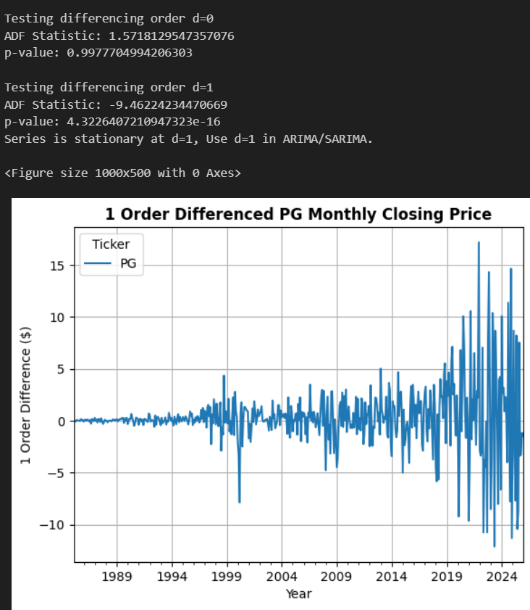
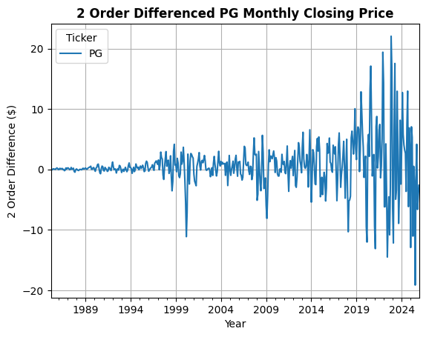
Qualitative answers
After performing first order differencing (d=1), The ADF test now indicates that the series is stationary. This is then confirmed visually, where the differenced series now fluctuates around a stable average with no trend. The second order differencing didn’t improve the behaviour. Thus, ARIMA/SARIMA should be used with first order differenced series.

3.2.
Objectives:
The objective was to test the presence of monthly or annual seasonality for the PG time series using ACF and PACF plots.
Results:
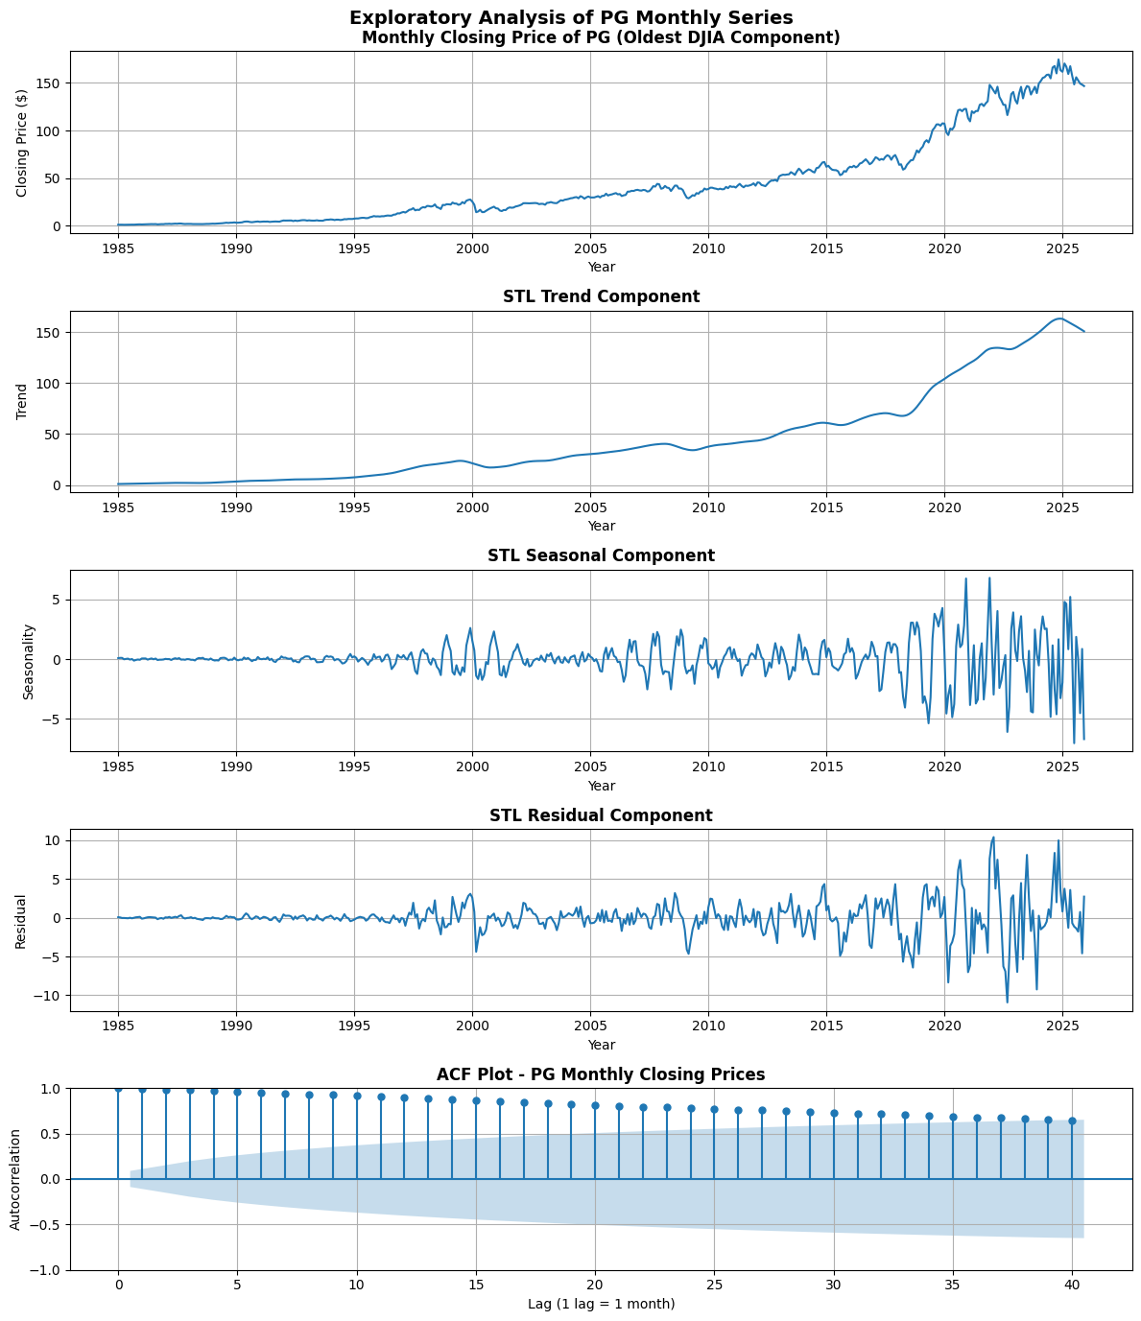
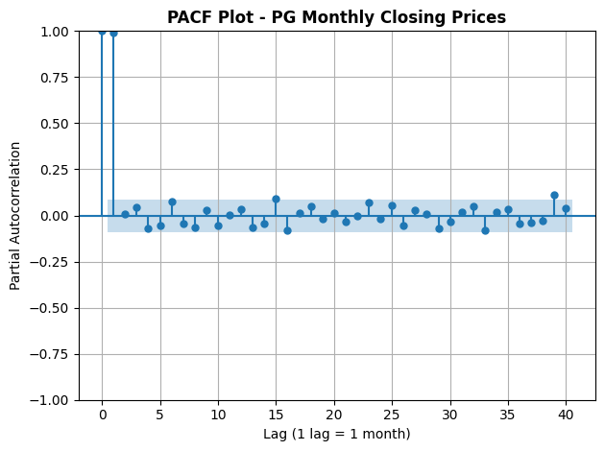
Qualitative answers:
The STL decomposition shows that PG has a strong long-term growth potential, but the seasonality component is very weak and lacks a permanent structure. After 2020, there are large fluctuations in the residuals, indicating volatility rather than seasonality.
The ACF decreases slowly, indicating that this series is trend-driven and non-normal, but does not show any recurring patterns at lag 12, so it does not show any annual seasonality. The PACF also does not show any significant seasonality.
Overall, PG is a series that is more trend-driven than seasonal, so adding a SARIMA term is not necessary and a non-seasonal ARIMA model is more appropriate

3.3.
Steps/Explanations:
The main objective for this sub-question was model development, forecasting, evaluation, and comparison between the three models (MA, ARIMA, LSTM) using MAE and RMSE. Finally, for each model, we had to plot actual times series data vs forecasted trajectories generated by the model.
Results:
- Simple Moving Average
Theoretical Motivation: The SMA works by averaging recent prices, allowing short-term fluctuations to be smoothed out and the true direction of the series to be seen. In financial markets, the SMA acts as a trend indicator: when it rises, it means that the rate is increasing, when it falls, it indicates that momentum is decreasing.[5]
Key Assumptions:
- The past information is useful for predicting the near feature.
- No strong seasonality present.
Limitations:
- Market shocks can cause SMA to lag.[5]
- Performs bad when prices levels shift quickly.[5]
- It cannot model volatility or nonlinear effects common in financial markets.[5]
Results:
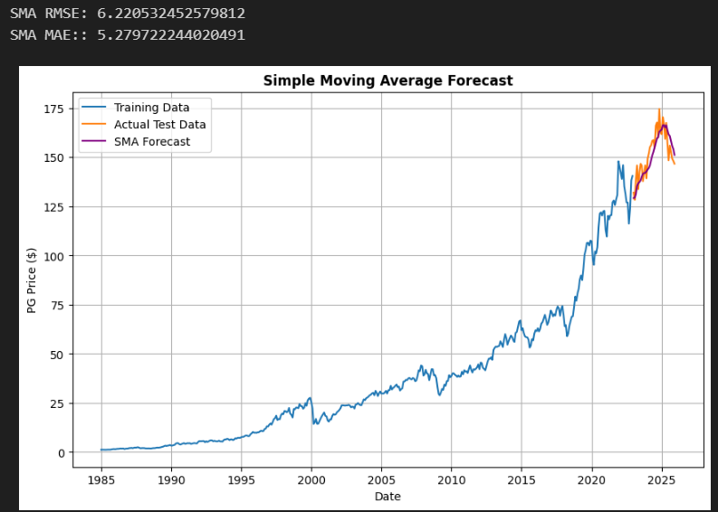

- ARIMA Model
Theoretical Motivation: ARIMA models rely on the integration of past data, past errors, and variance to show the time relationship in a series that has a normal distribution. In financial markets, where variables tend to be correlated at small scales, ARIMA can show how prices move together linearly.[6]
Key Assumptions:
- Stationarity of the differenced series[6]
- Linearity [6]
Limitations:
- ARIMA cannot work with nonlinear patterns
- Poor choice of ARIMA parameters can affect model performance
- In reality, financial markets often break stationarity because of shifts, crises, and volatility spikes.[6]
ARIMA parameters
P = 1
d = 1
q = 1
m = 0
Justification
From the PACF plot of the differenced series, we observed the highest spike on the first lag, this insight led us to chose p=1.
For stationarity, we saw that the first order differencing of the series made it stationary. Therefore, we chose d=1.
From the ACF plot, we observed that after the first lag, there was drop which is characteristic of an M(A) pattern. Thus, q=1.
Results:
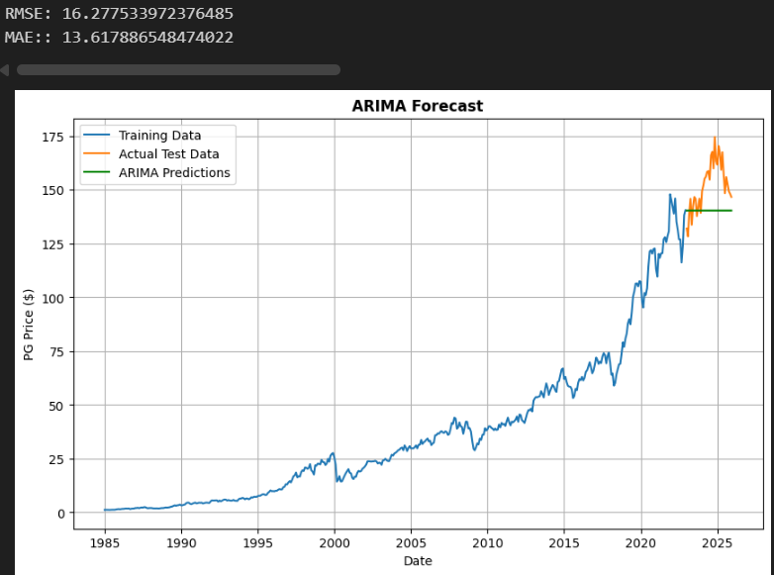

- LSTM
Theoretical Motivation: LSTM is built to capture long-term relationships using dedicated memory areas. This is especially important in financial metrics that have complex structures that are not captured by traditional methods of looking at past events.[7]
Key Assumptions:
- Enough data for training [7]
- Linear relationship between past and future values[7]
Limitations:
- LSTMs can easily overfit due to highly noisy financial time series[7]
- Needs sufficient data[7]
- Sensitive to hyperparameters[7]

LSTM data preprocessing
To use the LSTM model, we first converted the monthly PG prices into monthly returns because returns are more stable and easier for neural networks to learn from. After that, we applied MinMaxScaler to scale all return values into the range 0 to 1, which helps the LSTM converge faster. The final 36 months were reserved as the evaluation window, while all earlier observations formed the training set. The LSTM was set to look back 12 months at a time when predicting the next month. Finally, the input sequences were reshaped into the 3-dimensional format required by TensorFlow’s LSTM.
LSTM model architecture
LSTM Layer 1:
Input size = 1
Hidden size = 50
LSTM Layer 2:
Input size = 50, hidden size = 50
This increases the capacity to detect longer-term temporal patterns.
Fully Connected Layer:
Linear (50 ,1)
Converts the last hidden state into the final price prediction.
Forward Pass Logic:
- Moves data through the two LSTMs
- Takes the final timestep only
- Feeds it into the dense layer for prediction

LSTM training configuration
Loss function: Mean Squared Error (MSE)
Optimization: ADAM (adaptive momentum) used as optimizer with learning rate 0.001, providing stable convergence.
Epochs: 25 training epochs
Batch Size: 8 which is suitable for small datasets
Evaluation: RMSE and MAE were used on the test set

Results:
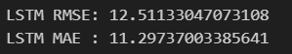
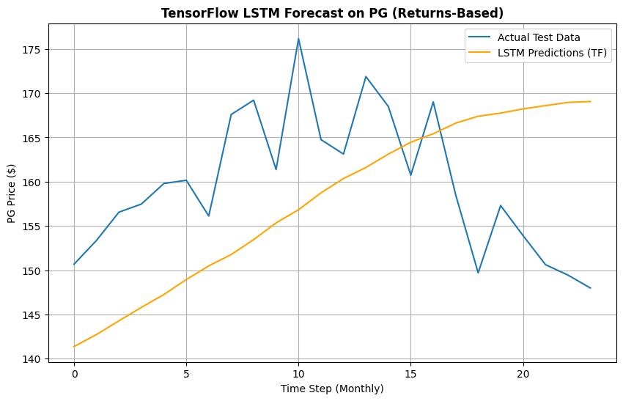
Qualitative answers for all the 3 models above:
SMA performed best because it had the lowest RMSE (6.22) and MAE (5.27), since PG prices change slowly and benefit from being stored in the short term.
The LSTM model (RMSE=12.51 and MAE=11.29) performed better than ARIMA but lower than SMA. It learned the overall upward pattern from the returns, but because monthly data is very limited, it still tends to produce smoother forecasts that miss some of the sharp movements in the actual prices.
ARIMA performed the worst (RMSE =16.27 and MAE =13.61). Even though it captures long-term trend direction, it struggles with the sudden jumps and volatility in the latest 36 months, causing large forecast errors.
Overall, SMA is the best model, LSTM improves but still trails behind, and ARIMA is the weakest due to underreacting to recent price fluctuations.
Financial and methodological reasons for the observed differences in forecasting accuracy
SMA performed best because it captured short-term changes and reduced errors better than ARIMA and LSTM, given that PG prices change slowly each month. LSTM performed in the middle because it captured the general direction of the trend, but it still struggled with nonlinear changes and sharp fluctuations due to limited monthly data. ARIMA performed worst because, although it captured the general trend, it lacked power over recent volatility and nonlinear behaviour in PG, resulting in larger forecast errors.

Using SMA to forecast the trend for the next year
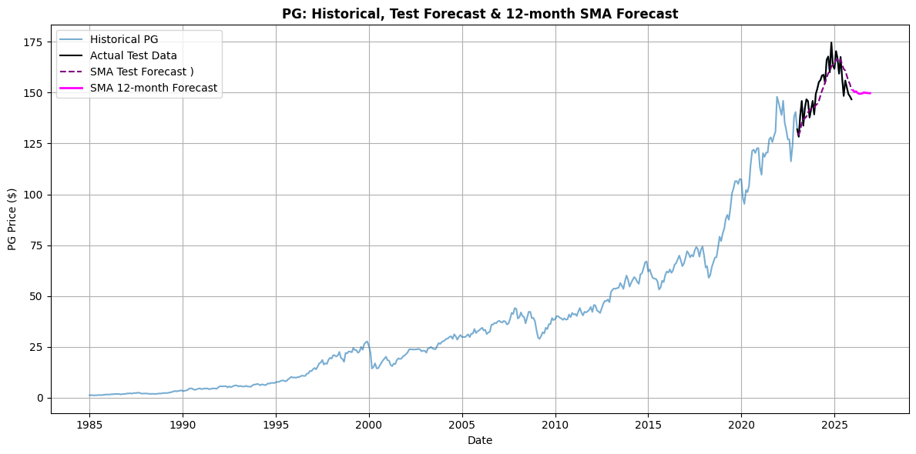
Qualitative answer:
The 1 year forecast by SMA shows a stable prolongation of the recent PG price level, demonstrating the model’s ability to averaging short term volatility.

References:
[1] “PCA Finance: Introduction to the Main Linear Technique for Dimensionality Reduction - Avenga.” Accessed: Nov. 27, 2025. [Online]. Available: https://www.avenga.com/magazine/pca-in-finance/
[2] “Systematic Risk: Definition and Examples,” Investopedia. Accessed: Nov. 27, 2025. [Online]. Available: https://www.investopedia.com/terms/s/systematicrisk.asp
[3] V. Blanco, A. Marín, and J. Puerto, “Exact Matrix Seriation through Mathematical Optimization: Stress and Effectiveness-Based Models,” June 24, 2025, arXiv: arXiv:2506.19821. doi: 10.48550/arXiv.2506.19821.
[4] “Clustered Heatmaps.” Accessed: Nov. 27, 2025. [Online]. Available: https://bioinformatics.mdanderson.org/public-software/ngchm/heatmaps/
[5] “Simple Moving Average (SMA) Explained: Definition and Calculation Formula.” Accessed: Nov. 28, 2025. [Online]. Available: https://www.investopedia.com/terms/s/sma.asp
[6] “ARIMA - GeeksforGeeks.” Accessed: Nov. 28, 2025. [Online]. Available: https://www.geeksforgeeks.org/data-science/model-selection-for-arima/
[7] “ARIMA vs. LSTM,” GeeksforGeeks. Accessed: Nov. 28, 2025. [Online]. Available: https://www.geeksforgeeks.org/machine-learning/arima-vs-lstm/

