**Clone YO app with Parse.com Swift and iOS 8.**

In this tutorial, you’ll learn how to make a application like YO (<https://itunes.apple.com/us/app/yo./id834335592?mt=8>) names Clone YO with cloud service Parse.com Swift and iOS 8.

Parse.com is backend cloud service from Facebook.

In the process of going through this tutorial, you’ll get some excellent practice with Swift, new iOS 8 features such as Interactive Push Notification. You’ll also learn a lot about social app architecture and best practices.

**Getting Started**

Start up Xcode 6.x, go to ***File\New\Project…***, choose the ***iOS\Application\Single View Application*** template and click ***Next***. Fill out the options as follows:

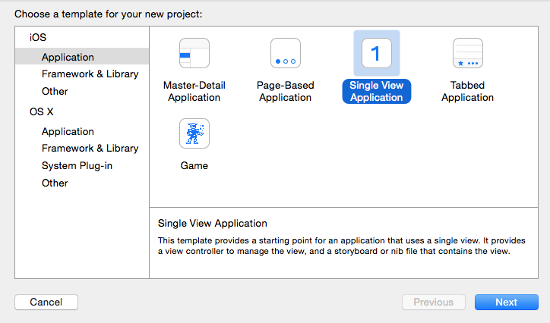

* Product Name: ***CloneYO***
* Language: ***Swift***
* Devices: ***iPhone***

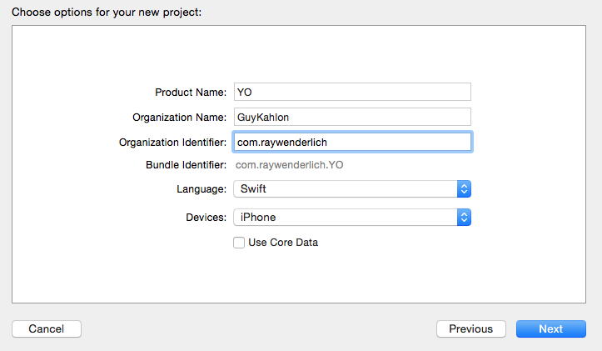

Click ***Next***, choose a folder for your project and click ***Create***.

This is a portrait-only application, so open the ***Target Settings*** screen and in the ***General*** tab, make sure only***Portrait*** is checked in the ***Device Orientation*** section:



The start project is ready, before starting the development of your CloneYO app, the first step is to create an app in the Parse backend. Every developer and every app requires a unique identifier.

Your first step is to visit [Parse.com](http://parse.com/) and click **Sign Up** to create a new account or login with existing account.

Once the account is created, you will be asked to create your first app. Every app you use with the backend must be registered separately. In this case, call it “Clone YO”

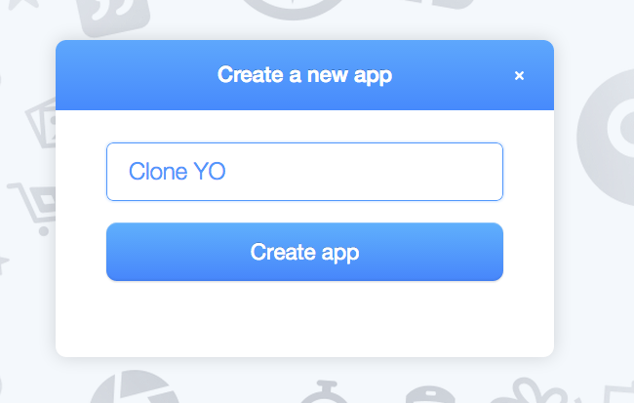

1. Continue according to instructions on the screen.

At the end of the process you should have the following information:

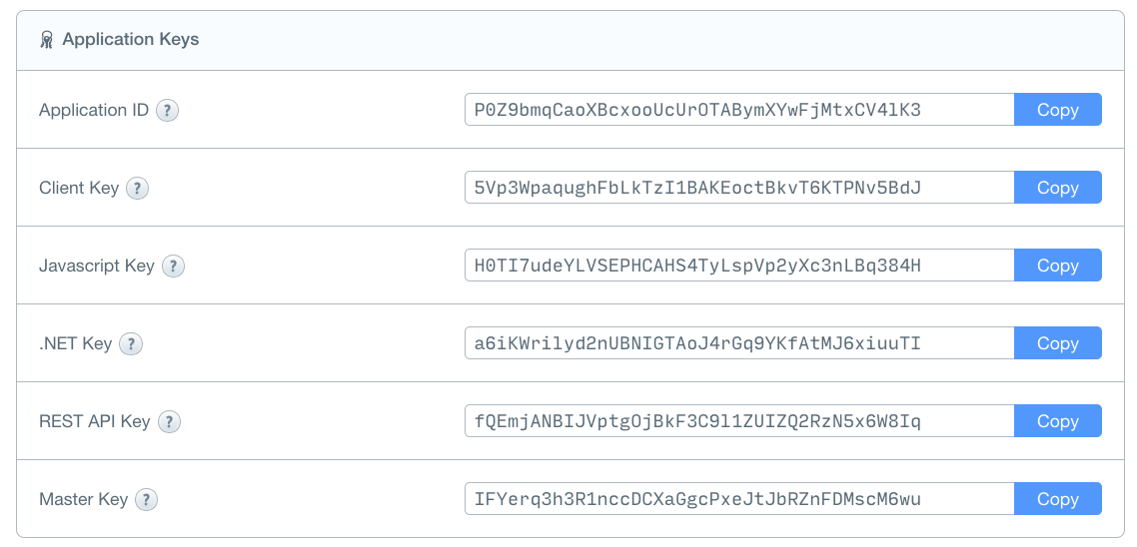

Great, now we have a start project and app in Parse .

Now we should to integrate parse iOS SDK into our project, download the latest Parse SDK for iOS from <https://parse.com/docs/downloads/>

Unzip the file.

Create new group

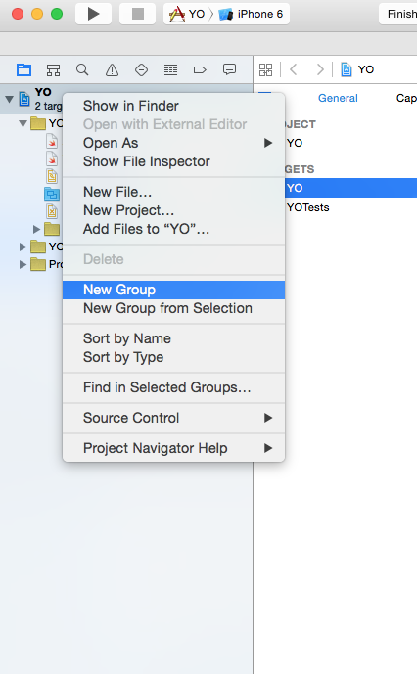

Called “Parse”

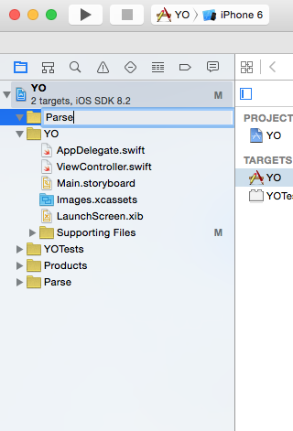

Drag and drop all the files from the Parse iOS SDK you unzip earlier.

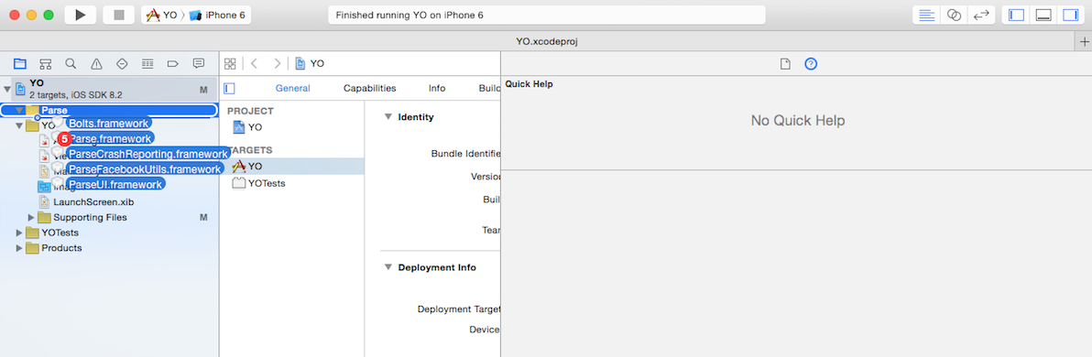

Don’t forget select “Copy items if needed”.

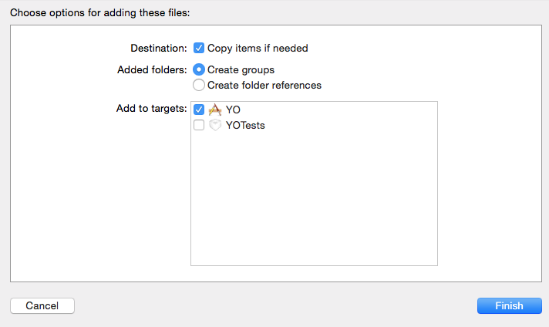

Parse iOS SDK is Objective C code and our project will written with Swift, So how we can use with Objective C code from Swift project?

All we need is bridging file, That bridge between the code is written in Swift code and Objective C code. we should to add all the imports (Objective C code ) to the bridging file.

How we create a bridging file?

There are several ways to create this bridge file, I would prefer the automatic way.

We create a new Objective .m file calls CustomObject.

go to ***File\New\File… (or just use the Xcode keyboard Shortcuts*** ⌘N***)***, choose the ***iOS\Source\Objective-C File***  and click ***Next***. Fill out the options as follows:

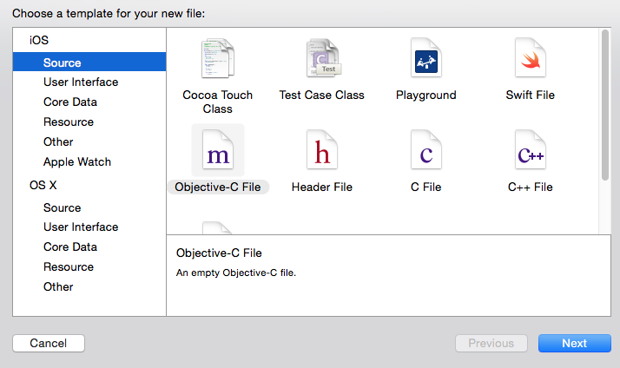

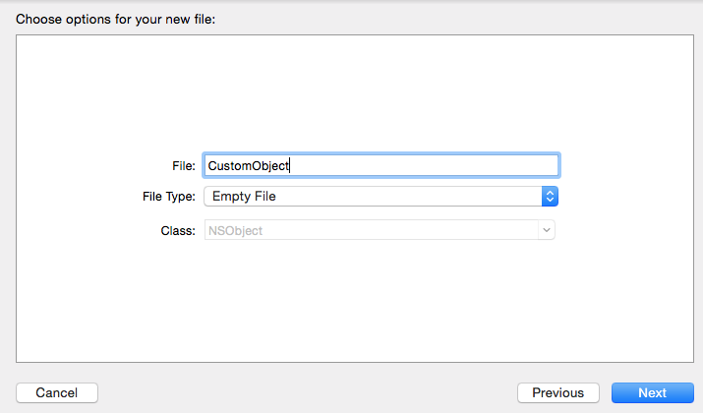

Click next.

Now the Xcode create a bridging file for us.

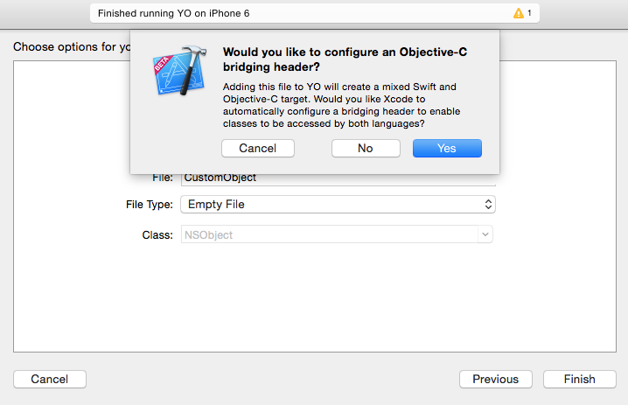

Click Yes and now you can remove the CustomObject.

Please ensure the have YO-Bridging-Header.h file in your prohect.

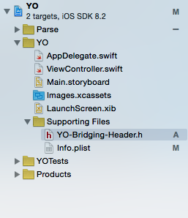

Parse also required list of other frameworks:

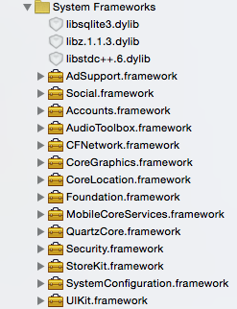

To add these frameworks, go to the YO target-> ***General section -> Linked Frameworks and Liberaries.***

Ok, We have start project, app id in Parse.com, iOS Parse SDK that wrote in Objective C code and we have bridging file to connect between our Swift code and Objective C code.

Open the YO-Bridging-Header.h and add:

#import <Parse/Parse.h>

Now we want to connect our parse application with our application code.

Open appDelegate.swift and replace with the following method:

func application(application: UIApplication, didFinishLaunchingWithOptions launchOptions: [NSObject: AnyObject]?) -> Bool {

Parse.setApplicationId("qhRyaWCd7ZOEJJhJmFKs6Z32uutxFkQYFFJBixaI", clientKey: "iWNE0YD5ri179DnEn8IE0PeTzRBZoVLaOJ0OZ5BI")

return true

}

Build and run the app to be sure all works fine.

Open the LaunchScreen.xib update the UILable on the bottom screen to “Clone YO tutorial RayWenderlich.com” and Changed the background color to RGB(135,64,69).

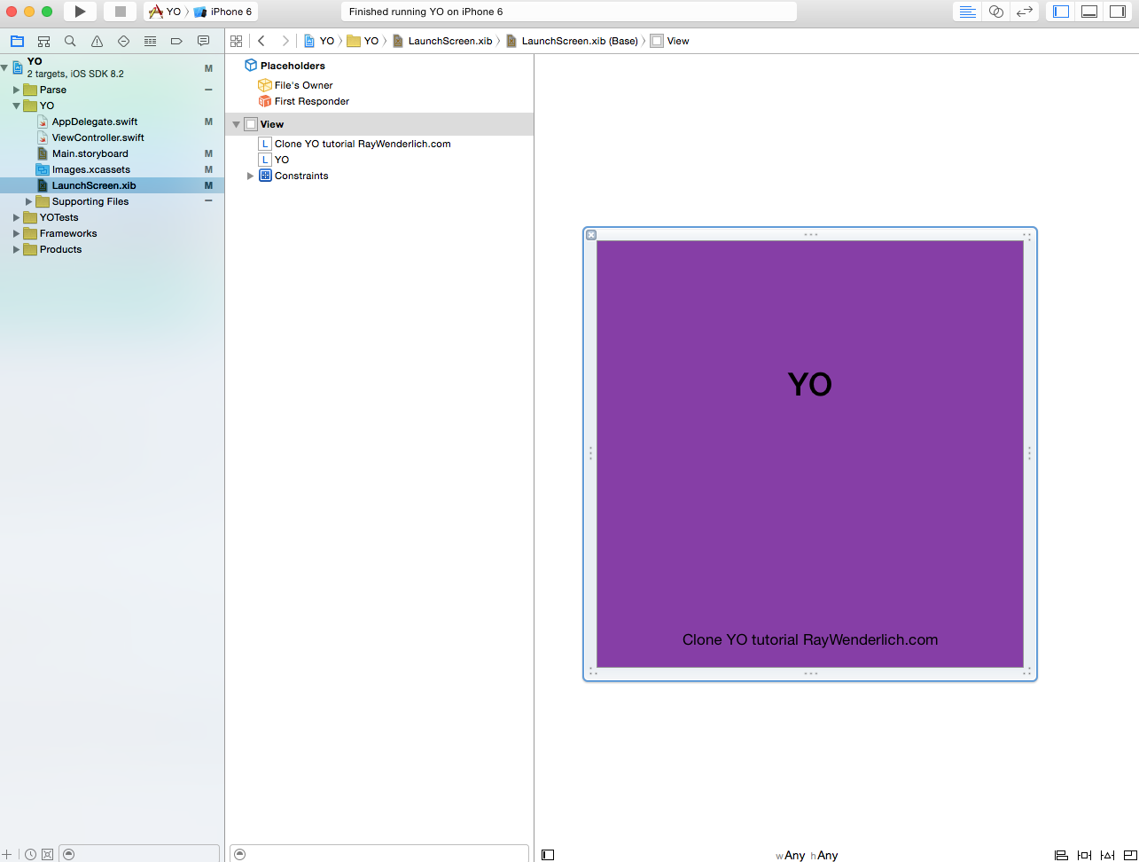

1.Login screen.

Open to Main.storyboard, Our app support only in iPhone so we need to change the size class for iPhone only:

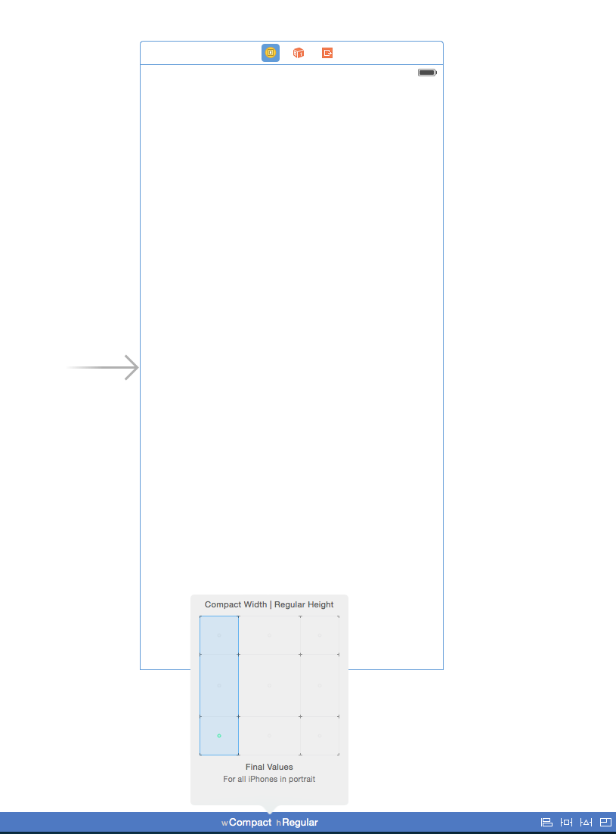

Drag and drop tableView:

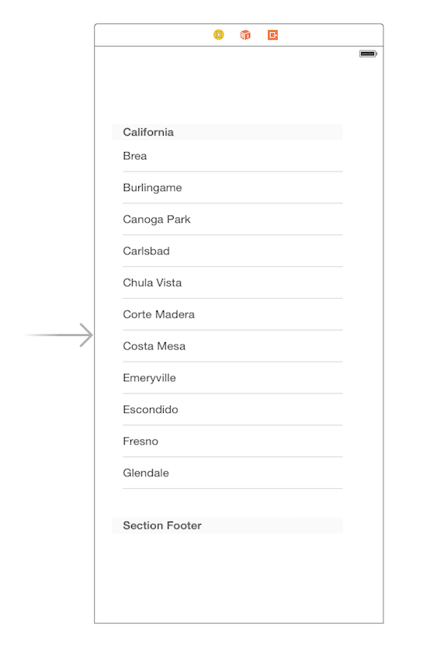

Set the viewController as delegate and data Source for the tableview.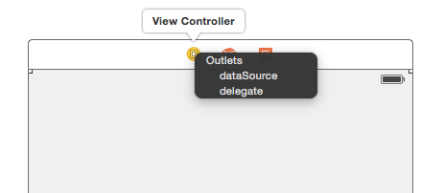

In addition update the auto layout:

