Documentation

Arg research and tool development

YOANN GATHIGNOL, Guillaume robert, titouan bouete-giraud, rayane bengaoui

2017

Contents

I) Introduction 2

II) Tools 2

a) Mail bot 2

b) Website generator 4

c) Twitter bot / chat bot 4

# Introduction

This documentation lists and details tools developed by a team of interns in the Robert Gordon University. This team was composed of 4 french students (Guillaume ROBERT, Rayane BENGAOUI, Titouan BOUETE-GIRAUD, Yoann GATHIGNOL) who were part of a 10weeks internship in RGU, and a teacher/researcher (Michael Heron). The goal of this internship was to develop tools that could be used to create ARG.

# Tools

## Mail bot

What is this ?

This is a package of java classes aimed to ease the creation of mailbot, usually in the context of creating an

Alternate Reality Game. Although this package also comes with a small example: The Good and the Bad bot, it is

still considered as a toolkit and need to be extended to match the desired final product.

Disclaimer :

Those classes were designed to allow the user to focus on the writing of the bot rather it's programming.

However, basic Java knowledge is still necessary as delving into the code will be required.

Do note that those classes was intended to be used specifically with a gmail mailbox. The code in EmailUsingGmailSMTP

could be adapted to accept other mail type, but this might cause issue with TheGoodAndTheadBot due to the security mesures used by those.

Several methods in EmailUsingGMailSMTP allows for easy operations of the mailbox within the code.

The class BasicARGMailBot is the basic behaviour of the type of bot aimed at by this project.

The classes TheGoodBot and TheBadBot work together as examples of what can be accomplished with this code.

Usage:

I – Setting up TheGoodBot and TheBadBot

1. Check out Story-Line.pptx provided with this code to better understand the idea of those bots.

2. Create 2 gmail addresses to be used by those bots and allow them to be accessed by less secured

applications (https://support.google.com/accounts/answer/6010255?hl=en).

3. Create a folder in which each user’s progress will be saved.

4. In this folder, create another folder containing the various attachment send during the progress

of the game to users (you can modify the path of this attachment in the code).

5. Create 2 separate mains: use TheGoodBot’s constructor and call loopWaitForEmail on it and a second

one with TheBadBot’s constructor and calling the same method. (Check out the main in the package

mailBot for a better understanding)

6. Run both mains (the game will not crash if both are not launched, but the user won’t be able to

progress through the game as intended).

II – Writing you own bot using user progress

Create a class inheriting from BasicARGMailBot and override both answerMailProgressionBased(…) method and

validateStep(…) method.

By doing so, you will have a bot that will handle the progress of each user contacting him by creating empty

folder in the one asked by the constructor. It will also automatically check the name of the step of the user

you are interacting with.

It is therefore required to handle how the step progress, and what should be done at each step. You can for

example write down specific answers depending on the step reached by user, not answer at all, ect… Again, check

out TheGoodBot and TheBadBot for examples.

## Website generator

Requierements : the folder CSS furnished with the application, and a "index.html" file.

==> allows everyone to generate a random website with different colors.

==> the user just have to press generate and a Css is generated,

if he wants to keep it he will have to copy the css wherever he wants to, else he will press generate

again. When he presses the button a CSS with random value will be generated.

## Twitter bot / chat bot

We also did some research to develop a bot that could twit automatically and could respond to certain type of twits, and a chat bot. We found a website called botlibre.com that allows you create a single AI that manages different kinds of bots :

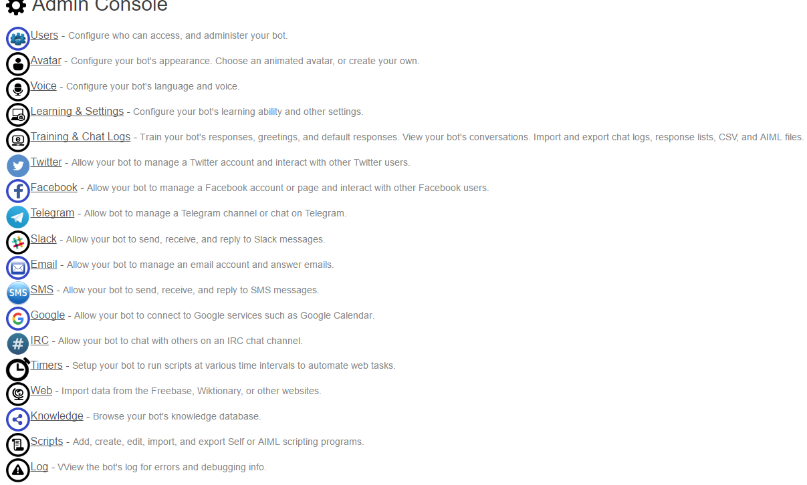

* With this website you can link a twitter account to your AI. There are different actions that the AI can do with it, and you have to configure it.

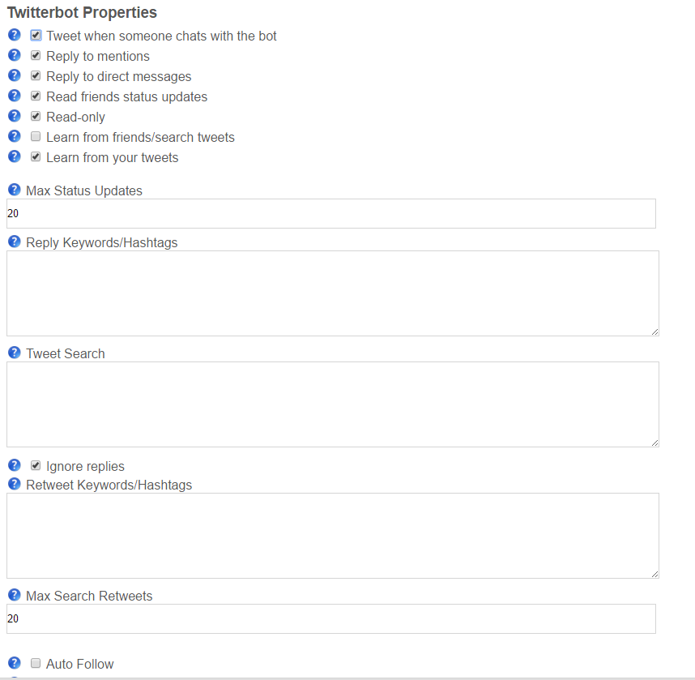

* You can configure the twitter bot to respond to certain questions or phrases when it’s asked to. Its answers are configured in the “Training and char logs” section :

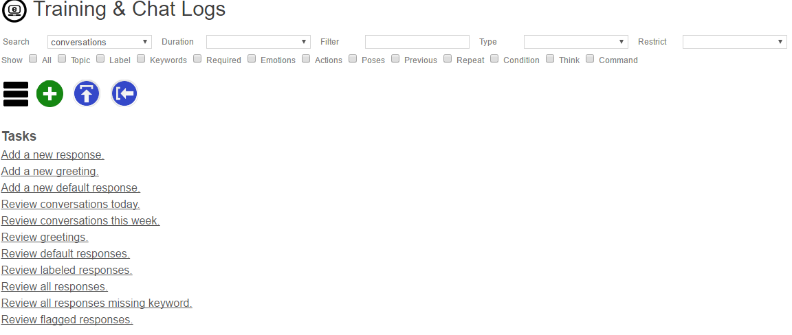

* You can also configure the bot to learn for the conversation it has, so it creates its own answers and will remember things (it is quite complicated).

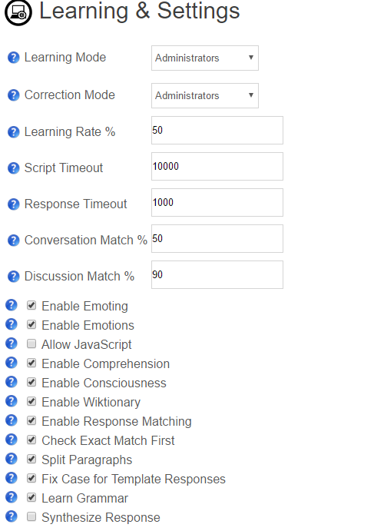

* You can also write scripts to directly alter the AI behaviour and make it do more complicated things, those scripts are written in “Self” which is a language very close to Javascript.

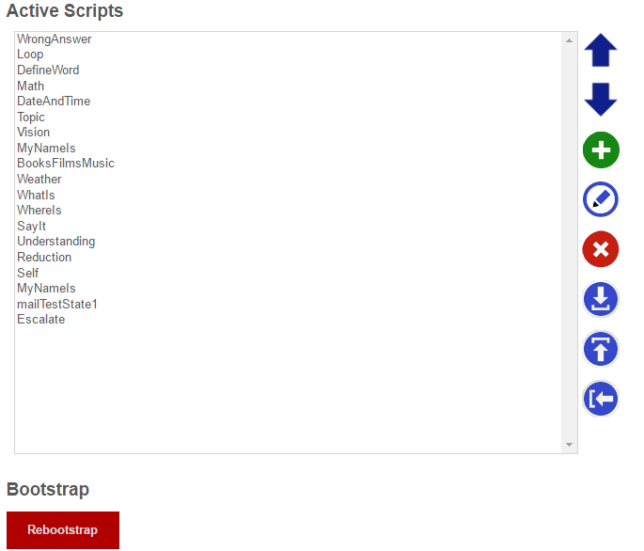

* 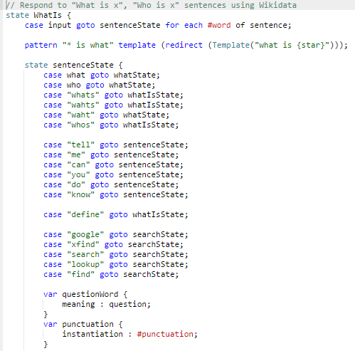Exemple :

This script will read each word of the input sentence, identify the meaning of it and will respond accordingly.

If the user types “who is Barack Obama ?”, the bot will respond with a short description from Wikipedia.

* Although this website is very interesting, the results are too inconsistent to really rely on it.