**CAN THO UNIVERSITY**

**COLLEGE OF INFORMATION AND COMMUNICATION TECHNOLOGY**

**DEPARTMENT OF INFORMATION TECHNOLOGY**

**🙞 🕮 🙜**

**BASIS THESIS**

**BACHELOR OF ENGINEERING IN**

**INFORMATION TECHNOLOGY**

**(HIGH-QUALITY PROGRAM)**

**E-LEARNING – A WEBSITE FOR LEARNING ONLINE**

**Student: Nguyen Trung Tam**

**Student ID: B1910697**

**Class: 2019-2023 (K45)**

**Advisor: Dr. Thai Minh Tuan**

**Can Tho, 05/2019**

**CAN THO UNIVERSITY**

**COLLEGE OF INFORMATION AND COMMUNICATION TECHNOLOGY**

**DEPARTMENT OF INFORMATION TECHNOLOGY**

**🙞 🕮 🙜**

**BASIS THESIS**

**BACHELOR OF ENGINEERING IN**

**INFORMATION TECHNOLOGY**

**(HIGH-QUALITY PROGRAM)**

**E-LEARNING – A WEBSITE FOR LEARNING ONLINE**

**Student: Nguyen Trung Tam**

**Student ID: B1910697**

**Class: 2019-2023 (K45)**

**Advisor: Dr. Thai Minh Tuan**

**Can Tho, 05/2019**

EVALUATION OF ADVISOR

....................................................................................................................................................................................................................................................................................................................................................................................................................................................................................................................................................................................................................................................................................................................................................................................................................................................................................................................................................................................................................................................................................................................................................................................................................................................................................................................................................................................................................................................................................................................................................................................................................................................................................................................................................................................................................................................................................................................................................................................................................................................................................................................................................................................................................................................................................................................................................................................................................................................................................................................................................................................................................................................................................................................................................................

Advisor

Thai Minh Tuan

ACKOWNLEDGEMENTS

I wish to express my deep gratitude and sincere thanks to my professor Thai Minh Tuan – A lecturer of College of Information and Communication Technology who gave me the golden opportunity to do this wonderful thesis on the topic “E-learning – a website for learning online”, which also helped me in doing a lot of Research and I came to know about so many new things I am really thankful to them. Then I would like to thank the lecturers of Can Tho University, specifically, lecturers of College of Information and Communication Technology who taught me invaluable knowledge when I studied.

I am extremely grateful to my family for their loves, prayers and caring for completion of this thesis. I am very much thankful to my friends for their support when I was doing research in Can Tho university.

Sincerely,

Can Tho, 16/05/2022

Nguyen Trung Tam

TABLE OF CONTENTS

CHAPTER 1: INTRODUCTION 1

CHAPTER 2: BACKGROUND 3

2.1. Background 3

2.1.1. PHP 3

2.1.2. MySQL 3

2.1.3. Other technologies 4

CHAPTER 3: DESIGN AND IMPLEMENT OF THE WEBSITE 5

3.1. Overview 5

3.2. Analyst and Design 5

3.2.1. Database Design 5

3.2.2. Database Model 6

3.2.3. Use Cases diagram 11

3.2.4. Detail Use Cases 12

3.3. Main Functions 22

3.4. Detail Of Functions in The System 22

3.4.1. Authenticate 22

3.4.2. Course Function 23

3.4.3. Quiz 23

3.4.4. Admin management 23

3.4.5. User Interface 24

CHAPTER 4: CONCLUSION 48

4.1. Conclusion 48

4.2. Future work 48

LIST OF FIGURES

Figure 1. Database diagram 5

Figure 2. Admin use case diagram 11

Figure 3. User use case diagram 12

Figure 4. Navigation bar before signed in 24

Figure 5. Navigation bar after signed in 24

Figure 6. Main page 25

Figure 7. Login form in login page 25

Figure 8. Sign up form in sign up page 26

Figure 9. List of courses and categories in courses page 27

Figure 10. List of courses video and categories in courses video page 27

Figure 11. Courses category page 28

Figure 12. Course detail page 29

Figure 13. Course video detail 29

Figure 14. Quiz page 30

Figure 15. Quiz detail page 31

Figure 16. Quiz result page 31

Figure 17. Search courses result page 32

Figure 18. Categories management page 32

Figure 19. Edit category form 33

Figure 20. Accounts management page 33

Figure 21. Edit account form 34

Figure 22. Languages management page 35

Figure 23. Add language form 35

Figure 24. Edit language form 36

Figure 25. Programming languages management 36

Figure 26. Add programming language form 37

Figure 27. Edit programming language form 37

Figure 28. Courses management page 38

Figure 29. Add course form 38

Figure 30. Update course form 39

Figure 31. Course delete form 39

Figure 32. Course topics management 40

Figure 33. Add new topic form 40

Figure 34. Update topic form 41

Figure 35. Courses video management page 41

Figure 36. Add course video form 42

Figure 37. Course video update form 42

Figure 38. Course video delete form 43

Figure 39. Course video topics management 43

Figure 40. Add new course video topic form 43

Figure 41. Edit course video topic form 44

Figure 42. Quizzes management page 44

Figure 43. Add quiz form 45

Figure 44. Update quiz form 45

Figure 45. Delete quiz form 45

Figure 46. Quiz questions management 46

Figure 47. Update question form 46

Figure 48. Add new question form 47

LIST OF TABLES

Table 1. Role Table 6

Table 2. User Table 6

Table 3. Categories Table 6

Table 4. Courses table 7

Table 5. Languages Table 7

Table 6. Programming Languages Table 8

Table 7. Course Programming Languages Table 8

Table 8. Course Topics Table 8

Table 9. Course Videos Table 9

Table 10. Course Video Topics Table 9

Table 11. Course Quizz Table 9

Table 12. Course Questions Table 10

Table 13. Course Question Options Table 10

Table 14. Course Question Answer Table 10

# INTRODUCTION

E-learning – a website for learning online using HTML, CSS and PHP

Nowadays, the necessary for self-learning is become more important because of the rapidly development of IT. However, there is a lot of unreliable information on the internet for learning purpose, people may find it hard to find and organize the information on the internet to learn effectively, eventually they lost interest about learning the subject that they used to want to study.

E-learning was created to provide a useful tool that supports people who want to learning online efficiently in the convenient way. The website will allow users to search for the courses about the subject that they want to learn (it can be in text like article or video), it also helps users to enhance the learning performance by doing some quizzes about the subject that they had learned.

The objectives and scope

The application provides main functions to help users find, search and explore wonderful courses. This thesis will be focused on the problem of searching and learning from the course. The scope of the study is: researching the problem of searching and learning online, solving the problem by implementing website with friendly UI/UX.

Research content

Methods:

- Analyzing requirements: research problems on the internet, analyzing

functionals, describing requirements to build systems.

- Design: Designing UI/UX; Analyzing and designing models: PDM.

- Implementing: Using HTML and CSS for frontend and PHP for backend server with MySQL

Solutions:

- Using knowledge of analyzing and de signing information systems, building

web applications: HTML, JavaScript, CSS, Algorithm …, etc.

Thesis outline

**Chapter 1**: Introduction

**Chapter 2**: Background

General information about the study and main functions of the system.

**Chapter 3**: Design and implementation

Introduction of UI/UX designs, models and implementation, describing

technologies which will be used in the study, use case diagrams, database and

details of function in the system.

**Chapter 4**: Conclusion and future work

# BACKGROUND

## Background

### PHP

PHP is a general-purpose scripting language geared toward web development. It was originally created by Danish-Canadian programmer Rasmus Lerdorf in 1994. The PHP reference implementation is now produced by The PHP Group. PHP originally stood for Personal Home Page, but it now stands for the recursive initialism PHP: Hypertext Preprocessor.

PHP code is usually processed on a web server by a PHP interpreter implemented as a module, a daemon or as a Common Gateway Interface (CGI) executable. On a web server, the result of the interpreted and executed PHP code – which may be any type of data, such as generated HTML or binary image data – would form the whole or part of an HTTP response. Various web template systems, web content management systems, and web frameworks exist which can be employed to orchestrate or facilitate the generation of that response. Additionally, PHP can be used for many programming tasks outside the web context, such as standalone graphical applications and robotic drone control. PHP code can also be directly executed from the command line.

The standard PHP interpreter, powered by the Zend Engine, is free software released under the PHP License. PHP has been widely ported and can be deployed on most web servers on a variety of operating systems and platforms.

The PHP language evolved without a written formal specification or standard until 2014, with the original implementation acting as the de facto standard which other implementations aimed to follow. Since 2014, work has gone on to create a formal PHP specification.

### MySQL

MySQL is an open-source relational database management system (RDBMS). Its name is a combination of "My", the name of co-founder Michael Widenius's daughter, and "SQL", the abbreviation for Structured Query Language. A relational database organizes data into one or more data tables in which data types may be related to each other; these relations help structure the data. SQL is a language programmers use to create, modify and extract data from the relational database, as well as control user access to the database. In addition to relational databases and SQL, an RDBMS like MySQL works with an operating system to implement a relational database in a computer's storage system, manages users, allows for network access and facilitates testing database integrity and creation of backups.

MySQL has stand-alone clients that allow users to interact directly with a MySQL database using SQL, but more often, MySQL is used with other programs to implement applications that need relational database capability. MySQL is a component of the LAMP web application software stack (and others), which is an acronym for Linux, Apache, MySQL, Perl/PHP/Python.

### Other technologies

**Bootstrap:** Bootstrap is the most popular CSS Framework for developing responsive and mobile-first websites. Bootstrap 4 is the newest version of Bootstrap.

**Tailwind CSS:** Utility classes help you work within the constraints of a system instead of littering your stylesheets with arbitrary values. They make it easy to be consistent with color choices, spacing, typography, shadows, and everything else that makes up a well-engineered design system.

**Draw.io:** is proprietary software for making diagrams and charts.

**Font Awesome:** is the icon library and toolkit to quickly making simple scalable vector images that can be customized with CSS for the web app.

**Github:** is a website and cloud-based service that helps store and manage code, as well as track and control changes of code.

# DESIGN AND IMPLEMENT OF THE WEBSITE

## Overview

E-learning is a website application that aid users for searching and learning online courses. The system provides core functionalities for users: search course, read course, do quiz and for admin: uploading course, quiz, …. It also provides utilities features to boost users learning performance.

When users visit the website, they can see uploaded courses in various topic. The courses will be shown with a brief detail information to help users have an overview of the course. User has to sign up for an account to work on advanced functions. When user is signing up, they have to provide a email address, username and password, if email is duplicated with other users or password is invalid, the system will show an error notification. After signing up, user can watch courses with detailed information and do quiz.

Admin will be granted full functionalities on the application and interact with the database.

## Analyst and Design

### Database Design

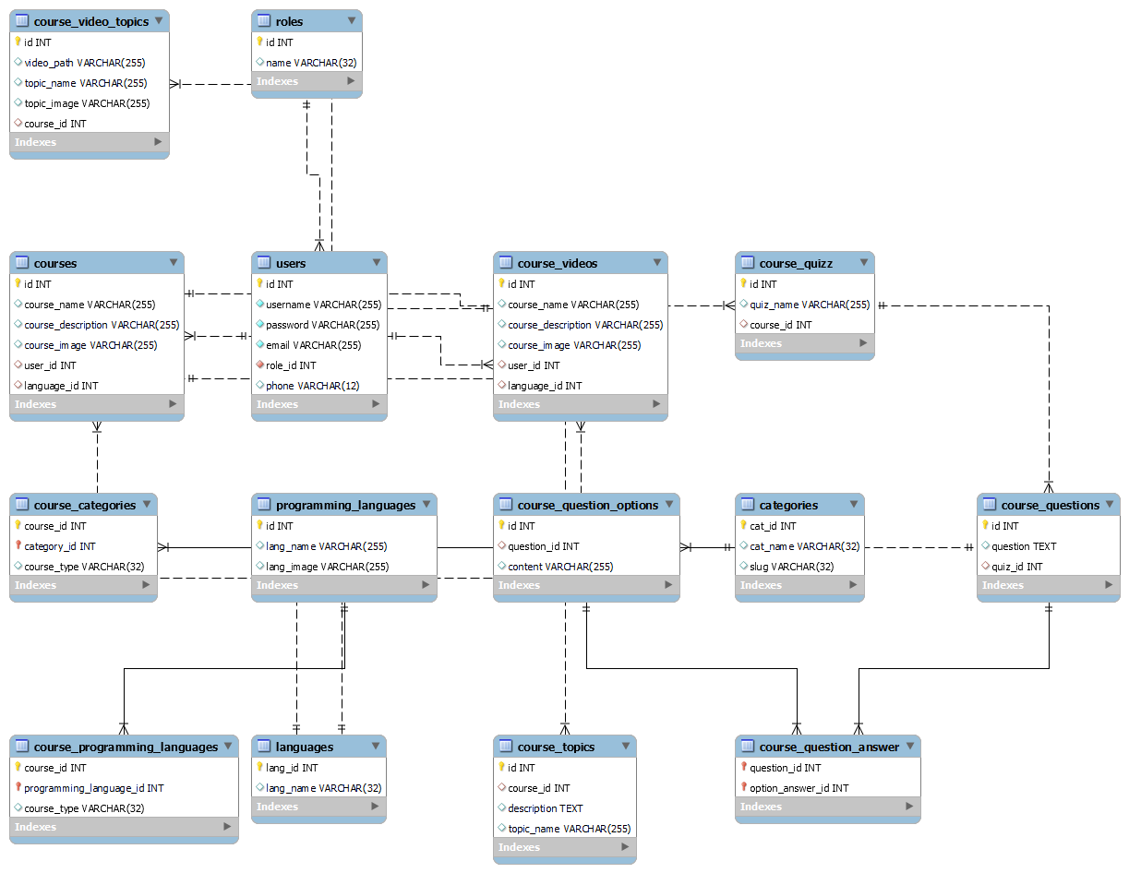

Figure 1. Database diagram

### Database Model

|  |  |  |  |  |  |
| --- | --- | --- | --- | --- | --- |
| **Role Table** | | | | | |
| **STT** | **Field** | **Type** | **Primary Key** | **Foreign Key** | **Description** |
| 1 | ID | int | x |  | ID of role |
| 2 | NAME | varchar(32) |  |  | Name of role |

Table 1. Role Table

|  |  |  |  |  |  |
| --- | --- | --- | --- | --- | --- |
| **User Table** | | | | | |
| **STT** | **Field** | **Type** | **Primary Key** | **Foreign Key** | **Description** |
| 1 | ID | int | x |  | ID of user |
| 2 | USERNAME | varchar(32) |  |  | Username to login |
| 3 | EMAIL | varchar(128) |  |  | Email of user |
| 4 | PHONE | varchar(12) |  |  | Phone number of user |
| 5 | PASSWORD | varchar (64) |  |  | Password of user to login (hashed) |
| 6 | ROLE_ID | int |  | x | Role of user |

Table 2. User Table

|  |  |  |  |  |  |
| --- | --- | --- | --- | --- | --- |
| **Categories Table** | | | | | |
| **STT** | **Field** | **Type** | **Primary Key** | **Foreign Key** | **Description** |
| 1 | CAT_ID | int | x |  | ID of category |
| 2 | CAT_NAME | varchar(32) |  |  | Name of category |
| 3 | SLUG | varchar(32) |  |  | Slug of category name |

Table 3. Categories Table

|  |  |  |  |  |  |
| --- | --- | --- | --- | --- | --- |
| **Courses Table** | | | | | |
| **STT** | **Field** | **Type** | **Primary Key** | **Foreign Key** | **Description** |
| 1 | ID | int | x |  | ID of course |
| 2 | USER_ID | int |  | x | ID of user own the course |
| 3 | LANGUAGE_ID | int |  | x | ID of language of the course |
| 4 | COURSE_NAME | varchar(255) |  |  | Name of course |
| 5 | COURSE_DESCRIPTION | varchar(255) |  |  | Short description of the course |
| 6 | COURSE_IMAGE | varchar(255) |  |  | Image path of the course |

Table 4. Courses table

|  |  |  |  |  |  |
| --- | --- | --- | --- | --- | --- |
| **Languages Table** | | | | | |
| **STT** | **Field** | **Type** | **Primary Key** | **Foreign Key** | **Description** |
| 1 | LANG_ID | int | x |  | ID of language |
| 2 | LANG_NAME | varchar(32) |  |  | Name of language |

Table 5. Languages Table

|  |  |  |  |  |  |
| --- | --- | --- | --- | --- | --- |
| **Programming Languages Table** | | | | | |
| **STT** | **Field** | **Type** | **Primary Key** | **Foreign Key** | **Description** |
| 1 | ID | int | x |  | ID of programming language |
| 2 | LANG_NAME | varchar(255) |  |  | Name of programming language |
| 3 | LANG_IMAGE | varchar(255) |  |  | Image of programming language |

Table 6. Programming Languages Table

|  |  |  |  |  |  |
| --- | --- | --- | --- | --- | --- |
| **Course Programming Languages Table** | | | | | |
| **STT** | **Field** | **Type** | **Primary Key** | **Foreign Key** | **Description** |
| 1 | COURSE_ID | int | x | x | Id of course |
| 2 | LANGUAGE_ID | varchar(255) | x | x | Id of the programming language |

Table 7. Course Programming Languages Table

|  |  |  |  |  |  |
| --- | --- | --- | --- | --- | --- |
| **Course Topics Table** | | | | | |
| **STT** | **Field** | **Type** | **Primary Key** | **Foreign Key** | **Description** |
| 1 | Id | int | x |  | ID of course topic |
| 2 | COURSE_ID | int |  | x | Id of the course it belongs to |
| 3 | TOPIC_NAME | varchar(255) |  |  | Name of the course topic |
| 4 | Description | text |  |  | Description of the topic |

Table 8. Course Topics Table

|  |  |  |  |  |  |
| --- | --- | --- | --- | --- | --- |
| **Course Videos Table** | | | | | |
| **STT** | **Field** | **Type** | **Primary Key** | **Foreign Key** | **Description** |
| 1 | ID | int | x |  | ID of course video |
| 2 | USER_ID | int |  | x | ID of user own the course |
| 3 | LANGUAGE_ID | int |  | x | ID of language of the course |
| 4 | COURSE_NAME | varchar(255) |  |  | Name of the course |
| 5 | COURSE_DESCRIPTOIN | varchar(255) |  |  | Description of the course |
| 6 | COURSE_IMAGE | varchar(255) |  |  | Image of the course |

Table 9. Course Videos Table

|  |  |  |  |  |  |
| --- | --- | --- | --- | --- | --- |
| **Course Video Topics Table** | | | | | |
| **STT** | **Field** | **Type** | **Primary Key** | **Foreign Key** | **Description** |
| 1 | ID | int | x |  | ID of course video topic |
| 2 | VIDEO_PATH | varchar(255) |  |  | URL of the video course |
| 3 | TOPIC_NAME | varchar(255) |  |  | Name of the topic |
| 4 | TOPIC_IMAGE | varchar(255) |  |  | Image of the topic |
| 5 | COURSE_ID | int |  | x | Id of the course it belongs to |

Table 10. Course Video Topics Table

|  |  |  |  |  |  |
| --- | --- | --- | --- | --- | --- |
| **Course Quizz Table** | | | | | |
| **STT** | **Field** | **Type** | **Primary Key** | **Foreign Key** | **Description** |
| 1 | ID | int | x |  | ID of quiz |
| 2 | QUIZ_NAME | varchar(255) |  |  | Name of the quiz |
| 3 | COURSE_ID | int |  | x | Id of the course it belongs to |

Table 11. Course Quizz Table

|  |  |  |  |  |  |
| --- | --- | --- | --- | --- | --- |
| **Course Questions Table** | | | | | |
| **STT** | **Field** | **Type** | **Primary Key** | **Foreign Key** | **Description** |
| 1 | ID | int | x |  | ID of the question |
| 2 | QUESTION | varchar(255) |  |  | The content of question |
| 3 | QUIZ_ID | int |  | x | The Id of the quiz it belongs to |

Table 12. Course Questions Table

|  |  |  |  |  |  |
| --- | --- | --- | --- | --- | --- |
| **Course Question Options Table** | | | | | |
| **STT** | **Field** | **Type** | **Primary Key** | **Foreign Key** | **Description** |
| 1 | ID | int | x |  | ID of option |
| 2 | CONTENT | varchar(255) |  |  | The content of the option |
| 3 | QUESTION_ID | int |  | x | The Id of the question it belongs to |

Table 13. Course Question Options Table

|  |  |  |  |  |  |
| --- | --- | --- | --- | --- | --- |
| **Course Question Answer Table** | | | | | |
| **STT** | **Field** | **Type** | **Primary Key** | **Foreign Key** | **Description** |
| 1 | QUESTION_ID | int | x | x | ID of the question it belongs to |
| 2 | OPTION_ANSWER_ID | int | x | x | Id of the option which is the answer |

Table 14. Course Question Answer Table

### Use Cases diagram

#### Admin

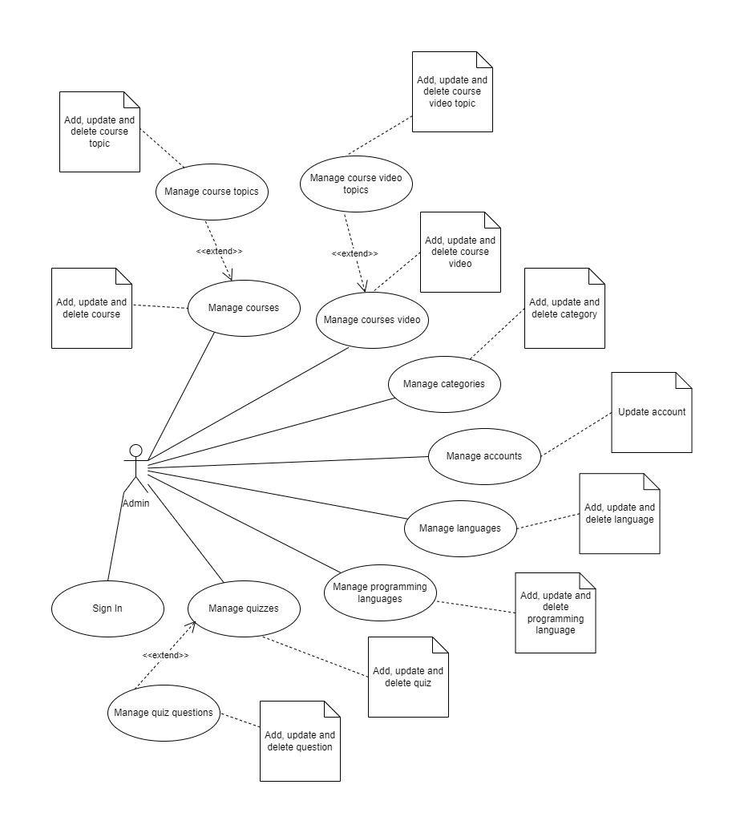

Figure 2. Admin use case diagram

“Admin” who has full rights on the system and interacts directly with the database. “Admin” can login and manage uploaded posts from users, they can watch a list of uploaded posts from “Member”, preview and decide to make it public or not.

#### User

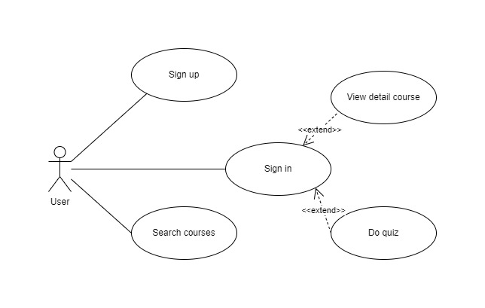

Figure 3. User use case diagram

After signing up, users will become “Member”, they can not only use functions of “Guest” users but also advanced functions: view detail course and do quiz

### Detail Use Cases

#### Account management

|  |  |
| --- | --- |
| **Id** | UC_01 |
| **Use case name** | Account management |
| **Description** | Provide account management functionalities to admin |
| **Actor** | Admin |
| **Condition** | Has login with admin role |
| **Activation** | Click on “Account” tab in admin panel |
| **Processing** | 1. Show list of users and the actions correspond to each user account 2. Click on the action correspond to the account to edit or delete account |

#### Update account

|  |  |
| --- | --- |
| **Id** | UC_02 |
| **Use case name** | Update account |
| **Description** | Provide account update functionalities to admin |
| **Actor** | Admin |
| **Condition** | Has login with admin role |
| **Activation** | Click on “Edit” or “Delete” button in accounts list |
| **Processing** | 1. When click on “Edit” button: 2. Redirect to the edit account page 3. Display the form to update account with old value has been set by default 4. Click on “Save” button to update account. If success update account, show the success notification, otherwise show error notification along with error messages 5. When click on “Delete” button: 6. Display the confirm dialog for user confirm. 7. Click on “Ok” button to delete course. If success update course, show the success notification, otherwise show error notification along with error messages |

#### Course management

|  |  |
| --- | --- |
| **Id** | UC_03 |
| **Use case name** | Courses management |
| **Description** | Provide courses management functionalities to admin. Including add, edit or delete course |
| **Actor** | Admin |
| **Condition** | Has login with admin role |
| **Activation** | Click on “Courses” tab in admin panel |
| **Processing** | 1. Show list of courses and the actions correspond to each course. In addition, provide “New” button to add new course 2. Click on the “New” button to open the tab for input course info to insert into database 3. Click on the action correspond to the course to edit or delete course |

#### Update course

|  |  |
| --- | --- |
| **Id** | UC_04 |
| **Use case name** | Update course |
| **Description** | Provide options to add, edit or delete course |
| **Actor** | Admin |
| **Condition** | Has login with admin role |
| **Activation** | Click on “New”, “Edit” or “Delete” button in courses list |
| **Processing** | 1. When click on “New” button: 2. Show form to input info of the course 3. Click on “Save” button to save course. If success add course, show the success notification, otherwise show error notification along with error messages 4. When click on “Edit” button: 5. Redirect to the edit course page 6. Display the form to update course with old value has been set by default 7. Click on “Save” button to update course. If success update course, show the success notification, otherwise show error notification along with error messages 8. When click on “Delete” button: 9. Display the confirm dialog for user confirm. 10. Click on “Ok” button to delete course. If success update course, show the success notification, otherwise show error notification along with error messages |

#### Course video management

|  |  |
| --- | --- |
| **Id** | UC_05 |
| **Use case name** | Courses video management |
| **Description** | Provide course videos management functionalities to admin. Including add, edit or delete course video |
| **Actor** | Admin |
| **Condition** | Has login with admin role |
| **Activation** | Click on “Course Videos” tab in admin panel |
| **Processing** | 1. Show list of course and the actions correspond to each course. In addition, provide “New” button to add new course 2. Click on the “New” button to open the tab for input course info to insert into database 3. Click on the action correspond to the course video to edit or delete course video |

#### Update course video

|  |  |
| --- | --- |
| **Id** | UC_06 |
| **Use case name** | Update course video |
| **Description** | Provide options to add, edit or delete course video |
| **Actor** | Admin |
| **Condition** | Has login with admin role |
| **Activation** | Click on “New”, “Edit” or “Delete” button in course video list |
| **Processing** | 1. When click on “New” button: 2. Show form to input info of the course video 3. Click on “Save” button to save course. If success add course, show the success notification, otherwise show error notification along with error messages 4. When click on “Edit” button: 5. Redirect to the edit course video page 6. Display the form to update course video with old value has been set by default 7. Click on “Save” button to update course. If success update course, show the success notification, otherwise show error notification along with error messages 8. When click on “Delete” button: 9. Display the confirm dialog for user confirm. 10. Click on “Ok” button to delete course. If success update course video, show the success notification, otherwise show error notification along with error messages |

#### Quiz management

|  |  |
| --- | --- |
| **Id** | UC_07 |
| **Use case name** | Quizzes management |
| **Description** | Provide quizzes management functionalities to admin. Including add, edit or delete quiz |
| **Actor** | Admin |
| **Condition** | Has login with admin role |
| **Activation** | Click on “Quizzes” tab in admin panel |
| **Processing** | 1. Show list of quizzes and the actions correspond to each quiz. In addition, provide “New” button to add new quiz 2. Click on the “New” button to open the tab for input quiz info to insert into database 3. Click on the action correspond to the quiz to edit or delete quiz |

#### Update quiz

|  |  |
| --- | --- |
| **Id** | UC_08 |
| **Use case name** | Update quiz |
| **Description** | Provide options to add, edit or delete quiz |
| **Actor** | Admin |
| **Condition** | Has login with admin role |
| **Activation** | Click on “New”, “Edit” or “Delete” button in quizzes list |
| **Processing** | 1. When click on “New” button: 2. Show form to input info of the quiz. 3. Click on “Save” button to save quiz. If success add quiz, show the success notification, otherwise show error notification along with error messages 4. When click on “Edit” button: 5. Redirect to the edit quiz page 6. Display the form to edit quiz with old value has been set by default 7. Click on “Save” button to save quiz. If success update course, show the success notification, otherwise show error notification along with error messages 8. When click on “Delete” button: 9. Display the confirm dialog for user confirm. 10. Click on “Ok” button to delete quiz. If success update course, show the success notification, otherwise show error notification along with error messages |

#### Course categories management

|  |  |
| --- | --- |
| **Id** | UC_09 |
| **Use case name** | Course categories management |
| **Description** | Provide course categories management functionalities to admin. Including add, edit or delete course category |
| **Actor** | Admin |
| **Condition** | Has login with admin role |
| **Activation** | Click on “Categories” tab in admin panel |
| **Processing** | 1. Show list of categories and the actions correspond to each category. In addition, provide “New” button to add new category 2. Click on the “New” button to open the tab for input category info to insert into database 3. Click on the action correspond to the category to edit or delete category |

#### Update categories

|  |  |
| --- | --- |
| **Id** | UC_10 |
| **Use case name** | Update category |
| **Description** | Provide options to add, edit or delete category |
| **Actor** | Admin |
| **Condition** | Has login with admin role |
| **Activation** | Click on “New”, “Edit” or “Delete” button in categories list |
| **Processing** | 1. When click on “New” button: 2. Show form to input info of the category. 3. Click on “Save” button to save category. If success add category, show the success notification, otherwise show error notification along with error messages 4. When click on “Edit” button: 5. Redirect to the edit category page 6. Display the form to update category with old value has been set by default 7. Click on “Save” button to save category. If success update category, show the success notification, otherwise show error notification along with error messages 8. When click on “Delete” button: 9. Display the confirm dialog for user confirm. 10. Click on “Ok” button to delete category. If success delete category, show the success notification, otherwise show error notification along with error messages |

#### Language management

|  |  |
| --- | --- |
| **Id** | UC_11 |
| **Use case name** | Languages management |
| **Description** | Provide languages management functionalities to admin. Including add, edit or delete language |
| **Actor** | Admin |
| **Condition** | Has login with admin role |
| **Activation** | Click on “Languages” tab in admin panel |
| **Processing** | 1. Show list of languages and the actions correspond to each language. In addition, provide “New” button to add new language 2. Click on the “New” button to open the tab for input language info to insert into database 3. Click on the action correspond to the language to edit or delete language |

#### Update languages

|  |  |
| --- | --- |
| **Id** | UC_12 |
| **Use case name** | Update language |
| **Description** | Provide options to add, edit or delete language |
| **Actor** | Admin |
| **Condition** | Has login with admin role |
| **Activation** | Click on “New”, “Edit” or “Delete” button in languages list |
| **Processing** | 1. When click on “New” button: 2. Show form to input info of the language. 3. Click on “Save” button to save language. If success add language, show the success notification, otherwise show error notification along with error messages 4. When click on “Edit” button: 5. Redirect to the edit language page 6. Display the form to update language with old value has been set by default 7. Click on “Save” button to save language. If success update language, show the success notification, otherwise show error notification along with error messages 8. When click on “Delete” button: 9. Display the confirm dialog for user confirm. 10. Click on “Ok” button to delete language. If success delete language, show the success notification, otherwise show error notification along with error messages |

#### Programming languages management

|  |  |
| --- | --- |
| **Id** | UC_13 |
| **Use case name** | Programming languages management |
| **Description** | Provide programming languages management functionalities to admin. Including add, edit or delete programming language |
| **Actor** | Admin |
| **Condition** | Has login with admin role |
| **Activation** | Click on “Programming languages” tab in admin panel |
| **Processing** | 1. Show list of programming languages and the actions correspond to each one. In addition, provide “New” button to add new programming language 2. Click on the “New” button to open the tab for input programming language info to insert into database 3. Click on the action correspond to the programming language to edit or delete it |

#### Update programming languages

|  |  |
| --- | --- |
| **Id** | UC_14 |
| **Use case name** | Update programming language |
| **Description** | Provide options to add, edit or delete programming language |
| **Actor** | Admin |
| **Condition** | Has login with admin role |
| **Activation** | Click on “New”, “Edit” or “Delete” button in programming languages list |
| **Processing** | 1. When click on “New” button: 2. Show form to input info of the programming language. 3. Click on “Save” button to save programming language. If success add, show the success notification, otherwise show error notification along with error messages 4. When click on “Edit” button: 5. Redirect to the edit programming language page 6. Display the form to update programming language with old value has been set by default 7. Click on “Save” button to save. If success update, show the success notification, otherwise show error notification along with error messages 8. When click on “Delete” button: 9. Display the confirm dialog for user confirm. 10. Click on “Ok” button to delete. If success delete, show the success notification, otherwise show error notification along with error messages |

#### Search courses

|  |  |
| --- | --- |
| **Id** | UC_15 |
| **Use case name** | Search courses |
| **Description** | Provide courses searching functionality |
| **Actor** | User |
| **Condition** | No need to login |
| **Activation** | Click on “Search” input in navigation bar |
| **Processing** | 1. Input the keyword in search input bar. 2. Press enter or click on the search icon 3. Show all the courses match the keyword that user has inputted |

#### Do quiz

|  |  |
| --- | --- |
| **Id** | UC_16 |
| **Use case name** | Choose and do quiz |
| **Description** | Provide feature to allow to choose and do the quiz |
| **Actor** | All |
| **Condition** | No condition needed |
| **Activation** | Click on “Quiz” section in main page |
| **Processing** | 1. User choose the course that they want to do the quiz 2. User choose the quiz belongs to the course they have selected 3. Choose “Start quiz” button 4. List of all the questions of the quiz will be shown to allow user to do the quiz 5. User choose “Submit” button after complete the quiz or the system will automatically submit the form when timeout 6. User will be redirected to the quiz result page to allow user to see the result |

## Main Functions

## Detail Of Functions in The System

### Authenticate

#### Sign Up Function

When users sign up, they have to enter their email address, username and password. If there are some errors in the signing up process, the system will show notifications. Otherwise, show success notification to user.

#### Sign In Function

Users sign in with signed up email and password, the system will authenticate, its email and password are both valid and, in the database, the system will direct users to the main page. Otherwise, the system will show an error message.

### Course Function

Course is a type of information that contains details of the course and is uploaded by admin. There are two types of Course in E-learning: Article course and Video p, article course will be represented by text as an article or a blog, video course will be uploaded with an video URL to represent the course content for the students. Course include title and description makes users have an overview about the results and requirements before they choose the course to learn. Course will be published after the admin previews the details to make sure it does not contain unclear information, after that, the admin will decide to approve or reject it.

Courses searching functionality

To search courses, users need to enter keywords in the input box, after that, pressing “Enter” and clicking search button. The system will compare with name and description in the database with the keywords. If it returns empty, the system will show a notification about no result found.

### Quiz

Quiz is a function that allows users to test what they have learned from the course to help students identify which they have forgotten and what they need to pay more attention. After users finish the quiz, the results will show for the student how many correct answers, wrong answers that they have completed. Users can do quiz through the quizzes page and choose the quiz of specific topic to test.

The quiz question can have many correct options or none, and the student need to choose all correct option for that question to be corrected. There is a timeout for the quiz that the student needs to finish the quiz before its timeout or the system will automatically submit it for the student.

### Admin management

Admin management is a feature that allow admin to manage and add more contents (such as course, video course or quiz) to website. Admin will have all the permission to add, update or delete any content in the website including modify user account. Admin can also manage (add, update or delete) category, language or programming language of the courses used in website.

### User Interface

#### Navigation bar



Figure 4. Navigation bar before signed in

Search bar, sign in button and sign-up button will be displayed on the navigation bar before signing in.



Figure 5. Navigation bar after signed in

After signed in, users will see the logout button.

#### Main page

Main page will be shown when users access the application. The navigation bar shows: name and logo of the application, search bar, sign in and sign up. Under the navigation bar, there are two big buttons that show two main functions of E-learning - uploading posts. The button with title “I need accommodation” is for users who need accommodation and they will upload posts to show their need with the others. The button with title “Share/Rent accommodation” is for users who want to share or rent accommodation, they will upload posts and show the details of their property to attract users.

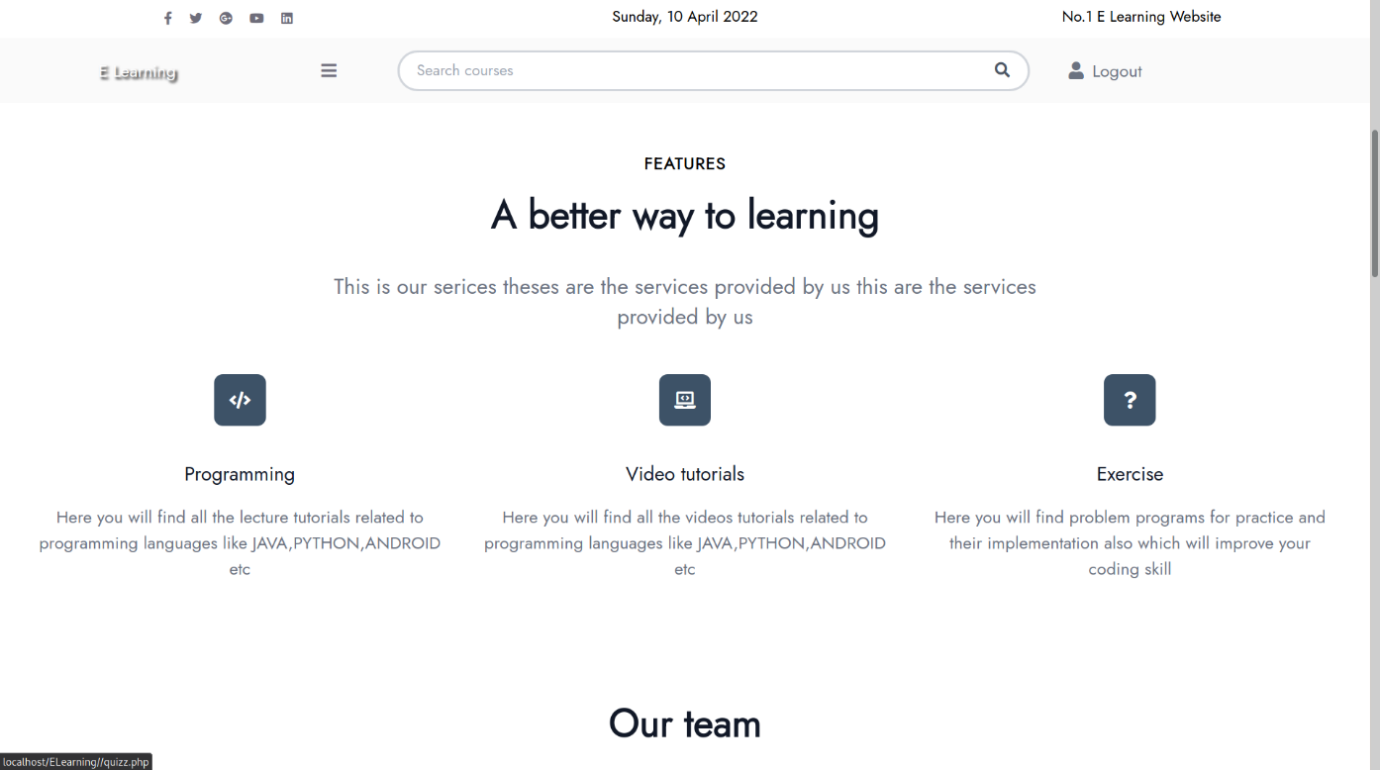

Figure 6. Main page

#### Sign in page

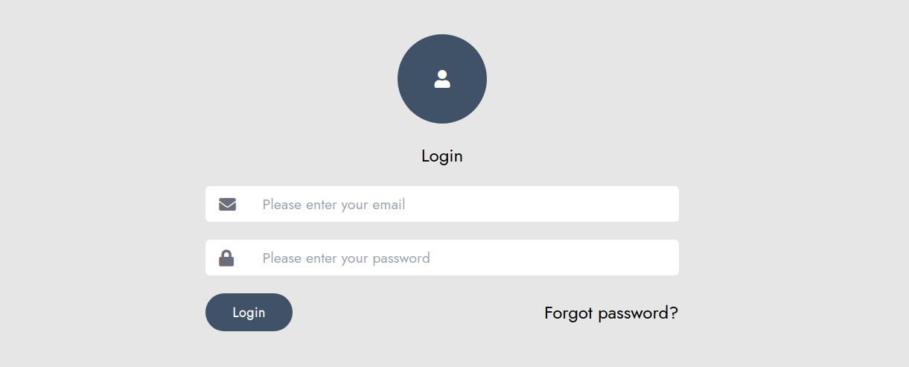

Figure 7. Login form in login page

Users can sign in with their email and password that they signed up before, if email or password is invalid, the system will show the error. Otherwise, the notification will show successful login for the user.

#### Sign up page

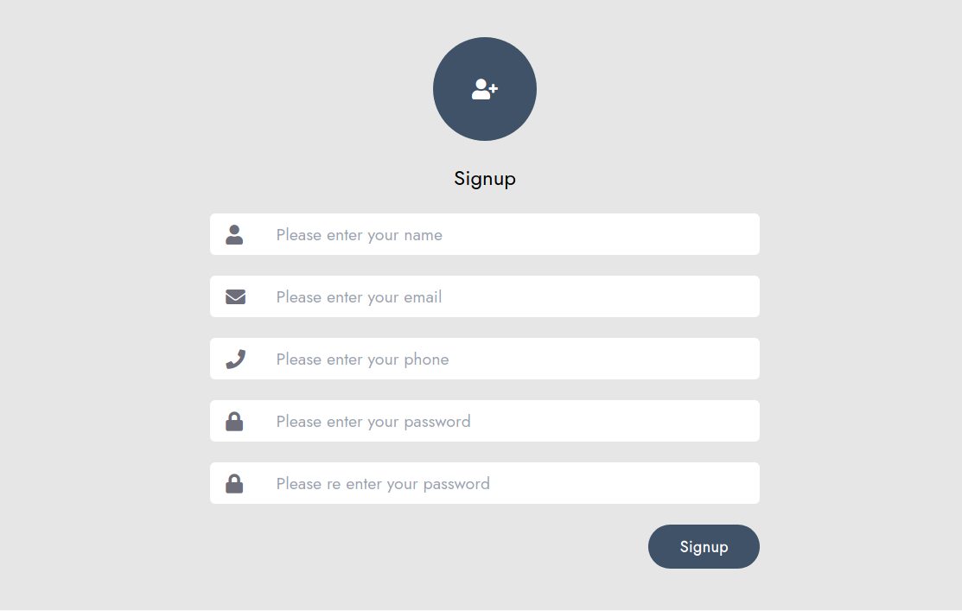

Figure 8. Sign up form in sign up page

To become a “Member”, users have to sign up with email, username and password. Email of the user must be unique for identification, if users enter duplicated email and the error message will be shown.

#### Courses page

In the courses page, users will see most popular courses article to select to learn. Besides, users can also see the top categories of course to filter courses by category.

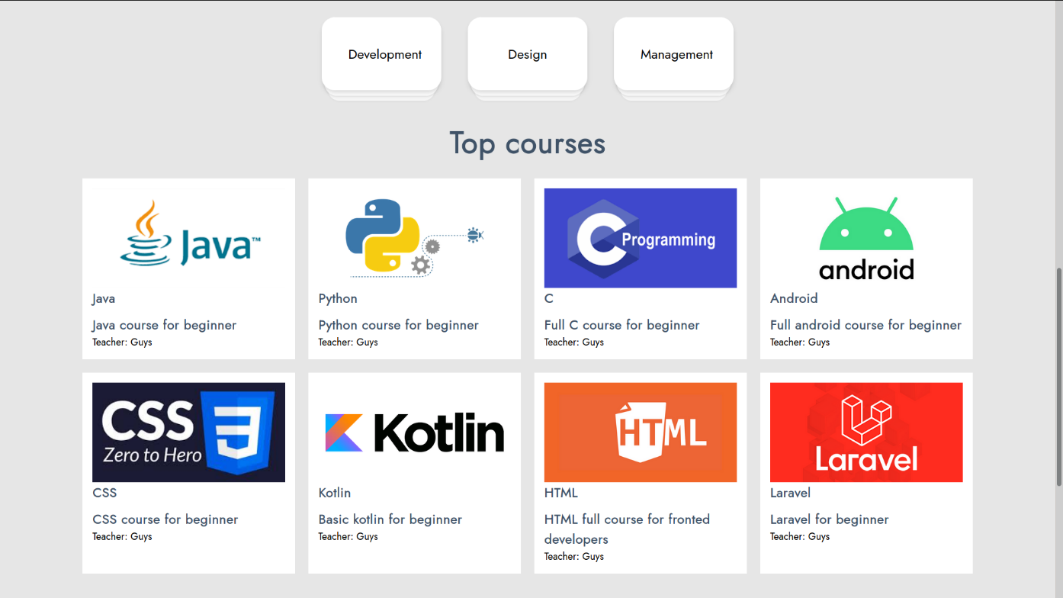

Figure 9. List of courses and categories in courses page

#### Courses video page

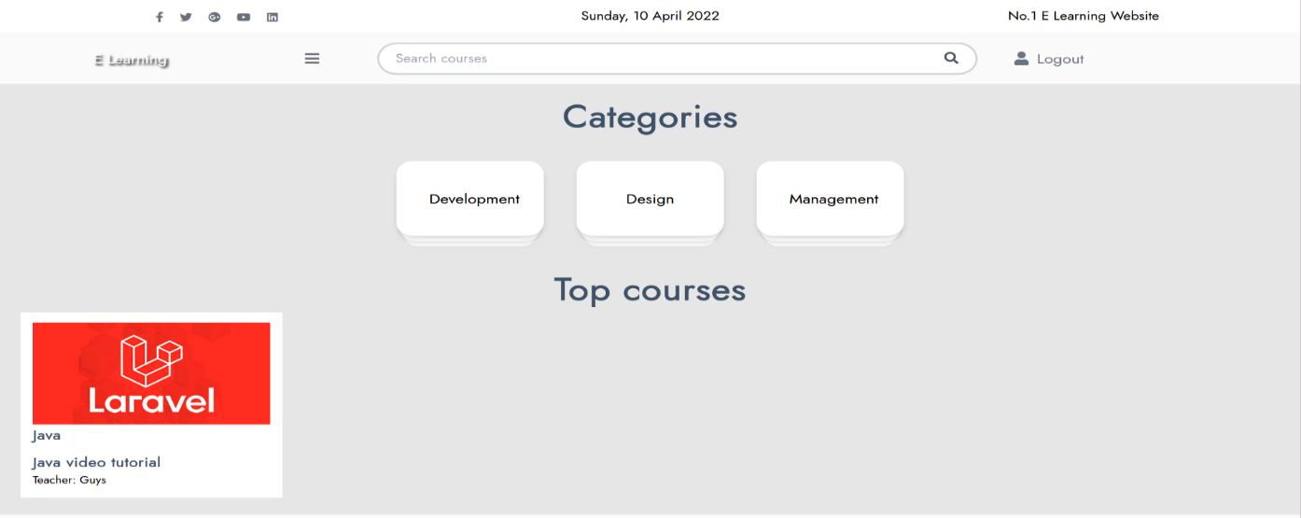

Figure 10. List of courses video and categories in courses video page

In the courses video page, users will see most popular courses video to select to learn. Besides, users can also see the top categories of course to filter courses by category.

#### Course category page

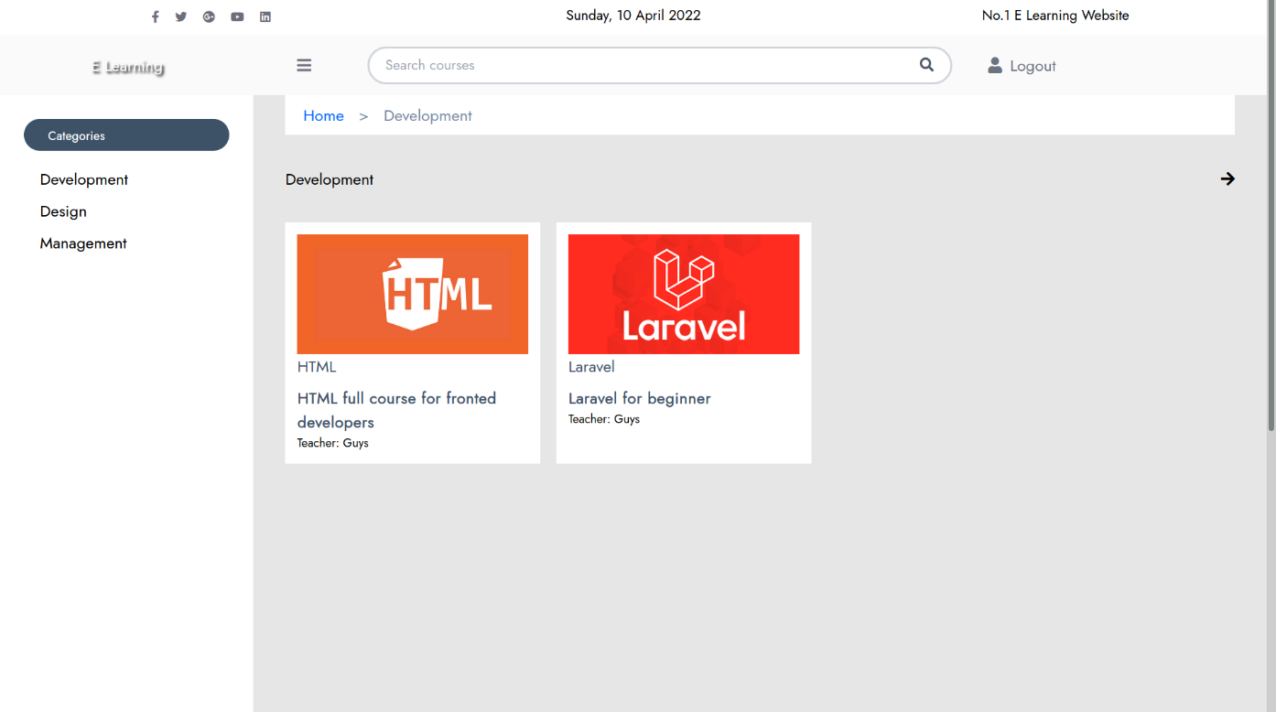

Figure 11. Courses category page

In the courses category page, users will see all the courses belong to a specific category.

#### Course article detail page

User can view the content of the course in this page as an article. Along with the content, user can see the related lesson in side bar of the page to navigate to the lesson they interested in. At the end of the lesson, user can click to the next lesson to learn for the next lesson.

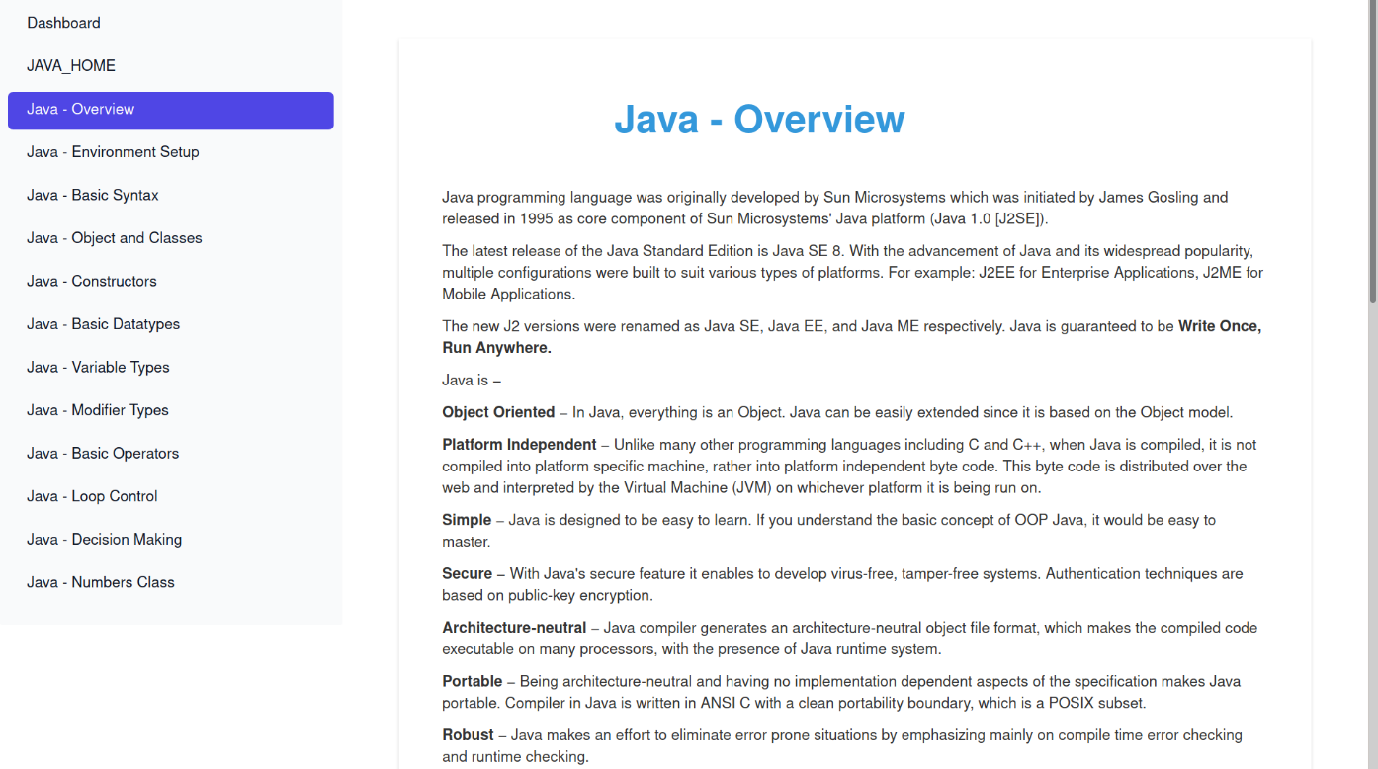

Figure 12. Course detail page

#### Course video detail page

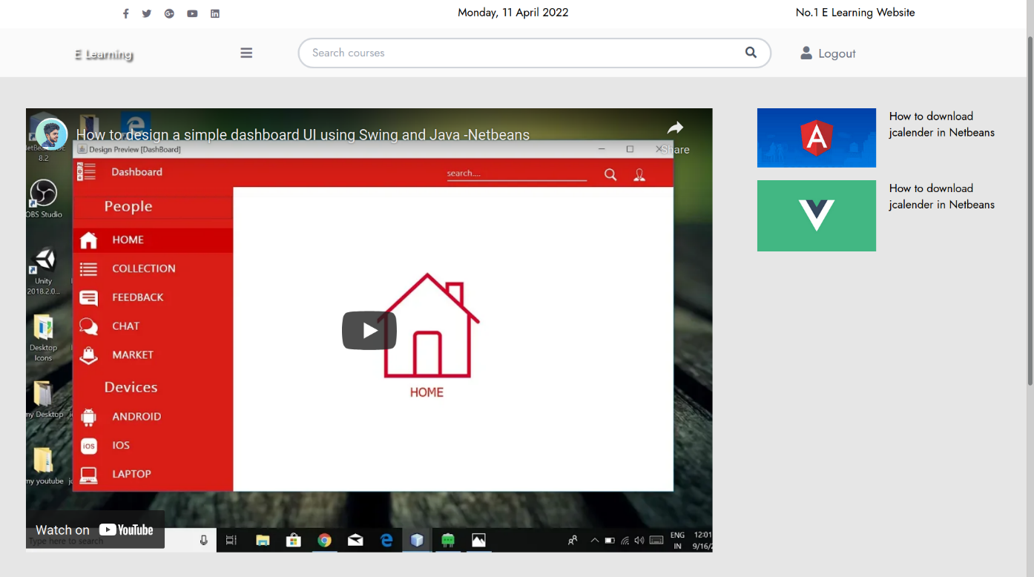

Figure 13. Course video detail

User can view the content of the course video in this as video. There are also related course video in side bar of the page to allow user navigate to the lesson they interested in. User can also click on the next button to view the next lesson video.

#### Quiz page

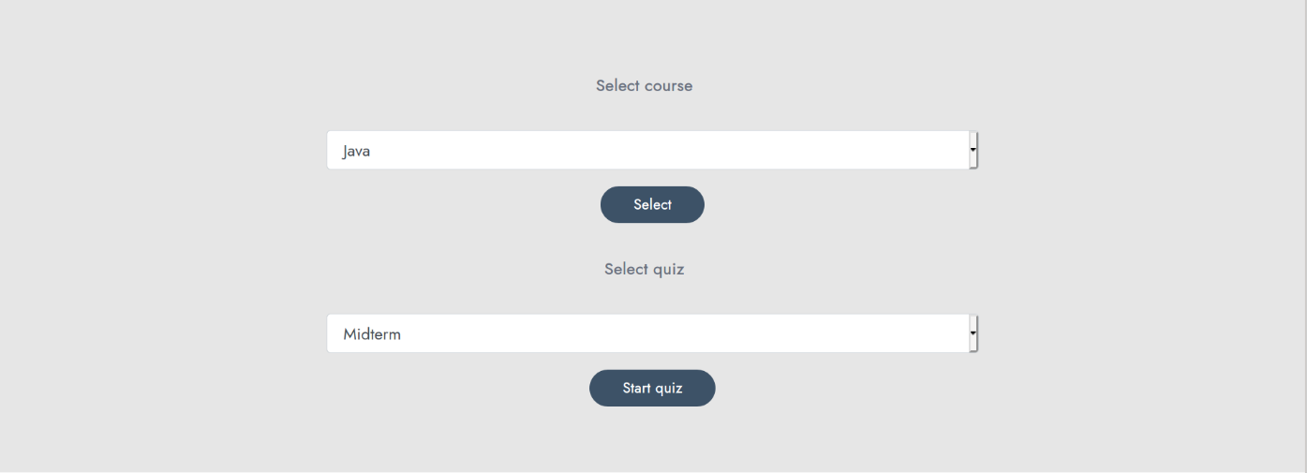

Figure 14. Quiz page

In the quiz page, users can select what course they want to do the quiz, after select course the quizzes option will show for users to select what quiz they can practice. After select quiz and submit, user will be redirect to the detail quiz page, where users can do the quiz and view the result after finish.

#### Quiz detail page

The quiz detail page will show the quiz for user to do. After choose answers for the questions, the user can click the submit button to finish the quiz, or wait for the timeout automatically submit.

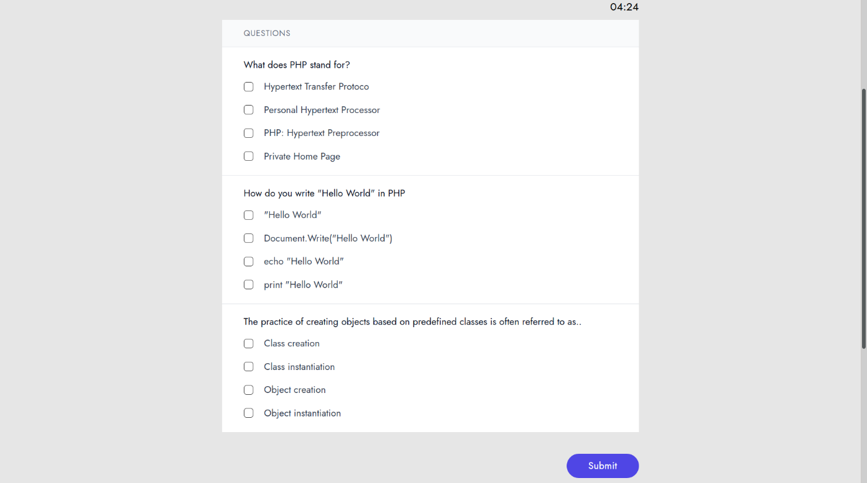

Figure 15. Quiz detail page

#### Quiz result page

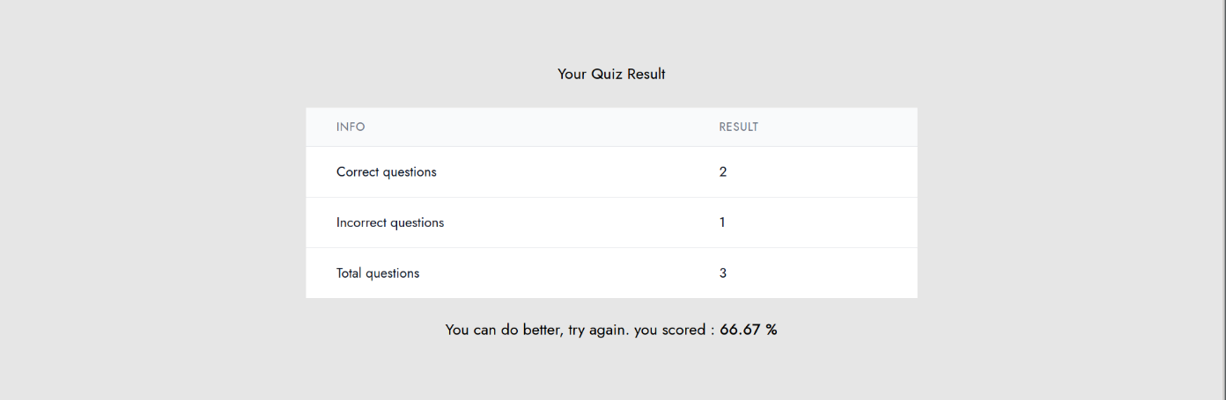

Figure 16. Quiz result page

After submit the quiz, the user will redirect to the quiz result page where the result of the quiz will be show for the user.

#### Search courses

Search course input will be shown in the header of the website to help users quickly search for the courses they want to learn. After input the keyword and click search users will be redirect to search results page where the courses match with the keyword will be displayed.

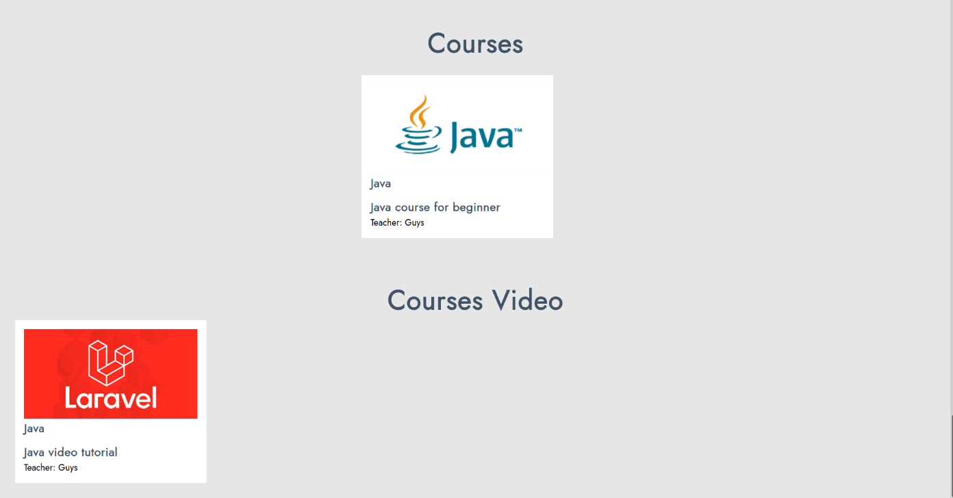

Figure 17. Search courses result page

#### Categories management page

The categories management page is where admin can manage the categories of the courses in E-learning website. The page will show the list of all categories available with the respect action for admin to update category (edit, delete). In addition, the admin can also add new category by tap on the add category section, then input the name of category and click submit button.

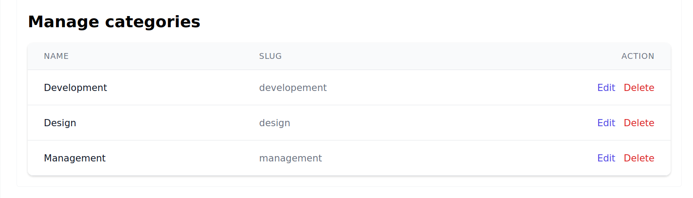Figure 18. Categories management page

When the admin clicks on the edit category, the admin will be redirected to the edit category page to edit the category. The admin can edit the name of category by input the new name and then click submit button to update the category.

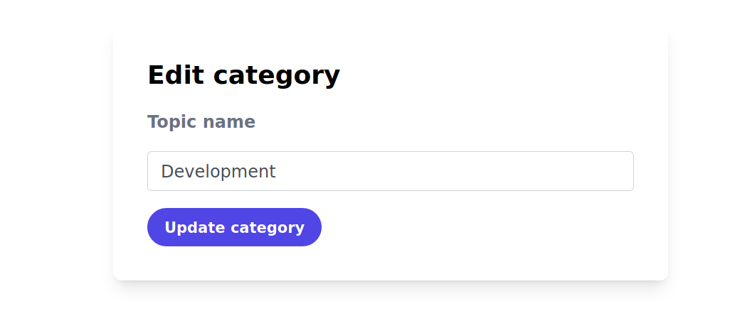

Figure 19. Edit category form

#### Accounts management page

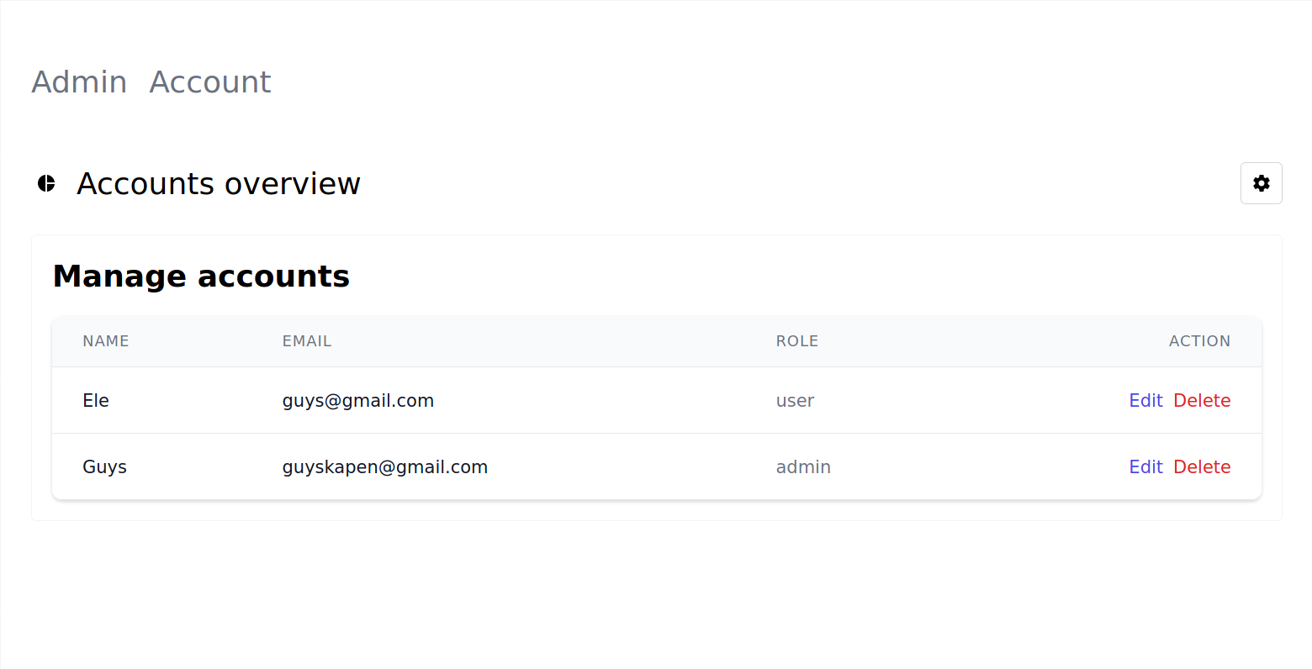

Figure 20. Accounts management page

The accounts management page is where admin can manage the account of the users in E-learning website. The page will show the list of all accounts available with the respect action for admin to update account (edit, delete).

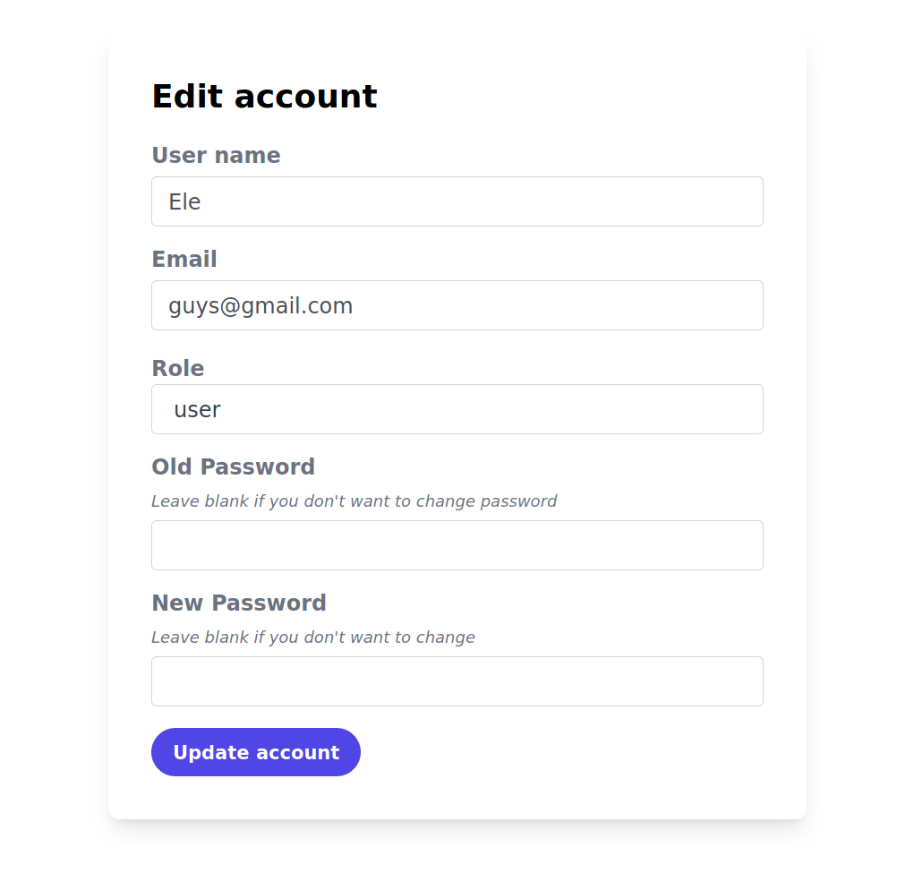

Figure 21. Edit account form

When the admin clicks on the edit account, the admin will be redirected to the edit account page to edit the account. The admin can edit the username, email, role, or password of account then click submit button to update the account.

#### Languages management page

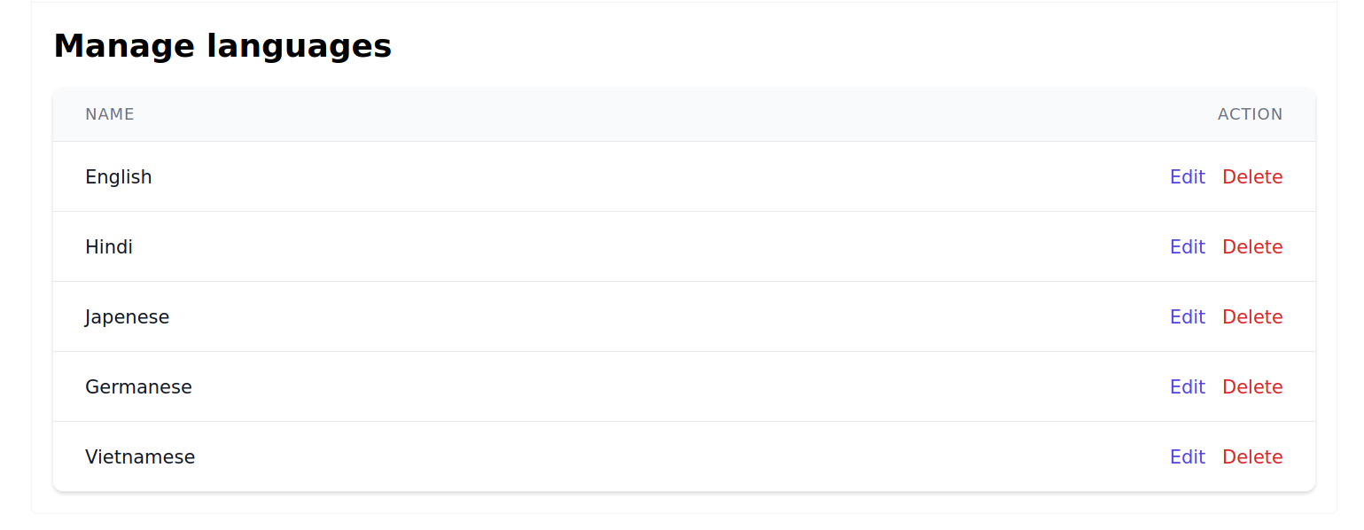

Figure 22. Languages management page

The languages management page is where admin can manage the languages of the courses in E-learning website. The page will show the list of all languages available with the respect action for admin to update (edit, delete).

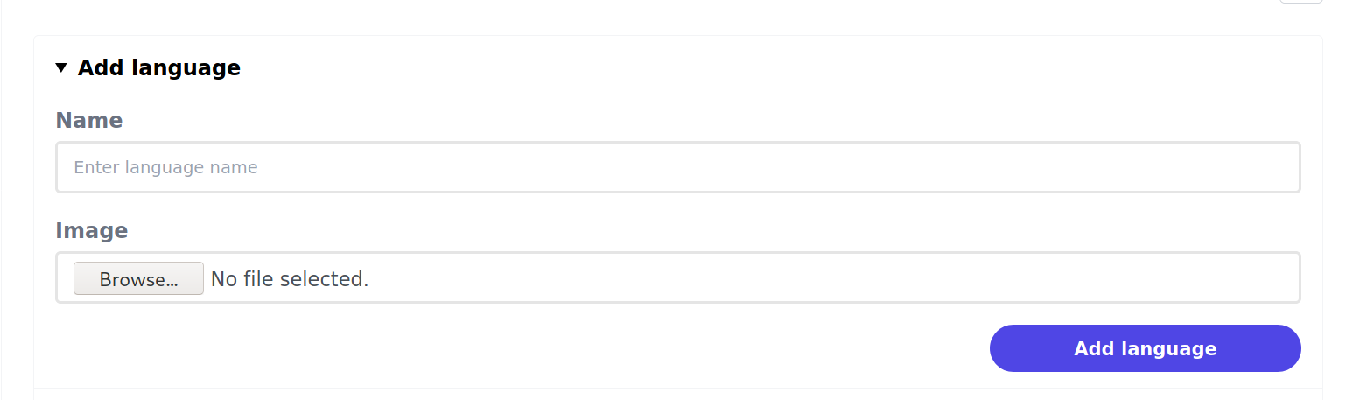

Figure 23. Add language form

In addition, the admin can also add new language by tap on the add language section, then input the name of language and click submit button.

When the admin clicks on the edit language, the admin will be redirected to the edit language page to edit the language. The admin can edit the name of language by input the new name and then click submit button to update the language.

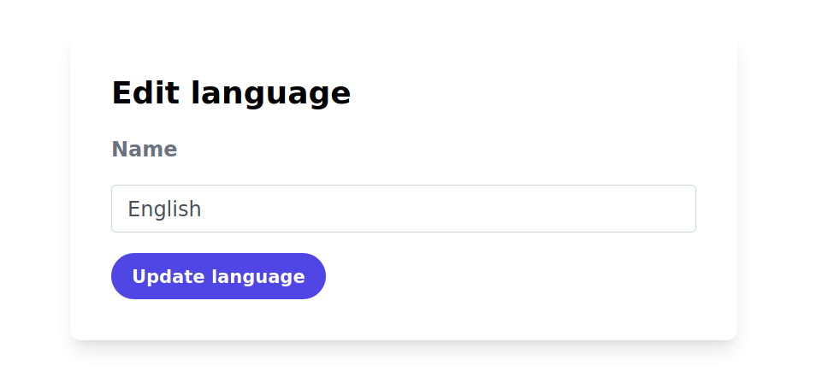

Figure 24. Edit language form

#### Programming languages management page

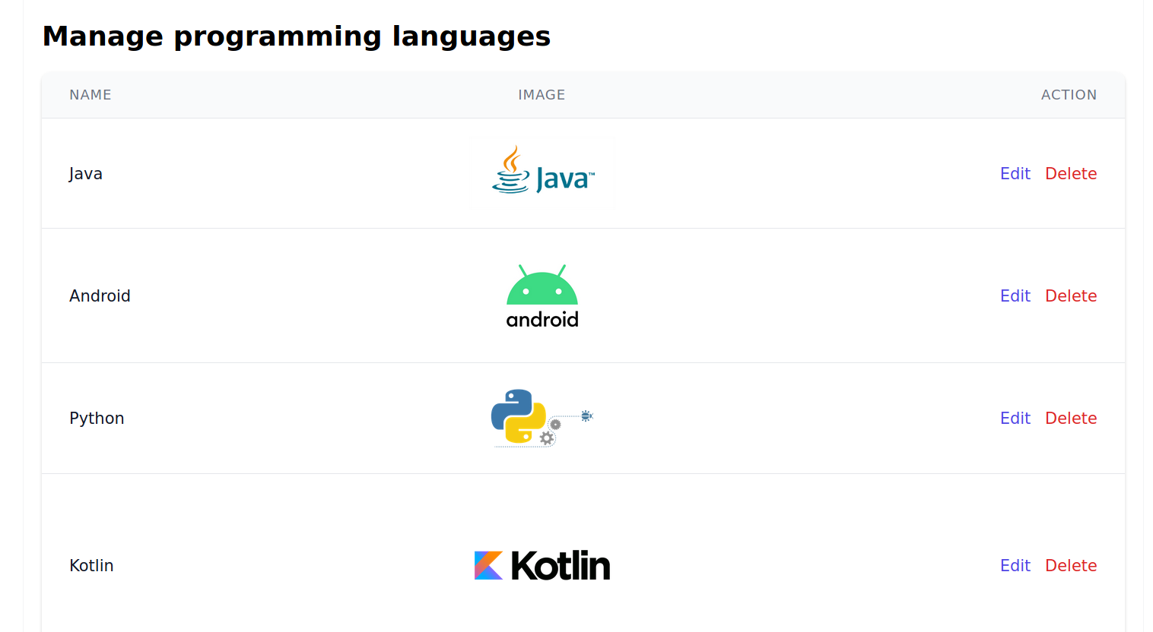

Figure 25. Programming languages management

The programming languages management page is where admin can manage the programming languages of the courses in E-learning website. The page will show the list of all programming languages available with the respect action for admin to update (edit, delete).



Figure 26. Add programming language form

In addition, the admin can also add new language by tap on the add language section, then input the name of language and click submit button.

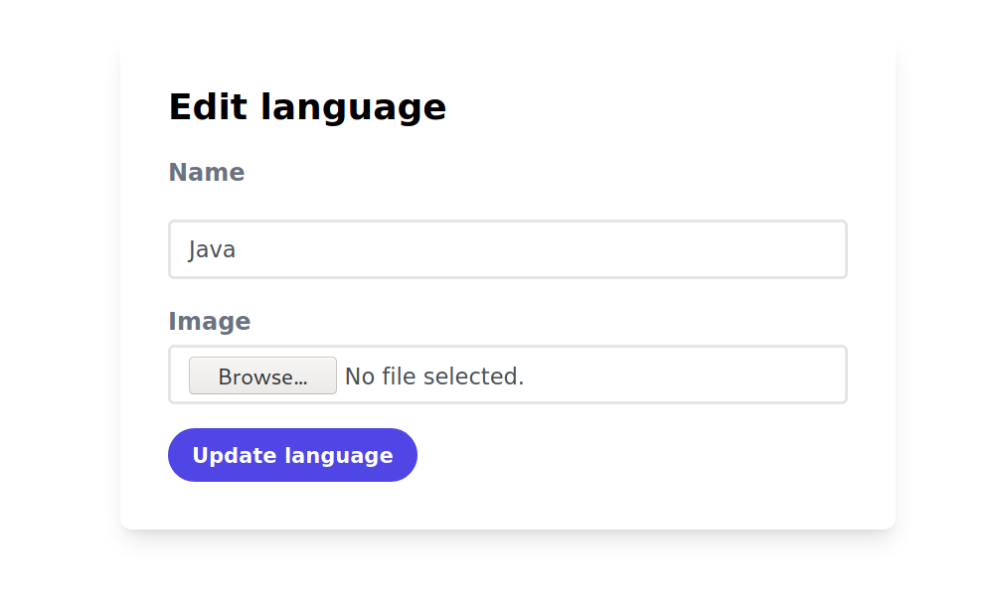

Figure 27. Edit programming language form

When the admin clicks on the edit programming language, the admin will be redirected to the edit programming language page to edit the programming language. The admin can edit the name of language by input the new name and optionally change the image, then click submit button to update the language.

#### Course article management page

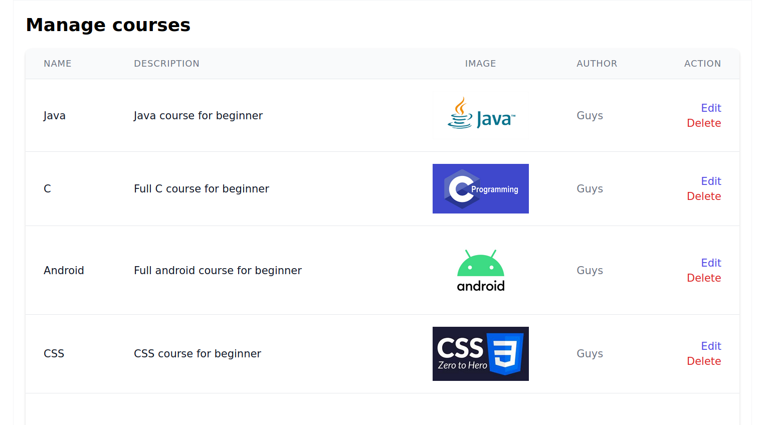

Figure 28. Courses management page

Course article management page will display the list of courses for admin to edit or delete. Moreover, when accessing this page, admin can also add, update or delete courses.

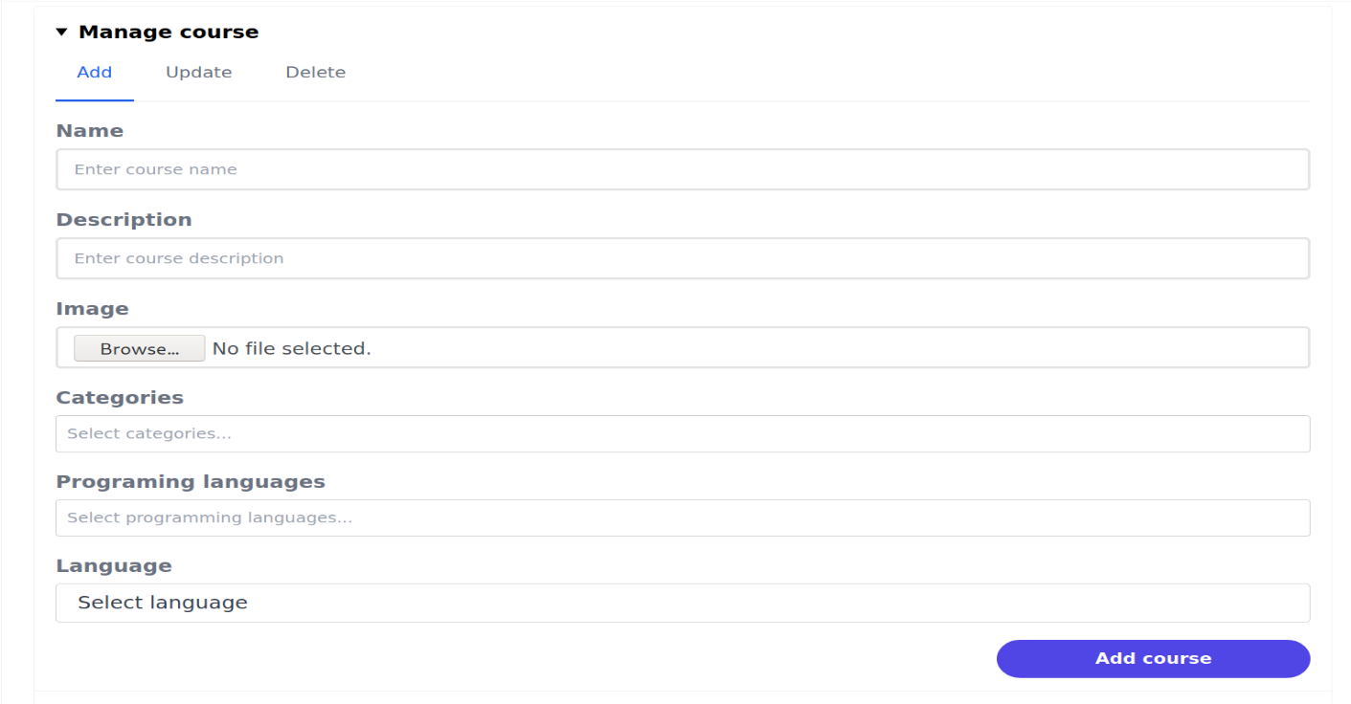

Figure 29. Add course form

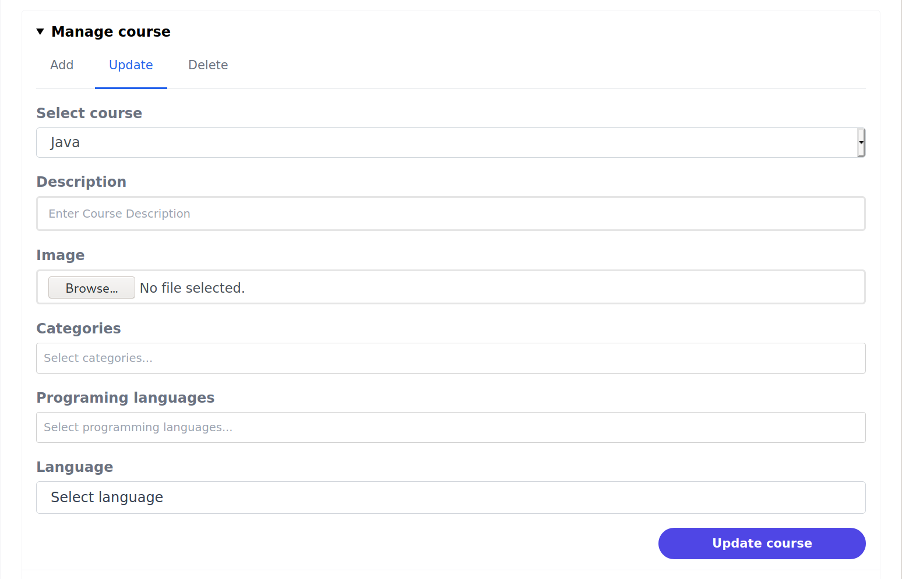

Figure 30. Update course form

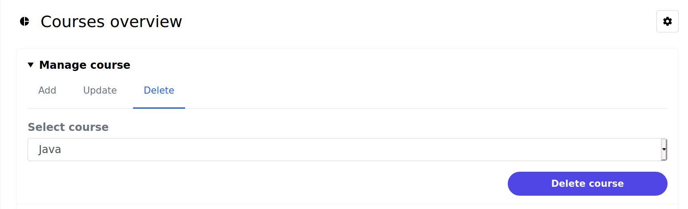

Figure 31. Course delete form

When the admin clicks on the edit course, the admin will be redirected to the edit course page to edit the course as well as the course topics. Besides, the page will also display all the course topics for admin to update (edit, or delete).

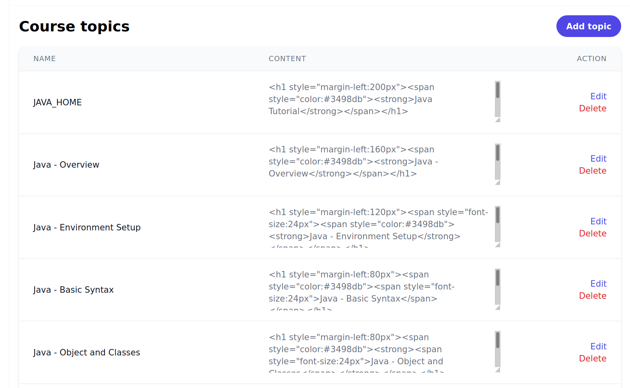

Figure 32. Course topics management

The admin can also click on the add topic button to add more topic to the course. When the admin clicks on “add topic” button, admin will be redirected to add topic page to add topic to the course.

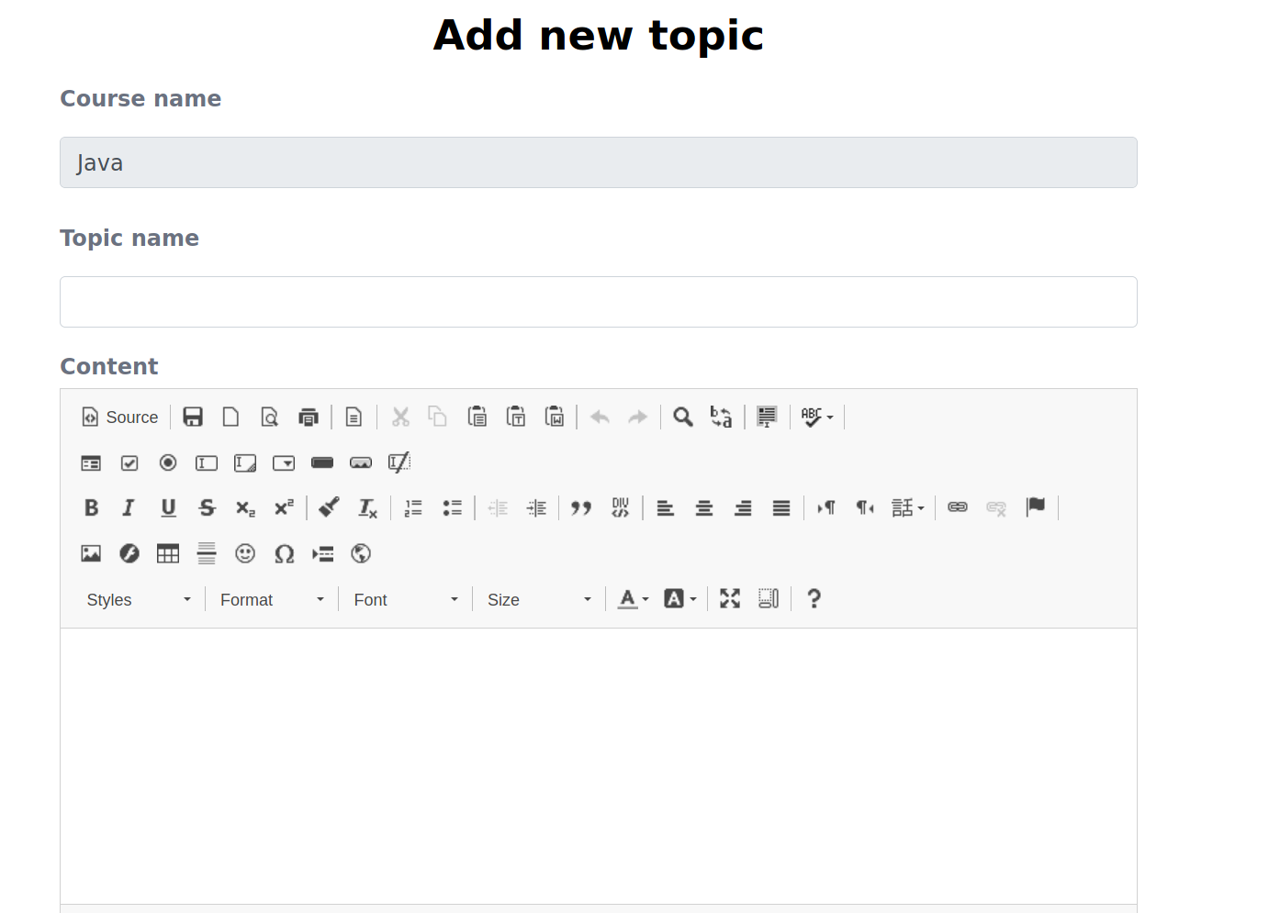

Figure 33. Add new topic form

When admin click on the edit button, the edit topic will be shown for admin to update the topic.

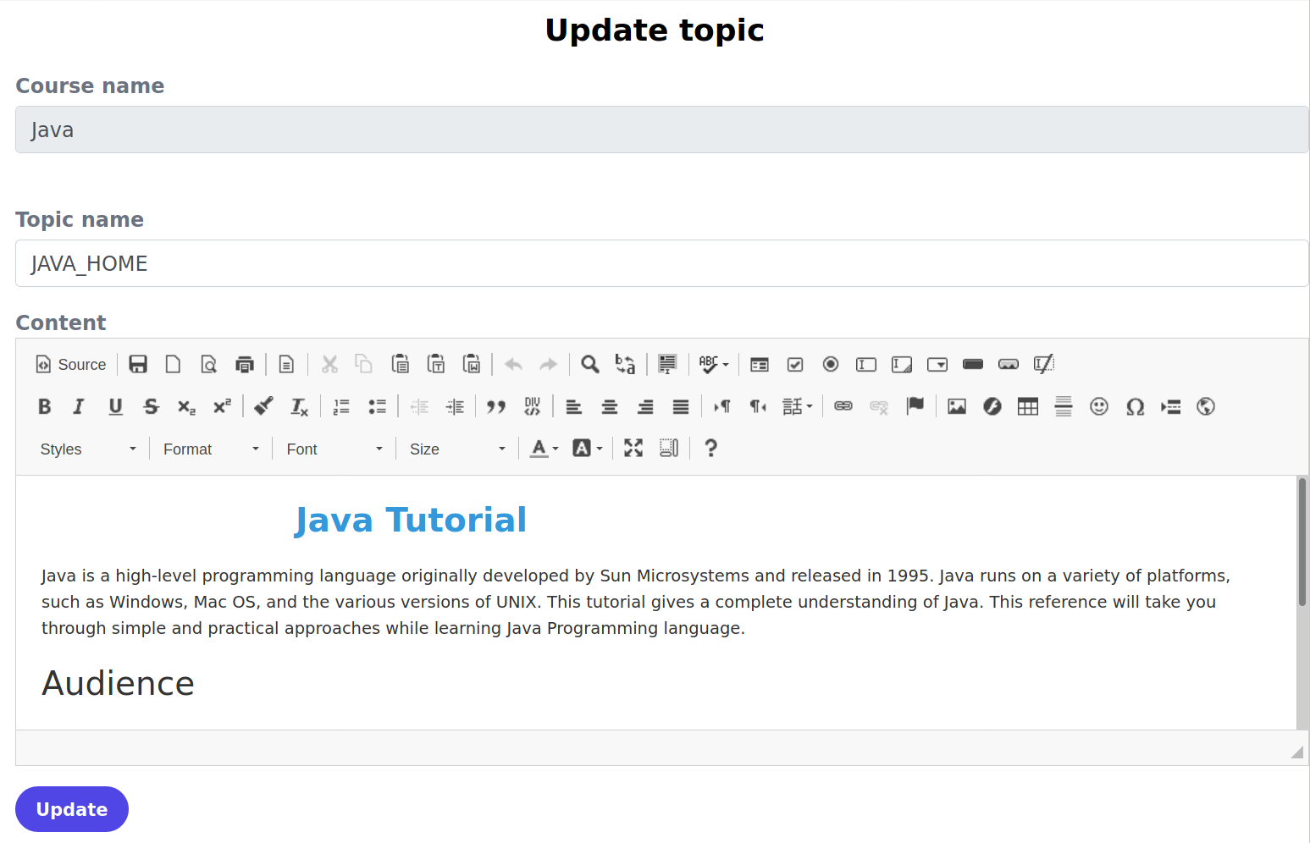

Figure 34. Update topic form

#### Course video management page

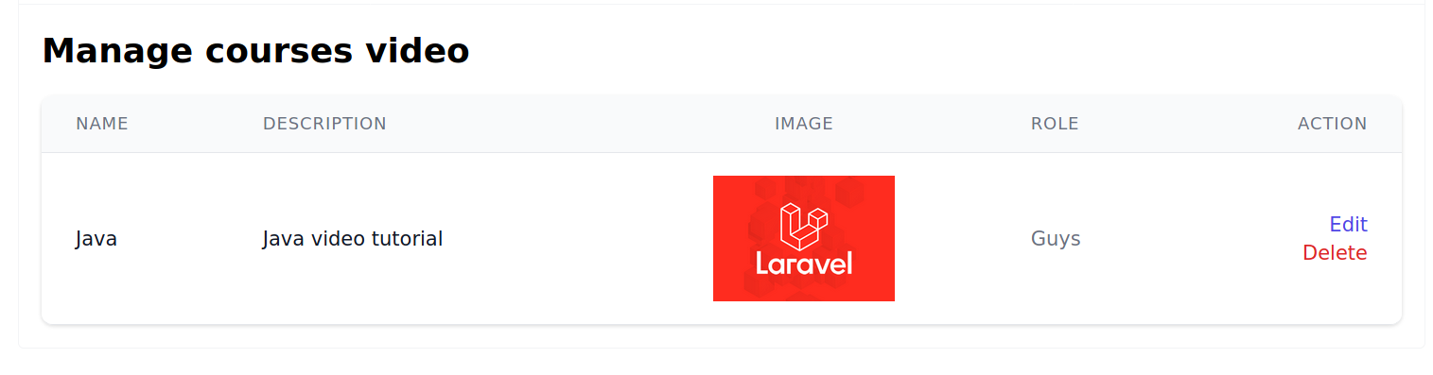

Figure 35. Courses video management page

Course video management page will display the list of courses for admin to edit or delete. Besides, the page will show the option to allow admin to add new video course.

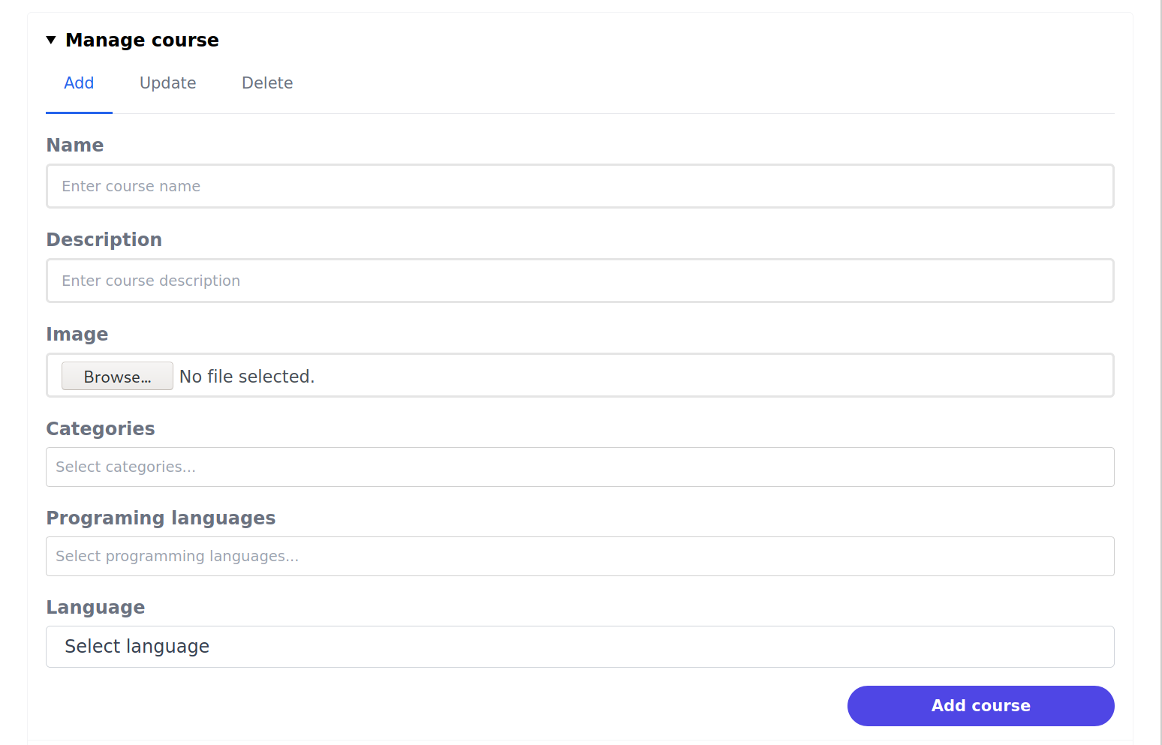

Figure 36. Add course video form



Figure 37. Course video update form



Figure 38. Course video delete form

When the admin clicks on the edit course, the admin will be redirected to the edit course page to edit the course. Besides, the page will also display all the course topics for admin to update (edit, or delete).

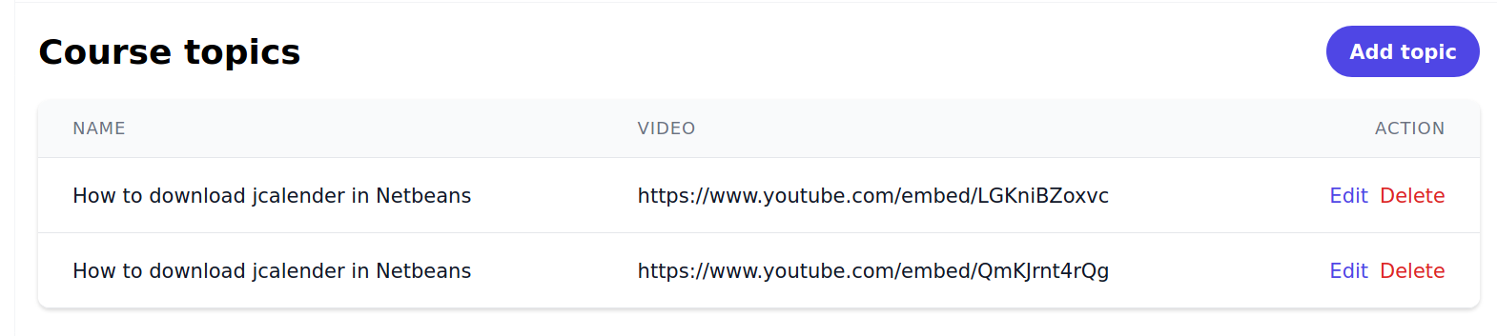

Figure 39. Course video topics management

The admin can also click on the add topic button to add more topic to the course. When the admin clicks on “add topic” button, admin will be redirected to add topic page to add topic to the course.

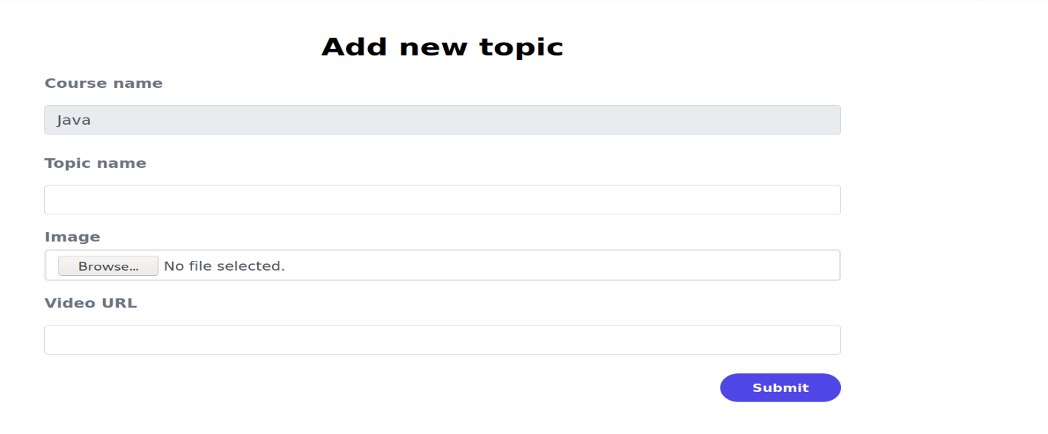

Figure 40. Add new course video topic form

When admin click on the edit button, the edit topic will be shown for admin to update the topic.

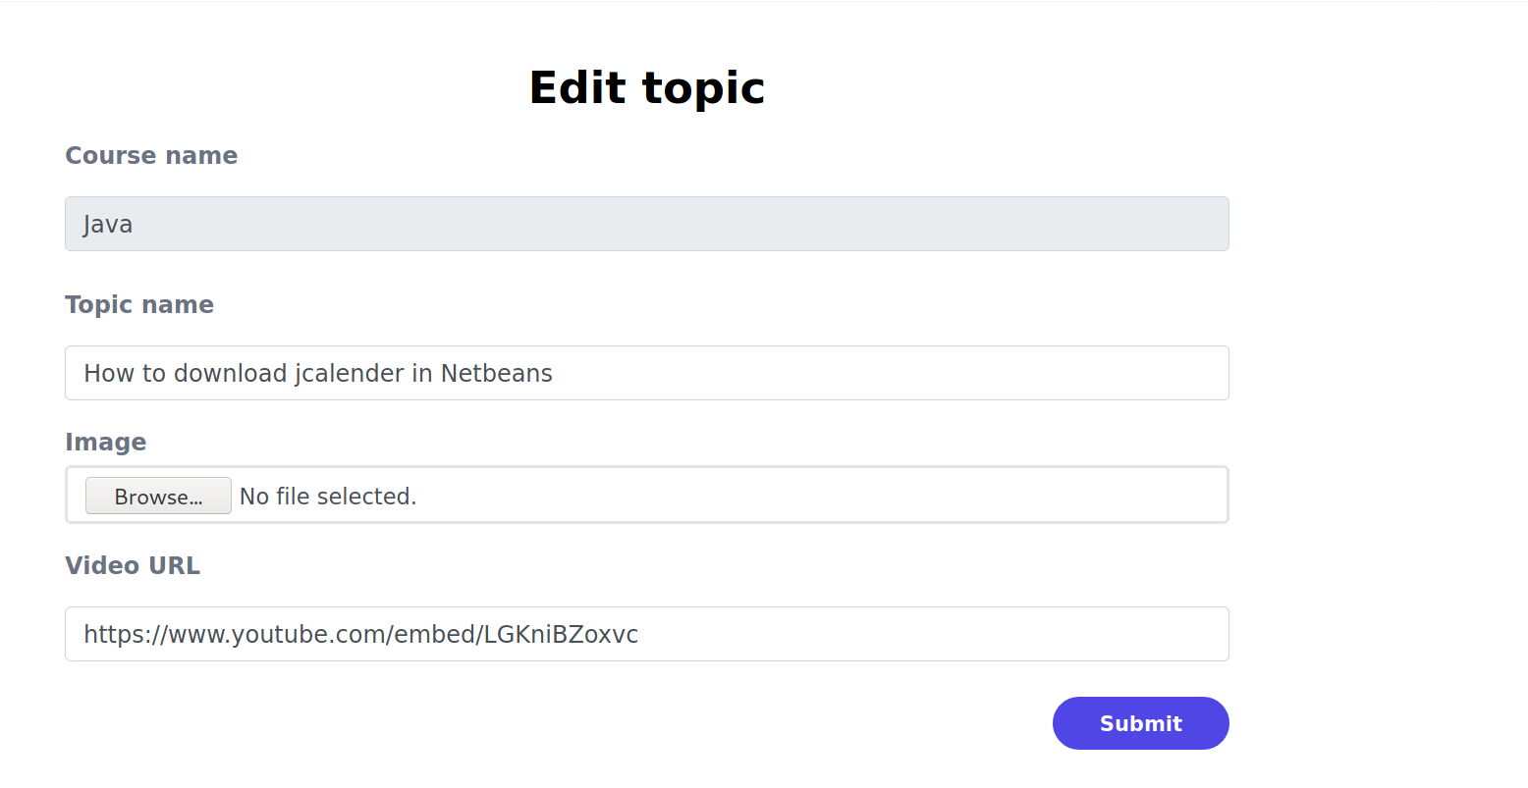

Figure 41. Edit course video topic form

#### Quiz management page

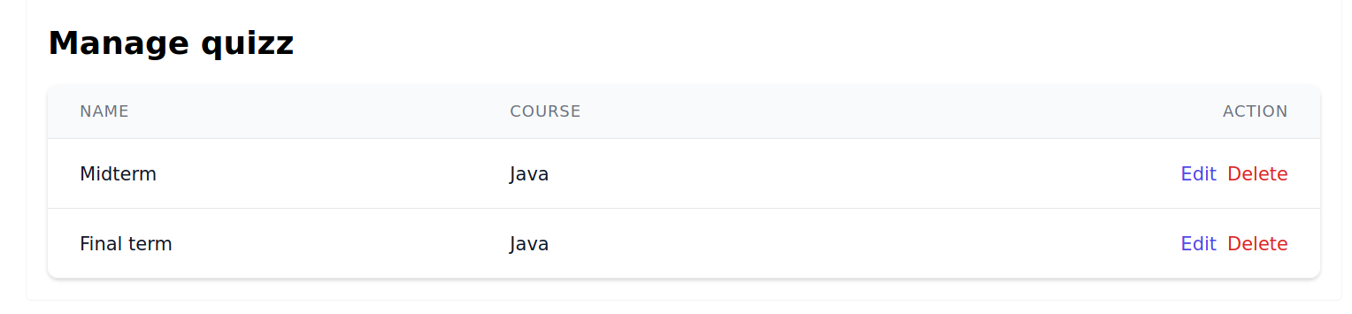

Figure 42. Quizzes management page

Quiz management page will display the list of quizzes for admin to edit or delete. In this page, admin can also add new quiz, update or delete quiz.

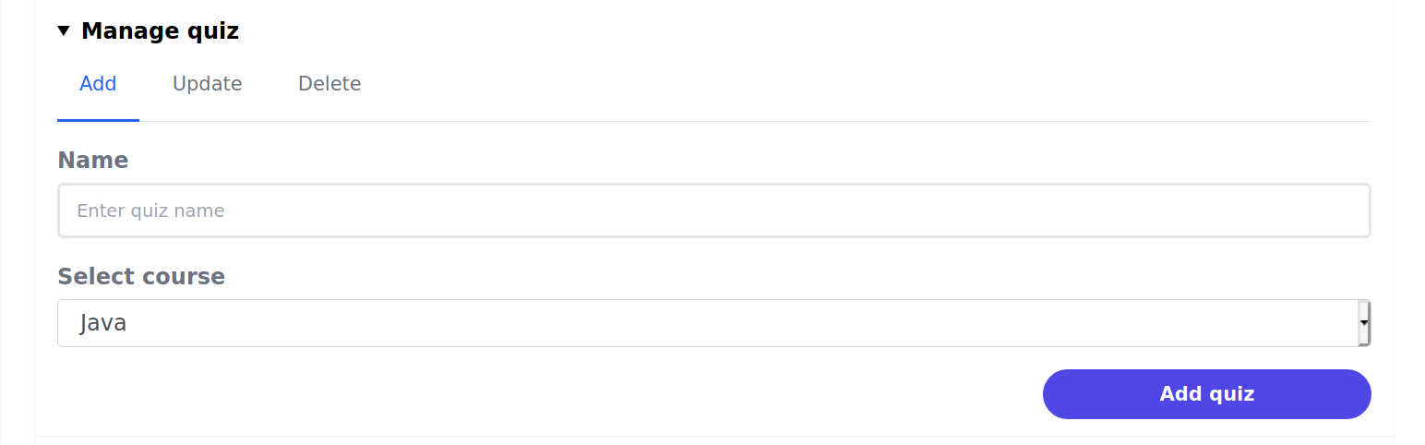

Figure 43. Add quiz form

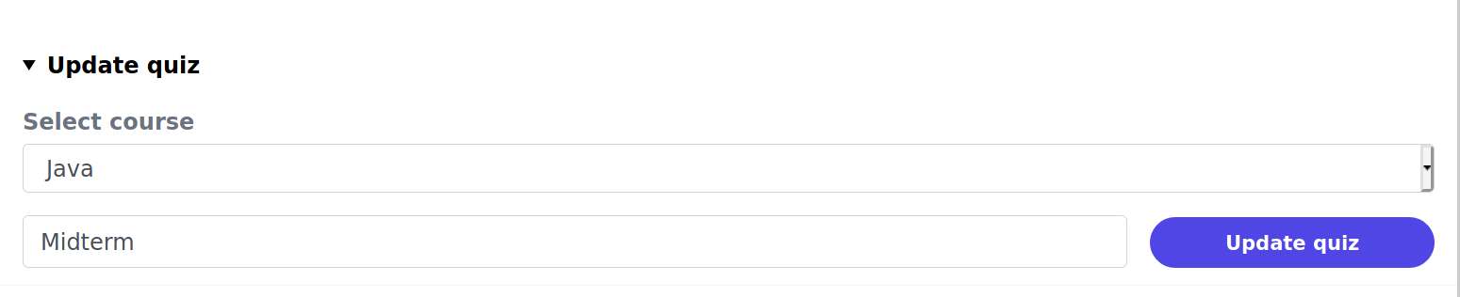

Figure 44. Update quiz form

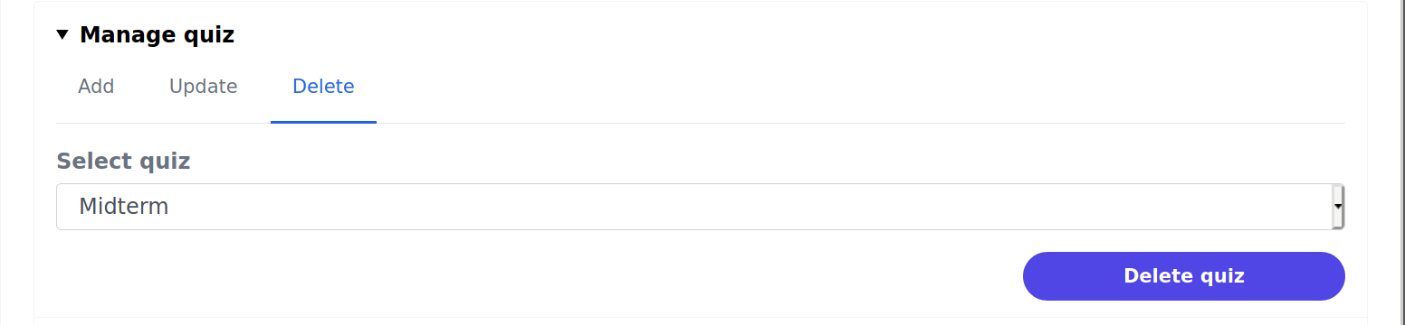

Figure 45. Delete quiz form

When admin clicks on the edit quiz link, the edit quiz page will be shown to enable admin to edit the quiz and show all the questions of the quiz for update.

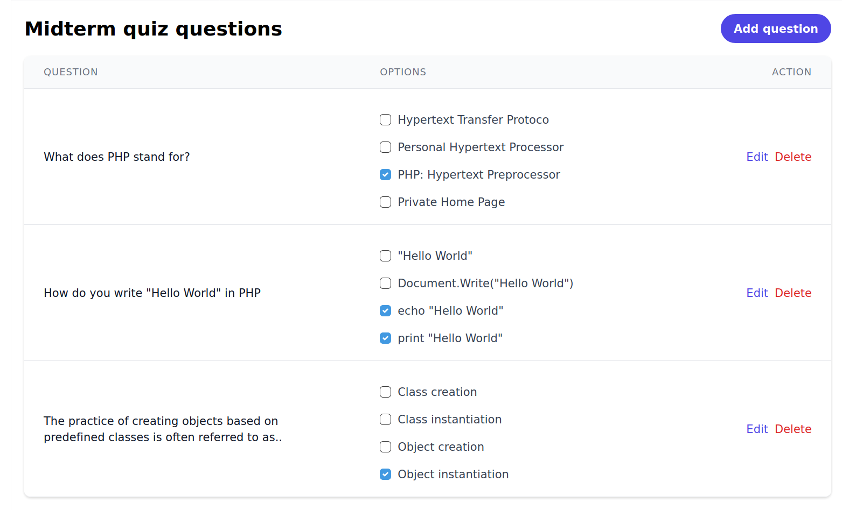

Figure 46. Quiz questions management

When admin clicks on edit button, the edit question will be shown to allow admin edit the question of the quiz.

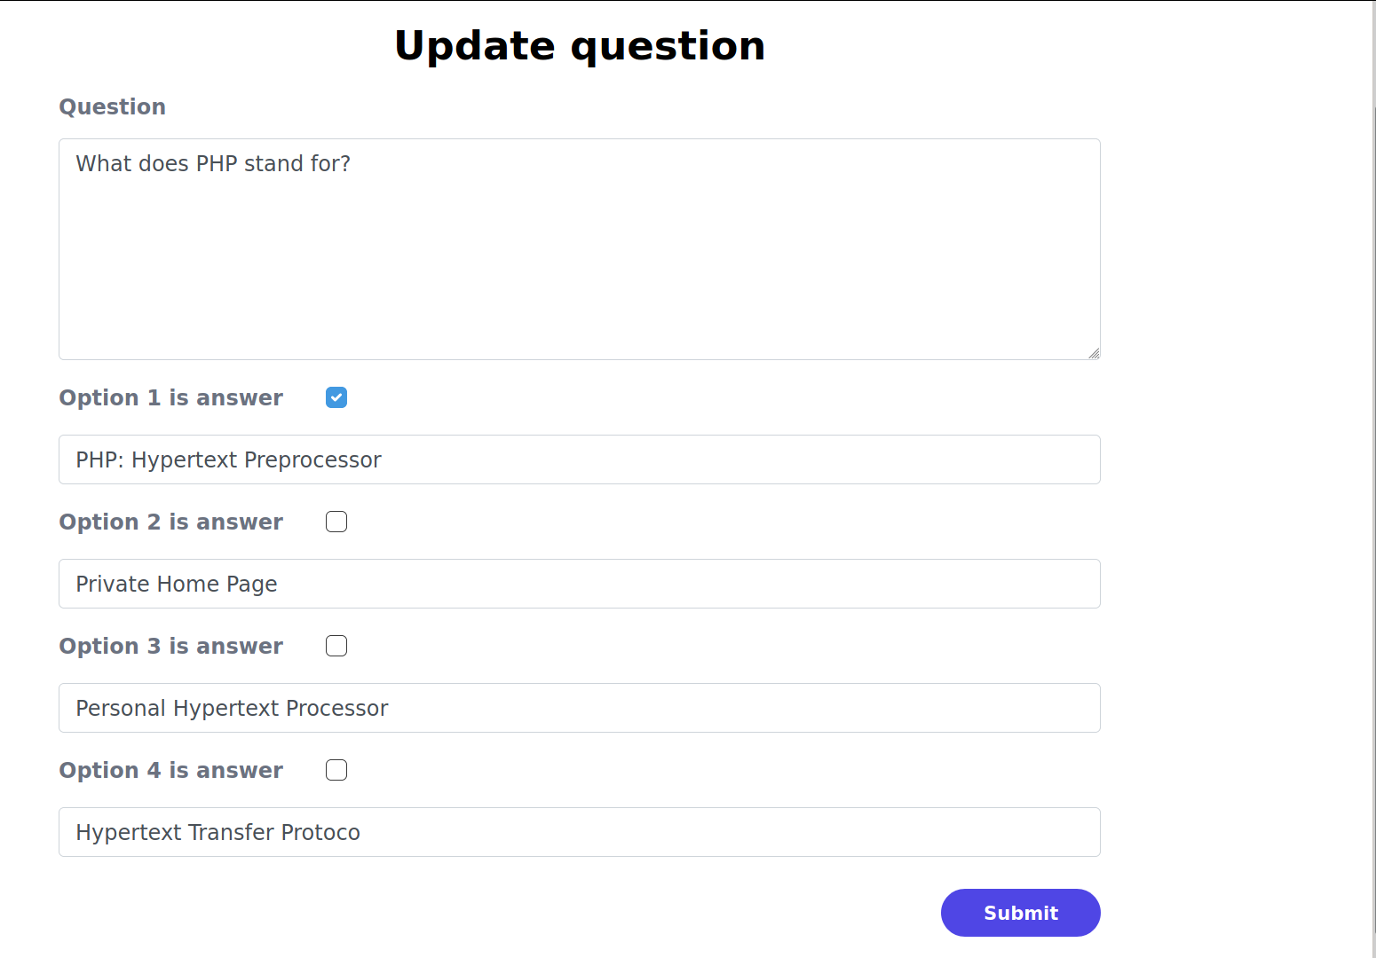

Figure 47. Update question form

Moreover, there is a “add question” button to allow admin to add more question to the quiz. After clicks on “add question” button, admin will be redirected to add question page to add question to the quiz.

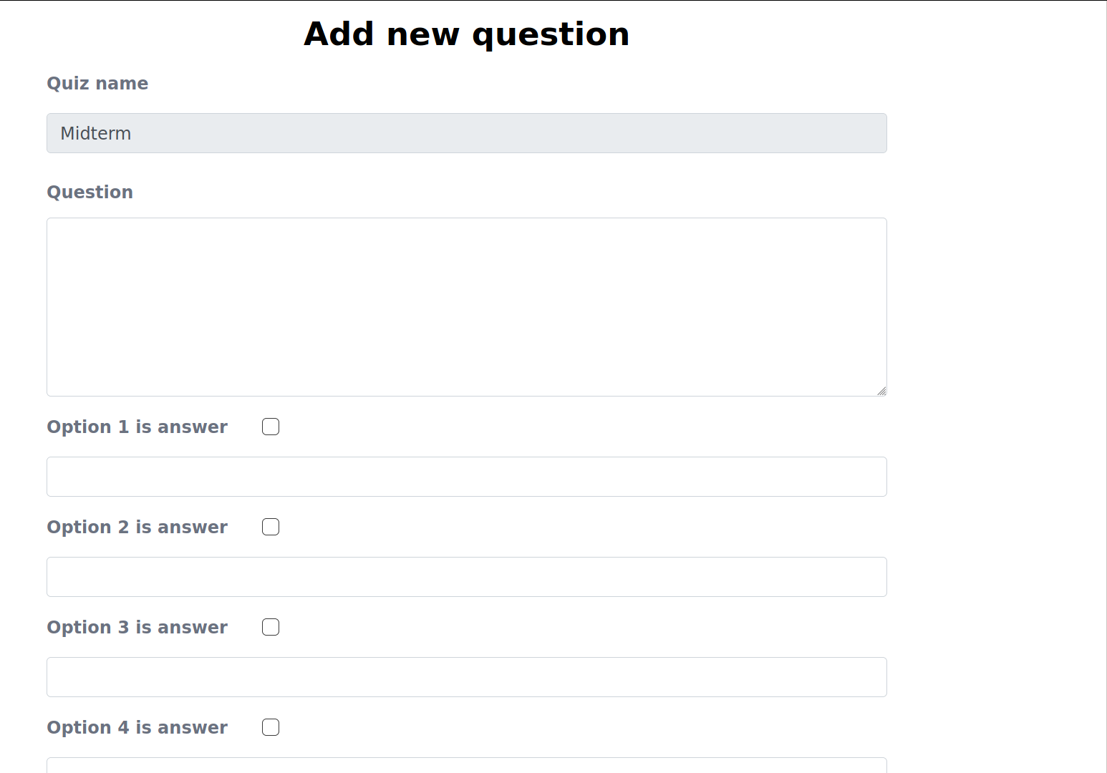

Figure 48. Add new question form

# CONCLUSION AND FUTURE WORK

## Conclusion

E-learning has reached the goal. We successfully created an application that provided a friendly UI/UX with workable functionalities: supporting users to search for courses that they are interested in. Besides, there is a quiz feature that boost their learning curves performance by allow users to examinate what they have learn. We also provide the course in the video format to make the courses more attract to the users than the tradition article course.

Although E-learning provides various useful functionalities, there are also have some limits. At the present, E-learning does not support author role users for upload courses beside admin yet. Moreover, the quiz feature is currently only to help users to examinate what they have learnt, but not to use to evaluate the overall result of the user learning the course. The search courses functionality is limited, only support search with course name, but not its language or programming language of the course.

## Future work

In the future, we plan to add the author role users to upload courses beside the admin, and add more feature related to this accordingly. We also will integrate the quiz feature into the course to evaluate the overall result the user has achieved when learning the course. We will add review and rating for the course to help users have the overall quality of the course before start to learn it, and help to improve the course through the review of the users. Besides, we will enhance the search courses feature with more options such as based on categories, languages or the programming languages of the courses. In addition, using AI to assist and recommend related courses based on user’s behaviors will effectively enhance the quality of the website as well as the performance and interest of the users

**REFERENCES**

|  |  |
| --- | --- |
| [1] | "Boostrap," [Online]. Available: https://www.boostrap.com. |
| [2] | "TailwindCSS," [Online]. Available: https://tailwindcss.com/. |
| [3] | "PHP," [Online]. Available: https://www.php.net. |
| [4] | "MySQL," [Online]. Available: https://www.mysql.com. |