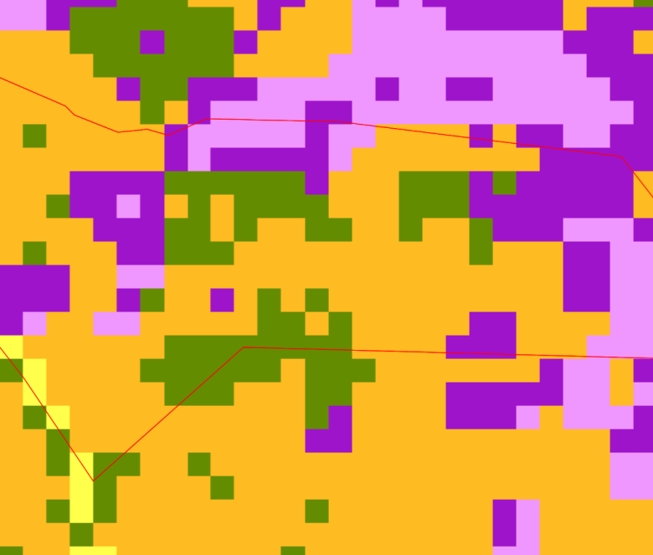





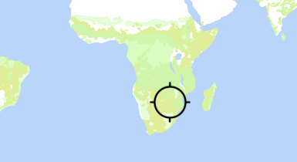



**© Map produced by Hand-in-Hand Geospatial Platform Thu, 23 May 2024 20:53:27 GMT.**

**CC BY-ND 4.0**

*https://data.apps.fao.org/*

**Bethel.kml**



**Bethel.kml**





***Disclaimer****: The designations employed and the presentation of material in this information product are not warranted to be error free and do not imply the expression of any opinion whatsoever on the part of FAO concerning the legal status of any country, territory, city or area or of its authorities, or concerning the delimitation of its frontiers or boundaries. FAO makes every effort to ensure, but does not guarantee, the accuracy, completeness or authenticity of the information in this information product.*

Bethel.kml