Table 1. Summary statistics of the samples in 9 study populations

|  |  |  |  |  |  |  |  |  |
| --- | --- | --- | --- | --- | --- | --- | --- | --- |
| **Table 1. Summary statistics of the flower measurements in 9 study populations** | | | | | | | | |
| Population (n) | GA (mm2) | | GSD (mm) | | GAD (mm) | | ASD (mm) | |
| Mean (±SE) | SD | Mean (±SE) | SD | Mean (±SE) | SD | Mean (±SE) | SD |
| Total (205) | 23.35 (±0.52) | 7.47 | 4.87 (±0.05) | 0.70 | 5.03 (±0.07) | 0.98 | 3.59 (±0.10) | 1.49 |
| S1 (30) | 19.79 (±0.64) | 3.52 | 4.75 (±0.13) | 0.73 | 4.73 (±0.20) | 1.08 | 2.56 (±0.22) | 1.20 |
| S11 (34) | 16.95 (±0.81) | 4.73 | 4.57 (±0.11) | 0.63 | 5.27 (±0.14) | 0.80 | 3.16 (±0.15) | 0.89 |
| S12 (25) | 21.75 (±0.94) | 4.68 | 5.02 (±0.18) | 0.90 | 4.65 (±0.14) | 0.70 | 2.66 (±0.17) | 0.84 |
| S2 (14) | 25.14 (±1.49) | 5.56 | 5.01 (±0.16) | 0.60 | 4.66 (±0.16) | 0.61 | 3.87 (±0.27) | 1.03 |
| S20 (18) | 34.62 (±1.82) | 7.72 | 4.91 (±0.13) | 0.52 | 6.38 (±0.23) | 0.91 | 6.32 (±0.43) | 1.71 |
| S27 (22) | 23.90 (±0.79) | 3.69 | 5.14 (±0.13) | 0.62 | 4.39 (±0.13) | 0.61 | 2.98 (±0.23) | 1.08 |
| S7 (25) | 23.44 (±1.41) | 7.03 | 5.08 (±0.13) | 0.65 | 4.60 (±0.16) | 0.79 | 3.92 (±0.21) | 1.06 |
| S8 (20) | 29.56 (±1.98) | 8.86 | 4.89 (±0.14) | 0.64 | 5.72 (±0.22) | 0.95 | 4.52 (±0.27) | 1.20 |
| S9 (17) | 23.16 (±1.27) | 5.23 | 4.57 (±0.18) | 0.74 | 5.43 (±0.17) | 0.66 | 4.05 (±0.22) | 0.90 |
| Note. The 9 study populations located in Costa Rica with total sample size at 205. The abbreviations used in the table are listed below: gland area (GA), gland-stigma distance (GSD), gland-anther distance (GAD), anther-stigma distance (ASD). | | | | | | | | |

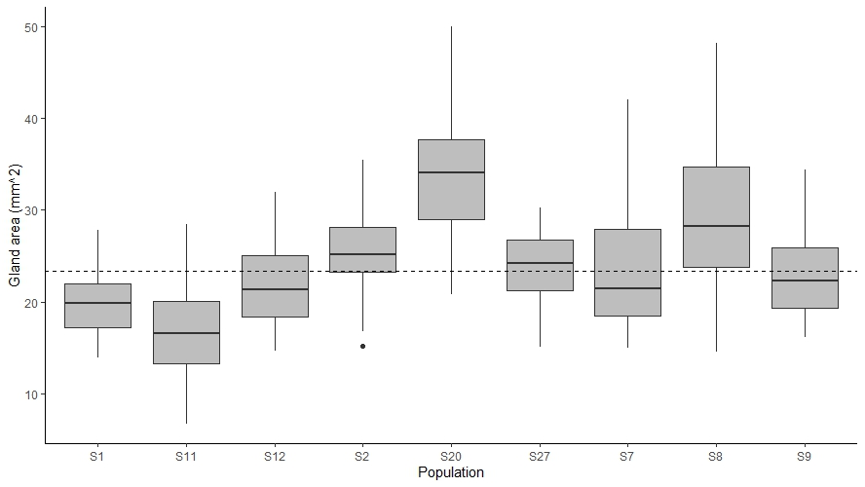**Figure 1.**

**Figure 1. The difference of mean gland areas among 9 study populations.** The dashed line on the plot represents the mean of gland areas in the whole study population. The results from ANOVA test and Tukey’s multiple comparisons test identify that population S11 has a statistically significant lower mean of gland areas when comparing to the other population (P<0.05), while S20 and S8 have significantly higher values (P<0.05).

Table 2. Linear mixed model for the relationship between gland areas and the distances among gland, anther and stigma.

|  |  |  |  |
| --- | --- | --- | --- |
| **Table 2. Linear mixed model for the relationship between gland areas and the distances among gland, anther and stigma** | | | |
| Measurement | β (95% CI) | Z | P-value |
| ASD (mm) | 1.42  (0.81, 2.04) | 4.577 | <0.001 |
| GSD (mm) | 2.75  (1.71, 3.79) | 5.178 | <0.001 |
| GAD (mm) | 1.78  (0.91, 2.66) | 3.992 | <0.001 |
| Note. The formula for this linear mixed model is GA ~ ASD+GSD+GAD+(1|pop), considering the population grouping as the random effect in the model. The intercept is -3.60 (±3.12). The abbreviations used in the table are listed below: gland area (GA), gland-stigma distance (GSD), gland-anther distance (GAD), anther-stigma distance (ASD), population (pop). | | | |

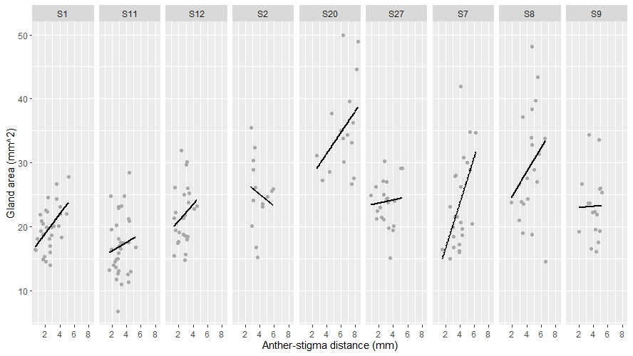Figure S1.

**Figure Supplement 1. Correlations between gland area and anther-stigma distance in 9 study populations.** The solid lines represent the linear regression (gland area ~ anther-stigma distance) results for each population.

Figure S2.

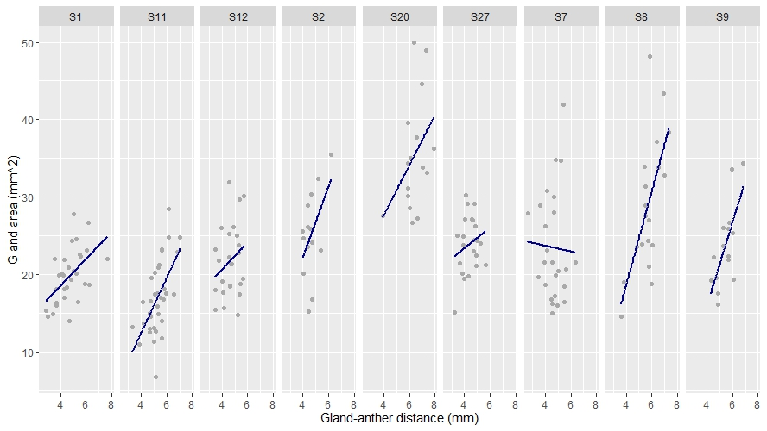

**Figure Supplement 2. Correlations between gland area and gland-anther distance in 9 study populations.** The solid lines represent the linear regression (gland area ~ gland-anther distance) results for each population.

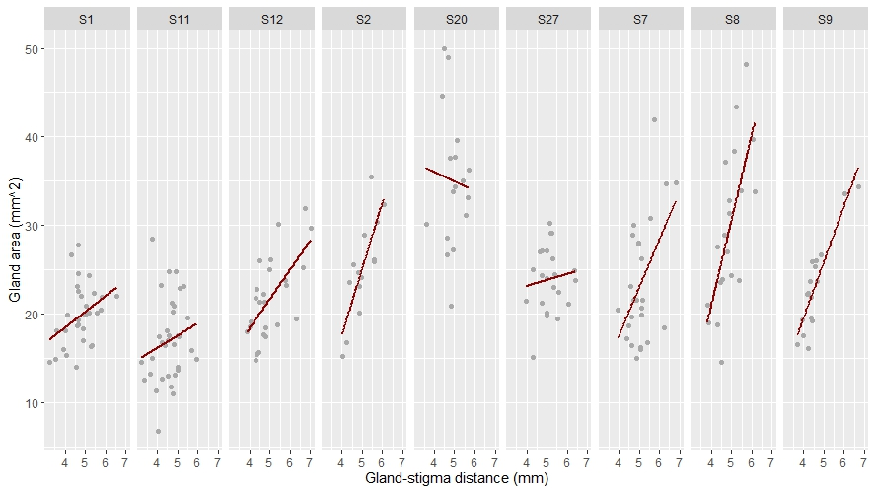Figure S3.

**Figure Supplement 3. Correlations between gland area and gland-stigma distance in 9 study populations.** The solid lines represent the linear regression (gland area ~ gland-stigma distance) results for each population.

**R-script:** https://github.com/GuyuanTang/BIOS14_Exercises/blob/Exercises/Midterm_Exercise.R