# SCVPN AutoLogin

# Pre-requisites

* Chrome needs to be installed and set up as the default browser.
* SCVPN Launcher must be running on the server.
* SCVPN Launcher version must be equal or bigger than 2.3.1
* Uncheck the option ***Request Confirmation Before Login*** from SCVPN configuration:

* Credentials to be used by the SCVPN Recycler need to be added to Windows Credentials Manager.

For this we open the Credentials Manager and click to add a new generic credential:

We will add It with Internet or network address: QCT_SCVPN@{pcc}, where {pcc} is the pcc of the sign in you will use to login to the SCVPN, and under username the {userID} of that login, in the password field you will need to type in the password:

# Download the necessary packages

From the following url, download the zip file: https://github.com/GuzmanFernandez/Syltours/blob/main/SCVPN_Recycler.zip

Unpack it to C:\sabre\apps\SCVPN_Recycler, so the folder contents are as follows:

# Installation of the Chrome extension.

To start, we need to enable developer mode in chrome. That will allow us to install our own extensions.

In order to do so, you need to open chrome, click on three little dots at the top right-hand corner of chrome, then click on Extensions, and then in Manage Extensions.

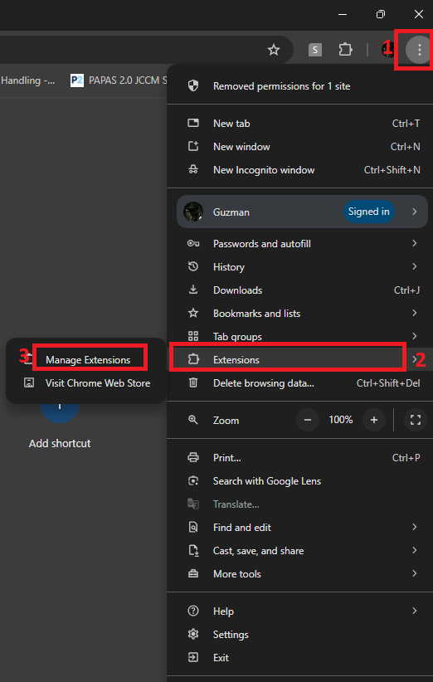

That will take us to the Extension settings, where we need to switch on the Developer mode at the top right-hand corner of the screen as shown below:

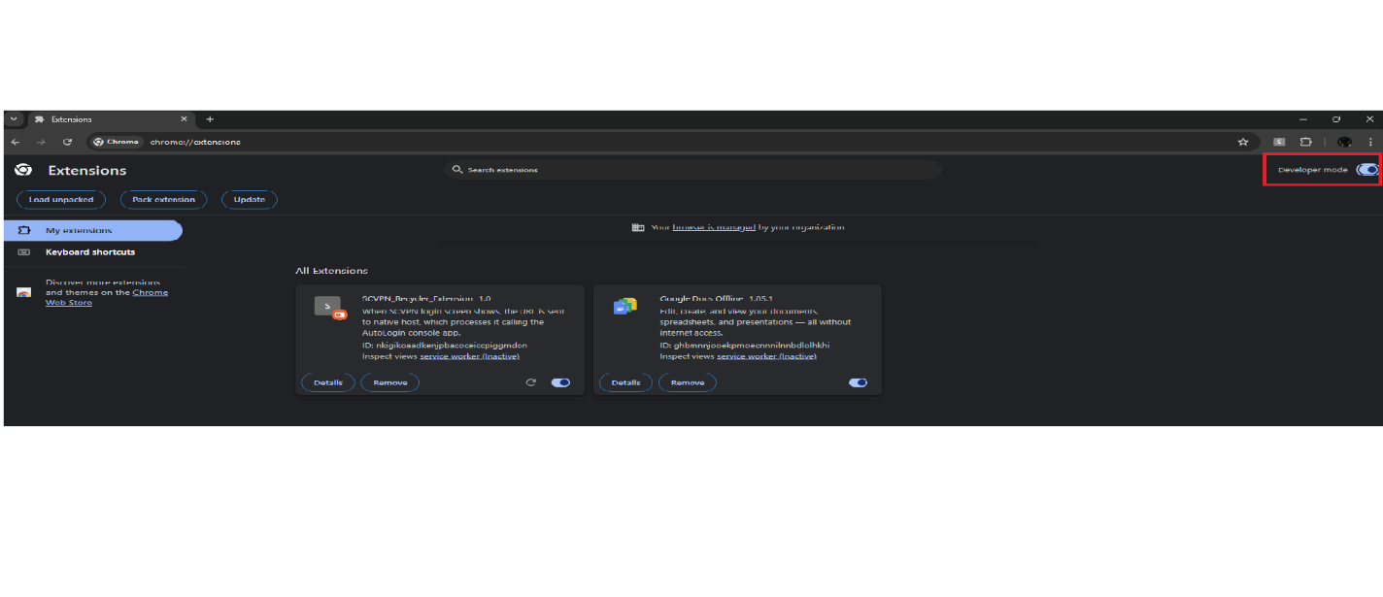

After developer mode has been enable, we should be able to install custom extensions to chrome.

So we will need to click on the **Load Unpacked** button at the top left of the screen, and browse to the folder where the extension is: C:\sabre\apps\SCVPN_Recycler\ChromeExtension

That will install the extension and also assign it with an extension ID:

Take note of this ID as we will need it in the next steps.

After installing the extension, we need to make some modification in the registry, for this step, you need to open regedit, and navigate to the following path:

HKEY_CURRENT_USER\Software\Google\Chrome\NativeMessagingHosts\com.sabre.scvpn_recycler

And there, we will need to set the default key with the following value:

C:\sabre\apps\SCVPN_Recycler\ChromeExtension\com.sabre.scvpn_recycler.json

After that, we will need to edit the file: C:\sabre\apps\SCVPN_Recycler\ChromeExtension\com.sabre.scvpn_recycler.json

And update the ID field with the ID previously assigned to the extension by chrome:

# Edit of the SCVPN_AutoLogin config file

Now you need to edit the following file:

"C:\sabre\apps\SCVPN_Recycler\SCVPN_AutoLogin\SCVPN_AutoLogin.exe.config"

And set your UserID and PCC to be used by the application to login to the SCVPN.

It has to be the same as the one for which you stored the credentials in Windows Credentials Manager:

# Conclusion

Now that everything is installed and configured, every time the SCVPN launcher needs to login to the SCVPN login portal, the chrome extension should trigger and perform he login automatically.